 |  | Valentine’s Menu  3 courses, 2 people, 1 price  £60 per couple | 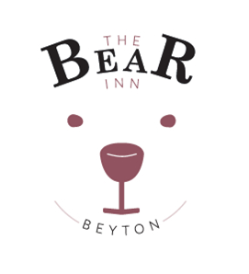
to start | 6 fresh oysters  Served on crushed ice with tabasco and lemon  Prawn, avocado and fennel salad  Served with a shot of Bloody Mary dressing  Roasted Red Pepper and Tomato Soup  Served with crusty bread  Chicken liver and wild mushroom pate  Served with red onion marmalade and toast
mains | Chargrilled salmon  With asparagus, baby potatoes and hollandaise dressing  Fillet steak with red wine and mushroom sauce  Served with parmentier potatoes and mixed green vegetables  Butternut squash, chickpea and red onion tagine  Served with fragrant rice  Lemon, garlic and thyme marinated chargrilled chicken  Served with Israeli cous cous, pomegranate, spinach and mint
to finish | Carrot cake cheesecake  With a caramel drizzle and pouring cream  Warm Dark Chocolate Brownie  With vanilla ice cream and chocolate sauce  Tangy lemon tart  With raspberry coulis and raspberries  Cheeseboard with Crackers and Homemade Chutney
Please let us know if you have any allergen requirements
The Bear Inn, Tostock Road, Beyton, IP30 9AG
Tel: 01359 270249 Email: contact@thebearinnbeyton.co.uk Website: www.thebearinnbeyton.co.uk
Facebook: thebearinnbeyton Twitter: @bearinnbeyton Instagram: @bearinnbeyton

