One of my favorite colleagues in the PA House, Rep. Vanessa Lowery Brown has cosponsored Rep. Gerald Mullery and my bill banning the anti-#LGBT practice of "conversion therapy."
Not only is Rep. Lowery Brown a staunch advocate of LGBT civil rights as cosponsor of both HB300 (the LGBT-inclusive nondiscrimination bill) and HB1686 (the #PA #MarriageEquality Act), as the Chairwoman of the #Pennsylvania Legislative Black Caucus, she is also a tireless supporter of all those within our Commonwealth who have been subjected to widespread marginalization and disenfranchisement.
Please join me in sending a big THANK YOU to Rep. Lowery Brown!
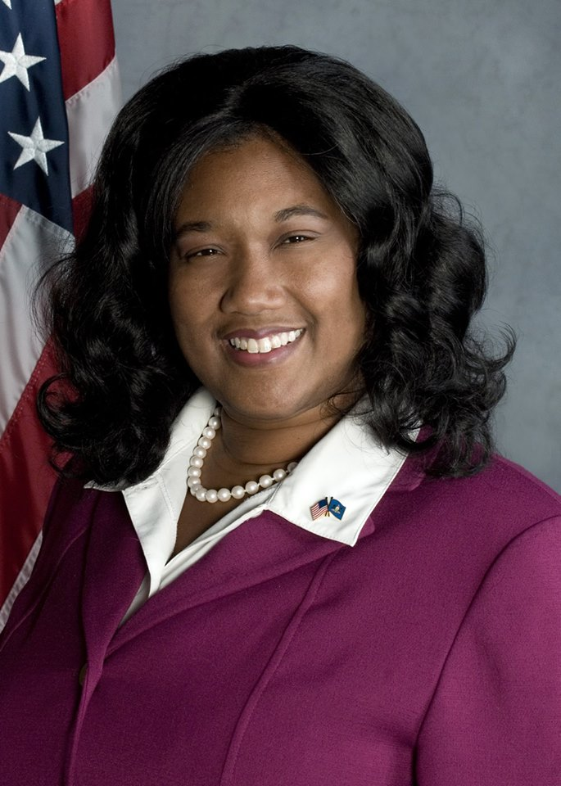
From the Facebook Page Brian Sims

