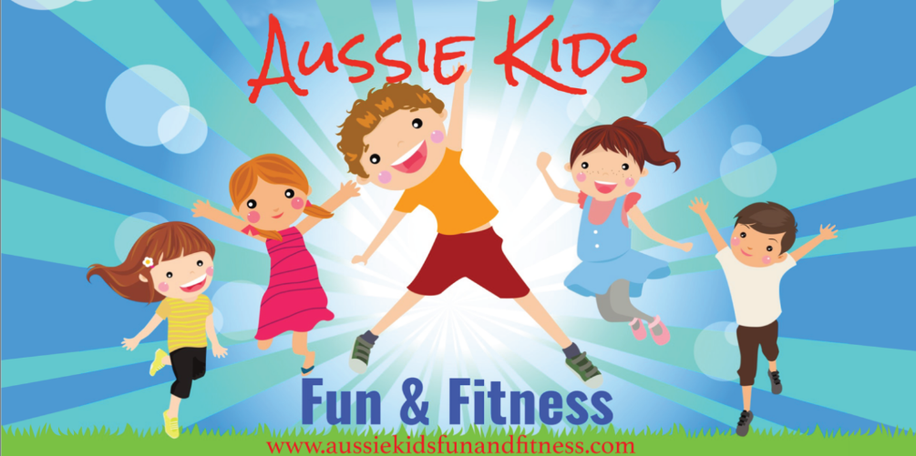
CUDGEN PUBLIC SCHOOL Vacation Care Program - July 2019
VISIT OUR WEBSITE www.aussiekidsfunandfitness.com PHONE: 0413974775
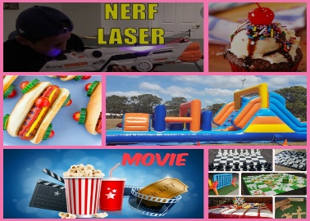 | 5 July  Laser Nerf  Cup Cake Decorating  Giant Yard Games  Movie - Hot Dog Bar  Inflatable Obstacle | 5 July  Body Art Painting  Beading  Foil Tattoos  Nail Art  Hair Feathers | 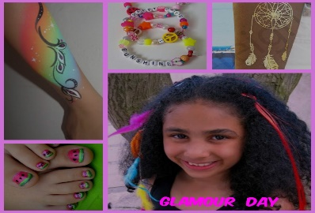
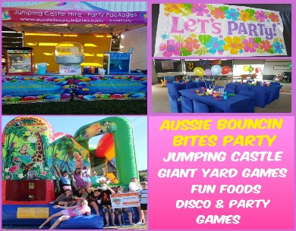 | 8 July - AUSSIE BOUNCIN BITES PARTY @ M’bah Leagues Club  Large Jumping Castle  Giant Yard Games  Disco & Party Games  Fun Foods | 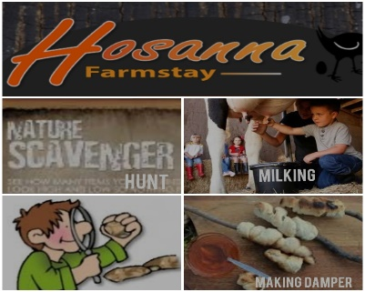 | 15th July- HOSANNA FARMSTAY  Camp Fire Damper Making  Feeding & Milking Animals  Nature Hunt  Bush Walk  BACK AT THE SERVICE – PITCHING TENTS
 | 9th July - TEN PIN BOWLING  Hungry Jacks Extra $6  Inflatable Obstacle  Sand Art Work Shop |  | 16th July -  Kids Biz  Indoor Play Centre  Claydough Workshop  Movie –Children’s Choice  Popcorn Bar
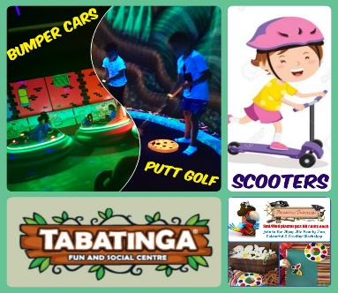 | 10TH July TABATINGA  - Bumper Cars  - Putt Golf  - Play Equipment  BRING YOUR SCOOTER & HELMET  PLASTER PARDISE WORRSHOP | 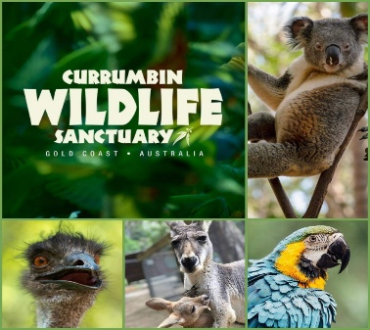 | 17th July –  Currumbin Wildlife Sanctuary  Reptile Shows Animal Feeding  Animal Encounters  Learn FUN & Interesting facts about the Wildlife  Picnic Lunch
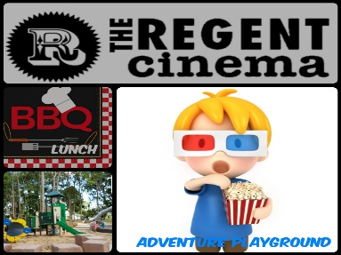 | 11TH JULY -  ADVENTURE PLAYGROUND – KNOX PARK  BBQ LUNCH  CINEMAS –  MOVIE TBA  POPCORN & POPPER | 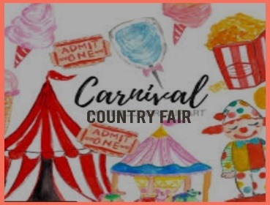 | 18th July –Country Fair  Races, Contests, Balloon Darts, Apple Bobbing, Pick a Duck, Jumping Castle, Guessing Games, Colouring Competition, Circus Activities, Fun Foods,  And More!!
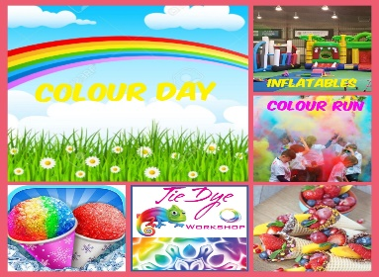 | 12th July–  COLOUR DAY  INFLATBLES  SNOW CONES  TIE DYE WORKSHOP  MAKE COLOUR RUN POWDER FOR THE COLOUR FUN RUN  COOKING – FRUIT & CHOCOLATE WAFFLE CONES | 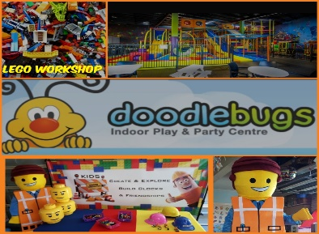 | 19th July - DODDLEBUGS  Huge Indoor Play Centre  Bring your socks  LEGO WORKSHOP  Bring your Scooter & Helmet

