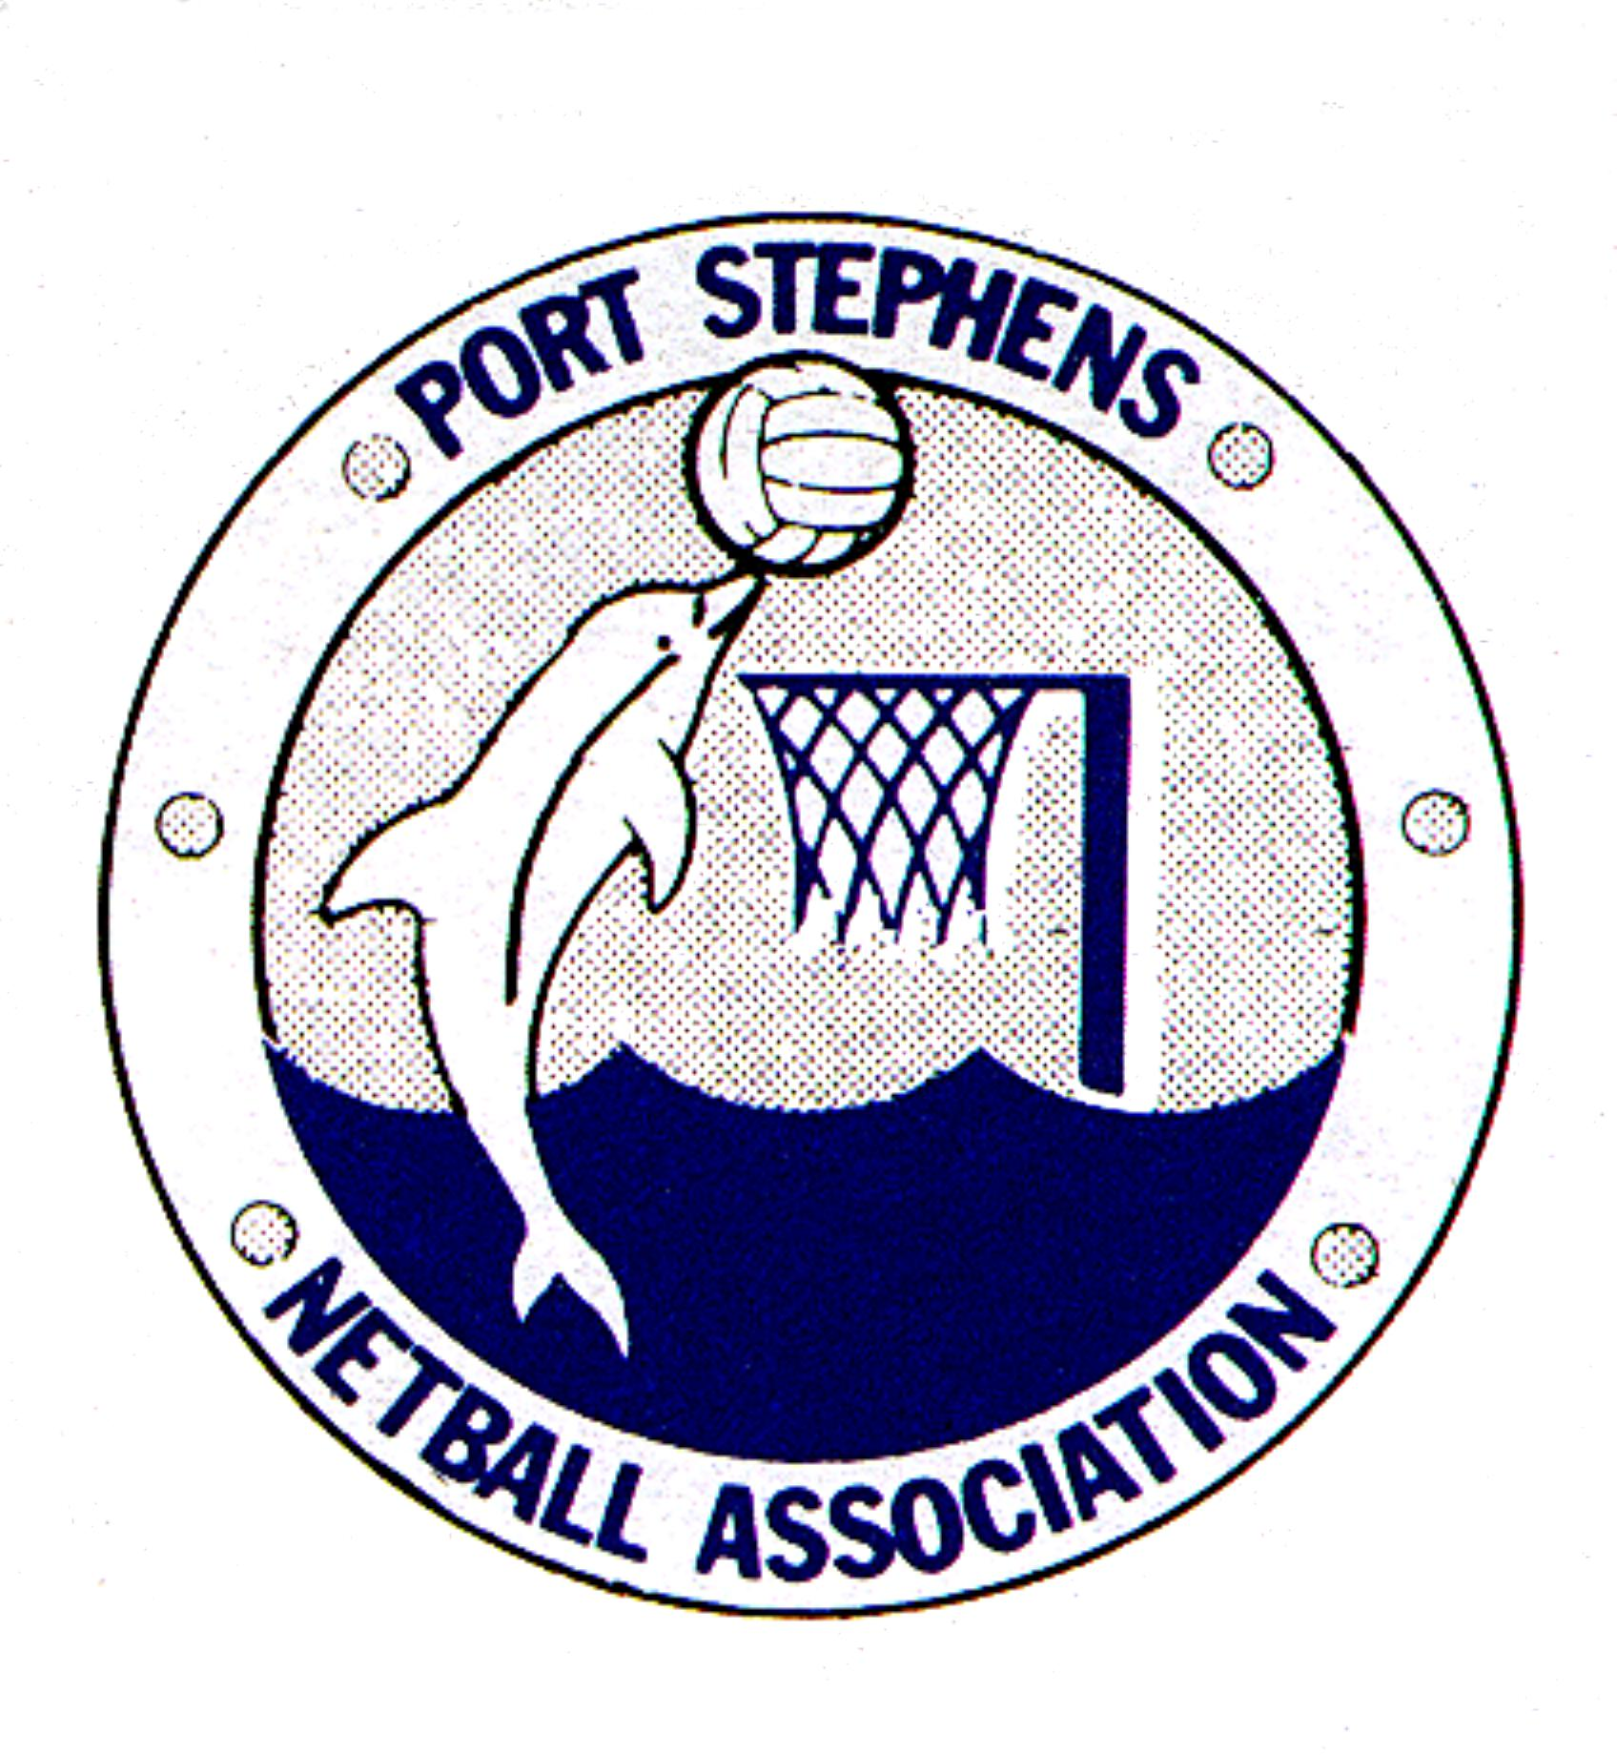
PORT STEPHENS NETBALL ASSOCIATION INC.
(Annual General Meeting :11th March, 2015)

Nomination for Office Bearers

I would like to nominate: …………………………………………………………………………………………………………..

Telephone number of nominee: ………………………………………………………………………………………………..

For the position of: …………………………………………………………………………………………………………………….
(See back of form for position)

PROPOSED: ………………………………………………………………………………………………………………………………….

SECONDED BY: …………………………………………………………………………………………………………………………..

NOMINEE’S SIGNATURE: ………………………………………………………………………………………………………

Preferable that: All nominations to be in the hands of the Secretary no later than fourteen (14) days prior to the Annual General Meeting. Please see attached forms listing the status of all Executive and Committee positions.

Executive Committee Positions – meetings every month + Council meetings
President Secretary Treasurer Representative Convenor
Minute Secretary Games Services Convenor Technical Services Convenor

Convenor Positions (non-Executive)
– meetings as required, reports to Executive position in brackets
(Secretary) Assistant Secretary
(Treasurer) Canteen Assistant Treasurer Registrar
(Games Services) Grading Fixtures Grounds

(Technical Services) Umpires Coaching Selections

Discipline Convenor

Sub-Committee Positions (non-Executive) – meetings as required
Appeals 3 elected + 2 reserves + 2 Executive nominated
Canteen 6 elected + Convenor
Fixtures 6 elected + Convenor
Grading 6 elected + Convenor
Grounds 6 elected + Convenor
Representative 6 elected + Rep Convenor + Ass. Treasurer + Ass. Secretary
Recorders 2 elected + Convenor
Selection 9 elected + Convenor (must hold Level 1 Coaching Accreditation)
Umpires 2 elected + Convenor

