Peninsula Piecemakers Quilt Guild 2019/2020 Mystery Quilt
(Finished Quilt size: 72” x 72”, Finished Block size: 12”)
Clue 4

6. Draw a diagonal line on the wrong side of 24 light 5" x 5" squares. With right sides together, layer a light and medium 5" square. Sew ¼" on both sides of the drawn line.
Cut apart on the drawn line. Square up to 4½” square. Open and press toward the medium fabric to form 48 half-square triangles.
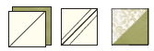
7. . . .
a. Sew the following in a row: a light 4 ½”, half square triangle from step 6 and a focus 4 ½” square to form Section H. Make 12.

b. Sew the following in a row: 2 half square triangle from step 6 and a focus 4½” square to form Section I. Make 12.
c. Sew the following in a row: a focus 4½” square, a half square triangle from step 6 and a light 4½” square to form Section K. Make 12.
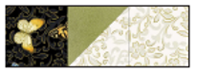
d. Sew sections H, I and K as shown below to make Block 6. Square up to 12½”. Make 12.
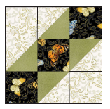

Next month you will get the final set of instructions showing how the blocks are to be put together! Completed quilt top is due at the March 2020 PPQG Quilt meeting. Remember, you only need to have the top completed, it doesn’t have to be quilted and binded.

