Nutrition Plus, Inc.
Emily Roark Patti Brenn Susan Morrell
(620) 221-2777 (620) 218-4994 (785) 224-4104
roark2@cox.net pattibrenn@cox.net smorrell12@gmail.com
November is:
- National Gluten-free diet awareness month
- National peanut butter lovers’ month
- National pepper month
- National pomegranate month
- National raisin bread month
- National roasting month
- National spinach, squash and sweet potato awareness month

Important dates to remember:

26th - checks go out/direct deposits go in
28th – Thanksgiving Day
29th – Black Friday
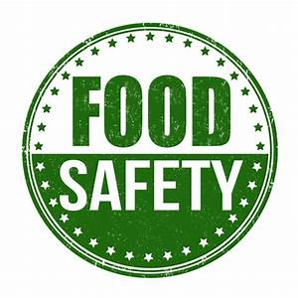
Food safety is important all year
As home daycare providers, we have the opportunity to help prevent food-born illness by practicing and teaching safe food preparation.
Food safety is important on holidays, special days, and every day of the year. Everyone wants to eat food that has been stored, prepared, and cooked properly. In cases where food has not been properly stored or refrigerated, there is an opportunity for bacteria to grow. Let’s talk about the different steps of food safety: Clean, Separate, Cook, and Chill.
November 2019
www.nutritionplusinc.com

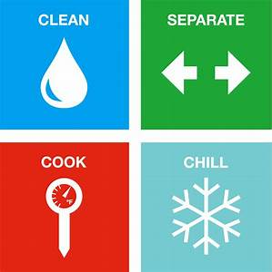

Clean: Everything you work with needs to be clean. Make sure your hands, all utensils, bowls, cutting boards, and other items used during food preparation are clean. Start with your hands. Use warm water and soap (antibacterial soap is not necessary). Scrub all over for 20 seconds. (Singing Happy Birthday Song twice is helpful to keep track of time) Rinse thoroughly and dry with a clean paper towel, using the paper towel to open any doors. When it comes to washing raw food you eat, you should wash fresh fruits and vegetables just prior to peeling, eating, or preparing them. There could be bacteria on the outside of the fruit. If you cut the fruit or vegetable before washing it, you could spread the bacteria to the inside of the fruits or vegetables.

Separate: Do not allow foods that will not be cooked to come in contact with foods that require cooking because of the possibility of cross-contamination. Fresh fruit is not cooked to a temperature that will destroy the bacteria and that creates an opportunity for someone to eat contaminated food. Vegetables will not be cooked to a high enough temperature to kill the bacteria that could possibly be on the meat. Always use separate cutting boards, plates, and cooking utensils for raw meats and cooked meats, as well as for any fresh foods that may not need cooking. Have separate bags for meats and vegetables so the juices from the meat won’t contaminate the vegetables.

Cook: It’s important to cook food to the correct temperature so the bacteria that causes foodborne illness will be killed. Use a calibrated thermometer to determine food has reached the appropriate temperature. The temperature for bacteria to multiply the quickest is between 40 °F to 140 °F, known as the “Temperature Danger Zone.” Cooking temperatures vary depending on the food. Ground beef = 160°, Ground turkey and chicken = 165°, Steaks and roasts (beef) = 145°, all poultry = 165°, fresh pork and ham = 145°, precooked pork and ham (to reheat) = 165°, leftovers and casseroles = 165°, fish = 145°, or until flesh is opaque white and separates easily with a fork.

Chill: Bacteria that can cause illness can grow in foods within 2 hours. If the weather temperature is 90 °F or higher, the 2 hour period is cut down to 1 hour. Cold temperatures will slow the growth of bacteria. Pack food in the refrigerator so that cold air can circulate; don’t overload your refrigerator. Do not pack perishables in the door of the refrigerator. Place raw meats on the bottom shelf or in a meat drawer where the temperature can be adjusted. This will lengthen the viable storage time. There is bacteria that can cause foodborne illness and bacteria that can cause food spoilage. Keep in mind, food that has not been refrigerated or has been left out of the refrigerator for hours may still look fine but may have bacteria multiplying in it; therefore, it becomes dangerous to eat. “When In Doubt, Throw It Out!”

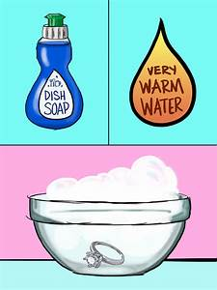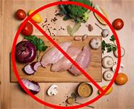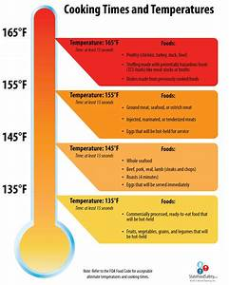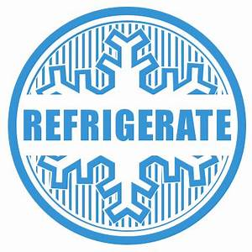

How to process your own pumpkins
- Cut the pumpkin in half, discarding the stringy insides.
- Microwave on high power for seven minutes per pound, turning pieces every few minutes to promote even cooking. Let the chunks cool, then purée the flesh in a food processor or mash it with a potato masher or food mill.
- You can refrigerate your fresh pumpkin purée for up to three days, or store it in the freezer up to six months, so you can enjoy fall pumpkins for months to come.
Easy Pumpkin Soup
2.5 pound pumpkin
1 onion sliced
2 cloves garlic
3 cups broth (chicken or vegetable)
1 cup water
Salt and pepper to taste
- Cut the pumpkin into 2.25" slices. Cut the skin off and scrape seeds out. Cut into 1.5" chunks.
- Place the pumpkin, onion, garlic, broth and water in a pot - liquid won't quite cover all the pumpkin. Bring to a boil, uncovered, then reduce heat and let simmer rapidly until pumpkin is tender (check with butter knife) - about 10 minutes.
- Remove from heat and use a stick blender to blend until smooth.
- Season to taste with salt and pepper, stir through cream (never boil soup after adding soup, cream will split).
- Ladle soup into bowls, drizzle over a bit of cream, sprinkle with pepper and parsley if desired. Serve with crusty bread!

Thanks for being the best part of Nutrition Plus!
Emily, Patti and Susan

