**Online Backup Solution & Hard Drive Recovery**

Our team has developed an online backup solution for you to offer to your clients that actually makes sense. We will provide you with tools to resell this product, including an unlimited amount of 30-day trials, free accounting backup plans, marketing materials, website content and a phenomenal support staff who is available for guidance whenever you need it. We even offer you the ability to [**BRAND**](https://mail.google.com/mail/?shva=1#13a794963ffab8ee_brand) this service with your own name and logo!

**Some of the unique features of online backup include:**

* The ability to brand with your company's name
* The ability to set your own prices when reselling
* Bandwidth throttle
* No restriction on bandwidth
* Local copy capability
* Auditing and reporting capability
* HIPAA and SOX compliant
* Secure data transfer and storage to SAS-70 Type II compliant data centers
* Scheduled automatic backups and multiple file revisions

**Examples of where you will see your brand name**

We have the ability to brand this service with your company's name so that you are selling your own product. Customers will see your name and your choice of logo every time they log onto their computers, and as a result, this is a great tool to help build and aid in client retention.

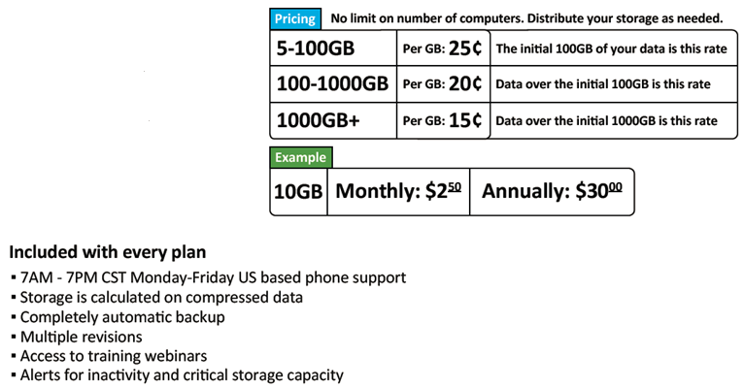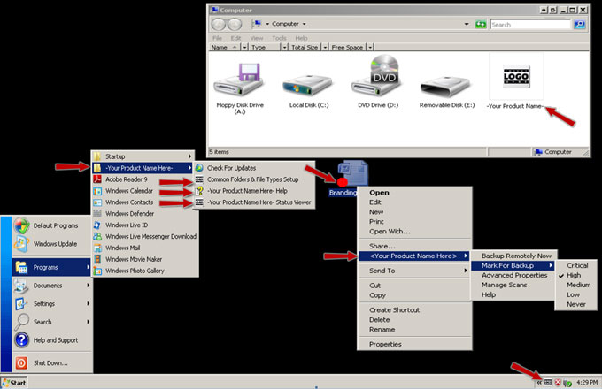

**Customers will receive:**

* + Complimentary diagnostics
  + Complimentary drive wipe services
  + Complimentary UPS Ground shipping
  + Complimentary DVD optical media for up to 25GB of recovered data
  + The ability to view their recovered data prior to any payment

**Please give me a call if you are interested in more details!**