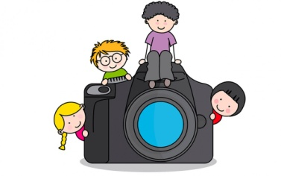

Photograph Consent and Release Form

I hereby give Old Union Nursery School the unqualified right and permission to reproduce, copyright, publish, circulate or otherwise use my child’s distinguishable image in education multimedia productions, including:
- Old Union Nursery School & Community Newsletters
- Promotional brochures & other print materials
- Old Union Nursery School’s website and social media pages

Yes ____________ No ____________

Print your child’s name: ___________________________________
Parent/Guardian Signature: _______________________________
Date: _________________

