______________________________________________________________
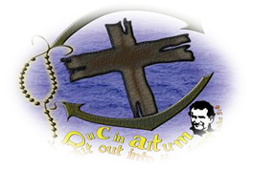
Duc in Altum – Montreal
Registration 2018 - 2019

Kindly type answers.
Send to: ducinaltum8.montreal@gmail.com

Last name: First name:
Date of Birth: year: month: day: age:
Address:
Postal code:
Mobile:
E-mail:
Degrees in progress or completed:
Present Work:
Company:
My parish:
I heard about DIA from:
What motivates you to join DIA?

Today’s date:

Registration: $350 - Cash or Cheque on or before October 1, 2018
Cheque: Pay to the order: OMMDM – Duc in Altum
Memo: Your name
(OMMDM stands for: Les Oeuvres de Mère Marie Dominique Mazzarello)

