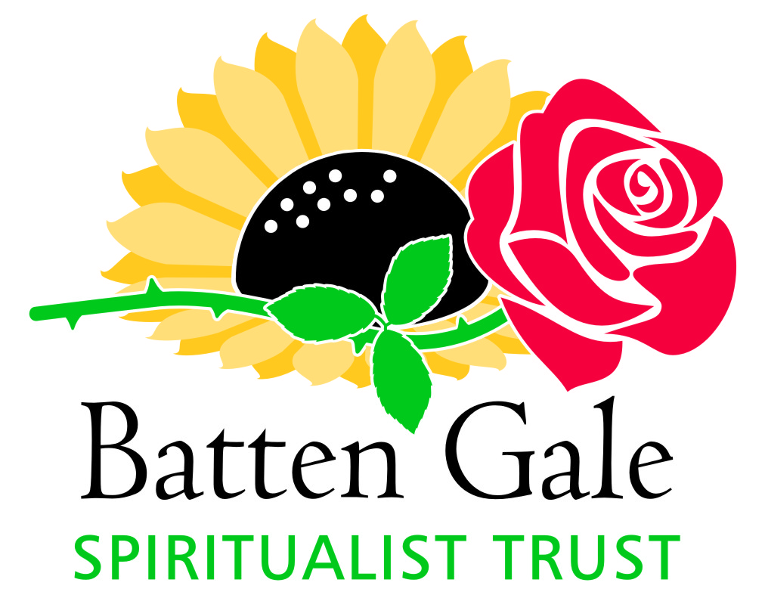
“One Last Time”
One final adventure with four of the very best tutors from the Arthur Findlay College
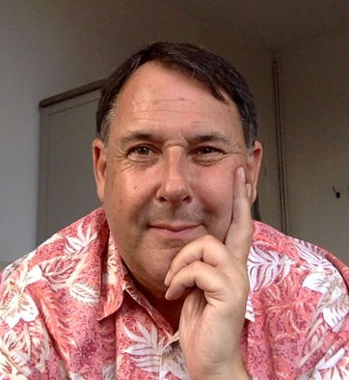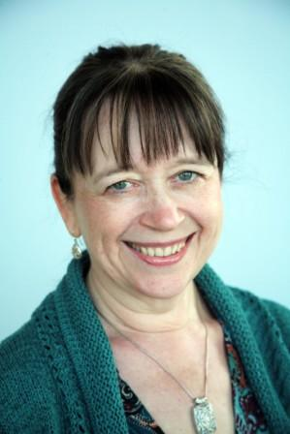
Steven Upton Stella Upton
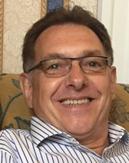
John Johnson Martin Colclough
Book Early Spaces Limited
Pick Your Course
Trance Development
Communication Mediumship (Evidential, Platform, Private Sittings)
New for this year – Special Tutorials Electronic Voice Phenomena Spirit Photography Bring your recording device and camera
Register on-line www.insearchofspirit.com Click on “Register for a Course”

After a dozen years we are closing the curtain on an exciting experiment. The opportunity to work with our very special tutors and students from around the globe has been a joy and a privilege; hopefully our efforts have contributed to a greater understanding of Mediumship. The 2019 Stansted Experience is the end of our journey and your last opportunity to participate in this unique programme for Mediumship development.
Announcing the Final Edition of The Stansted Experience™ September 15 - 20, 2019
Tuition Fee $1395 CAN per person, 2 sharing double room $1645 CAN – Private Single Room Includes: instruction, accommodation, all meals
New location directly on the beautiful Bay of Quinte Travelodge Wyndham Hotel, Belleville, Ontario, Canada
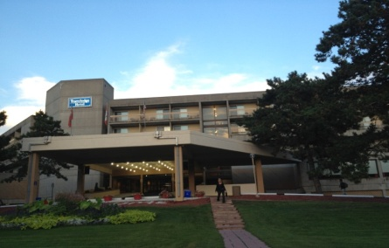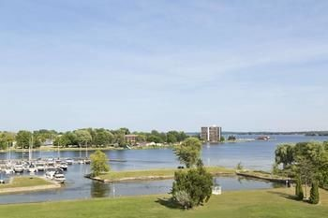

All rooms with balconies, mini fridges, microwave ovens, individual climate control and air conditioning. Use of indoor and outdoor swimming pools, exercise room, walking and biking trails, walking distance to downtown area.

Your Tutors
MINISTER STEVEN UPTON - Steven has been involved the Spiritualist movement since 1971. He started developing his healing mediumship in 1977, attending The Arthur Findlay College as a student from 1979 and qualifying as a SNU Teacher and College Tutor in 1995, specializing in the teaching of trance and trance healing. Steven is one of the most respected practitioners and teachers of trance healing throughout Europe, the mid East and North America. He is course organizer for The Stansted Experience.
STELLA UPTON OSNU - Stella took her first church service in 1990 and became a tutor at The Arthur Findlay College in 1999. Since then she has been teaching and demonstrating mediumship on a regular basis, along with private sittings for survival evidence or personal assessment. A more recent development is the painting of Auragraphs. Along with teaching at the College, she has been working with groups of students throughout the UK and internationally. Among the many subjects she teaches are Relaxation, Meditation, Awareness, Colour, Spirit Art, Paranormal Phenomena and Evidential Mediumship.
JOHN JOHNSON OSNU - “To enable us to work in harmony with the spirit world takes time, trust, discipline and practice on so many levels and it is important that those who wish to work in this work recognize this and have respect for the work they do”. It was apparent from an early stage that John had a key spiritual awareness that could be developed to a high standard to benefit others. John regularly teaches at The Arthur Findlay College where he has organized development groups and workshops; he has also worked in Scotland, Holland, South Africa, Switzerland, Italy and Germany.
MINISTER MARTIN COLCLOUGH - New to our tutorial team for 2019, Martin has been a working medium for over twenty years and is a tutor at the Arthur Findlay College. He works throughout the United Kingdom as well as Italy, Switzerland, Germany, Norway and Sweden. He is the author of two books: Simply Mediumship, A Beginners Guide, and Simply Trance Mediumship, A Beginners Guide. He is also a director in his own training company, TSFellowship that provides training in Mediumship, working in the altered states, Inspirational Speaking, and Spiritual Healing. Martin believes that we can all develop our mediumistic gifts, and he helps people through his easy going and friendly approach. He also has extensive experience in the field of spirit photography.
Choose Your Course
TRANCE DEVELOPMENT This course will focus on trance mediumship and its many aspects including speaking, healing and physical phenomena. Whether you are a beginner, an experienced medium, or just interested in finding out more about trance, an understanding of the entranced states can improve your attunement with the Spirit World to enhance all forms of mediumship. Our tutors are leading practitioners and teachers of the trance process employing methods such as mind focus techniques and empowerment exercises designed to assist students in exploring the wonders of a closer working relationship with Spirit.
MEDIUMSHIP FOR EVIDENTIAL COMMUNICATION, PLATFORM DEMONSTATION AND PRIVATE SITTINGS Whether you have little or no experience or are a practicing medium there will be a group for you with the opportunity to develop and fine tune your skills with concentration on utilizing mediumistic and psychic abilities for private sittings, and techniques for platform demonstrations. You will learn the distinctiveness of true evidence and take your mediumship to new levels. This is a unique opportunity to delve into new aspects of Mediumship enhancing your skills to build a closer working relationship with Spirit. Your tutors are specially trained to guide you through the process of achieving a higher level of consciousness and opening your senses to new levels of awareness and understanding. Be prepared to work hard with lots of practice and have fun at the same time.
A new adventure for 2019 - Special Tutorials
Electronic Voice Phenomena – Spirit Photography
Bring your recording devices and cameras

The 2019 Stansted Experience™ - Registration Form

Name: …. ………………

Address: ………………

City: ………..Province/State: ………………

Country: Postal/Zip Code: ………………

Telephone: ……………………………………………………… .. Email: ……………………………………………………………………………………….

Choose your course: check only one
⃝ Trance Development ⃝ Communications Mediumship

Tuition Fee, check one:
Residential Student: Single: $1645......... Double/Sharing: $1395..........

Please provide a brief profile of your Mediumship experience on the back of this form or attach a separate page

Note: - Before making your room selection please read the following.
If you wish to share a room with a particular individual please provide name otherwise rooms will be assigned on a random basis. Note: Any upgrade from a double to a single room after check-in cannot be guaranteed. Any upgrade will be subject to the other person assigned to the room also agreeing to upgrade to a single room.

I wish to share a double room with........................................

Diet - check one: Normal: ....... Vegetarian: ....... Gluten Free ...... Vegetarian/Gluten Free …….

Payment Terms: A deposit of $200.00 is required with registration, balance payable by June 30, 2019
If balance not received by due date, registration will be cancelled and deposit forfeited.
Payment can be made by Interac bank transfer to email address “mail@insearchofspirit.com”
or personal cheque payable to “The Batten Gale Spiritualist Trust” mailing address:
The Batten Gale Spiritualist Trust, c/o Albert Batten,
1337 County Road 3, Carrying Place, ON Canada K0K 1L0

Signature....................................................
Date:.......................................................................
Note: Check-in after 3 pm for a 4:30 pm start The Stansted Experience is a proprietary trademark of The Batten Gale Spiritualist Trust
Please note Cancellation Policy
After acceptance and confirmation of registration:
Cancellation prior to 60 days of course start date: forfeiture of deposit, 45 - 59 days: 25% of total fee, 30 – 44 days: 50% of total fee, 15 - 29 days: 75% of total fee, 14 days or less: 100% of total fee
It is the intent of The Trust to provide multiple groups in various disciplines of mediumship however we reserve the right to cancel any group or the entire course. In the event of a cancellation of the entire course, all monies paid will be refunded.

