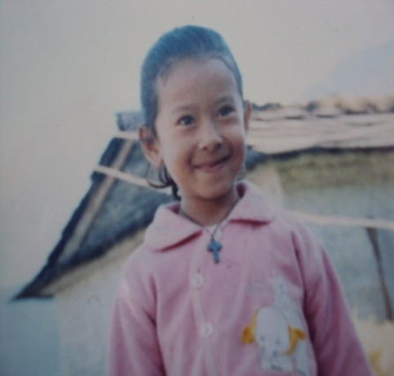
PRISKILA
CHILD’S ID NO: WPPC-0027
DATE OF BIRTH: Jan. 2003
AGE 10 YEARS
RELIGIOUS BACKGROUND : CHRISTAN
Priskila is a ten year old girl from Gorkha district of Nepal. She has one brother and her father and mother in the family. They are farmers and a very poor family in their village. Priskila’s mother grew up with her relatives because Priskila’s grandfather and grandmother left her mother when she was at the age of 6 years. So Priskila’s mother got married at the age of 14. Her father and mother both are uneducated and because of financial conditions her parents were not able to send her to a good school where she can get a better education.
Priskila is a very hard working girl. She would like to be a teacher and help to teach the poor children of her village. Her favorite subject in school is Nepali.

