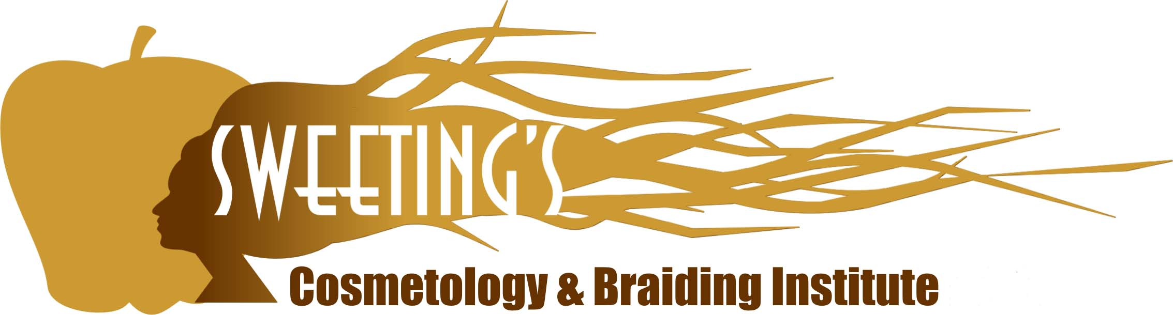
2923 Murfreesboro Road, Nashville, TN 37013
www.SweetingsCosmetology.com
615.361.7147

Online School Procedures and Policies
Procedures
- The school reserves the right to terminate a student for the following (a) breech of school standards, (b) missed thirty (30) consecutive days (c) failure to maintain a satisfactory progress percentage of 70% in academics.
- If a student cannot finish his/her cosmetology course, a written release will be given at the discretion of the school director.
- If a student is terminated, there is a $250 reinstatement fee due prior to returning to class. Reinstatement is at the discretion of the school director.
Policies
Copyright Notice
The website and its content is copyright of Sweeting’s Cosmetology & Braiding Institute (SCBI). All information or material is solely for use by the student enrolled in SCBI and may not be shared, copied, edited, stored, linked with, or used, in any other website, print, visual, broadcast medium, or electronic retrieval system. You may not distribute or commercially exploit the content. Any redistribution or reproduction of part or all of the contents in any form is prohibited.

Refund/Cancellation Policy
A student may cancel a signed enrollment agreement with no penalty within three (3) business days of signing the agreement. After the three day cancellation period, NO REFUND will be given. All cosmetology hours are retained for seven (7) years. See Memorandum of Understanding for online Natural Hair Styling Program.

Transfer of Hours
Before enrolling at Sweeting’s Cosmetology & Braiding Institute (SCBI), it is the responsibility of each student who resides outside the state of Tennessee to inquire with their Cosmetology State Board to determine if the State of Tennessee Natural Hair Styling hours attained is transferable to the state in which he/she resides. SCBI takes NO responsibility for hours that are not transferred.
*************************************************************************************************
I have read and understand the policies and procedures for SCBI online Natural Hair Styling Program. I understand that if I live outside the State of Tennessee, SCBI is NOT responsible for hours that are not transferable.
Printed Name: ____________________________________________________________________________________
Signature: ______________________________________________________________ Date: ___________________

