

Recommended packing:
Drop Bags- Ziploc bags, labels, nutrition
Sun Screen
Chap Stick
Shoes
Socks
Running Clothes (hot for day and cold for night)
Blanket or yoga mat (if your runner stops or needs massage)
Cold weather clothes for crew (the nights can get extremely cold)
Rain Gear
Foot Prep (we like Odor Eaters foot powder)
Chafing supplies
Collapsing cooler (there are not a lot of things open at night)
Headlamp (2 and batteries)
Watch
Camera

Pre-Planning- Work with your team to know the nutrition plan and have the materials you need for the drop bags and extras for during the race. You will be going through the small towns in Greece and there are not any 24 hour Walmart available! Prior to the race you will be staying in Glyfada and there are a plethora of grocery stores where you can get supplies a lot cheaper than on the road; you can get a case of water for the price you will pay for one water in a small town. We like to go to Lidl- there are a few along the route. You will be traveling through the ancient cities so most of the stops are a local little eateries or churches (or just on the side of the road.)

Runners may run with a phone for emergencies however they may not use it for music or wear headphones. I recommend cell phones for the crew as the GPS function works great- who knew Google Maps went through Greece! The first year we had AT&T and were charged for data but that might have changed since. We have since used T-Mobile and have had excellent service and no additional charges unless we made voice calls. Just check with your provider as you don’t want to return to a phone bill larger than the price of your airfare!

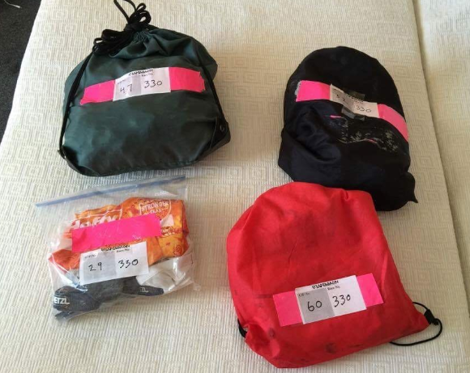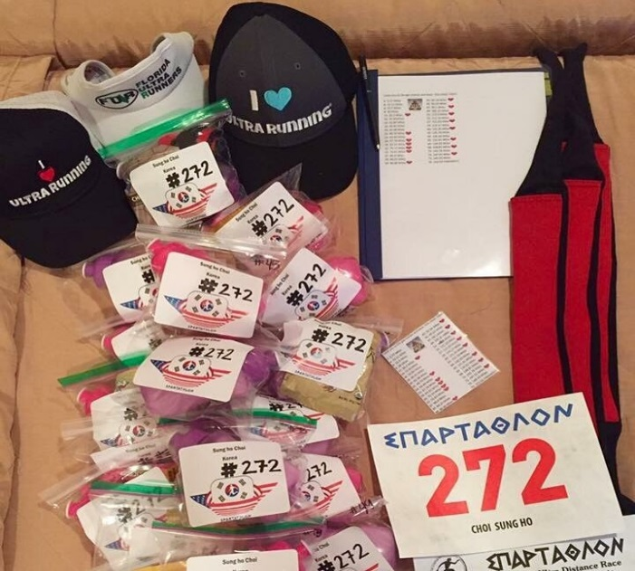

For drop bags I recommend Ziploc bags with your name, number and country labeled inside of them. I have used stickers one year and a sheet of paper inside during another year- both worked! You must label your bags with checkpoint number and runner number- this is at the minimum. You can save up water bottles or purchase disposable squirt bottles from the Dollar Tree if you use specific liquids during the race. For the most part, this is a hot race! You will need salt tabs, sun screen and Chap Stick is an extra treat! You will drop these in the aid station boxes at the pre-race meeting and the race volunteers will have them on the course for you. If you are only doing liquids as a drop bag, you can use a water or soda bottle with you liquid, place your runner information on the outside and cover with clear tape.

The next few pages are a general overview of average times and arrival to each of the aid stations and some spreadsheets I made to help me throughout the race, but please note this is just a general idea! You know your runner and can put in your own speeds- that is why this an editable document!

You might not use or want them but I am a dork and have fun with things like this! Bob Hearn has also shared his spreadsheet and you may save an edit as you see fit- please note that you will need to adjust formulas and paces to fit your running abilities/needs.

For Bob’s spreadsheet click below:
https://docs.google.com/spreadsheets/d/102Ibe1TfGTfrCSRnrHfFbHtEdn2C30HrvI0YvoRhXXM/htmlview

Step table per 5 minutes (with mild fluctuations at athlete speed)
By receiving consideration of the route circumstances (uphill - downhill etc)

Α/Α  C.Ρ | STATIONS | CLOSING  HOUR | TIME  in minutes | DISTANCE  In klm | SPEED  klm / hour

1 | IERA ODOS | 07,30 | 30 | 3,9 | 7,9
2 | DAFNI | 08,05 | 35 | 5,4 | 9,2
3 | SKARAMAGAS | 08,35 | 30 | 4,5 | 9,1
4 | ASPROPIRGOS | 09,10 | 35 | 5,7 | 9,7
5 | ELEFSINA | 09,30 | 20 | 3,2 | 9,5
6 | ELLINIKA PETRELEA | 09,45 | 15 | 2,3 | 9,0
7 | HOTEL AKTI | 10,15 | 30 | 4,2 | 8,5
8 | JET OIL | 10,35 | 20 | 3,0 | 9,0
9 | NEA PERAMOS | 10,55 | 20 | 3,1 | 9,1
10 | MEGARA | 11,20 | 25 | 3,5 | 8,5
11 | WEIGHT BRIDGE | 11,45 | 25 | 3,4 | 8,3
12 | CONCRETE SPACE RIGHT | 12,10 | 25 | 3,5 | 8,5
13 | HOTEL KOKKINIS | 12,30 | 20 | 3,1 | 9,1
14 | SMALL OPENING LEFT | 12,45 | 15 | 2,4 | 9,3
15 | ZORBAS TAVERN | 13,10 | 25 | 3,5 | 8,5
16 | KINETA BUS STATION | 13,30 | 20 | 3,0 | 8,8
17 | HOTEL SIAGAS | 13,55 | 25 | 3,2 | 7,8
18 | AG. THEODORI | 14,25 | 30 | 4,2 | 8,3
19 | MOTOR OIL | 15,00 | 35 | 4,7 | 8,0
20 | KERAFINA | 15,35 | 35 | 4,2 | 7,3
21 | CORINTH CANAL | 16,10 | 35 | 3,5 | 6,0
22 | HELLAS CAN | 16,30 | 20 | 2,5 | 7,4
23 | MILLS PAFILI | 17,00 | 30 | 3,4 | 6,9
24 | EXAMILIA | 17,35 | 35 | 4,2 | 7,3
25 | JUNCTION COR./TRIPOL | 18,05 | 30 | 3,3 | 6,7
26 | ANCIENT CORINTH | 18,25 | 20 | 2,0 | 6,1
27 | SCREECH VILLA | 19,00 | 35 | 4,1 | 7,0
28 | ASSOS | 19,25 | 25 | 3,0 | 7,1
29 | ZEVGOLATIO (CORINTH) | 19,45 | 20 | 2,0 | 6,1
30 | SMALL CHURCH | 20,20 | 35 | 3,8 | 6,5
31 | SOULINARI | 20,55 | 35 | 3,9 | 6,6
32 | HALKION VILLAGE | 21,25 | 30 | 3,1 | 6,1
33 | BIG TREE | 22,00 | 35 | 3,9 | 6,6
34 | SMALL SHRINE | 22,35 | 35 | 3,4 | 6,6
35 | ANCIENT NEMEA | 23,00 | 25 | 3,1 | 7,3
36 | OASIS TAVERN | 23,40 | 40 | 4,1 | 6,1
37 | CHURCH ON RIGHT | 00,00 | 20 | 2,0 | 6,0
38 | UNDERGROUND JUNCTION | 00,35 | 35 | 3,2 | 5,5
39 | SMALL SHRINE | 01,10 | 35 | 3,0 | 5,1
40 | MALANDRENIΙ | 01,50 | 40 | 4,2 | 6,3
41 | JUNCTION TO LIRKIA | 02,20 | 30 | 3,3 | 6,5
42 | SIGN TO LIRKIA | 02,45 | 25 | 2,7 | 6,5
43 | LIRKIA | 03,10 | 25 | 2,5 | 6,0
44 | SMALL OPENING LEFT | 03,40 | 30 | 3,0 | 6,0
45 | KAPARELI | 04,10 | 30 | 2,6 | 5,2
46 | OPEN SPACE RIGHT | 04,45 | 35 | 3,5 | 6,0
47 | MOUNTAIN BASE | 05,10 | 25 | 2,1 | 5,1
48 | MOUNTAIN TOP | 05,50 | - | - | -
49 | SAGAS | 06,25 | - | - | -
50 | GAS DEPOT LEFT | 06,50 | 25 | 2,5 | 6,1
51 | BRIDGE | 07,15 | 25 | 2,8 | 6,6
52 | NESTANI | 07,30 | 15 | 1,7 | 6,6
53 | X ROADS VITINA | 08,05 | 35 | 4,0 | 6,8
54 | GHIOSA TAVERN | 08,25 | 20 | 2,0 | 6,0
55 | UNDERGOUND PASSAGE | 08,40 | 15 | 1,3 | 5,3
56 | KIOSK | 09,20 | 40 | 4,7 | 7,0
57 | ZEVGOLATIO (ARCADIA) | 09,45 | 25 | 2,6 | 6,3
58 | T JUNCTION | 10,15 | 30 | 3,2 | 6,5
59 | SMALL FARMHOUSE | 10,40 | 25 | 2,5 | 6,1
60 | ALEA-TEGEA | 11,10 | 30 | 3,5 | 6,9
60α | KAMARI | 11,25 | 15 | 1,8 | 7,0
61 | PB GAS STATION | 11,40 | 15 | 1,5 | 6,2
62 | MANTIREA | 12,15 | 35 | 3,7 | 6,3
63 | PAPANTONIS | 12,55 | 40 | 4,1 | 6,1
64 | Church ST. NIKOLAS | 13,25 | 30 | 3,5 | 6,9
65 | ARDAMIS | 13,45 | 20 | 2,4 | 7,1
66 | OPEN SPACE | 14,15 | 30 | 3,4 | 6,7
67 | BUS STATION | 14,55 | 40 | 4,5 | 6,8
68 | MONUMENT | 15,25 | 30 | 3,2 | 6,5
69 | MODERN HOUSE ARCHES | 16,00 | 35 | 3,3 | 5,7
70 | OPEN SPACE | 16,40 | 40 | 4,7 | 7,0
71 | JULIETS HOUSE | 17,00 | 20 | 2,1 | 6,4
72 | VOUTIANOI | 17,25 | 25 | 3,1 | 7,3
73 | KLADAS | 18,05 | 40 | 4,7 | 7,0
74 | EVROTA BRIDGE | 18,30 | 25 | 3,1 | 7,3
75 | FINISHING POINT | 19,00 | 30 | 2,4 | 4,8

The red cells are areas that you can aid your runner.
Check Point | KM | Crew | Pivotal Distance | Goal | Actual | Notes
1 | 3.9
2 | 9.3
3 | 13.8
4 | 19.5
5 | 22.7
6 | 25
7 | 29.2
8 | 32.2
9 | 35.3
10 | 38.8
11 | 42.2 | Crew Allowed | Marathon | 3:45 Hours
12 | 45.7
13 | 48.8
14 | 51.2
15 | 54.7
16 | 57.7
17 | 60.9
18 | 65.1
19 | 69.8
20 | 74
21 | 77.5
22 | 80 | Crew Allowed | 50 Miles | 8 Hours
23 | 83.4
24 | 87.7
25 | 91
26 | 93 | Crew Allowed
27 | 97.1
28 | 100.1 |  | 100K- 62 miles | 10:30 Hours
29 | 101.9 | Crew Allowed
30 | 105.9
31 | 109.8
32 | 112.9 | Crew Allowed
33 | 116.8
34 | 120.2
35 | 123.3 | Crew Allowed | 76 Miles | 12:30 Hours
36 | 127.4
37 | 129.4
38 | 132.6
39 | 135.6
40 | 139.8 | Crew Allowed
41 | 143.1
42 | 145.8
43 | 148.3 | Crew Allowed
44 | 151.3
45 | 153.9
46 | 157.4
47 | 159.5 | Crew Allowed | 100 Miles | 18-19 Hours
48 | 161.8
49 | 164.5
50 | 167
51 | 169.8
52 | 171.5 | Crew Allowed
53 | 175.5
54 | 177.5
55 | 178.8
56 | 183.5
57 | 186.1 | Crew Allowed | 115 Miles | 25 Hours
58 | 189.3
59 | 191.8
60 | 195.3 | Crew Allowed
60A | 197.1
61 | 198.6
62 | 202.3
63 | 206.4
64 | 209.9
65 | 212.3 | Crew Allowed | 131 Miles | 28 Hours
66 | 215.7
67 | 222.2
68 | 223.4
69 | 226.7
70 | 231.4
71 | 233.5
72 | 236.6 | Crew Allowed | 147 Miles | 31 Hours
73 | 241.3
74 | 244.4
75 | Finish | Crew Allowed | 153 Miles | 33 Hours

The follow is the aid stations and mile markers. I laminated (ok so tape-laminated) this so that it could be used by the runners throughout the race. The hearts are places that the runners can receive aid (cheesy I know!)

2- 5.77 Miles 43- 92.14 Miles
4- 12.11 Miles 45- 95.62 Miles
6- 15.5 Miles 47- 99.1 Miles
8- 20 Miles 49- 102.21 Miles
11- 26.2 Miles 52- 171.5 Miles
14- 31.81Miles 55- 111.10 Miles
16- 35.85 Miles 57- 115.63 Miles
18- 40.45 Miles 59- 119.17 Miles
20- 45.98 Miles 60- 121.35 Miles
22- 49.70 Miles 62- 125.70 Miles
24- 54.49 Miles 64- 130.43 Miles
26- 57.78 Miles 65- 131.91 Miles
29- 63.31 Miles 66- 134.02 Miles
32- 70.15 Miles 68- 138.81 Miles
35- 76.61 Miles 70- 143.78 Miles
37- 80.4 Miles 72- 147.01 Miles
39- 84.25 Miles 73- 149.93 Miles
40- 86.86 Miles 75- 153.53 FINISHED!!!

Now that you have all the prep and spreadsheets you ever wanted, let’s go over the crew rules!

- NEVER get offended- it is not your race, you are there to support your runner and need to be understanding of their feelings physically and emotionally! Suck it up- they already are!
- Keep yourself safe- your runner cannot and should not need to stress out wandering if you are safe or not! Eat, drink (not wine yet!) and keep up with your runner safely!
- Stay positive and supportive!
- Aid stations are like a pit stop- think NASCAR; zoom in, take care of business and zoom out! It is not a buffet or hotel!
- Know your runner and what he/she likes. Planning before the race will save a lot of time during the race and the possibility of getting hurt feelings- thick skin!
- There are a slew of emotions that your runner will go through- don’t baby them, just be understanding and change the subject or let them have space.
- Running an ultra hurts! If you ask them if they are hurting, chances are they will say yes! This does NOT mean they need to stop, it just means they are running an ultra. Support and push forward!
- If you have any agenda, lose it! You are here for your runner and will need a lot to focus on him or her; especially as everyone starts to get tired! Rotate with team members and nap as needed.

- Be prepared! I like to be organized, here is an example and makes it easy to carry to aid stations- we shall call it a Pacer Bento Box! I would suggest a plastic container that is easy to carry and you can easily get to items. I got our bag at Wal-Mart in the craft section. It is picture below, I think I paid $10 or $12 and it fits easily into a suitcase.

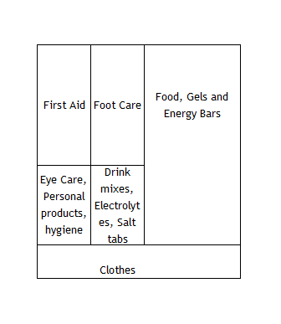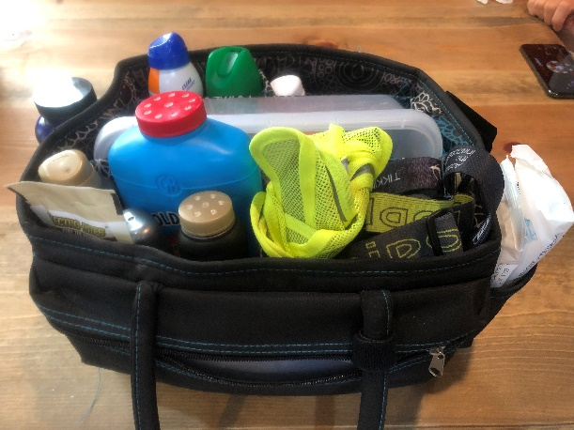

- HAVE FUN but remember this is what your runner has been training all year for, set him or her up for success and push them!

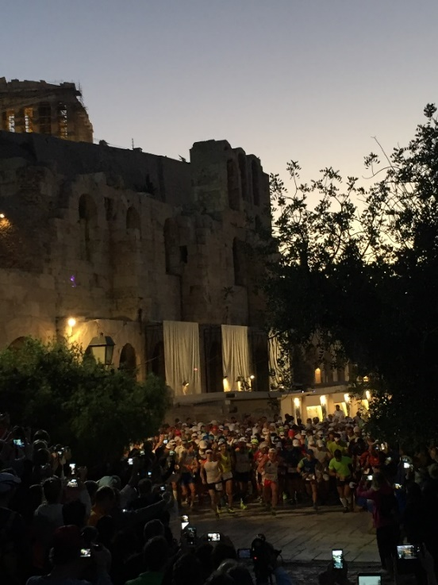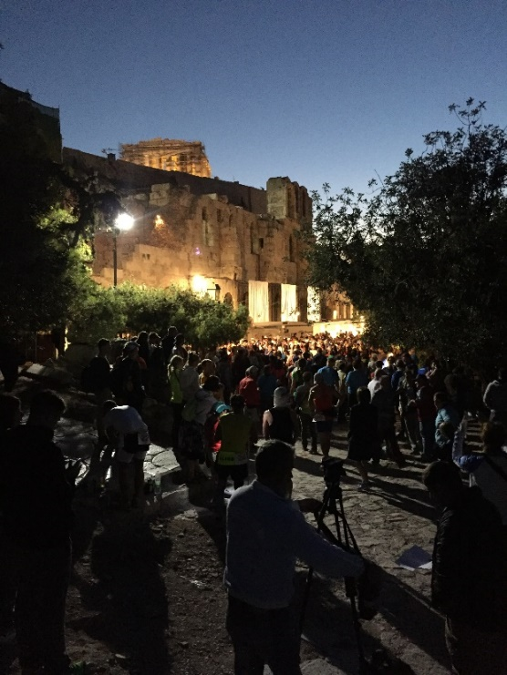

The Starting Line- Make sure your crew and you are there early and they have their cameras ready. If you get to the Acropolis by 6:00 am there is plenty of parking, it is recommended to leave your hotel by 5:20 in order to get there by this time. You can set your GPS to the Acropolis and it will take you to the base where there is a parking lot. Once the race starts, it is a little stressful getting out of the city but relax, you will see other crew vehicles and find the race route. All of the crew vehicles will have a large window decal that they give you at race registration.
Here are examples of the markings on the roads, but if you ever think you are lost (and cannot see runners) put one of the names of the stops into your GPS and it is easy to get back on path.
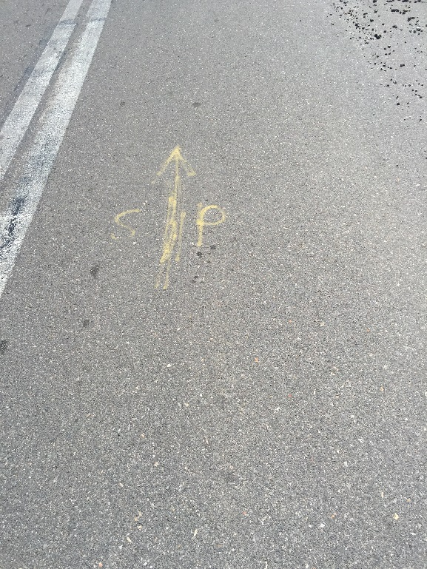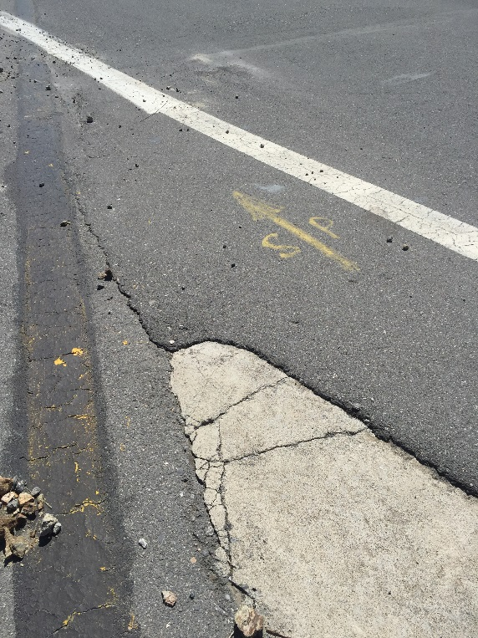
Mile 1-25- (Check points 1-11, you can aid your runner at #11) During this time the runners are on their own. There are plenty of aid stations along the way and the runners can have their drop bags at any aid station they choose. It is a little stressful getting out of Athens, but be patient. If you map your GPS to the Hotel Siagas and take the route along the water, you will find the race course. You don’t have to follow the GPS once you find the runners as you will easily be able to follow them until the mountain. During this time I recommend you get gas and any last minute items you may need. You are not prohibited from taking pictures of your runner during this time however you may not stop on the side of the road or give aid to your runner. You may stop at safe aid station locations but you CANNOT interfere with the aid station or the race. This is very important because you do not want to jeopardize your runner’s race and get them disqualified.
Mile 26-50- (Check points 12-22, you can aid your runner at #22) Holy hotness! This is when the heat is on outside and in the race! At mile 26 there is a grocery store that has any supplies you may need (and a bathroom!) If you do not have a cooler, as I have not had in the past, you can buy a utility bucket and ice here. This was easy to throw in the backseat and keep things cold and also fill ice bandanas later. This is the first time you can give aid to your runner so do not be late. The parking is tight, I would recommend parking just after the check in point and walking back to meet your runner (it is not far.) This will save you when you try to get out after your runner leaves again.
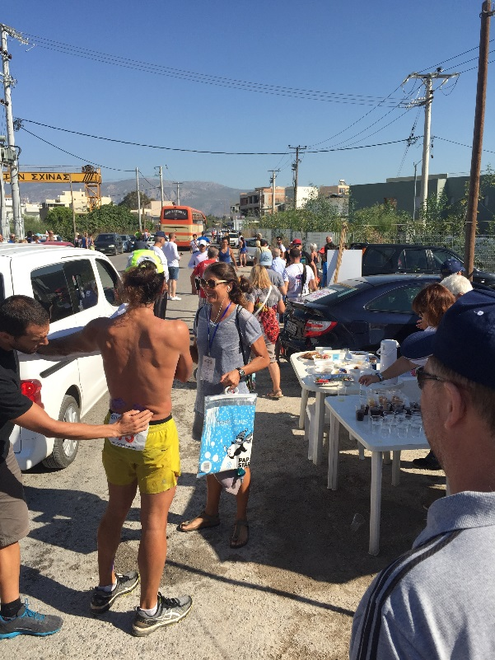

Some important things to think about for your runner at the mile 26 stop are hydration, make sure that he/she has drop bags or salt tabs between the next few stops, sunscreen/chap stick, chafing and just over all nutrition. Now for you, enjoy the views! You will be riding along the ocean there are so many places to stop and take in the views. One of our favorite places to stop is the Hotel Siagas which conveniently has an aid station in front of it. You cannot assist your runner but you can cheer, take quick pictures and then take in some fresh ocean air! Don’t forget to get your exercise in!
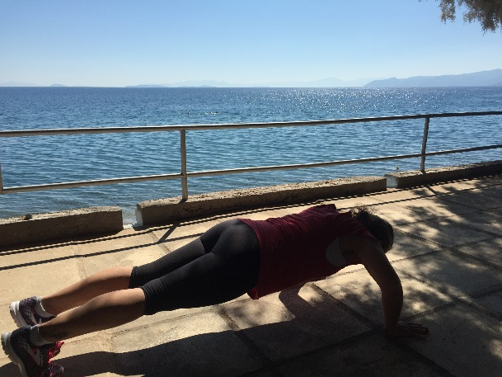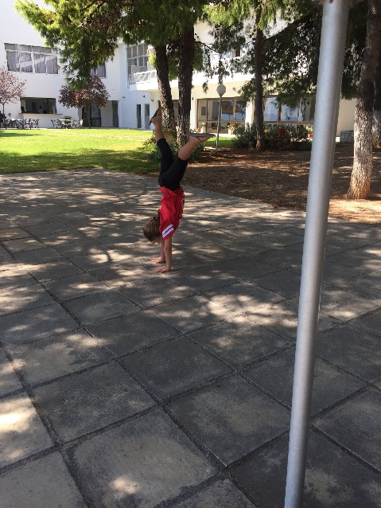
The race then takes you past a huge oil refinery (plug your nose) and this is another great photo op- wait...it is a no photo zone, but it took me 3 years and lots of pictures to figure that out!
You will pass over the Isthmus canal prior to the 50-mile checkpoint and this is a great photo op even though you cannot assist your runner. History lesson, the canal separates the Greek mainland from the Peloponnese, turning it into an island. It is 6.4 km long but only 25 meters wide- most of the modern ships cannot fit through the canal! It actually took about 2,000 years to be completed due to money, technical abilities and fear of floods.
Mile 50 is your second chance to aid your runner- from here on out you will be seeing them a lot more! This stop is VERY busy and plan to park and walk! The aid station will be on the left and parking goes on the way down that road. There are noodles, rice, massage and drinks/snacks available for the runners at this stop. Take the time here to take care of any clothing changes, blisters, etc. For the support crew there are no stores available so make sure you have what you need. The next stop has some amazing restaurants so make sure you save your appetite!
Mile 51-57- (Check points 23-26, you can aid your runner at #26) If you were to take straight roads this is roughly half way between Athens and Sparta. This is where I recommend getting some lunch or dinner, the food is all great! You will be in the main store ancient town of Corinth. If you have time to shop, there are a few stores where you can get unique souvenirs- the shop owners are very nice- we have gone back after the race just to say hi! When you come into the square there is a grocery store on the right, they carry ice and the essentials- bring cash (Euros)!
History Fact: Ancient Corinth was one of the largest and most populated cities in 400 BC Greece. The Romans demolished the city in 146 BC but it was rebuilt in 44 BC and Julius Caesar inhabited it during this time. The ruins that you see to the left of the town square is the Temple of Apollo.
Mile 58-63- (Check points 27-29, you can aid your runner at #29) The sun has been going down when we have it these miles in the past. Your runner is passing the 100k mark and probably starting to think about the mountain. Keep them focused on the next 40 miles as the weather starts to cool off.
Mile 64-70- (Check points 30-32, you can aid your runner at #32) I made sure to top off my gas as this point, one of the check points is at a gas station. Always better to be safe than sorry.
Mile 71-76- (Check points 33-35, you can aid your runner at #35) Mile 76ish is a church aid station where the community makes and sells kabobs- they are great! There are massage tables and light food at this aid station. Make sure you are very cautious when driving through these spots as the roads are narrow and there are runners, crew and bystanders everywhere!
We drove back through this town one year and found that it was the home of one of the first Olympic tracks and the first tunnel for the athletes to go through. The Nemian games were held here. These were held every year before and the year after the Ancient Olympic games as were the Isthmian games. This was part of a Olympiad cycle and the Pythian games completed the cycle being held every third year. The games were held in honor of Zeus and supposedly founded by Heracles. There are also the ruins of the Temple of Zeus. If you are into history, google the Battle of Nemea! The town is called Nemea and also have some really amazing wine!
Mile 77-86ish- (Check points 36-40, you can aid your runner at #40) The roads through these areas are very narrow and you will have to deal with local traffic (not much as only 300 or so people live in the area, but would rather make you aware of the possibilities!) Aid station 40 is in Malandreni Village at Mr. Dedes’ Tavern. This area is known for their good wine and golden green olive oil free from chemicals.
Mile 87-92- (Check points 41-43, you can aid your runner at #43) There are a lot of dirt roads during these miles, drive slow as to not raise extra dust up on the runners. There are years this is wet and others that it is dusty and full of stones. Be careful, there are potholes! Lyrkia is a lively town and you can get coffee and small items.
Mile 93-100- (Check points 44-47, you can aid your runner at #47) This is where the incline will begin and the runners will make their way up to the mountain station. When we have gone through it has always been night time and damp. The road is winding, steep and dark. You will come back down part of this to jump on the highway after the next station (while the runners go over the mountain.)
Mile 101-106.5- (Check points 48-52, you can aid your runner at #52) This is the “base” of the mountain, even though the runners just ran up a cement mountain to get here! Make sure that your runner is prepared as they are headed up and over the mountain and temperatures are known to drop, it is dark (for most runners) and they are just a wee bit tired after running 100 miles and about to run up a steep, gravely mountain with HUGE cliffs- maybe a dose of caffeine and confidence is a great choice for this aid station! The backside of the mountain is steep and full of zigzags and rocky terrain. Make sure to give your runner a jacket if needed and fresh headlamp with batteries, you will be able to park close to the aid station but just be prepared. For the crew there are porta-potties and this is a great place to take a cat nap.
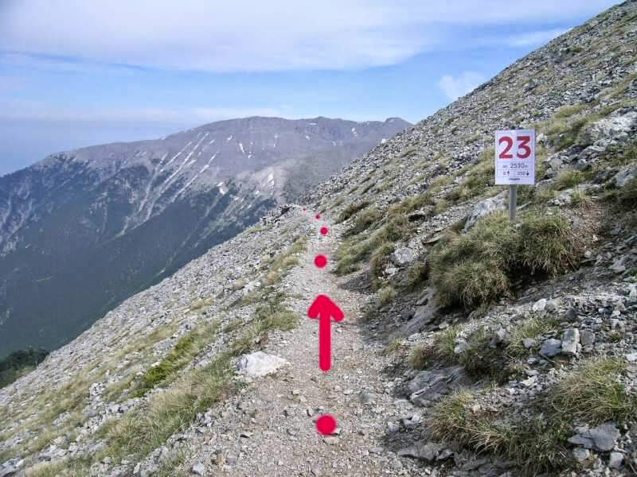
After your runner leaves the aid station and heads up the mountain, it is time for you to move to the next check point that is over the mountain. You will need to get on the highway (it is a toll road but tell them you are with the race and they will let you through) and go around the mountain. Take the exit to Nestani and then go right. You will see a race official about a half mile down and you will turn right. During this time you are going actually be backtracking the race course to the small town that the runners come off the mountain in. I think, don’t quote me, you will pass 2-3 aid stations as you backtrack. In the town you will have to find parking (it is VERY small) and you will see the aid station is at the only open restaurant in the middle of the town- you can’t miss it! The bathrooms are clean and they have been serving food every time we have gone through.
Mile 107-115.5- (Check points 53-57, you can aid your runner at #57) Do not let your runner stop or give up! This is your only job- oh and feeding them! In past races (and depending on what time your runner comes through this area) it has been very cool and damp during these miles. They will be running through farmlands.
Mile 116-121ish- (Check points 58-60, you can aid your runner at #60) It is rolling roads from here on out with beautiful sights as far as the eye can see! Lots of road and not much cover.
Mile 122-131- (Check points 61-65, you can aid your runner at #65) Make sure you have sunscreen for your runner! There is not a lot of shade in these areas. There are a few restaurants and bathroom stops along the way…if you see it and you THINK you need it…STOP! They are not often!
For curious minds, those small glass, metal or wood houses that you see along the side of the roads are roadside shrines. Inside are normally candles, a color picture of a saint and flowers. Some people assume that they are built as a remembrance for traffic victims and some of them are; some are just there for devotion or to let you know that there is a church or monastery in the vicinity. It was written that “Shrines to pagan gods were built in the same spots and for the same purpose- to provide the traveler with a moment of rest and prayerful reflection.” (Nicholas Gage) By stopping and pausing to admire the shrines, tourist are connected with the enduring life of Greece and also able to take a look at the beauty of nature.
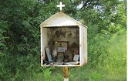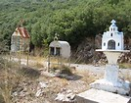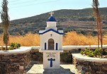
Mile 132-147- (Check points 66-68, you can aid your runner at #68) Not that you are going to care at this point, but you are going to see some breathtaking sights! Try to use toothpicks to hold your eyes open and take in the scenery!
Mile 148 to the FINISH!- (Check points 69-72, you can aid your runner at THE FINISH) There is a lot of traffic and closed roads so make sure you go straight from the last aid station to park at the finish. Once you cross the Evrotas River Bridge the end is in sight! You will have to walk to the Statue of Leonidas. In past years they have allowed the crews to run their runner in. Each runner finishes by touching the statue and is presented an olive wreath and offered a goblet of water from the Evrotas River (this was also done in ancient time to the Olympians!)
History Lesson: Leonida was the Spartan king who famously led a small band of Greek allies at the Battle of Termopylae in 480 BCE against the Persian army. The Battle of Thermopylae is the most famous battle of the Second Persian Invasion of Greece and one of the most famous battles in European ancient history. Unlike other battles, however, it was not a victory for the Greeks, but a defeat. Its fame is derived from being one of the most courageous last stands by the vastly outnumbered defending army of Greek city states led by King Leonidas of Sparta against the invading Persians under King Xerxes.
There is first aid at the finish line. They also soak the runners’ feet so don’t plan on rushing them! Allow them to enjoy this experience. All of the hotels are within walking distance of the finish (with the exception of one which requires a shuttle that is organized by the race.) If you purchased the race package you will receive dinner coupons from your hotel, we have not been let down yet by the hospitality and deliciousness of the local eateries! One of our favorite restaurants is Diethnes, the owners speak great English and love talking to the runners (and the food is great!)

