Coming Soon
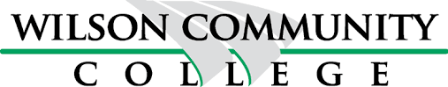

HIGH SCHOOL DIPLOMA/EQUIVALENCY
CLASSES AT S.A.Y. CENTER
639 Walnut Street, Wilson, NC 27893

Monday thru Thursday
Sign Up Now!
Call Us Today 252-265-9764

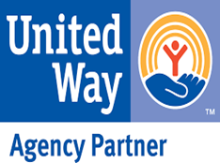

WILSON COMMUNITY COLLEGE

CLASSES AT S.A.Y. CENTER

Sign Up Now

Ready to earn your High School Diploma?
If you don’t have a high school diploma, you can earn a high school equivalency (HSE) at S.A.Y and get the full benefits of a high school diploma
Having your HSE can open a lot of doors. People who have a diploma or equivalency earn more than people who don't. Also, many jobs and training programs require that you have one or the other. You can earn your HSE at S.A.Y.
You must be at least sixteen years old to enroll. If you are under eighteen years old, you must complete a student release form

What is a high school equivalency?
A high school equivalency or HSE is a recognized alternative to a high school diploma. There are three common exams used to determine high school equivalency:
- The General Educational Development (GED®) test
- The High School Equivalency Test (Hi-SET)
- The Test Assessing Secondary Completion (TASC)
Interested? Complete contact information below and return to:
S.A.Y @ 639 Walnut St. Wilson, NC or email to contactus@stjohncdcwilson.org

Last Name First Name Address City, Zip

Phone Number Email Address

Preferred Hours (Check all that apply)
9:00 AM – 12:00 PM 3:00 PM – 6:00 PM 5:00 PM – 8:00 PM

