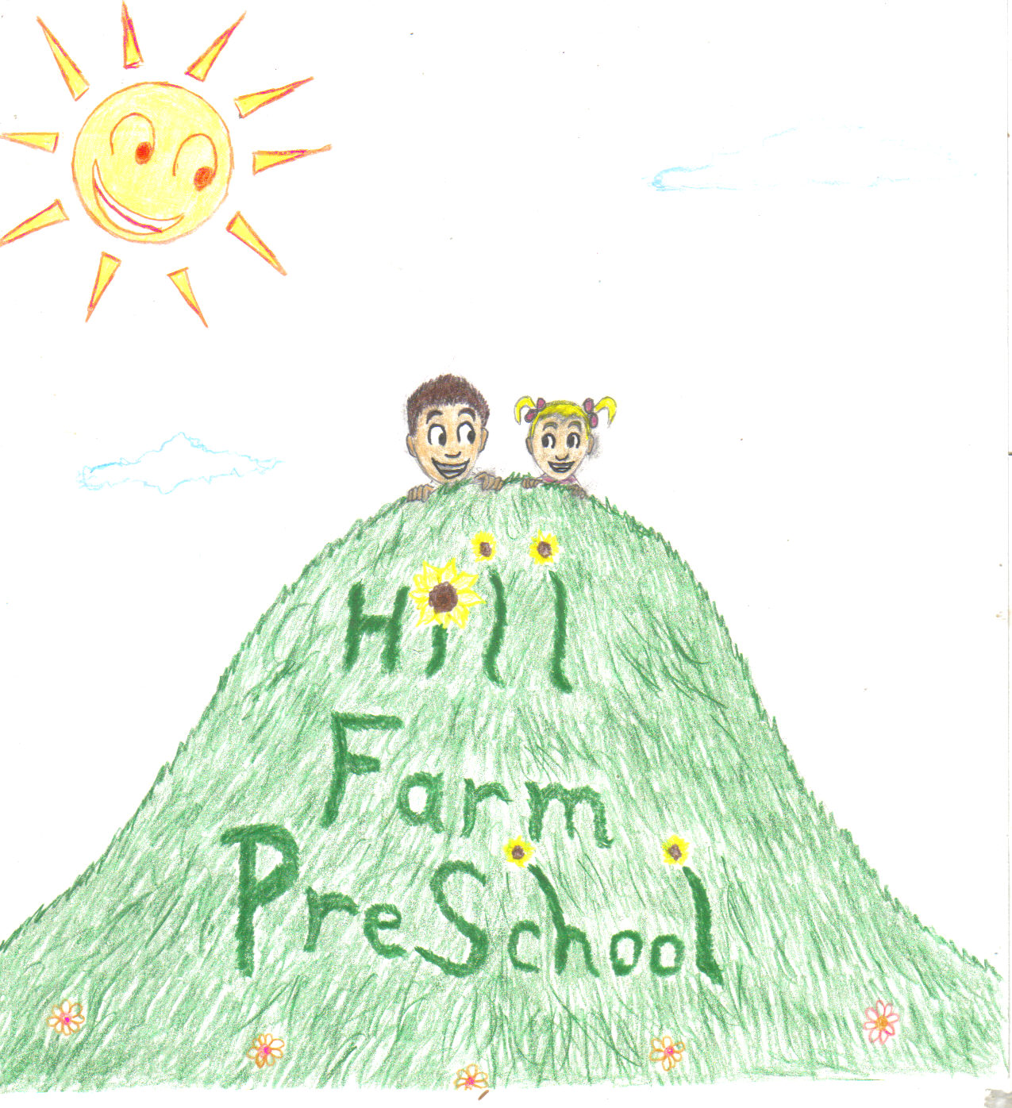
Hill Farm Preschool
160 Hill Farm Road
Fairfield, CT 06824
203)292-9533
www.hillfarmpreschool.com

Mommy and Me Two Year Old Program-Fridays
Fall Session-September 16, 2016 thru December 16, 2016
(No class on November 11th and November 25th).

Winter Session-January 6, 2017 thru March 31, 2017.
(No class on February 17th .)

9:30am to 11:45am: 24-36 months-Tuition-$420(12 classes)
Theme-based curriculum designed specifically for two year olds including:
- Warm, nurturing environment
- Developmentally appropriate activities
- Educated, experienced early childhoood teachers
- Hands-on activities
- Tactile experiences
- Beautiful location in the Greenfield Hill section of Fairfield
- Flexible payment options
Child’s Name____________________ Date of Birth__________________
Parents Names____________________________________________________
Address_________________________________________________________
Home Phone___________________ Cell Phone______________________
Email______________________________________
Fall Session________ Winter Session__________ Both______
Payment: Full____or 4 installments(Fall-Aug thru Nov and Spring-Dec thru March) $105___
Payment options: Check #____________
Credit Card #_____________________________Exp. Date______ CVC Code___

