Let’s Find out Where Did the GUN 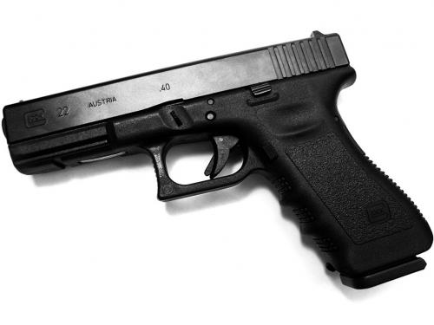REALLY Come From
Aareyun James, only 19 years old, was murdered on November 17th 2012 in the 1200 block of 7th St. in W.P.B. His murder remains unsolved and as a community advocate and initiator of the Save OUR Children Initiative…we recognize that the heinous murders that are plaguing OUR communities is a symptom of a problem that deserves immediate and appropriate attention.
Aareyun’s murder was one crime committed, on that night… “Is Aareyun’s premature death a result of gun trafficking?”
We, the community and the grieving loved ones deserve answers… we need to know… “Where Did the GUN REALLY Come From?”
Was Aareyun murdered by an illegal gun; if so, how did it get into OUR community?
“Track the gun…stop gun trafficking…keep illegal guns off of OUR streets!”
Before the gun was in the hands of a murderer, where was it?
How does youth in our communities get access to guns?
How many more youth in our communities have been murdered due to gun violence, since November 17th2012?
If Aareyun’s murderer(s) did not have access to a gun, Aareyun would be alive today…Who ALL is responsible for Aareyun’s murder…Who brought the gun into OUR community? Who is dedicated to keeping illegal guns off of OUR streets…what are they doing?
Was Aareyun’s murder an isolated incident; does residents of this community feel safe? In order to create safer communities for OUR children, we have to identify and treat the problem, we can no longer observe the symptoms, ignoring that youth violence is an underlying issue that is eroding our society, one child at a time.

