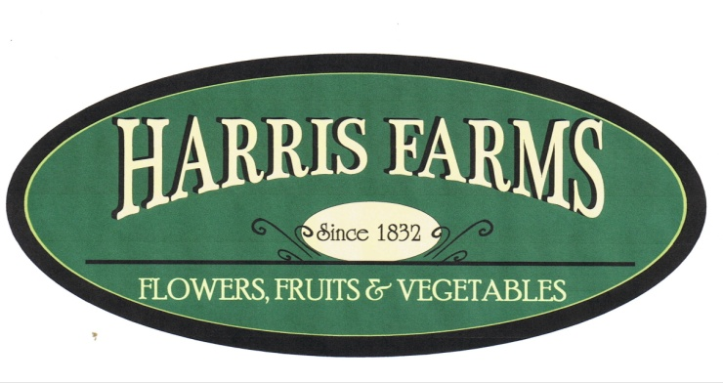
We Grow For You!

Employment Application Form

Employee Information:
Name:_______________________________________________________ First Last Middle
Address:

How Long:
Cell Phone:
If under 18, please list age:
Are you able to lift over 40 pounds? Yes No
Are you able to stand, lift, walk and bend for extended period of time (6 to 8 hours)? Yes No
Are you able to work outside in any type of weather elements:(sun, rain, heat, humidity, cold, etc.) Yes No
Have you ever been convicted of a crime? Yes No
Do you have a driver's license? Yes No
What is your means of transportation to work?
Days/Hour Available to Work: please fill in time available on the day of week or mark "no preference" if you are available all day and any hours:
No Preference Monday Tuesday Wednesday Thursday Friday Saturday Sunday
First date available to work:
Harris Farms Markets season is from April through October. Harris Farms field labor season is late June through September.
References:(Please use names of people other than family members.)
Name:
Phone:
How do you know this person:
Name:
Phone:
How do you know this person:
Work Experience:(Please list any previous work experience beginning with you most recent job held.)
Name of employer:
Contact Name:
Phone Number:
Employment Dates: From (date) to (date)
List duties performed, skills used or learned, and what you did on the job?

I certify that all of the information provided in this employment application is true and complete to the best of my knowledge. I understand that Harris Farms, Inc. may investigate information I have furnished. I authorize any person, firm or organization from any responsibility in disclosing such information, including from all liability for any damage that may result from furnishing such information to Harris Farms, Inc.
By signing below, I certify that I have read and agree with these statements.

Signature of applicant Date:

Harris Farms, Inc. is an equal employment opportunity employer. We adhere to a policy of making employment decisions without regard to race, color, religion, sex, sexual orientation, national origin, citizenship, age or disability. We assure you that your opportunity for employment with this company depends solely on qualifications.
Thank you for completing this application form and for your interest in Harris Farms!

