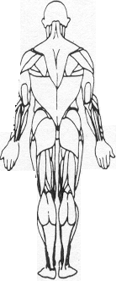

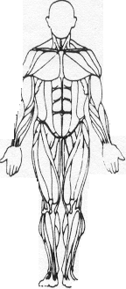

Personal Fitness Concepts

2311 Nelson Street

# Richmond, Virginia 23228

804-264-4473

## Carlos DeJesus Medical Exer-Therapist

“Connecting Health Care with fitness by assisting the Medical Community through the development of safe and effective exercise prescriptions for special population and post-rehab clients”

# Informed consent

I, (print name) ____________________________________, certify and acknowledge:

1. That Carlos DeJesus has advised me before beginning my participation in Exercise Therapy, fitness, or bodybuilding exercise that I should consult a licensed physician prior to beginning my participation in order that my physical condition and my suitability for Exercise Therapy or an exercise program could be professionally and independently evaluated.

2. That Carlos DeJesus has advised me prior to my beginning his recommended exercise program,

That such participation in vigorous exercise may carry some risk to the musculoskeletal system

(Sprains, strains) and the cardio respiratory system (dizziness, discomfort in breathing, heart

attack). I hereby certify that I know of no medical problem (except those noted below) that would

increase my risk of injury as a result of participation in a regular exercise program.

1. That I have consulted my own physician prior to participation in the exercise program or have,

without any undue influence from Carlos DeJesus or anyone on his behalf, determined not to consult a physician prior to the exercise program.

1. That I freely and knowingly assume all the risks inherent in an exercise program, which risks have

been explained to me by Carlos DeJesus and I hereby waive any right, claim, or cause of action

against Carlos DeJesus, his officers, directors, employees, and agents and release them from any

liability for any injury, cost, damage, expense, or claim which I or anyone on my behalf might have as a direct result of my participation in an exercise program.

1. That I have read the foregoing, and that I understand and agree with each of the foregoing, and

Have received a copy of this Agreement on the date described below.

Signature: _____________________________________ Date: __________________________

Witness: ______________________________________ Date: __________________________