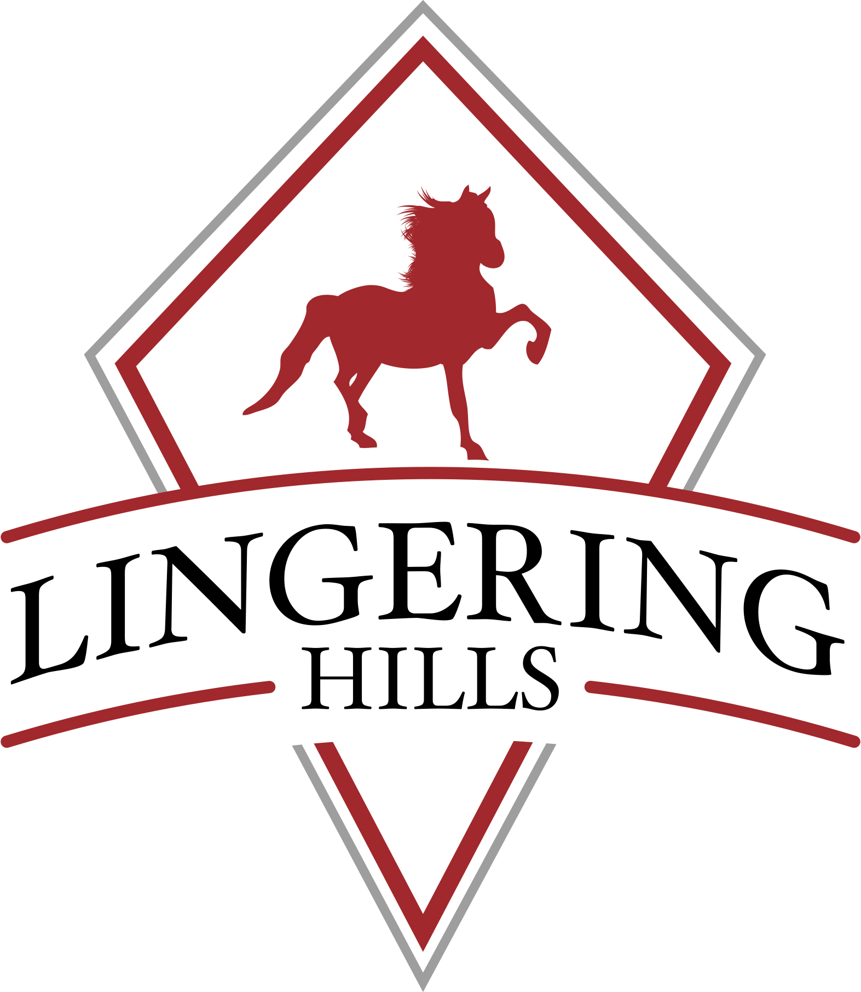

109 Scantic Rd. East Windsor, CT 06088
Phone: (607) 343-3324 www.lingeringhills.com
BIRTHDAY PARTY RELEASE FORM
Guest Name: _________________________________________Date of Birth: _____________________
Parent/Guardian:_______________________________________________________________________________ Address Street:_______________________________ City:_________________________ State:__________ Zip:______________
Telephone Home: _____________________________ Cell: ____________________
Email: ____________________________________
RELEASE
Risks:
I understand that the handling, use and riding of a horse involves the risk of injury or death, despite all safety precautions. If a horse is frightened or provoked or even without any such reason it may divert from its training and act according to its natural instincts which may include, but are not limited to: stopping short, changing direction or speed at will, shifting its weight from side to side, bucking, rearing, biting, kicking or running from danger. These risks exist for any person around a horse, whether mounted or on the ground.
I, the Student, (or parent/guardian) recognize the inherent risks of injury involved in horseback riding/driving generally, and in learning to ride/drive in particular. In taking lessons at “LHS”. or participating in Lesson Program activities, I assume any and all such risk of injury and further, I voluntarily release “LHS” its owners, instructors, employees and agents from any and all responsibility on account of any injury I (or my child or ward) may sustain while on the premises of “LHS” or participating in Lesson Program activities, and I agree to indemnify and hold harmless “LHS”, its owners, agents, instructors, and employees on account of any such claim.
Student: ______________________________________________ Date:_________________________________________________ Parent/Guardian:________________________________________ Date:_________________________________________________
ATTENTION! Under Connecticut Law, a participant in equine activities assumes the risk of any injury, harm, damage, or death and any legal responsibility that may occur to participant resulting from the inherent risks associated with equine activities. Pursuant to § 52-557p, equine professionals are not liable for damages resulting from the inherent risks of equine activities.

