Maths Tasks
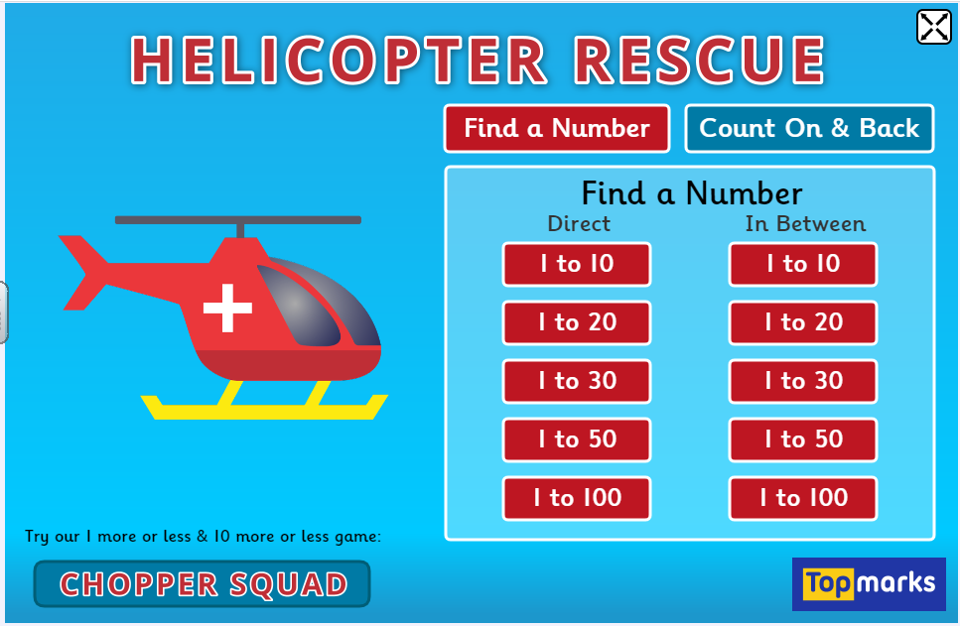

https://www.topmarks.co.uk/learning-to-count/helicopter-rescue
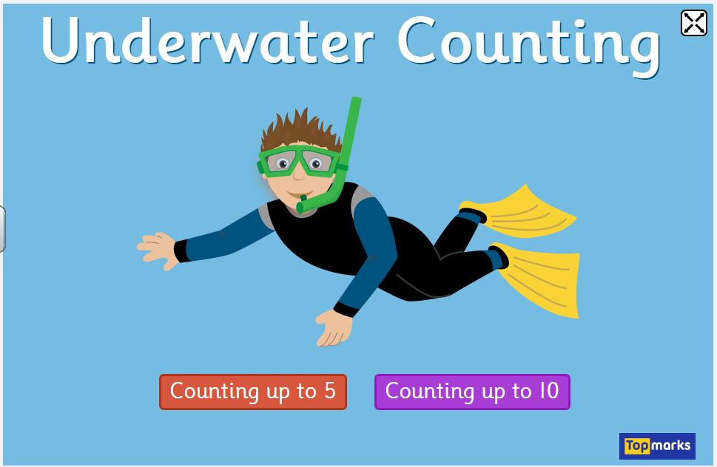

https://www.topmarks.co.uk/learning-to-count/underwater-counting
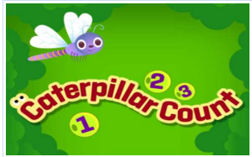

https://www.tvokids.com/preschool/games/caterpillar-count

Shapes
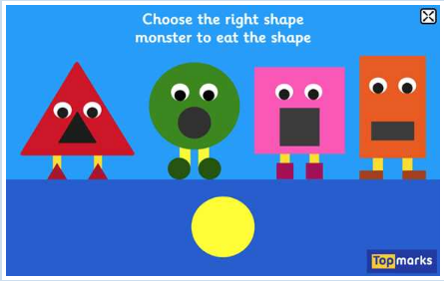
https://www.topmarks.co.uk/early-years/shape-monsters
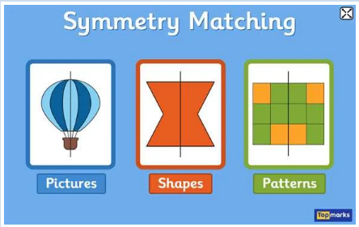

https://www.topmarks.co.uk/symmetry/symmetry-matching
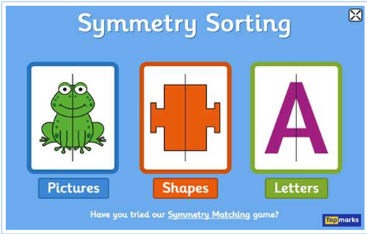
https://www.topmarks.co.uk/symmetry/symmetry-sorting

