CUSTOM T-SHIRT AND TANK TOP ORDER FORM
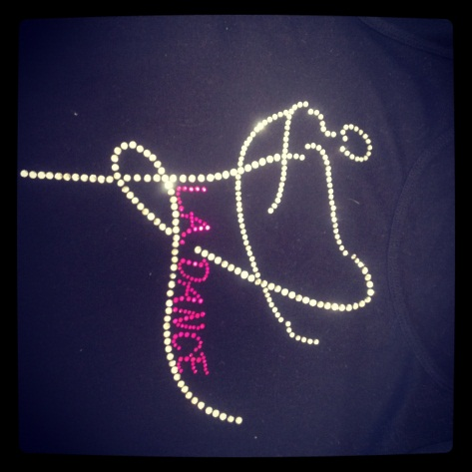 All of the shirts will look like this on the front! Just like all the dance teachers shirts!

All t-shirts and tank tops are black and are made to order. Ordering is very simple:
Step 1: all shirts are black (Circle one) t-shirt or tank top
Step 2: size (circle one) child small child medium child large
Step 3: Would you like custom letters on the back of your shirt??? You can have your name put on the back of your shirt, or your favorite style of dance for example “Ballet” “Tap” or “Jazz”, or the year “2012”. Anything you want! It is an additional $1.00 per letter:
______________________________________________________________________________
Each shirt is $24.99 + any fee’s for additional lettering put on the back + 7% sales tax.
If you’re just ordering a basic shirt with NO lettering on the back the total cost with tax is $26.74 please make checks payable to L.A. Academy of Creative Arts
Step 4: Fill out the information below and attach payment:
Child’s Name: _______________________________Phone Number:______________________
Address:_______________________________________________________________________
School:_________________________________
Each shirt is custom ordered and printed please allow 2-4 weeks for arrival of shirts. We will call you when your shirt has arrived.

