Before Hiroshima: Forgotten Prisoners of War in Japan, Burma and the Far East
Dedication
This book is dedicated to all those who suffered as prisoners of war or interns in the Far East, those that sadly died there and those that returned, and those that waited for them.
In particular, it is dedicated to my Dad who survived his captivity through determination and a never-ending sense of humour. We miss him and are all very proud of him.

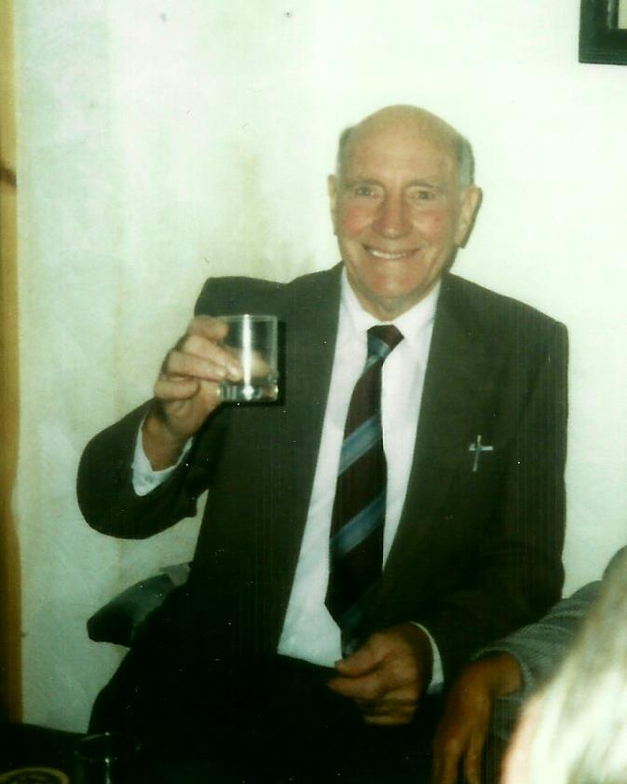
Gunner William Albert Halls
1922-1998

Foreword
Most people think of VE Day in May as the end of World War II, yet it did not officially end until Japan finally surrendered in August 1945 – now known as V-J Day on 15th August.
The treatment of prisoners of war (POWs) in Japan was particularly cruel and a higher proportion of them died in these camps than those held in Germany. Their personal stories are moving and demonstrate the courage and spirit of every FEPOW. But, the long-term impact spreads much further to include the lives of close family and friends.
This book aims to present the stories of FEPOWs and their loved ones, those that were waiting at home to hear news of what was happening in the Far East during the war, as well as those that lived with them in the years after they were released. Support was negligible, assuming they actually recognised that they needed help and were willing to ask for it. For families, there was no support at all. This book includes reflections from many people over the years, and it is clear that everyone was left to find their own way through these traumatic times.
“We are starving, not melodramatically, but slowly” wrote Eric Cordingly in his diary. “The grim thought comes into one’s mind that many of these crosses cover the mortal remains of men reported safe after battle. Men who need not have died but for the facts and conditions of our captivity.” (Cordingly L. , 2015)

Introduction
While individual stories vary according to how and where they were captured, treatment was generally the same – namely cruelty, starvation, and a total disregard for human life by their captors. The more I spoke with wives and families of FEPOWs, it became clear that their experiences were also similar, both during and after the war. No support, no recognition of the condition POWs were in on their return or the long-term impact of their experiences on wider family members and, crucially, a cynical lack of acknowledgement of how bad it had been for Japanese POWs in particular.
This is a more formal collection of anecdotal evidence, gradually building a wider picture of the families during and after the war. In 2020, the 75th anniversary of the end of the war, there will be many remembrance events and celebrations of victory over adversaries. I believe this is an ideal time to present the human aspects of the brutal captivity of soldiers in the Far East, particularly Japan

The Conflict in the Far East
Brief Timeline

- 1937 – Japan invaded China
- 1938 – controlled Amoy in southern China
- 1941 7-8 December Japan attacks Pearl Harbour
- 1941 Japan attacks Hong Kong which capitulates on Christmas Day. They then enter Burma
- 1942 – Japan invades the Dutch East Indies
- 1942 – February – Singapore surrenders to the Japanese. Japanese land in Java
- 1942 – May – POWs in A Force sail to Burma
- 1942 – July – B Force sails to North Borneo
- 1943 – March – D Force goes by train to Thailand, followed by F and H Forces
- 1943 – March – E Force sails to North Borneo
- 1943 – October – both ends of Thai-Burma railway meet at Konkoita
- 1943 – December – survivors of F Force return to Singapore
- 1944 – American forces return to the Philippines
- 1945 – August 6th – Atomic bomb on Hiroshima
- 1945 – August 9th – Atomic bomb on Nagasaki
- 1945 – September 2nd – Japanese sign official surrender

How it all started
While the war in Europe was well underway from 1939, no-one recognised the extent to which Japan was preparing for its proposed reign over the whole of South-East Asia. After all, they had invaded China in 1937, took control of Amoy in Southern China in May 1938, and by the end of that year they were just 45 kilometres from Hong Kong. By 1941 they occupied the whole of Indochina (Tett, 2002).

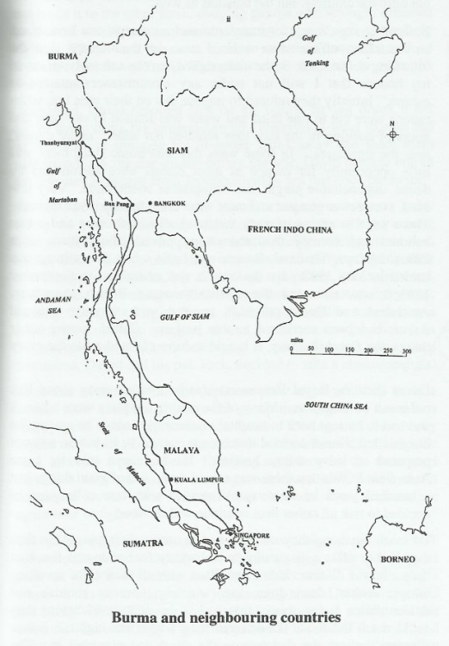

Official documents, diaries and letters from serving men in the region, commentators in Britain, America and Canada, about the decisions of how to defend Hong Kong and later Singapore, are extremely critical about the whole venture. (Critchley, 1991) (Morris, 1987).
For example, Sir John Hammerton was mentioned in an article (War Illustrated published in WWII) as saying about the possibility of an attack by the Japanese “Presuming that they delivered their onslaught by land, sea and air together, their forces would encounter the determined resistance of a great fortress, a navy of strength at which we can only guess….an army which has recently been reinforced…and an Air Force much more than a match for Japan’s”. Not quite a true picture of the potential threat.
In October 1941, 1,975 inexperienced recruits who had never fought in battle were sent from Canada to a tropical, rough terrain they were ill prepared for. Within 3 weeks they were in the midst of ferocious battle with little ‘coherent strategy’ to their defence action. By Christmas 1941 the battle was lost, and Hong Kong was surrendered.
Nearly a quarter of the Canadian soldiers were lost even as they surrendered, the rest taken prisoner. Overall, “4,400 men were killed, wounded or missing, but more than 11,000 survived” and were taken prisoner (Morris, 1987).
By the end of 1941, 60,000 Japanese troops took control of the Malay Peninsular and Singapore, capturing 137,000 British and Indian troops. A letter home from J Wyatt in December 1941 describes how he and a group of 9 others fought the Japanese desperately as part of the Battle of Kampar, a few of them only just escaping with their lives “tramping 30 miles that day” to reach the British lines.
Singapore fell soon after Hong Kong, the Causeway between the island and mainland blown up but still the Japanese advanced – much to the surprise of military leaders who thought it highly unlikely that they would be able to advance so quickly and across such difficult terrain. (Wilkinson)

A Japanese version of events
Another version of events, though still reflecting what we have already seen from other sources, is the book by Colonel Masanobu Tsuji (translated by Margaret E Lake) who was directly involved in the conflict. As the cover note says, there is “much in this volume that will be of interest to historians”.
“The Capture of Singapore 1942: Japan’s greatest victory, Britain’s worst defeat” was published in 1997 (Tsuji, 1997)and gives a very clear picture of how the Japanese viewed these events at the time. He notes:
A few themes emerge that are as timeless as war itself: the difficulties of coordinating different branches of the armed forces, endless logistical problems, harsh terrain and unpredictable weather, squabbling between units for precedence and the “fog of war” that renders first reports from the battlefield unreliable”.
When the Japanese entered the British barracks in Singapore, they found fresh food still on tables – a sign of how unexpected the assault had been. Notes were dropped by air advising the British to surrender, stressing the continued danger to civilians if they did not. After 70 days of fighting, on 15th February 1942, the British commander, Lt-General Percival met with the Japanese to agree terms of surrender and ask for “a guarantee of the safety of the lives of the English and Australians who remain in the city”. This was agreed, though as we know these terms were not fully met (Tsuji, 1997).
Capture
FEPOW Chaplain Eric Cordingly kept a record of most of his time in captivity. Eric arrived with the 18th division days before Singapore’s final stand. It was to be a short battle. Japanese forces invaded the island and broke into Alexandra Hospital killing doctors, nurses, a chaplain and more than 200 patients in their beds. There is a particularly harrowing description of the events at Alexandra written by Jeff Partridge PhD based on his research (Partridge, 2001).
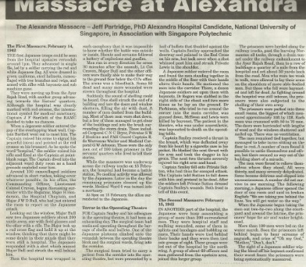by Jeff Partridge PhD
With Britain’s commanding general surrendering to Japan on 15th February 1942, Eric Cordingly felt that this was indeed the time that a chaplain “so useless in combat” would be at his most valuable to the men held captive. We will see later how important the role of religion was during this time. In April 1943, he was sent from Singapore to Thailand as part of “F” Force, only to find the promises of “blankets and even gramophones” to be a distinct lie.
Instead, F Force worked on the Burma Railway. Within the first 4 months, 90% of the men were sick and by the end 45% had died. While approximately 100,000 romushas and 12,000 POWs lost their lives working on this railway, during the construction of the Pakanbaroe railway, 673 Allied POWs and 80,000 romushas lost their lives.

Ships sunk through Allied action
In the first instance, it is estimated that around 87,000 prisoners of war were taken and eventually 4,500 civilians were interned (Tett, 2002). They sent 60,000 British, Dutch and Australian POWs to Thailand from Singapore and Java to help build the Burma railway. Due to the difficult terrain, they were transported in cattle trucks, many of them sick already, in heat and cramped conditions travelling for around 5 days. Others were sent by sea to Rangoon where they worked on the track to meet those working from the opposite direction. (J Chalker)
In total, 23 ships transporting POWs are thought to have been sunk by Allied forces during the conflict in the Far East, with the loss of nearly 11,000 POWs and thousands of romushas.
Life in Captivity
Life in camp
All prisoners of war are treated poorly, but it is clear that the Japanese were particularly cruel to their prisoners. Dad recalled that each day, prisoners lined up and waited to see whether any of them were chosen to be beheaded, and who it might be this time. Some days it was no-one.
They were given rancid rice to eat and nothing else, sometimes resorting to eating grasses, although apparently there was some rumour that there had been a camp dog at one time that suddenly disappeared! Sadly, many more prisoners died when in captivity in Japan than in other POW camps in Europe.
At first, he also records that they were actually allowed quite a bit of freedom during the first few weeks, even though they were not allowed outside the barbed-wire fencing surrounding their camp. Eric Cordingly even records the efforts put into establishing the Church of St George’s at Changi which the guards allowed.
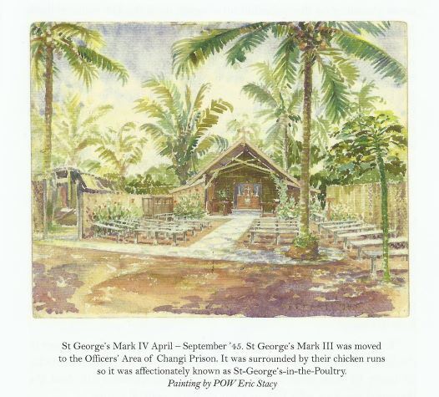
Eric also gave a talk in 1975 where he gave an example of the help he received from a young Japanese soldier who professed to being a Christian rather than Buddhist. Any written materials were banned, so when Eric and an Indian doctor were caught with scraps of scribbled notes from men asking about friends, they were handcuffed together and put down a pit – around 12-foot deep and 4-foot square. In the night, the young soldier came down a ladder with a banana each and some sweetened tea for the two captives, telling them to eat them quickly. He then disappeared. It was many hours before the two men were released from the pit.
I love the following quote from Eric’s diary:
I would not have thought it possible to smoke a block of writing paper [air-mail paper]. I must consider a testimonial to the paper manufacturers … “I have smoked your writing paper for the past three weeks and find it in every way satisfactory!” (Cordingly E. , 2015).
During these three years in Thailand to the time of the Japanese capitulation in August 1945, nearly 20,000 British, Australian, Dutch and American POWs died as a result of the railway project together with 90,000 Asian labourers. Thousands more were unaccounted for. (Chalker)
Communication
The War Office and the British Red Cross were trying their best to locate POWs and to find information about the thousands of “missing” men. Unfortunately, this lack of real information had dire consequences for the families. If he was reported as missing or thought to be dead, payments to his spouse was stopped. If he was thought to be alive as a POW, then payments continued. We can all see how devastating that would be as it was often 2-3 years before news came of those originally thought “missing”. In March 1943, there were a reported 5,000 letters delivered to Changi jail – they had received none for over a year before that.
Working prisoners
HDuckworth (1999) also describes their work existence in very graphic detail. We were dragged out by the hair to go to work, beaten with bamboo poles and mocked at. We toiled, half naked in the cold, unfriendly rain of Upper Thailand. We had no time to wash and if we did it meant cholera. Our comrades died, we could not honour them even at the graveside because we were still working.
Women and children in captivity
There is generally less recognition of the situation for women who were captured in the Far East although there were around 130,000 Western civilians captured, 41,000 of these were women, many of them Dutch ( (Archer, 2015). Clearly, so many women and children as internees was not what the Japanese had planned for and anecdotal evidence notes how they were unsure what to do with them once they were captured. Lavinia Warner commented that there seemed to be no reason for the arbitrary movement of women, viewed as useless mouths, from camp to camp rather than just killing them (Warner, 1982).
The Japanese army invaded the peninsula and took Singapore on 15th February 1942. like many other women she found herself taken, with one suitcase, all she was allowed, containing with other items some muslin nappies, to Changi Prison. As she was pregnant, she was allowed to ride on a truck with others who were elderly, pregnant or with small children, including her sister Diana who had a little daughter just 8 months old. Their youngest sister Isobel had to walk the long hot trek from Singapore city.
As they approached the gates of the prison, the truck halted and a column of less fortunate women who had walked about 15 miles in the hot sun, marched past into the prison. They were singing, "There'll always be an England, and England shall be free". Mother never forgot that.
Banka Straits was notorious for Japanese ships sinking those trying to flee to the supposed safety of the Dutch East Indies. If survivors managed to swim to shore on Banka Island, they were likely to be massacred on the beach. A woman who survived the line-up of a group at the water’s edge was shot through, just above the hips, and eventually got to Muntok. This remarkable woman, Margaret Dryburgh, then gave evidence at War Crimes Trials in Tokyo in 1946. Although groups of survivors from boats sunk in Banka Straits were then massacred on the beach, another group who reached the shore were given some coffee by one soldier and an officer provided a nurse dressed only in her corsets with a jacket. Nevertheless, treatment of the women was extremely brutal in some cases.
The Changi Quilts
This is an exceptional piece of evidence from Changi and a testament to the fortitude of the women interred for so long. The quilt is held in the Red Cross museum, so thanks go to the Red Cross for allowing us to reproduce the images. The Changi Quilt is made up of various squares stitched together, each depicting a scene or symbols that hold special meaning to the women producing it plus her signature. For example, there are scenes of a room remembered, hills of Tipperary, flowers and trees, toys, and pretty dresses.
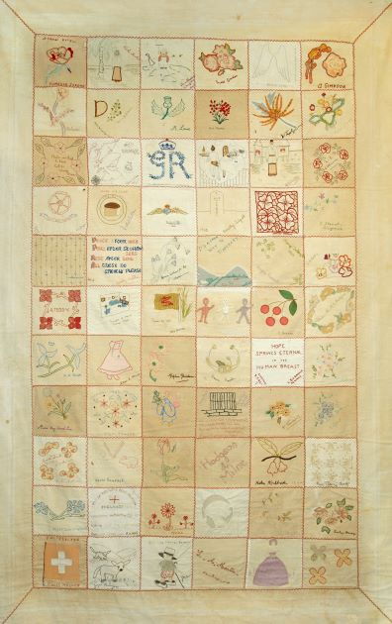
The special event “The dustbin parade”! When men and women prisoners took out the bins, this was the closest they could get to each other so, they often tried to arrange for husbands and wives to actually get a glimpse of each other. It clearly caused some amusement to the prisoners as they wondered what the Japanese thought of men and women all of a sudden wearing their best clothes to take out the rubbish!
The end of the war
The US dropped the atomic bomb on Hiroshima, killing more than 70,000 people, then three days later dropped another bomb on Nagasaki killing a further 40,000. Until this point, the intention had been to “exterminate” all FEPOWs still alive if allied troops on the ground had moved forward on the Malay Peninsula. However, given the scale of the US attacks, Japan surrendered unconditionally to the Allies on board the USS Missouri in Tokyo Bay.
Just before the war ended, every prison camp was issued with the following instructions (now held at the Imperial War Museum) to be carried out if Japan was attacked by Allied forces:
Whether they are destroyed individually or in groups, or however it is done, with mass bombing, poisonous smoke, poisons, drowning, decapitation or what, dispose of them as the situation dictates. In any case, it is the aim not to allow the escape of a single one, to annihilate them all, and not leave any trace.
Liberation
Plans were put in place to rescue the thousands of POWs in camps around the Far East, including many British, American, Canadian, and Australian prisoners. My father described the day when they realised the war must be over.
“We suddenly realised the guards were shouting, well screaming really, at each other with lots of running around. Definitely panic in their voices, so we wondered if there were some Allied troops nearby. Then suddenly, it all went quiet and we looked at each other in our hut, waiting for something terrible to happen. Bu, we could hear the gate creaking, and when I looked out of the window, the whole camp was deserted. Not a Jap soldier anywhere. And the gates were open! Next, we heard the drone of planes overhead, and things started to drop from the sky.”
When they finally came to rescue my father, there were 50 men left from an original total of 500 in this camp. But again, he chuckled when he said they dropped food parcels before the troops came in to liberate the camp, expecting there to be more men. Even though they had not eaten proper food for so long, they did their best to eat as much as they could manage knowing they would just be sick.
Repatriation
In all, it took three and a half months for POWs to be repatriated – very impressive given the size of the task. They were generally in such poor health, even after a length of recuperation, that people did not recognise them on their return. My grandmother didn’t recognise my father when he got off the train in Birmingham, and she ran up and down the platform crying, looking for him.
People at home did not seem to understand what these men had been through. Quote from an employer at the time “while you have been lazing about in a POW camp, we’ve been keeping the country going”.
An example of the lack of understanding by the authorities in Britain is a story in the 2002 COFEPOW Newsletter that says it all!
Martin [Prechner] tells me that when his father (a POW in Singapore and Java) was demobbed in 1946, he received a bill from the Royal Air Force for £1.18s. When he queried this, he was told it was the cost of the greatcoat he did not return after the war (Editor, 2002).
When British women were repatriated, the Home Office asked relatives and friends not to meet ships when they docked, there was no formal welcome back or press coverage and L Warner (Warner, 1982) refers to “the shame-faced public attitude of the authorities towards these war victims”. Just as sad is the fact that the War Graves Commission has scant records of women who died as Far East civilian internees.

Remembrance Day November 1997
In 1997, I was asked to take part in a Reconciliation Visit to Japan, and to lay the wreath at the Remembrance Service at Hodogaya Commonwealth Cemetery in Yokohama. I was there to represent British FEPOWs as well as my father who had been captured in Hong Kong.
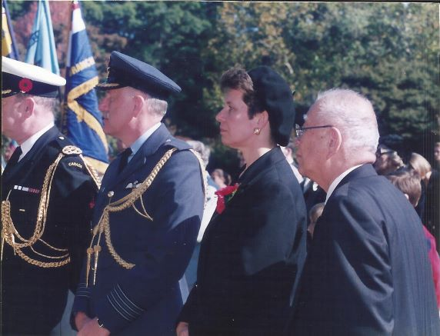

Memorials
There are many Memorials to the prisoners who worked and died during captivity in the Far East. As
The JEATH museum is the open-air museum built in Kanchanaburi, Thailand in memory of those who worked on the “Death Railway” and the River Kwai bridge. It is based on the style of a typical hut POWs lived in and houses photos and artefacts from this terrible period of the war. It is interesting that their leaflet makes a point of saying it
“has been constructed not for the maintenance of the hatred among human beings, especially among the Japanese and the allied countries, but to warn and teach us the lesson of HOW TERRIBLE WAR IS. MAY PEACE ALWAYS CONQUER VIOLENCE”
The Kwai Railway Memorial museum and library was built at Hell Fire Pass by the Australian government as an official memorial to the workers of the railway.
The National Memorial Arboretum in Alrewas, England is a permanent reminder that also presents a message of peace. Each area represents different arms of the Forces and other organisations.
The first tree was planted in the Burma Star and Far East Grove in August 1998, and a section of the Burma railway track is installed there. Queen Elizabeth, the Queen Mother, opened the Field of Remembrance on 9th November 2000 and it was officially opened in May 2001
Conclusions
Government failings post-war
The general feeling has always been that everyone in the Far East area of conflict was let down by incompetence and lack of any “expertise”, including the “low standard of some of the troop reinforcements which arrived late in the day” (Elphick, 1995). The loss of Singapore in particular was seen as “a critical event in world politics shattering the myth of white superiority and the end of European empire-building in the East”.
The critical question of why no inquiry into what is described as such a disaster does not actually seem to have been answered even now. We can see why there was such dismay by ex-FEPOWs who felt everything was being swept under the carpet.
What of the Death Railway? While the main construction was completed in 1943, some POWs and local workers were needed to keep the supplies moving along the track. In 1945, Allied bombers destroyed several sections of the track around Brenkasi yard.
POWs went back to their camp, now guarded by the Koreans rather than the Japanese, and what was left of the track was ripped up by the local Thai people, bits being sold to the Thai rail authorities – a nice touch!
In the 1980s, an Australian company started work there, found the train engine hidden inside a cave and transported it to the Museum at Kanchanaburi. There are still many more examples of what happened in different camps and the heroic actions of prisoners who had to “live for the day and control imagination” (Terry Waite).
To you all – we salute you!
See the full story in “Before Hiroshima: Forgotten Prisoners of War in Japan, Burma and the Far East” ISBN 978-0-9926100-9-8

