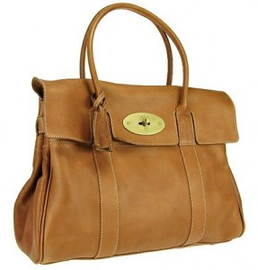
With the trend for oversize bags which may also weigh a significant amount; the Mulberry Bayswater weighs in at 1.3kg even when empty, every woman is faced with two dilemmas:
The desirability of the handbag and what she puts into it!
We need to consider what carrying any bag does to our posture. Carrying on our shoulders creates an imbalance in our shoulders and the subsequent imbalance in our posture which may also lead to headaches or neck pain.
Carrying a bag at arm’s length, particularly when heavy, still takes its toll on our arms and shoulder joints. If you pack your with a lap top, a bottle of water, a kindle, a phone, possibly a diary, make up, and a purse with coins inside it can potentially weigh the equivalent of two, 2kg bags of sugar! So, however you carry it, your bag will cause strain.
Given that pain comes, not only as a result of a sharp trauma or accident, but often from repetitive movements, such as lifting up, swinging a bag from the car seat-well or, from behind on the back seat, it is these actions which day after day lead to conditions such as ‘encapsulitis’ or frozen shoulder, or tendonitis.
Even our children are not immune to these problems. Many carry significant weight in inappropriate bags shunning the potential help of the back pack.

The value of Amatsu is that it relieves the impact of these strains, ironing out the knots and restrictions on our muscles and fascia, giving the body more mobility and lessoning the risk of these knots or restrictions leading to stiffness, niggling pain or sudden, sharp pain – rebalancing the pelvis too.

- Consider the size and shape of the bag for you and the purpose you want to use it for

- When choosing a back pack consider its size and shape for the user and ensure it has padded, adjustable straps. Adjust the straps so that it’s base does not hang too low below the waist as this will cause you to lean forward to compensate for the weight

- Try not to always carry a bag on the same shoulder or across the body on the same side. If a load is heavy consider splitting it into two or consider a wheelie trolley

- When carrying your bag avoid doing other things at the same time eg. texting or telephoning, both put additional adaptive stress on the neck

- When lifting a bag do not lift it at a distance and/or from the floor

  - counter or table top is safer to lift from
- pull it closer to your body first so that
- when lifting you can use your core and keep, feet, hips, knees, hips and shoulders pointing in the same direction to avoid excessive upper body twisting

- Don’t always carry the same bag!

- Think about what you really need to put into it on a daily basis

