“In a world of my creation” Wizard of Oz Directors blog

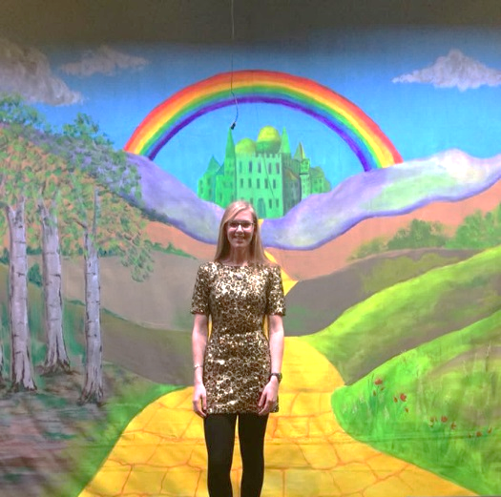
The Wizard of Oz has been one of my favourite films since I was a young child. I always dreamt of one day having a beautiful sparkly pair of ruby slippers and meeting a fairy in a far-off land. I love the adventure throughout and the friendships that are made between Dorothy, Scarecrow, Tin Man and Lion. Having been part of the Winslow Players for many years, I wanted to take the chance to do something that hadn’t been done before and was honoured to be chosen to direct the 50th Anniversary Pantomime, especially as I wrote it myself.

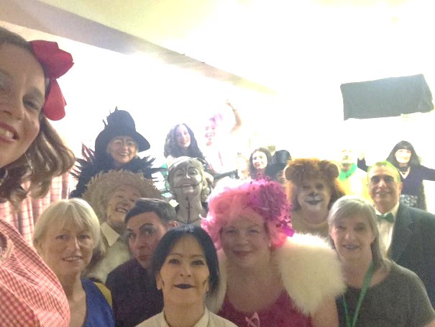
In the final few days leading up to showtime, there were a few things I was nervous about. From thinking about whether or not an audience would turn up, to knowing that I had to stand up as myself in front of an audience! I never realised how much harder it would be to be myself instead of portraying a character. Opening night was amazing! The feeling of excitement, nerves and apprehension, I’ve never felt anything like it!! As soon as the curtains opened I knew I had done everything I could and it was in the hands of my very talented cast and crew. I was constantly on the edge of my seat... not one minute went by when I wasn’t thinking or hoping for it all to continue running smoothly! It mostly did run smoothly; there were a few forgotten lines, a flash that didn’t go off, and a ripped costume, but nothing that would be noticeable to anyone but me.
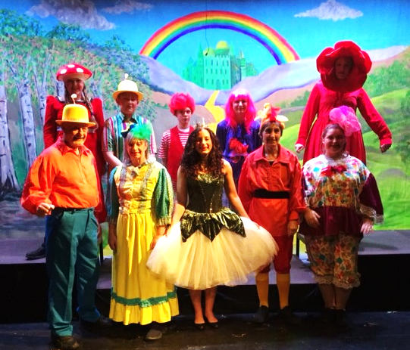
As the cast walked down at the end of the first performance, and I heard the cheering,
clapping and the singing, I cannot explain the feeling that I felt! Pure pride, happiness and love for all involved. My eyes were welling up and I just felt so warm, bubbly and excited inside! It wasn’t just me who enjoyed it. I remember walking past a lady who said, “I can’t believe I’ve never come to see the Winslow players before...they are outstanding.” I took the chance to agree, before promoting the next production in May. Hopefully she will be back! There was also a gentleman who joined in as I was thanking people for coming. I looked at him and he said, “sorry I thought I had better join in it looked like too much fun”. He had come from America to watch; that was a big honour. The majority of people said how fantastic the whole cast were. A close friend of mine after the performance claimed she had fallen in love with Auntie Em, she said it was like the inner her. Scarecrow was another character mentioned and even the witch by a couple of the brownies.
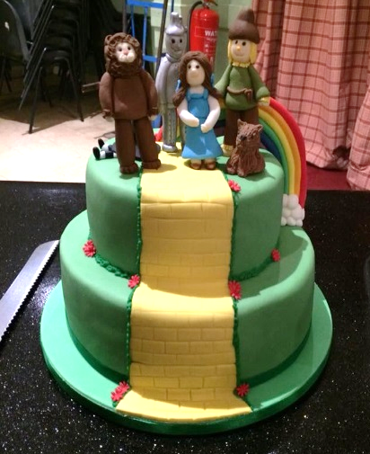
Across the four performances, it all went brilliantly. There are far too many stand out moments to describe, but I loved seeing how much the cast were enjoying themselves. The terrible jokes (I can say that, as I wrote them!), the cooking scene, the audience reactions, the bonds between the characters, the singing and dancing and pretty much everything else. I loved it all and couldn’t pick a favourite moment.

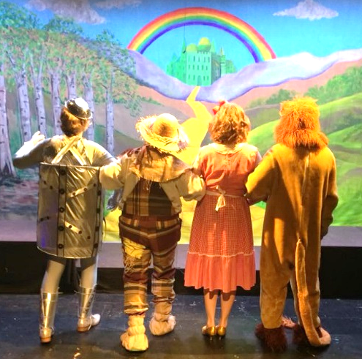
I am so glad I took the chance to direct and learnt a lot in the process. I have learnt to have faith and trust in myself, to sometimes sit back and just enjoy and stop worrying about what is out of my control. I have learnt that you may have to repeat yourself more than once to get heard or understood! I’ve also learnt that the members of the Winslow Players are incredibly talented individuals. I would do it again in a heartbeat… but maybe I’ll give it a few years first!

