**Have Happy and Safe Memorial Holiday!**

Remember Celebrate Honor

 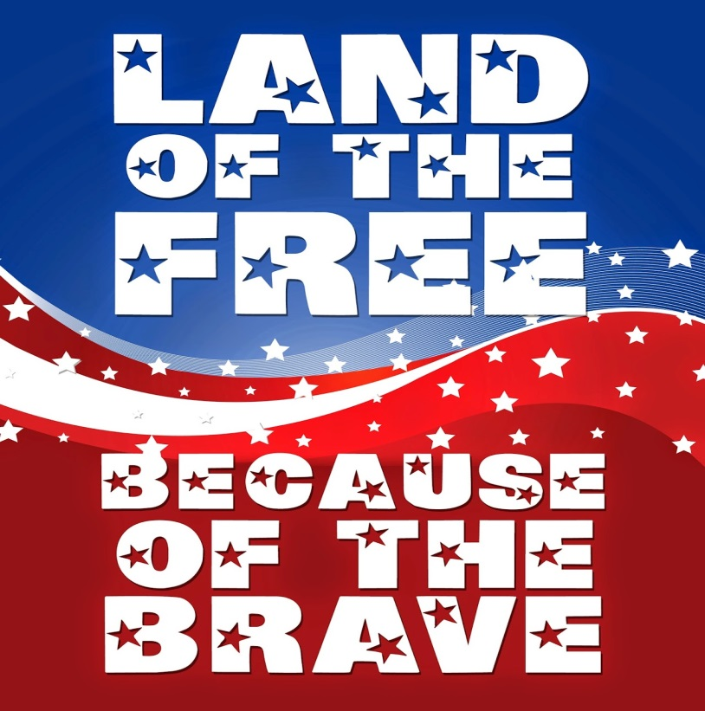

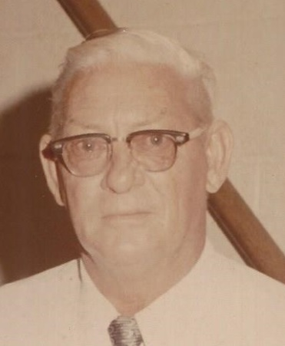 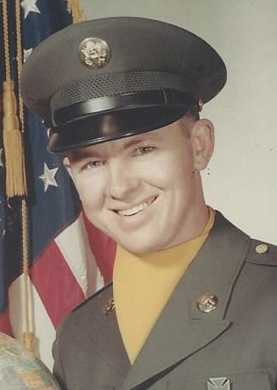 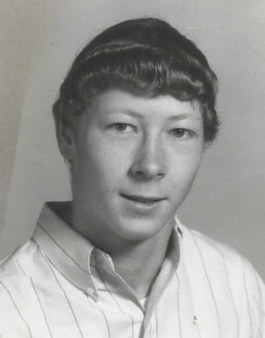

James Elmo Streett, US Army WWII James Earle Streett, US Army Michael Elmo Streett, US Navy

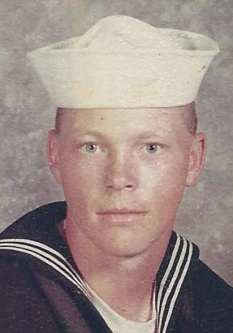 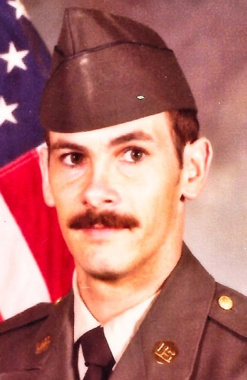 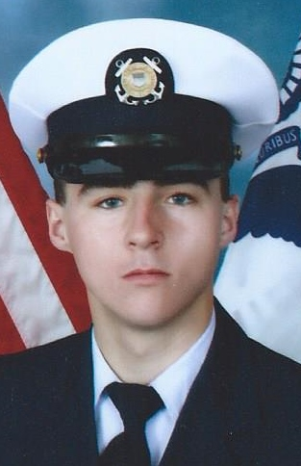

Rodney Kent Streett, US Navy Ben Dino Streett, Darian Bryce Coker, US Coast Guard

SC National Guard