1/1/09

INSPIRATION

A New Year brings with it hope of renewal, expansion, and progress. There is something about starting fresh that causes us to feel recharged and hopeful again. It marks a beginning point when we can mentally let the past go and look to the future with the belief that life will be good.

Beginnings are almost always filled with optimism. This New Year we are intensely challenged to find that optimism, which has been drowning in a pool of despair helped along by a particularly negative media. Even if for most of us life hasn’t changed much, we worry about ‘what will happen if…’ Our thoughts run to future negative scenarios which cause anxiety to rise and optimism to plummet. My suggestion is to turn the television news off. Take a break from the constant flow of negativity. Listen to music, treasure your relationships, play with your kids, count your blessings, and know in your heart that all is well.

Occasionally, take a reality check by looking around. The streets are filled with gas consuming cars, true, even when gas was $4.00 a gallon. Most of those cars are heading to work-- not unemployment lines. Beautiful houses lit for the holiday season speak of hope. People live there and are able to heat their homes and provide for their families. Restaurant parking lots are full, especially on a Friday or Saturday night. A friend and I had to leave two restaurants in Southfield on a Thursday night to find a third with no wait time for seating! Inside these busy restaurants you will see tables filled with adults and children; entire families able to afford dinning out.

This doesn’t mean part of society is not hurting and struggling financially. There are families that cannot heat their homes or go to restaurants or drive anywhere even with lower gas prices. It just means that things aren’t as dire as the media would have you believe.

The lack of balance in the media’s reporting causes undue anxiety. It benefits all of us to remind ourselves of this imbalanced reporting.

When I begin to excessively worry, I check myself by making a gratitude list. What better time to do that than in a New Year, a new beginning? I begin to focus on the blessings I have instead of what I fear I won’t have. I make a list and rapidly realize how quickly that list grows. I tick off my list one at a time…breathing clean air, lungs strong and clear, an ability to walk, see, taste, touch and smell, the beauty of a sunset or sunrise, the love of my family, the snuggly warmth of my cat’s soft belly, his complete trust to expose his vulnerable belly to me and let me rub it, living in a free country, reading any book I want, listening to music, hearing the unbridled laughter of a child, the list goes on and on before including any material abundance. Appreciating one’s abundance brings peace and hope. It is an amazing tool to help jumpstart optimism and keep it aglow with gratitude and hope.

Another method I use to increase my optimism is to read inspirational stories of magnificent people who overcome enormous obstacles like Nick Vujicic . His videos are on You Tube.

(Please take a moment and tune into his videos before reading further)
http://www.youtube.com/results?search_query=nick+vujicic&search_type=&search=Search) Ctrl + click to follow the link…Watch in particular the video titled…

“Be Inspired”



This man fills us with awe and inspiration. He has overcome a tremendous disability and
brings a message to the world of hope and of God’s perfect love. Nothing seems impossible
when you listen to Nick’s message of love. He sees beyond the limits of his body to the unlimited potential of his spirit. Like a crystal clear waterfall his perfect spirit flows through him, profoundly touching everyone who hears and sees him. Soon they lose their awareness of his physical deformity and only see the beauty of his heart.

Each of us is born with this intrinsic beauty, this spirit of the Divine, this purity of essence. Sometimes we get lost along the way just as Nick did when he contemplated suicide. Our life circumstance might be such that we lose hope. Our despair leads to a wish for escape… then we see or hear an uplifting story or video like Nick’s. He reminds us of the resiliency of the human spirit and its ability to overcome all circumstances. A new found sense of hope arises and we find the courage to continue on.

Inspirational stories abound. They encourage us to remember how powerful we are when we focus our spirit on the positive. People like Nick are extreme examples of this positive force and are truly inspirational to us. Most of us aspire to possess only a percentage of Nick’s faith and courage. Even in smaller doses our faith and courage can help us achieve astounding victories. A father choosing to use a softer, mentoring tone to his young son instead of an angry outburst is victorious and is reflecting Nick’s spirit. When a woman puts a supporting arm of love around her man who just got laid off, instead of plying him with her worries, she experiences victory and embodies the beauty we see in Nick. When a child steps in to stop a bully from picking on another smaller child, his victory represents Nick’s loving spirit. Each in our own way can seek the Divine within us. We have the ability to see our life circumstance as only temporary and to learn that how we live our life is far more important than our particular life situation.

“Some people go through life trying to find out what the world holds for them only to
find out too late that it's what they bring to the world that really counts."
From the book: 'Anne of Green Gables'
Written by Lucy Maud Montgomery

In my musings I imagine the planet earth to be similar to a Hollywood set. Located throughout the world are differing dramas playing out on various stage sets. Each of the plays has its own cast of characters and story-line. What connects these dramas is the theme of opportunity. Everyone has a choice to use their particular story to bring something meaningful to the world and to remember that ultimately they are spiritual beings living a human drama. Or they have a choice to never awaken to the truth that their drama is temporary, a prop to help bring a life lesson to their spirit. They buy their story as real then succumb to deep despair.

One of the most desolate stories of human history is the story of the victims of the Nazi extermination camps. Viktor Frankl wrote achingly of the importance of creating meaning in order to survive the horror of the Nazi concentration camps. As horrific as his experience was, Viktor Frankl found meaning in it by tapping deeply into his spirit. He understood that life holds potential meaning even in the most miserable of circumstances. In his book, “Man’s search for meaning”, he noted that those in the concentration camp who lost meaning in their lives succumbed to death far quicker, even if possessing heartier constitutions, than those who maintained meaning. He believed that one can find purpose even in suffering, especially if one frames his suffering in terms of import, such as, ‘one’s personal suffering prevents the suffering of a beloved or one’s suffering by example brings a greater spiritual awareness to the world’.

Viktor Frankl’s ability to focus on treasured images of his wife helped him survive the horror of the camps. He imagined her beautiful countenance as he trudged through the rough

terrain to the grueling, daily work details. His body was assaulted by icy winds while wearing only the tattered remains of clothing that did little to protect him from the cold. He would have entire conversations with his wife. He saw her smile, nod her head and heard her answer him back. It helped him when he was unbearably cold, fatigued, and weak from lack of food. He writes,

“Then I grasped the meaning of the greatest secret that human poetry and human thought and belief have to impart: The salvation of man is through love and in love. I understood how a man who has nothing left in this world still may know bliss…”

Salvation in the concentration camps depended on an inmate’s ability to turn inward to a rich inner life where he recalled all that he ever learned or accomplished, therefore,
was able to see himself as a worthwhile human being not the nameless, faceless, stripped-down, skeletal ‘nothing’ the Nazis would have him believe he’d become.

Viktor Frankl and Nick Vujicic both demonstrate in their unique way that forces beyond our control can take away everything we possess except one thing, our freedom to choose how we will respond to the situation. The behavior of Americans shortly after the tragedy of 9/11 is a great example of this. We chose to respond by coming together as one, helping others and giving of ourselves in time, money, and comfort. We let go of our daily complaint and kept within our hearts the shared vision of what it means to love and to be American…generous, free and united. For a short time we witnessed the best in us during the worst of times.

The indomitable human spirit lies deep within. It is more difficult to access during times like these when there is a daily assault on our fears. Because of this assault it is even more important that we develop daily practices that will keep us connected to our core of inner peace.

For a short time in the earlier part of December I lost my peace of mind by becoming enraged at the auto company bridge
loan drama. Maybe because it involved my beloved state, I allowed the radio broadcasts
about Washington’s crassness toward our auto industry to upset me to such a degree
that I felt called to action. I wrote an angry, frustrated letter to our state representative and senators and sent it off. This action did not
relieve my anger; instead it seemed to incite it even more. Throughout the day, I spoke about my outrage at the arrogance of Congress. I felt personally insulted by their demeaning attitudes toward our auto executives. I jumped headlong into my victim consciousness and effectively lost my peace of mind. By the end of the day I was exhausted by the negative energy I willingly carried the entire day. I realized it was time to do a Radical Forgiveness worksheet on Congress and on politicians in general. I needed to release the negative core beliefs that fueled my outrage and needed to restore my peace of mind. Thankfully, Radical Forgiveness once again came through and I was able to use this opportunity for growth instead of just experiencing useless outrage. I reminded myself that all things happen as they should and are to be used for our spiritual growth and that all would be well.

Practices that promote peace of mind take many forms… meditation, prayer, gratitude lists, Radical Forgiveness worksheets, volunteer work, or anything that will help us rise above our circumstances to a higher level of thought.

The Web site, www.contemplativemind.org lists the many benefits of using contemplative practices to seek one’s inner core of peace..

Benefits:
Transforming your relationship with yourself:
- Generating an overall sense of calm and well-being
- Managing your stress and its impact on your body
- Deepening your self-understanding
- Sharpening your focus, concentration, and insight
- Upholding your core values in your personal and professional life
Improving your relationships with others:
- Enabling you to treat people with compassion and wisdom
- Helping you to see conflicts from different angles, opening up creative possibilities for problem-solving and resolving disagreement
- Improving your listening skills
Enriching your relationship with the world around you:
- Increasing your global awareness and appreciation for the interconnection of all life
- Developing the ability to question, explore, adapt to rapid change, and deal with complexity
Radical Forgiveness tools can really be helpful when feeling despondent or angry about the current times. Use these wonderful, restorative tools daily along with contemplative practices to manage your mood during this time of struggle. Maintain a vision of what you want not what you fear. Trust that we are more than our human selves and forces of good are always in the works. Use each lesson to advance your soul and be grateful for every opportunity to grow and expand your soul.

Soon our situations will improve and we will speak of these times in terms of the lessons learned, much like our parents speak of the Great Depression.

From my heart to yours…Karen Bashawaty

The Tree of Contemplative Practices
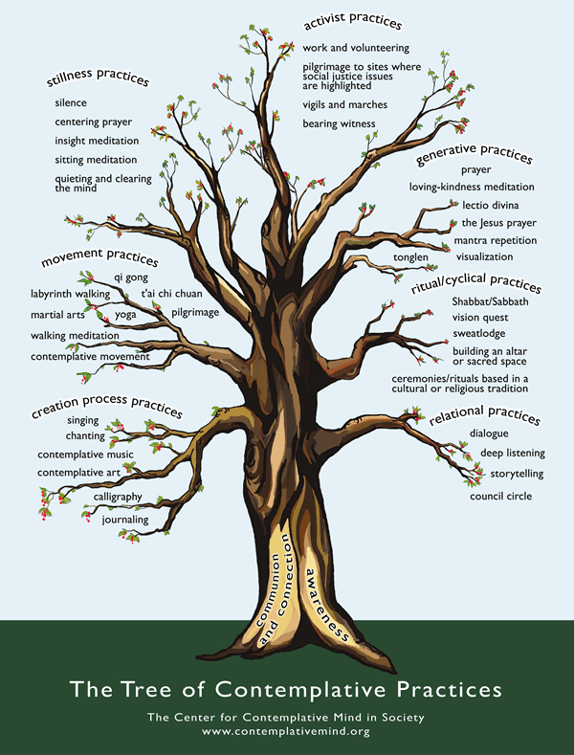
GROUP FOR “BREAKING FREE’ 21 DAYS TO FORGVING YOUR PARENTS.

I am offering a seven week group for those who have purchased the online program “BREAKING FREE”. It will provide the support to help you through the program, prevent procrastination and will support you through the more difficult modules. Every week at least three modules would be completed by group members. The weekly group meeting would help them process the information they learned or redo a module to get more out of it.

Please contact me by email if you have interest in this type of group. I will charge only $20 dollars for a two hour meeting since I

don’t have to create the original program. The total for the entire group is $140.

k-bash@comcast.net – Use your coupon and take another 10% off!


10% OFF
ON ANY RADICAL FORGIVENESS SERVICE
Clip Coupon to receive your
Savings at your next RF session
MY FIRST TELEVISION INTERVIEW
A friend, Joe Homsey, and I were interviewed for the Grosse Point cable TV show, “Out of the Ordinary, Into the Extraordinary”, hosted by Robert and Pamela Taylor. Robert and Pamela were so excited about Radical Forgiveness and Joe’s program, Force 2012, which he uses to accurately describe personalities just with birth date information; they decided to tape second interviews, creating a two part show. The two parts will be shown on consecutive weeks. They were lovely hosts and made us feel very comfortable and welcomed. I will send out a notice when I have the exact airing dates.

BEST WISHES FOR THE NEW YEAR. MAY 2009 BE YOUR BEST YEAR YET!

A LETTER TO MY FRIENDS

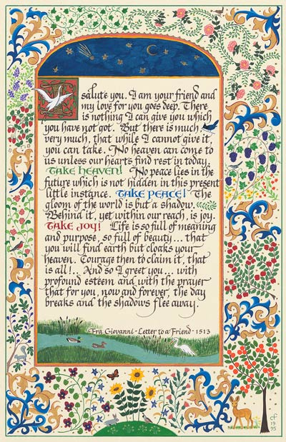
http://proseandletters.com/Prints/FraGiovanni/html

