George Mason University

Pesticides:

Are They as Harmful as We Think?

Sadaf Atayee
Health and Environment (GCH 360 – 002)
Professor Shannyn Snyder
Monday, December 11, 2017

Introduction

“Pesticide” is a term used to describe “any device, method, or chemical,” (Harding, F., 2006) used to “kill, repel, or control certain forms of plant or wildlife…” (Pesticides, 2017) that compete for the human food supply and/or are otherwise unwanted. There are different categories of pesticides including insecticides, fungicides, herbicides, rodenticides, and nematicides, bactericides, and larvicides, each having different functions. Refer to Table 1 for the intended purpose of some types of pesticides.
Humans have been cultivating crops for centuries and have been devising methods since to prevent insects and rodents from eating and/or destroying valuable crops. Some cultures planted during certain phases of the moon as it was believed the moon affects the behavior of insects and rodents. Some went to the trouble of plucking insects from their plants by hand and created sounds to ward off bugs and other critters. Other cultures even rotated their crops annually to keep insect populations in the soil at a low. This system reduces the amount of pest population in the soil as some pathogens can survive in this damp and dark environment year after year with the help of their host-crop, (Nunez, 2010).
Like centuries ago, the goal of pesticides has remained the same: to protect crops from insects, rodents, and other creatures that feed or harm vegetation. However, pesticides are not just harmful to bugs, insects, rodents, other animals, and the environment; they are also harmful to humans. These chemicals pose serious threats to humans as they are toxic, even in small amounts, and have several modes of entry (oral, respiratory, and dermal). Pesticides have a negative impact on health as they can cause allergies, cancer, lead to infertility, and in severe cases even death.
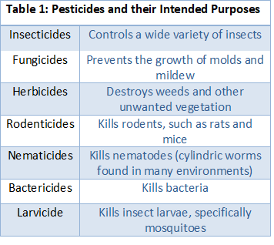Background
History
Even centuries ago, civilizations utilized chemicals in order to protect their crops. Sulfur was used in Rome, arsenic in China, and the crushed petals of a specific chrysanthemum flower, pyrethrum, was used in the Middle East (Pesticide, n.d.). Today, there are several different classes of such chemicals, each containing several pesticides.
There are two generations of pesticides:
- first generation pesticides
- second generation pesticides

First generation pesticides were used before the 1940s and were highly poisonous natural compounds, such as arsenic and hydrogen cyanide. The use of these chemicals was eventually abandoned because they were toxic to humans, ineffective at their job, discovered to be water and soil pollutants, and non-biodegradable. Second generation pesticides, which are synthetic organic compounds such as chlorinated hydrocarbon and DDT, were used in the 1940s and are still used today. They are man-made organic chemicals, considered to be less toxic to humans, and are more biodegradable.
Just before World War II a Swiss scientist, Paul Müller, discovered that a chemical, DDT (dichlorodiphenyltrichloroethane), kills insects. Shortly after the war, pesticides became extremely popular when farmers got word of this inexpensive, water-insoluble miracle powder. It 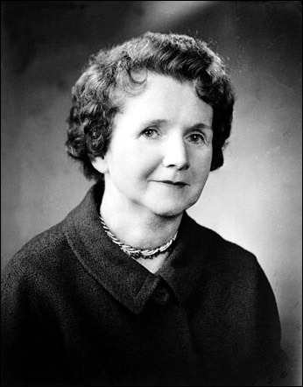not only killed pests but helped boost crop yield and control vector-borne diseases such as malaria (Muir, 2012).
Image 1
However, in 1962 a Scientist, Rachel Carson (Image 1), published a book that issued warnings about pesticides (specifically DDT) and the effects they have not only on human health but on the health of the environment as well. In 1972, the United States banned the use of DDT as it was discovered what Carson was warning against was true and that pesticides are indeed harmful to humans, plants’ ecosystems, and nontarget creatures (“organisms other than those pesticides are intended to kill,” (Muir, 2012)).

Health Implications
As mentioned above, there are many types of pesticides. Most, if not all, of these chemicals are harmful to humans. The World Health Organization estimates that each year there are about 3 million cases of pesticide poisoning and nearly 250,000 deaths, (Bertolote, Butchard, Besbelli, 2014). Exposure to pesticides can cause a wide range of health implication, including “asthma, allergies…cancer, hormone disruption, and problems with reproduction and fetal development,” (Lah, 2011.) The following pesticides and their effects on human health will be discussed:
- Atrazine
- DDT (dichloro-diphenyl-trichloro-ethane)

Atrazine
Atrazine is a synthetic herbicide. It is mainly “used on crop such as sugarcane, corn, pineapples, and macadamia nuts,” (Toxic Substances Portal – Atrazine, 2015). This herbicide is applied to soils in order to prevent weed growth, but it can enter the air after its been applied to the soil. There is potential for rain to cause the atrazine to be washed from the soil and cause contamination in “surrounding areas, including streams, lakes, or other waterways.” It can also penetrate deeper into the ground and enter the groundwater. In the soil, this chemical breaks down quite quickly. However, if it enters water it does not breakdown nearly as quickly, which is why atrazine is so commonly found in drinking water collected from wells.
One way that atrazine impacts the health of humans is by disrupting the endocrine system. This chemical is responsible for altering the levels of key hormones and can even delay puberty. Atrazine has been shown to convert testosterone to estrogen, which leads to desmasculinization.
Because atrazine disrupts hormone function, it can also alter how an individual’s reproductive system functions. Studies show that couples who live on farms treated by this herbicide are at risk for having premature babies. Atrazine also “causes changes in blood hormone levels which affects the ability to reproduce.” In addition to causing infertility and pre-mature babies, this chemical has shown to cause cancer since pesticide are carcinogenic to humans. Long-term exposure can put women at greater risk for developing breast cancer and men prostate cancer (Atrazine, n.d.).

DDT
DDT is a synthetic insecticide that was initially used to combat vector-borne diseases such as malaria and typhus. Because it was so effective in killing insects, farmers began using it as a solution to protect their crops from insects. However, In 1972 the US government banned the use of DDT because it had such severe impacts on the health of humans.
When it was in production, DDT was found in the air, water, and soil. Like atrazine, because DDT is used in the soil it too can travel to other water sources and even penetrate deep down into groundwater. The insecticide was also sprayed directly over crops and vegetation and into the air as well in order to control mosquitoes. Although DDT has been banned for 45 years in the United States, it can still be found in the environment as some soils still contain traces of the chemical, which are then taken up by plants that are eaten by animals who feed humans. Because DDT traveled to water sources, traces can still be found in fish today. Also, many countries that used DDT have also placed bans on the insecticide, though some did not. Americans still come into contact with DDT through products that have been imported from overseas.
If one were to eat large amounts of DDT (in grams) over a short period of time, the individual’s nervous system will most likely be affected. Studies show that people who swallow large amounts of this chemical experience tremors and seizures as well as “sweating, headaches, nausea, vomiting, and dizziness,” (Toxic Substances Portal – DDT, DDE, DDD, 2015). Those who work in factories and are exposed to small amounts of DDT over a long period of time were shown to have changes in the levels of liver enzymes produced, which can affect an individual’s digestion and purification of blood. Studies show that women who have increases of DDT in their blood while pregnant are at higher risks for giving birth pre-term. Also, women who have experienced long-term exposure to DDT were associated with a “reduction in the duration of lactation,” (Toxic Substances Portal - DDT, DDE, DDD, 2015).

Methodology
How It’s Made
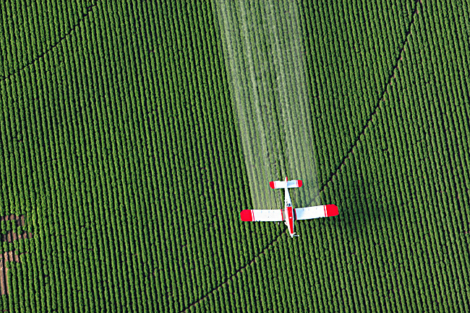There are two components of any pesticide: (1) an active ingredient and (2) inert ingredients. “The active ingredient kills the pests, while the inert ingredient facilitates spraying and coating the target planet”, (Pesticide, n.d.). Manufacturing a pesticide involves at least three separate activities. First, the active ingredient is synthesized in a factory where it proceeds to be formulated into a liquid or powder. It is then packaged and sent to the farmer who dilutes the chemical before applying it to the fields – if the pesticide is in liquid form a carrier is used to dilute the mixture, whereas inert powders are used to dilute pesticides in that are in powdered form.
Image 2
Application of pesticides can be done in a couple of different ways – typically a plane is used to spray the chemical across large flat areas. Trucks with spraying tanks can also be used, which help disperse the pesticide closer to the ground. For smaller farms, hand pumps are used to distribute the pesticide as it is a better option from an economic standpoint. See Image 2.

Government Regulations
“The U.S. uses about 5.1 billion pounds of pesticides each year”, (Sass and Wu, 2011). Because pesticides are harmful to not only the intended organisms but to crops, the ecosystem, and humans as well, there are strict laws for regulating the use of such toxic chemicals. The government agency that regulates pesticides is the U.S. Environmental Protection Agency (EPA). The EPA only allows the selling of pesticides that “will have no unreasonable adverse effects on the environment or human health”. The organization can also pull pesticides off the market if it no longer meets the health safety standard.
Pesticides are banned when it poses an unreasonable risk to humans and/or the environment, has common active ingredients that are toxic, and has high exposure risk – whether short or long term. (Gallea, 2013). The EPA also provides instructions on how a pesticide should be used, how often it can be used, and if the applicator needs protective clothing and/or equipment when handling the pesticide.
If a company seeks to register their pesticide, many scientific studies must be conducted, per the requirement of the EPA, in order to “assess various aspects of the chemical, including toxicity, ecological effects and environmental fate.” The company must list the ingredients of the pesticide, name the specific target, mention the “amount, frequency, and timing of its use,” (About Pesticide Registration, 2017), and include instructions on how to safely store and dispose of the chemical. But unfortunately, even with all these regulations harm to humans, the environment, and unintended targets still occurs.

Cases Involving Pesticides
Case #1
In 2015, the county of Montgomery, Maryland passed a bill that banned the use of certain cosmetic pesticides on private property, even though these pesticides have been approved by the federal government. On August 3, 2017 a Circuit Court judge, Terrence McGann lifted this ban, which was to go into effect in January 2018. Environmental advocates argued that the chemicals were a hazard not only to the environment but also humans as some studies showed the compounds may cause cancer. Judge McGann overturned the ban because he claimed it conflicted with federal and state regulations “that allow the use of the cosmetic pesticides”, (Chason, 2017). Had this ban not been overturned, the 187 jurisdictions of Maryland would have to set their own regulatory systems for pesticide use. Judge McGann claimed that his decision helped “’avoid confusion from diverse requirements’ that could endanger public health,” (Chason, 2017).

Case #2
In August of 2011, two Minnesota farmers found themselves in court after contamination occurred. One man operates a 1,500-acre organic farm that is surrounded by non-organic fields. The organic farmer’s land and crops became contaminated with pesticides when his neighbor’s chemicals drifted onto his property as they were sprayed. Federal regulations state that if organic crops are tainted by herbicides, they “must be sold at lower, nonorganic prices and that the tainted field must be removed from organic production for three years,” (McEowen & Herbold-Swalwell, 2011). The National Organic Program (NOP) states that the “organic” label applies to crops that do not exceed a 5% pesticide level in accordance to the EPA’s regulations. The organic farmer claimed that because his crops are now tainted, he is not able to sell his crops under the organic certification. The trial court ruled in the plaintiff’s orders, “barring the co-op from spraying within one-half mile of the plaintiff’s farms and requiring the co-op to give notice when spraying in the area,” (McEowen & Herbold-Swalwell, 2011).

Analysis
For both cases I think the judges based their rulings on what they thought best. The judges took into consideration both sides of the argument and made their decision accordingly, trying to do as little harm to the environment and the people involved as possible. For Case #1, the judge picked the lesser of the two evil rulings. Had he not lifted the ban, the entire state of Maryland (187 jurisdictions) would have had to come up with lists of pesticides they approve for the use on private-properties, individually. With all these jurisdictions deciding on many different cosmetic pesticides each, the state of Maryland’s air quality would have been worse off than it is with Judge McGann’s ruling. The overturn of the ban means that all the jurisdictions are to sell the same pesticides, which would control and prevent the possibility of many pesticides mixing together and potentially harming humans and the environment more than they would without the removal of the ban.
For Case #2, the case was a little more delicate as it involved two neighbor farmers who choose to farm differently – one producing organic crops, and the other producing crops that are sprayed with pesticides. The judge ruled in favor of the plaintiff because this was not the first time the neighbors were in court over this topic. The plaintiff makes his living off of his crops, as does his neighbor; however, because he sells organic crops if they are tainted with pesticides he must sell his crops at a lower price than what his non-organic neighbor would. To make this situation fair, the judge stated that the non-organic neighbor must have a wide perimeter around his farm in order to prevent contaminating his neighbor’s organic crops. Had the judge ruled differently, the farmer who produces organic crops would have suffered greatly financially.

Solutions
One obvious solution would be to stop the use of pesticides all together. Not only would air and water quality improve with less chemicals flowing in them, humans would be much healthier and less at risk for health conditions, such as cancer and reproductive issues.

Example
Figure 2
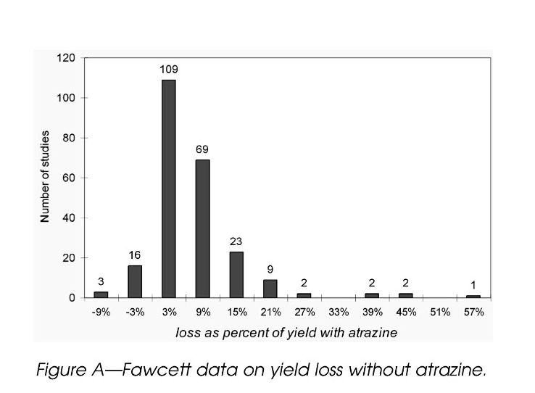A study conducted showed that farmers would only experience less than 1% loss of crops if they discontinued the use of atrazine Figure 2 shows a graph of several studies conducted and the percentage of loss farmers experienced when Atrazine was not used.

Although it sounds like a great alternative, it may not be the best solution as the quantity of crops produced and sold will dramatically decrease and fruits and vegetables would become more expensive for consumers. Another solution would be to use organic pesticides, though studies have shown that using organic pesticides does little to improve health implications. While anything “organic” tends to be healthier, when it comes to pesticides that is not true. In order for organic pesticides to really work, farmers would have to spray incredible amounts on their crops. This means that organic produce has double, maybe even triple, the amount of pesticides sprayed on them as do their non-organic counterparts (Hom, n.d.).
A possible solution would be crop rotation – every year farmers would plant new crops in different land plots. For example, a farmer would replant his corn where he grew his tomatoes the previous year. As mentioned above, this prevents pesticides from becoming too comfortable with specific crops that nourish them best.
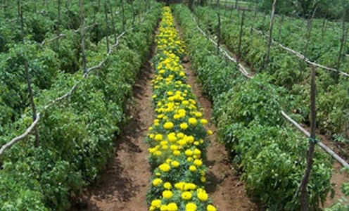One of the best solutions could possibly be the addition of trap crops (Image 3) on farms to distract pests from valuable crops. The idea is that farmers plant a sacrificial crop (or crops) in order to attract pests towards the trap crop and away from the main crops being grown (Dore, 2010). Pests tend to have a preference for what crops they like to feed on, so if farmers plant a few rows of favored trap crops near their vegetation, the pests would likely be more attracted to the sacrificial crop and hopefully leave the main crops alone.
Image 3

Conclusion
Pesticides have been used for centuries to deter insects and rodents away from plants. Although they succeed in their job, they are harmful to nontarget organisms, the environment, the ecosystems of vegetation, and humans. The use of pesticides has caused many health implications including, cancers of all kinds, infertility, lactation problems, respiratory illnesses to name a few, and even diabetes and overweight and obesity. It is imperative that people understand the dangers of pesticides and to make educated decisions about what they are putting in their bodies and how it affects their health.

Works Cited

About Pesticide Registration. (2017, May 24). Retrieved from https://www.epa.gov/pesticide-registration/about-pesticide-registration

Atrazine. (n.d.). Retrieved from http://www.panna.org/resources/atrazine

Bertolote, J. M., Butchart, A., & Besbelli, N. (2014). The Impact of Pesticides on Health: Preventing Intentional and Unintentional Deaths from Pesticide Poisoning. Retrieved from http://www.who.int/mental_health/prevention/suicide/en/PesticidesHealth2.pdf

Chason, R. (2017, August 03). Court strikes down Montgomery County's ban on lawn pesticides. Retrieved from https://www.washingtonpost.com/local/md-politics/judge-rules-against-controversial-montgomery-county-ban-on-lawn-pesticides/2017/08/03/7350d7d2-7858-11e7-8f39-eeb7d3a2d304_story.html?utm_term=.4005bd5462e3

Dore, J. (2010, June 04). Trap Cropping to Control Pests. Retrieved from https://www.growveg.com/guides/trap-cropping-to-control-pests/

First and Second Generation Pesticides. (n.d.). Retrieved from http://apes08.tripod.com/insecticide/id14.html#

Gallea, B. (2013, January 06). Pesticides. Retrieved from https://www.slideshare.net/BonnieGallea/pesticides-15878360
Harding, F. (2006). Breast Cancer: Cause, Prevention, Cure. Aylesbury (England): Tekline Pub.
Hom, L. (n.d.). About Organic Produce. Retrieved from https://www.ocf.berkeley.edu/~lhom/organictext.html
Lah, K. (2011, May 06). Effects of Pesticides on Human Health. Retrieved from http://www.toxipedia.org/display/toxipedia/Effects+of+Pesticides+on+Human+Health
Lear, L. (2015). Rachel Carson's Biography. Retrieved from http://people.oregonstate.edu/~muirp/pesthist.htm
McEowen, R. A., & Herbold-Swalwell, E. C. (2011, August 03). Pesticide Drift on Organic Crops Offers Complex Court Case. Retrieved from http://www.westernfarmpress.com/government/pesticide-drift-organic-crops-offers-complex-court-case
Muir, P. (2012, October 22). A. HISTORY OF PESTICIDE USE. Retrieved from http://people.oregonstate.edu/~muirp/pesthist.htm
Nunez, J. (2010, December 03). Crop Rotation as a Method of Disease Control. Retrieved from http://www.westernfarmpress.com/management/crop-rotation-method-disease-control
Pesticide. (n.d.). Retrieved from http://www.madehow.com/Volume-1/Pesticide.html
Pesticides. (2017, August 28). Retrieved from https://www.niehs.nih.gov/health/topics/agents/pesticides/index.cfm
Sass, J., & Wu, M. (2011, August 24). US Pesticide Regulation: Weaknesses, Loopholes, and Flaws Undermine Farmworker Health. Retrieved from http://www.psr.org/environment-and-health/environmental-health-policy-institute/responses/us-pesticide-regulation.html?referrer=https%3A%2F%2Fwww.google.com%2F
Toxic Substances Portal - Atrazine. (2015, January 21). Retrieved from https://www.atsdr.cdc.gov/PHS/PHS.asp?id=336&tid=59#bookmark01
Toxic Substances Portal - DDT, DDE, DDD. (2015, January 21). Retrieved from https://www.atsdr.cdc.gov/phs/phs.asp?id=79&tid=20

