# BEN SALEM UNITED CHURCH OF CHRIST

**WHERE TO REACH US:**

**MAILING ADDRESS:**

PO Box 128, Andreas, PA 18211

**STREET ADDRESS:**

1965 Church Hill Road

Lehighton, PA 18235

## Church Phone: 570-386-3870

**Social Hall Phone: 570-386-4990**

**E-mail:** [**bensalemucc@ptd.net**](mailto:bensalemucc@ptd.net)

**Website: www.bensalemucc.com**

**Fax: 570-386-3870 [call, speak to secretary, then call back]**

**Pastor Michael McGowan: Home – 610-759-9126**

**Office e-mail:** [**pstrbens@ptd.net**](mailto:pstrbens@ptd.net)

One

In

Christ

BEN SALEM UCC

**NON-PROFIT ORG**

**U.S. Postage**

**PAID**

**Lehighton, PA**

**Permit #4**

PO 128

ANDREAS PA 18211-0218

RETURN SERVICE REQUESTED

DATED MATERIAL



2018

February

**BEN SALEM VOICE**

**February 2018**

**Ben Salem United Church of Christ,**

**PO Box 128, Andreas, PA 18211**

Brothers and Sisters in Christ,

Questions, questions, questions, we all have questions at times. Questions are the human species way of learning and are instrumental in our development. Of course, questions can become annoying when they are repetitious such as when a three year old responds to everything you say with ‘why?’ God bless them for their curiosity but sometimes you have to respond with – “why do you think (fill in the blank) happens?” This way they learn to stop and think about something on their own.

But it also can be stated how all great minds ask questions because they know it is the easiest way to gain deeper insight. Philosophers ask questions about the meaning of life, morality, truth and so on. Theologians are always asking how I understand God; teachers ask questions to gain insight into what their students already know so they can focus their lessons. And questions are also a good way to gather information about an entity such as a church.

Recently the Membership and Growth Committee of which I am a part came up with three questions to ask the congregation. The questions posed were devised to help the committee understand what the congregation thinks about their church. Our goal was to hear from the people and how they perceive the church which you all form as members. The first question that was asked was – “*As you consider this church community, how would you describe Ben Salem to a stranger?*”

In the responses to this question we found that the small percentage of people who responded all had a very positive image of the church community. They wrote about the helpfulness of the people and how the congregation responds to need. Also stated was how the people are friendly, welcoming and family minded. Some said they are happy with the amount of activities in the church while others thought we need to open the facility to even more activity, especially from outside the congregation. Most mentioned the beauty of the building and the comfort of its amenities, while others reflected on the long history of the church. Although some questioned whether the church can remain relevant in this day and age, others said the church has a promising future. All in all I think those who responded would do this church justice if they spoke about it to a stranger. And that is a good thing, because if we don’t have a good perception of ourselves as the church why would anyone else want to join with us as the church?

The goal of the second question was to have the congregation think about whether they experience God in the life of the church. The committee asked: **We experience the Father, Son and Holy Spirit in our worship, music, teaching, fellowship, prayer and service to others.** “*The previous statement is the second part of Ben Salem’s Mission statement. Spiritually, how are you experiencing this on a personal level?*” Some who responded divulged how they feel God’s Spirit in the same way the statement states. They wrote this keeps them spiritually centered as they traipse through the waywardness of this world on a weekly basis. Numerous respondents wrote that the church helps them stay spiritually grounded and helps them find God in the world since it is a ‘Living Savior’ who we serve. Others stated how all the things mentioned in the mission statement help them work on their own personal relationship with God while others feel they experience God spiritually by witnessing the love and excitement of the children in the church.

Peace and Blessings,

Pastor Mike



**Worship Services:**

February 4 8 AM & 10:30 AM Worship/Communion

11 8 AM & 10:30 AM Worship

14 7:30 PM Worship/Ash Wednesday/Communion

18 8 AM & 10:30 AM Worship/Lent I

25 8 AM & 10:30 AM Worship/Lent II



**Communion:**

Sunday, February 4th

8AM & 10:30 AM

Ash Wednesday, February 14th 7:30PM

**ADULT BIBLE STUDY**

**Thursday Mornings**

**10AM – 12 Noon**

**Fellowship Hall Board Room**

***Please join our group as we continue studying “Be Authentic”***

***(Genesis 25-50)***

***by Warren Wiersbe***



Worship Schedule for March & April 2018

March 4 8AM & 10:30AM (Lent III/Communion)

11 8AM & 10:30AM (Lent IV)

18 8AM & 10:30AM (Lent V)

Hand Bell Choir

Sunday, February 11th

10:30 AM Service

25 8AM & 10:30AM (Palm Sunday)



29 6PM (Maundy Thursday/Communion/Tenebrae)

April 1 8AM & 10:30AM (Easter Sunday)

8 8AM & 10:30AM (Holy Humor Sunday)

15 8AM & 10:30AM

22 8AM & 10:30AM

29 8AM & 10:30AM

**Lenten Services (at 7:30 PM)**

**“A Journey to Easter Vigil”**

February 14 – Ash Wednesday

at Ben Salem UCC

February 21 – at St. Peter’s

– Rev. McGowan, Ben Salem

February 28 – at St. John’s

– Rev. Buckwalter, St. Peter’s

March 7 –at Ben Salem UCC

–Rev. Campbell, Zion’s Stone

March 14 –at St. Peter’s

– Rev. A. deForest, St. John’s

March 21 –at Zion’s Stone

– Rev. C. deForest, St. John’s

**CALL TO ANNUAL**

**CONGREGATIONAL MEETING**

**NOON**

**IN THE FELLOWSHIP HALL**

Come for a meal, fellowship, and to hear reports from 2017. We will also discuss the future of Ben Salem UCC. Please bring a covered dish and plan to attend this important meeting! A sign-up sheet is in the Narthex.



**COFFEE HOUR**

Volunteers needed!





All Choirs will practice on Tuesday nights during the Lent season. *(Please disregard the Wednesday night entries on the calendar.)*

Cherub Choir 6:30PM

Junior Choir 6:30PM

Senior Choir 7:00PM



**Special Speaker**

** February 4, 2018**

**8 AM & 10:30 AM**

**Mr. Gary Barraco**



**Theme: 3 Great Loves: Love of Neighbor**

**Sermon Title: “I See You”**

****Church Business**

**Note from Church Office & Financial Secretary:**

Remember, it is important to keep us informed of any address changes. Please give changes of address to either Dollie Behr or Sue Messina.

**Have you moved recently? Members can help by updating the church office with their new address prior to moving. It is also helpful to provide the church office with your home phone numbers, cell phone numbers and e-mail addresses if you wish. By doing this we can keep in touch with you and also provide you with important information regarding the church. Thank you in advance for your help.**

**How to Contribute to Our Operating Budget: to pay Ben Salem’s bills]**

**Use your weekly envelope [in your envelope packet]**

**Designate “Current Expenses”:**

**[Benevolence is only for Missions – OCWM]**

**Place in offering plate or send to the Church:**

**Ben Salem UCC, P.O. Box 128, Andreas, PA 18211**

**2018 Church Board Members:**

##### Elders: Brian Beidleman,VP, Barry Fink, Pres.,

##### Kenneth Oswald, Cliff Snowberger

Deacons: Terry Blair, Shirley Kline, Doris Lusch, Robin Lutz,

Robert Pope, Sec., Barry Reed, Carly Smith, Ron Steigerwalt

##### Pastor: Rev. Michael McGowan

##### Church Secretary: Dollie Behr

##### Treasurer: Dawne Beidleman

Financial Secretary’s Address: Susan Messina, 66 River Road,

Tamaqua, PA 18252

**Upcoming Church Board Meeting:**

**February 19th at 7PM**

Ben Salem History Books – Very limited # available

$60 – Contact the Church Office 570-386-3870

***Have you remembered the church in your will?***

**Upcoming Committee Meetings:**

Cemetery Association: February 1, 7PM

Called to Care: *no meeting date set*

Property Committee: February 15, 7 PM

Newsletter Assembly: February 28, 6PM

***(please submit information 1 week prior)***

Fundraisers Meeting: March 12, 6:30PM

Mission Committee: online meetings at [cti2@ptd.net](mailto:cti2@ptd.net)

**Cemetery Association Officers**:

Next Meetings: February 1 and March 1 at 7 PM

President: Bernice Steigerwalt Vice President: Evan Beblavy

Caretaker: David Fritz Secretary: Walter Keeck

Treasurer: Doris Lusch Trustee: Richard Bealer

**Cemetery Lot Prices:**  $300 [with perpetual care]

**Scheduling Events at Ben Salem Church:**

To prevent scheduling problems…prior to calling meetings or events,

please check with the Church Secretary at 570-386-3870 to make sure that the date you have planned is available.



**Recycle…Save your soda cans…**

Aluminum cans will be taken to Zaprazny’s.

Remember aluminum cans and clean

aluminum only and should be placed in bags.. There is a fenced in area to the rear of the old social hall for aluminum cans. Please do not place any of the following items in this area: garbage, wood, plastic, or other metals.

**Do not place aluminum cans in garbage shed.**

Hospitalization ? If you or someone you know is going to be in the hospital for surgery, please let the church office know a day or two before the surgery. This way the Pastor will make every effort to be there to visit and pray with the patient before the surgery.

Note new email address for Church &

Pastor McGowan

[bensalemucc@ptd.net](mailto:bensalemucc@ptd.net) – Church Office

[pstrbens@ptd.net](mailto:pstrbens@ptd.net) – Pastor McGowan

**Altar Flower Sponsors: [Checks payable to Ben Salem UCC]**

A sign up sheet is located in the narthex. The cost of flower sponsorship is $20.00. If you would like to sponsor flowers, please call Cindy Smith at 570-386-4248. ***Payment should be sent directly to: Cindy Smith, 707 Hoffman Rd., Lehighton, PA 18235.

**Note: All bulletin and flower sponsorship should be paid in advance.**

**Bulletin Sponsorship:** [Checks payable to Ben Salem UCC]

Please call Sue Messina at 570-386-2880 with your sponsorship information or e-mail her at [suemess@ptd.net](mailto:suemess@ptd.net). The cost of Bulletin Sponsorship is $7 per week. *** Payment should be sent directly to: SusanMessina, 66 River Road, Tamaqua, PA 18252.

***Please do not call the church office with sponsorships!***

**Pastor’s Office Hours:**

**Monday – work from home**

**Tuesday – 10 AM to 2 PM [visits in the afternoon]**

**Wednesday – 9 AM to 1 PM [visits in the afternoon]**

**Thursday – 10 AM to 5 PM**

**Friday & Saturday [by appointment]**

**Financial Report**

**December 2017**

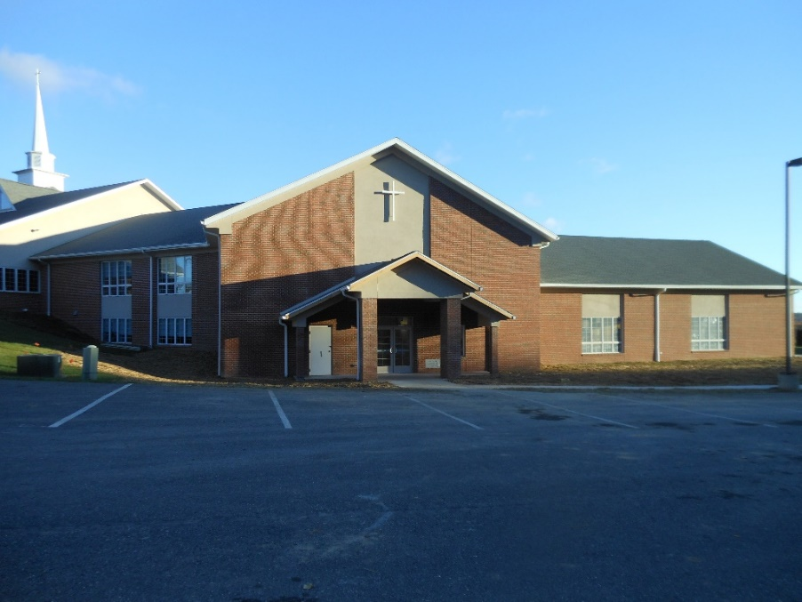

[**Philippians 4:13**](https://www.kingjamesbibleonline.org/Philippians-4-13/) – “I can do all things through Christ

who strengthens me.”

**Phase II Mortgage**

**Mortgage Loan $1,041,771.33**

**2016 Principal Payments** 131,771.33

**2017 Principal Payments** 85,000.00

**Balance December 31, 2017 $825.000.00**

**General Fund - January to December 2017**

Balance 1/1/2017 **$ 7,071.97**

Income - 229,256.52

Expenses- 223,915.62

Balance 12/31/17 **$12,412.87**

Thank you for your continue support in fulfilling our commitment!!!

______________________________________________________________________________

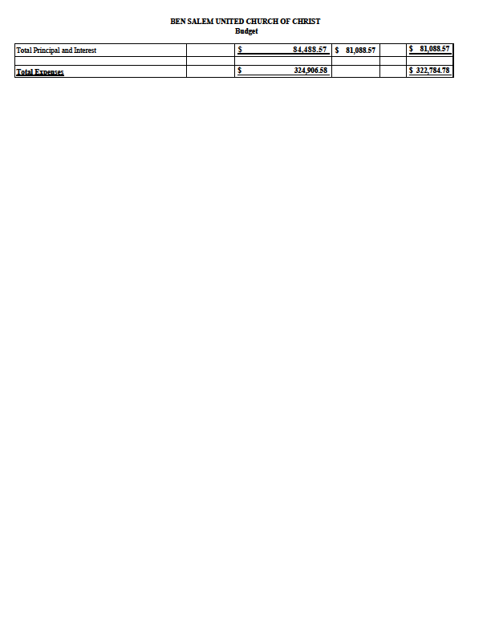

**Do you like the convenience of scheduling bills through Internet Banking?**

Not having to worry about writing those checks each month is nice. Well if your bank offers free internet banking why not schedule your giving to the church on a bi-monthly or monthly basis. The bank could send the check every other week or every month and you wouldn’t have to worry about having cash on a Sunday. If this sounds good then simply schedule your offering like you do your other bills and have it sent to: Ben Salem UCC, P.O. Box 128, Andreas, PA 18211-0128 If there is a place for a note about the payment you can even fill in how much you would like to go to the church and how much should go to OCWM. It’s that simple – really! Our treasurer receives the check and your account is credited the same as if you utilized an envelope. And if you are uncomfortable not having an envelope to put in the plate – don’t forget there are other envelopes to utilize in the box you receive at the start of each year. If this sounds good to you – please consider signing up with your bank. Thank You.

The Stewardship and Finance Committee

**MISSION MINDERS-FEBRUARY, 2018**

Now that 2017 is behind us, we can reflect on the ways in which your mission donations helped those in our community and beyond, and thank you for your continued support of our efforts.

We began the year with a very successful project that benefited **Dylan and Gavin’s Rainbow**, a charity begun in memory of two Lehighton brothers who both died in their early teens from cancer. Our next project, **Coco’s Foundation**, benefited a regional charity that helps with cancer research and funding the needs of families whose children are stricken with cancer. Your generous outpouring of over $2,000 to the **Gower Family Fund**, helped one of Ben Salem’s own during their time of tragedy and loss. Our mission project for the last quarter supported **Family Promise,** which is one of the most important and successful missions in which our church participates. In addition to the costs incurred for hosting families four to five times per year, Ben Salem also donated $600 this year to administrative costs of the program. The Youth Group also generously donated its time and efforts to making the **Christmas Box and Bethany Bow** projects successful for 2017.

**ADDITIONAL MISSION PROJECTS FUNDED DURING 2017**

1. $250 donated to Penn Northeast Conference earmarked for people in Houston and Florida who sustained catastrophic damages with hurricanes Harvey and Irma.
2. $250 donated to the City to Shore MS Ride in honor of Paula Breiner’s Team, “Paula’s Posse”.
3. $250 donated to St. Peter’s Center in Weissport for supplies and toiletries that are distributed to needy families each month.
4. $100 donated to Martin Flu Foundation, a charity founded by Pastor Mike and Diane in memory of their son who died from flu complications.
5. $200 donated to Allentown Rescue Mission, which cares for the basic needs of homeless men in the Allentown area.

**CONTINUING MISSION PROJECTS**

1. **Family Promise** willhost a week in March. Volunteers are always needed. See Karen Hayman if you can help.
2. **Feed a Neighbor meal** will be sponsored by Ben Salem in May and November. Help needed to serve meal. Contact Bernice Steigerwalt.
3. **Food Bank distributions** during 2018. See LaVaun Shanton to help.
4. **Additional Mission Projects** will be announced in the next newsletter.

**HAVE A WONDERFUL 2018**



**Ben Salem UCC will be hosting Family Promise from March 25 – 31, 2018.**

**Our hosting week will end Easter morning.**

Volunteers are needed to prepare and serve dinners, fellowship with the families (play games or read with the children), and stay overnight. Donations of food, snacks, and baked goods are needed, as well as items for Easter Baskets. Please consider helping out!

Contact: Karen Hayman at 570-241-7842

khayman@ptd.net



**HOMEMADE STICKY BUNS**

Reminder to pick up your pre-ordered Sticky Buns

on Saturday, February 10th

from 1-2PM in the Fellowship Hall.

Upcoming Fundraisers:

* Candy Making: March 5, 6, 12, 13
* Spring Bazaar: Friday, March 16 from 5-7:30PM AND

Saturday, March 17 from 9AM – 3PM *(Volunteers Needed!)*

* Hoagie Sales: March 22nd & April 26th
* 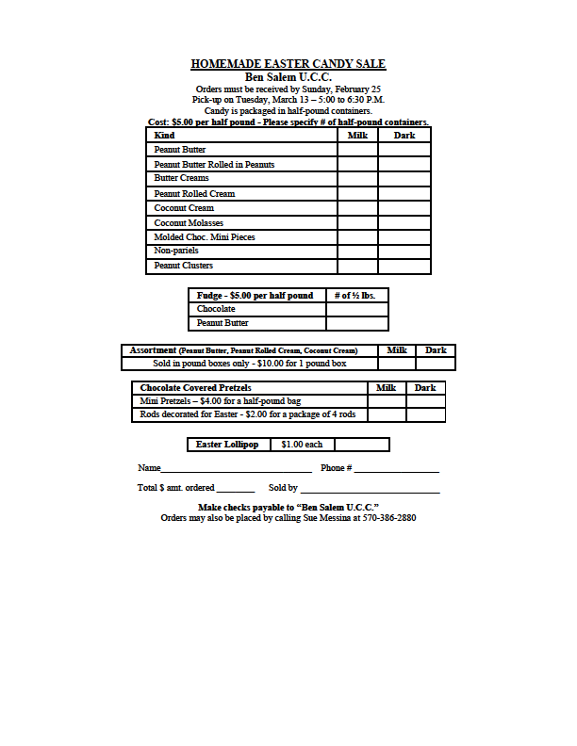Ham & Dandelion Dinner: April 21 *(making dressing on April 16)*

**Items Needed for**

**Easter Candy Making:**

*(Please sign up in the narthex or call the church office if you can make a donation.)*

* 35 lb Powder Sugar
* 10 lb Granulated Sugar
* 25 lb Butter
* 20 - 8 oz pkg Philadelphia Brand

Cream Cheese

* 10  40 oz Jars Jiff Creamy

Peanut Butter

* 7  - 16 oz Jars Karo Light
* 15 lb Dry Roasted Lightly Salted

Peanuts

* 6  -  14 oz Bags Coconut
* 7  Rolls Wax Paper



**HOAGIE SALE - BEN SALEM U.C.C.**

**ORDERS DUE MARCH 11 PICK-UP MARCH 22 (10:30 AM – NOON)**

NAME_____________________________________ PHONE #___________________

PLAIN – HAM, SALAMI, CHEESE, LETTUCE & TOMATOES (no onions or peppers)

PLAIN ________ WITH HOT PEPPERS (no onions) _________

WITH ONIONS ________ WITH ONIONS & HOT PEPPERS _________

TOTAL # ORDERD ______ @ $5.00 EACH TOTAL AMOUNT DUE $__________

Place order form in box in narthex or call Sue Messina at 570-386-2880.



**Bazaar**

**BEN SALEM UCC**

*1965 Church Hill Road, Lehighton*

**Saturday, March 17, 2018**

**9AM – 3PM**

***Also…Open Friday, March 16th from 5-7:30PM!!!***

* ******Raffle
* Basket Raffle *(100+ Items!)*
* Food, Bake Sale & Homemade Easter Candy
* Quilt Raffle & Knotted Blankets
* Wooden Handcrafted Items

**Egg Hunt at 11AM: *Old Social Hall***

***at 1749 Church Hill Road***

***10% of the profits will be divided between Lehighton United Veterans Organization***

***and Lehighton American Legion Post 314.***

***In case of inclement weather, please check our website at*** [***www.bensalemucc.com***](http://www.bensalemucc.com)

*Contacts: Judy: 570-401-1518 Karen: 570-241-7842*

**CLOTHING BIN UPDATE**

A red clothing bin is in place

by the old Social Hall. Please feel free to donate clothing or shoes

that you no longer need. The church can earn up to 10 cents/lb.

**Safety Committee:**

If someone in the congregation is aware of a safety issue, it should be reported to one of the safety committee members listed below or to someone on the Church Board.  The purpose of the committee is two-fold.  Ben Salem will get a discount on the insurance bill and the same time enhance the Risk Management of the Ben Salem properties.  Members of the Safety committee include:  Ron Steigerwalt, Rodger Diehl, Barry Reed, Tom Kupres,

Pastor Mike – Ex Officio.

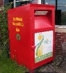

***Beginners Country Line Dancing*** *- No experience necessary!*

*If you are interested in this activity, please contact*

*Dot Eberts at 570-386-2149 for more information.*

*Classes will meet Wednesdays from 9:30-11:30AM. Free will offering.*





**GAME DAY INFORMATION**

**Wednesday, February 28th**

***(Weather permitting)***

**12:00 Noon**

**Fellowship Hall**

***Bring a snack to share!***

***Thank You Notes:***

Dear Prayer Shawl Makers,

Thank you for the beautiful prayer shawl and especially the healing prayer! God Bless You,-- Pat Chandler

Dear Prayer Shawl Makers, I would like to take this opportunity to thank you for the lovely prayer shawl made by the Prayer Shawl group at Ben Salem UCC. Also, thank you to Terry and Amy Lusch for delivering it to me. It will certainly be of great comfort to me during this very difficult time of the loss of my husband Roger. With heartfelt and deep appreciation, Hazle Arner

Dear Prayer Shawl Makers, Thank you for the beautiful prayer shawl and all your thoughts and prayers. They are helping as the treatments are scheduled to be complete as of February 13 with a good outcome. God Bless!

Thank you, Vince Crostley

Dear Brothers & Sister in Christ, On behalf of the Mission Outreach Committee, I would like to thank all of our brothers and sisters in Christ from Ben Salem UCC for preparing and serving a most wonderful meal to the folks at our community meal on November 30, 2017. Please take comfort knowing that through your heartfelt outreach, scores of folks were able to sit down and enjoy a wonderful supper in an atmosphere of friendship and fellowship. Thanks again

and God bless each of you. Kenneth J. Leffler, Member of Mission Outreach Committee, Zion UCC, Lehighton

Dear Friends of Ben Salem UCC, Good Day!...Greeting with love and peace. How are you? I hope and I pray that you are fine. Me and my family are fine. Last September and October we had a cooking contest in school in connection with my major for this track which is cookery. Last December 15, was our contest in cooking again which was the basis for our grades. I am so thankful and happy because I have high grades in all my subjects. This coming December 20 will be our Christmas party in school. Each one of us are assigned something to bring that can be shared with everyone. I am so excited for that day to come. This time of year brings to mind those things in life that are most important. It reminds us to focus on all of the good things around us. Wishing warm greetings to all of my friends at Ben Salem UCC during this holiday! Merry Christmas and Happy New Year! Love, Rhea Alemaida



**Blanket Makers / Quilters:**  The Blanket Makers and Quilters meet on Thursday mornings starting at 9 AM at the Social Hall. Anyone is welcome to come and join them.

A new quilt has been picked for the Quilt Raffle, tickets will be available throughout the year at church dinners & functions. See Dollie Frantz, Betty Nothstein or Linda Stoss to purchase tickets. Tickets are $1 each or 6 for $5. The winner of the 2017 sampler quilt was

Karen Hayman, Money raised through ticket sales & sales

of knotted blankets goes directly to Phase II Fund.

**NOTE:** An ongoing project of this group is to make hand-knotted blankets for the needy.

Lap robes, caps, walker bags and blankets were delivered to Valor Clinic by Sally & Mike Wargo. Blankets, walker bags, lap robes were delivered to Veterans Home in Bethlehem

by Don and Gail Handwerk**.**



Thrivent Choice®: Strengthening communities. Changing lives.

Thrivent Choice, the member-advised charitable grant program from Thrivent Financial, continues to be a welcome funding source for congregations and nonprofit organizations nationwide. If you are an eligible Thrivent member, you likely are aware of this easy, convenient way to help make a difference for organizations you care about. The Thrivent Choice program offers a way for eligible members to recommend where Thrivent Financial distributes some of its charitable grant funds each year. Eligible benefit members are designated Choice Dollars® that they can direct, thereby recommending charitable grant funding for their choice among thousands of enrolled congregations and nonprofit organizations, including **Ben Salem United Church of Christ.** If you are eligible to participate in Choice Dollars, or are uncertain about your eligibility, visit Thrivent.com/thriventchoice. Or contact your local Thrivent Financial representative. Directing Choice Dollars® is subject to the Terms and Conditions of the Thrivent Choice® program. Visit Thrivent.com/thriventchoice for complete Terms and Conditions.



**LOOKING FOR A PICTURE….**The Church Leaders are looking for an old picture of our Church as a “Log Cabin”. If you can help us, please contact Sharon Elder or the Church Office.





**Names of 2018 Graduates Needed:** If you know someone who is graduating this

year, please call or email the Church Office. This includes high school and college

graduates. Please include majors and degrees if possible. Graduate Recognition

Sunday will be held sometime in June.



The Confirmation Class is collecting items to assemble Hygiene Kits to send to areas devastated by the hurricanes. Donations of the following new items are appreciated and can be placed in the bin in the Narthex.

1 Hand Towel – 15”x28” up to 16”x32” (no larger) – no fingertip, bath, dish, or microfiber

1 Washcloth 1 Wide Tooth Comb 1 Fingernail/Toenail Clipper 1 Bar of Soap (original packaging) 10 Standard Band Aids

1 Toothbrush (original packaging)



**YOUTH GROUP: DODGE BALL GAME!!**

**Saturday, February 24th from 9AM – 12 Noon in Fellowship Hall**



**The older youth will be hosting a Dodge Ball Game in the**

**Fellowship Hall. Other local youth groups have been invited**

**to attend. Hot dogs and drinks will be served at Noon.**

**Come out and play or watch the youth enjoy a fun morning**

**morning of exercise and fellowship! Bring a snack if you wish.**

**C:\Documents and Settings\Dollie\Local Settings\Temporary Internet Files\Content.IE5\ZOPX6LMZ\MC900097247[1].wmfSpecial Prayers**

**Our Members and Friends with Special Needs:**

**In Institutions:**

Margaret “Peg” Daniels, Christian Health Care, 301 Sicomac Ave., Room 41 W, Dogwood Lane, Wyckoff, NJ 07481

Vera Frantz, Pleasant Trees Senior Center, 65 E. Lizard Creek Road, Lehighton, PA 18235

**Keep in Your Prayers**:

Lillian Andreas Betty Anthony Paul Bachman, Jr. Judy Bartek Josh Blackwell

Leslie Blackwell Say Blair Richard Bloom Paula Breiner Pam Buchinsky Lucille Cope Deanna Cunfer Vincent Crostley Israel Daniel Hunter Davidyock

Ellen Diaz Ed Diehl Vanna Frantz Lori George Curtis Gower

Kenneth & Larue Graver Gail Handwerk Ray Hassler Phil Henning Barbara Houser

Louise Houser Norb Huber Dolores Kuehner Lucy Livingood Kandice (Eberts) Marguardt Tom Mertz Maralyn Miller Mitchell Nace George Neumann II Darlene Nothstein

Mildred Rehrig Skip Rudy Michael Sedar Dominic Sendi Debbie Sherman

Riley Shimko Karen Solt Bernice Steigerwalt Bruce E. Steigerwalt Delroy Steigerwalt

Richard Steigerwalt Shirley Stoudt Derek Szena Jill Vecchio Darlene Wargo

Missionary Jeff Mensendiek [Japan] & Sendai Student Center Samantha Zipp, Mission in Philippines

**\*\*\*When you place a name on the prayer list, please remember to update the church office when the person**

**is doing better and can be removed from the list. Thank you!**

**Prayer Chain**: The Prayer Chain is a way for anyone to request prayer for a specific need….

[or thanksgiving or joy]. To have our Prayer Chain pray for you: Contact Betty Nothstein at 570-386-5644. Please call Betty if you would like to be called with others’ prayer requests as part of the Prayer Chain.

**Meals Ministry**: Do you know someone who is shut-in or recovering from a hospitalization, serious injury or illness, or mourning the loss of a loved one that could benefit from a hot or a frozen meal? Ben Salem has a Meals Ministry Team that can help ease the daily burdens of families or individuals within our church and community by providing ready-to-eat meals. If you would like to volunteer with this ministry or know of someone in need, please contact Karen Hayman at 570-241-7842 or the Church Office.

**Called to Care**: Trained volunteers from our church are available to assist the Pastor in visiting shut-in or hospitalized church members who are no longer able to attend regular worship services or participate in church functions. If you would like a “Called to Care” volunteer to visit you, please contact the Pastor at the Church Office (570) 386-3870. We are looking for more volunteers for this Committee! If you are interested in sharing God’s love with shut-in members of our congregation, please contact Pastor McGowan.

**Prayer Shawl Ministry:** The Prayer Shawl Committee is in need of helpers to make prayer shawls. If you can knit or crochet and would like to help, please contact coordinators Betty Nothstein at 570-386-5644 or Barbara Snowberger at 570-386-2112 for more information. If a prayer shawl is needed, please contact Betty or Barbara.

**Support Our Troops - All military personnel**

Jessica A. Bealer: FC2# Bealer, Jessica, A USS Paul Hamilton

[DDG-60] CS/CF, FPO AP 96667-1278

🡪 Jessica is now back on base in the USA

Jeremy Zellers, Norfolk, VA – on Submarine Newport News

*Please notify us if you know of anyone who is serving at this time or if names are missed or status changes.





**Congratulations to Daniel and Nadean (McGowan) Geiger**

**on the birth of their son, Arlo Matthew Geiger. Arlo was born on January 7, 2018.**

**Congratulations to Eric and Cortney (Zimmerman) Knadler**

**on the birth of their son, Maverick Richard Knadler. Maverick was born on July 28, 2017.**

**Our Sympathy is extended to:**

~ to the family of Eleanor Green who passed away on January 14, 2018.

~ to the family of Theresa Elder who passed away on December 20, 2017

~ the family of Lawrence Andreas who passed away on December 23, 2017.



February 2018

|  |  |  |  |  |  |  |
| --- | --- | --- | --- | --- | --- | --- |
| Sunday | Monday | Tuesday | Wednesday | Thursday | Friday | Saturday |
|  |  |  |  | 1  9AM Blanket Makers &  Quilters  10 AM Bible Study  6:30 PM Hand Bells  7 PM Cemetery Assn. | 2 | 3 |
| 4 Communion  Joyful Noise off.  8 AM Worship  9:15 AM Sunday  School  BP monitoring  10:30 AM Worship | 5 | 6 | 7  9:30 AM Line Dancing  6:30 PM Cherub & Junior  Choirs  7 PM Senior Choir | 8  9AM Blanket Makers &  Quilters  10 AM Bible Study  6:30 PM Hand Bells | 9  Prep for Sticky Buns | 10  Sticky Bun Sale  1-2PM Pickup |
| 11  8 AM Worship  9:15 AM Sunday  School  10:30 AM Worship/  Hand Bells | 12 | 13 | 14    9:30 AM Line Dancing  6: 30 PM Cherub & Junior  Choirs  7 PM Senior Choir  7:30 PM Ash Wednesday/  Communion/Ben Salem | 15  9AM Blanket Makers &  Quilters  10 AM Bible Study  6 PM Church Audits  6:30 PM Hand Bells  7PM Property Comm. | 16 | 17  Fellowship  Hall Reserved  M. Lusch |
| 18 **LENT I**  8 AM Worship  9:15 AM Sunday  School  10:30 AM Worship | 19  President’s Day  7 PM Church Board  Meeting | 20  Senior Choir | 21  9:30 AM Line Dancing  6:30 PM Cherub & Junior  Choirs  7:30 PM Lenten Service  at St. Peter’s Church | 22  9AM Blanket Makers &  Quilters  10 AM Bible Study  6 PM Snowdate/Audits  6:30 PM Hand Bells | 23 | 24  9 AM to 12 Noon  Dodge Ball  Game  Youth Group |
| 25 **LENT II**  8 AM Worship  9:15 AM Sunday  School  10:30 AM Worship  Easter Candy Orders Due | 26 | 27  Senior Choir | 28  9:30 AM Line Dancing  12 Noon Game Day  6 PM Newsletter  6:30 PM Cherub & Junior  Choirs  7:30 PM Lenten Service  at St. John’s Church |  |  |  |