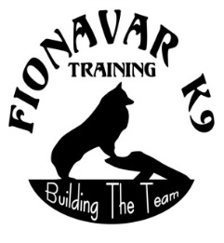
Fionavar K9 Training “Building The Team” For Competition

Box 11 RR 3 Site 15 OLDS, AB T4H 1P4
403- 507-9832 flcaught@telus.net
www.fionavar-k9s.com
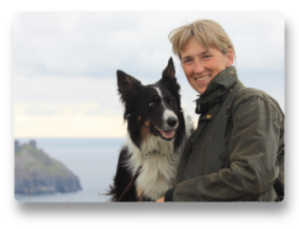
Kathy Keats: Momentum Mindset Seminar
www.theagilitycoach.ca
March 6, 7, 8, 2020

NAME: ___________________________________________________________

ADDRESS: _______________________________POSTAL CODE_____________

PHONE: (H) _______________ (C) ________________ (W) __________________

EMAIL: __________________________________________________________

DOG’S NAME: _____________________ AGE: ____________________________

LEVEL CURRENTLY COMPETING IN: __________________________________

Cheques made out to, Fionavar K9 Training, mail to Lynda Caughlin
Box 11 RR 3 Site 15 Olds AB T4H 1P4

Cost is $430 (GSTincluded) METOHD OF PAYMENT:
Cheque ___ Cash ___ e-transfer ___

$130 non-refundable deposit required at time of registration.
$300 Final payment by February 10, 2020

Format timeline: Friday March 6, all participants, (no dogs) 1pm – 5 pm
Saturday Group A 8 am – Noon, Group B 1 pm – 5 pm
Sunday Group B 8 am – Noon, Group A 1 pm – 5 pm
There are a few audit spot available, contact Lynda for info

_____ Deposit at time of registration

_____ Balance (by Feb. 10 2020)

__________ TOTAL

