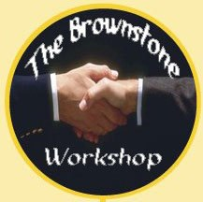-

Yasmeen

yasmeen033@aol.com

(919) 262-3906

Affordable, convenient, confidential, one-on-one support, immediate answers and dialogue

Send questions via email. Include your name, topic, 3-6 questions, and your short term goals.

Coaching Fees & Sessions

**30-minute phone session: $55**

**60-minute phone session: $85**

**90-minute phone session: $150**

Email (yasmeen033@aol.com)

[www.thebrownstoneworkshop.com](http://www.thebrownstoneworkshop.com)

Ph: (919) 262-3906

Telephone Coaching Services

Yasmeen

Yasmeen033@aol.com

(919) 262-3906

Yasmeen

yasmeen033@aol.com

(919) 262-3906

Yasmeen

yasmeen033@aol.com

(919) 262-3906

Yasmeen

yasmeen033@aol.com

(919) 262-3906

Yasmeen

yasmeen033@aol.com

(919) 262-3906

Yasmeen

yasmeen033@aol.com

(919) 262-3906

Yasmeen

yasmeen033@aol.com

(919) 262-3906

Yasmeen

yasmeen033@aol.com

(919) 262-3906

Yasmeen

yasmeen033@aol.com

(919) 262-3906