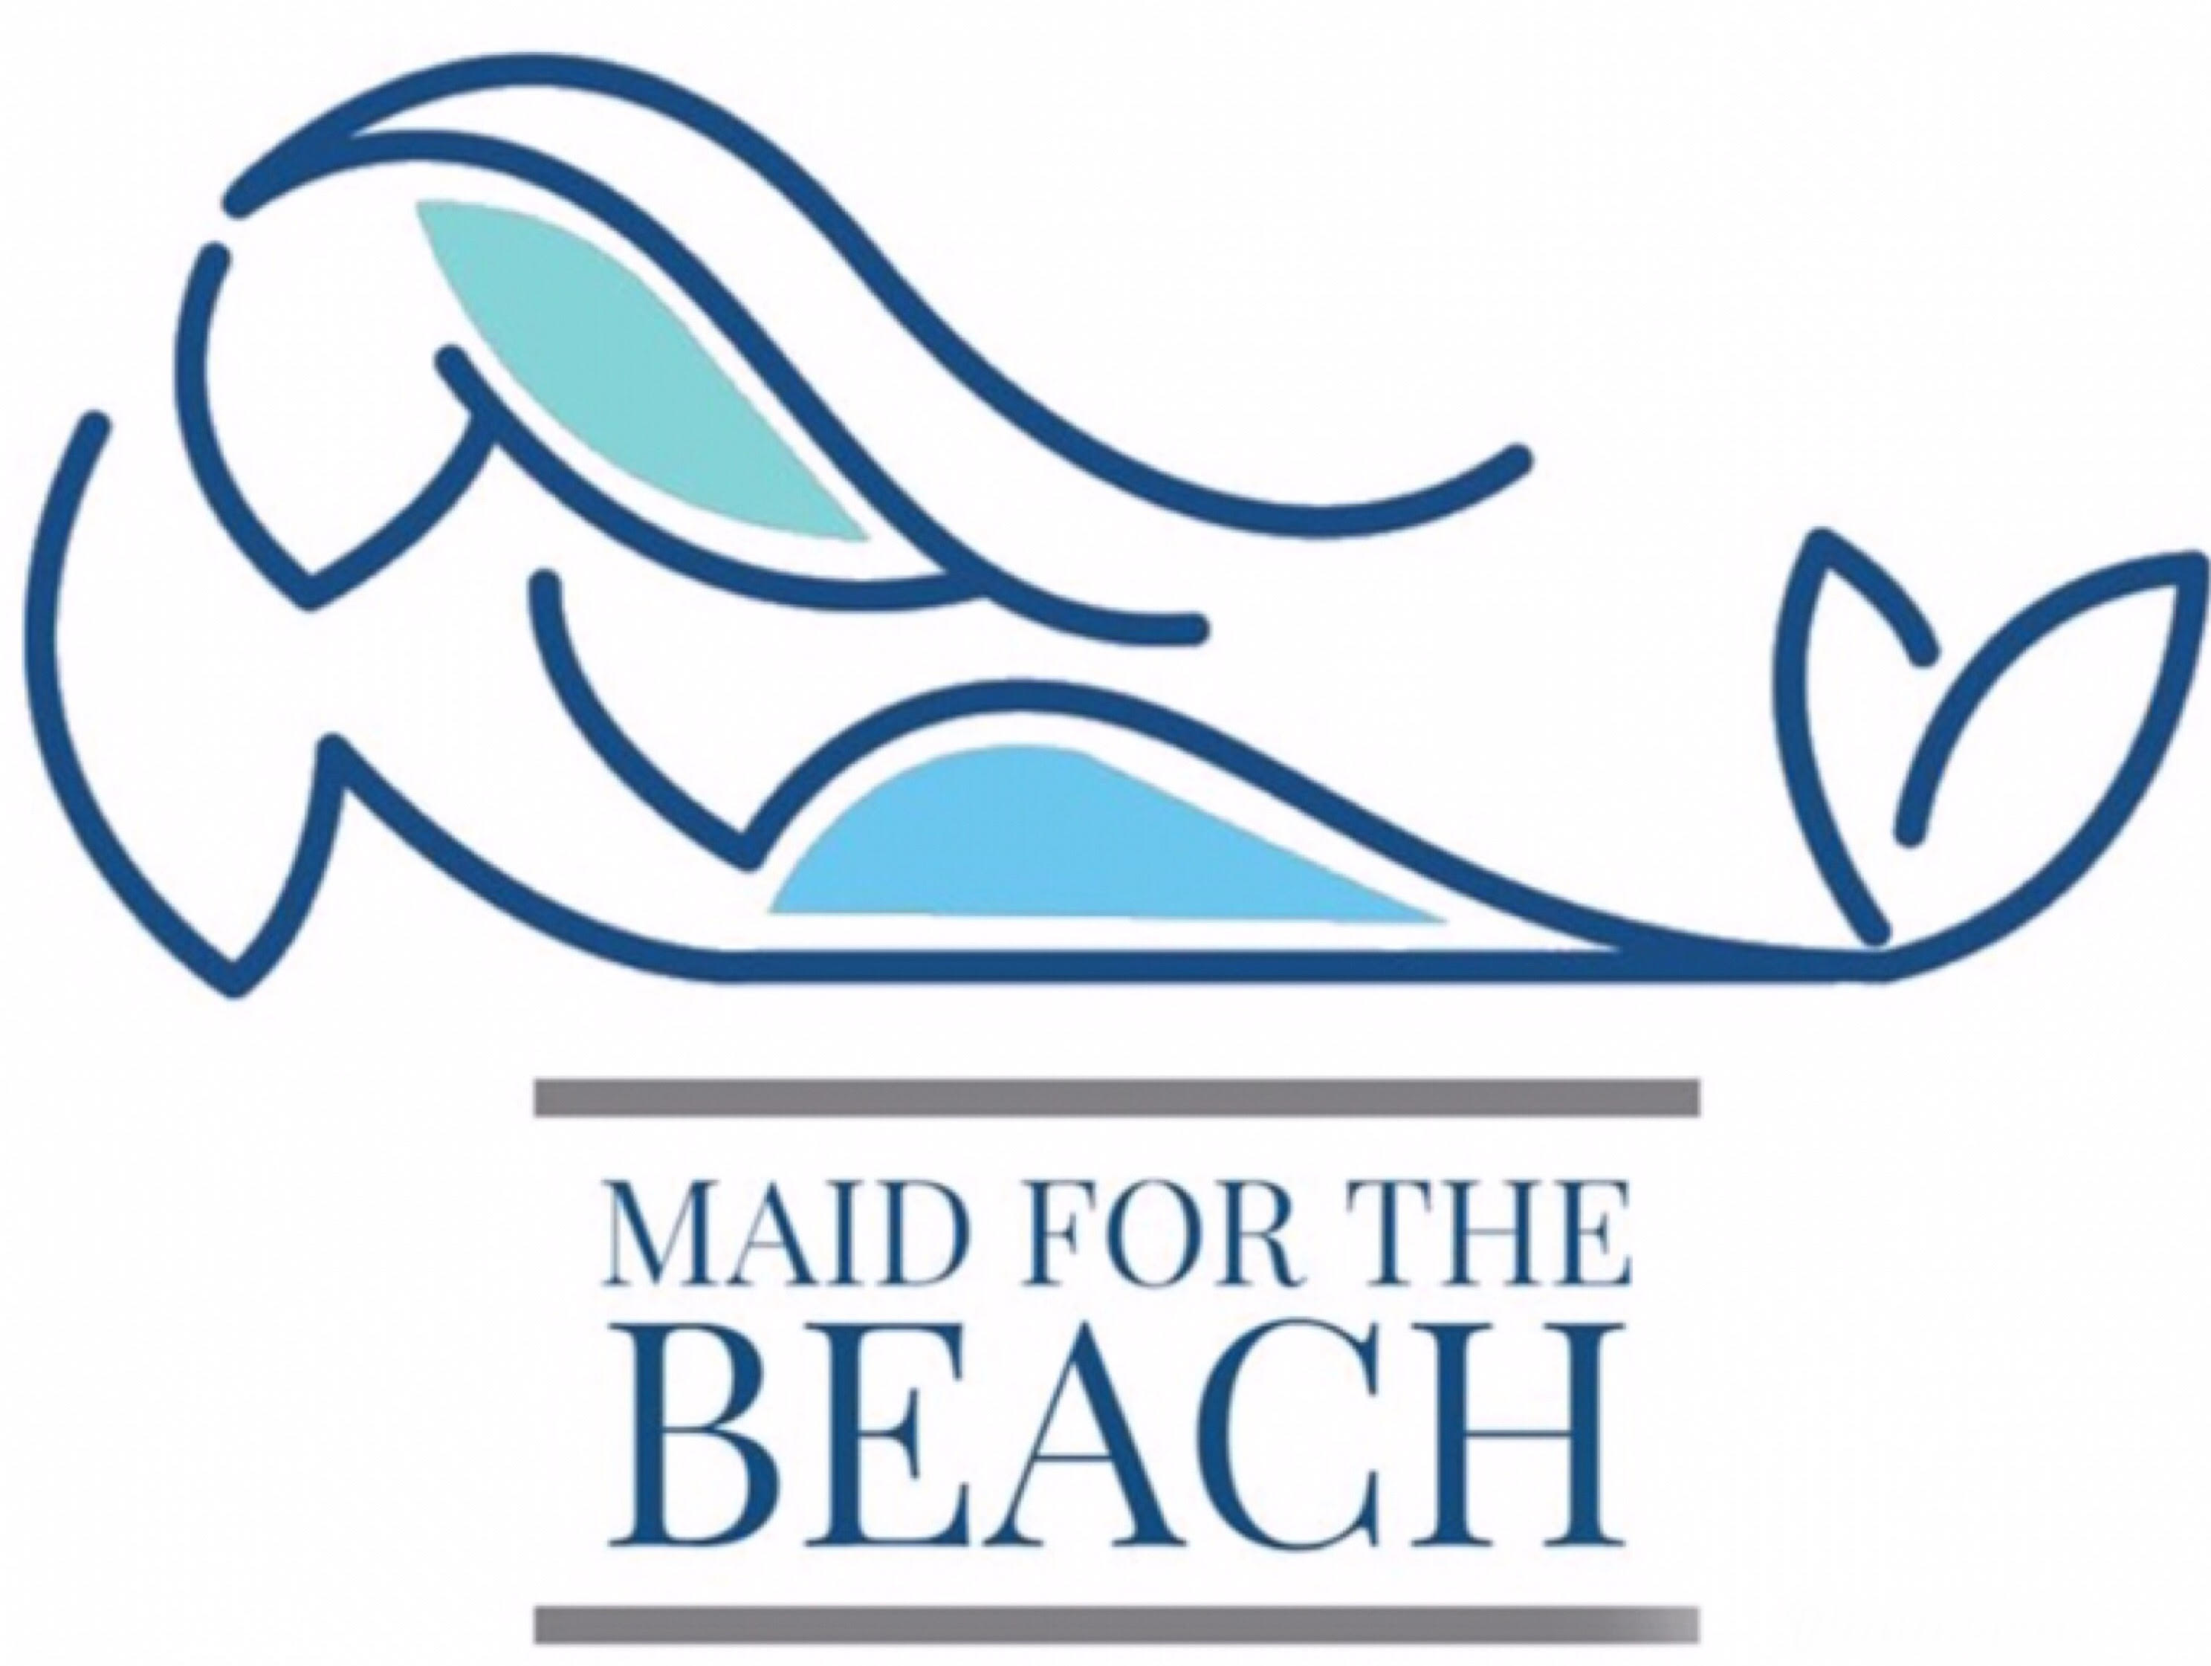

Maid For The Beach
2090 Cross Gate Blvd. Suite 304
Surfside Beach, SC 29575
843-360-5819
www.maid4thebeach.com

[Website]
How To Prepare For, and Make The Most Of Your Cleaning Consultation:
Please a take a moment to look around your place of business. Using the space below, outline the challenges, or needs of your space, regarding cleanliness.
You may need to ask the following: How does the exterior of your office, facility or building appear? How do you feel about the overall appearance of the inside of your place of business? What changes in your current cleaning program would you like to make? Are there specific needs, and or laws your business must adhere to regarding sanitation? Overall, how do you feel about the air quality?
In order of importance:
- ________________________________________________________
- ________________________________________________________
- ________________________________________________________
- ________________________________________________________
- ________________________________________________________Schedule your free cleaning consultation today, and receive an follow up proposal for services by texting or calling: 843-360-5819 or via email: peacelovenbeach@gmail.com

My appointment is scheduled on ____/____/2020 at ____ am/pm.

Client Questionnaire
To understand your janitorial needs, please take a moment to answer the following, prior to your free consultation:
- Is it important for your business to receive quality cleaning services with an experienced and reputable company? YES or NO

- Do you feel your visitors, clients, patients, and or customers value a clean space? YES or NO

- Overall do you agree with the phrase, “you get what you pay for?” YES or NO

- Do you value quality workmanship and industry standards? YES or NO

- Would you prefer to supply your own paper products, hand soap, kitchen soap? YES or NO

- Is your business currently engaged in a contract for cleaning services? YES or NO

- If yes, when does the contract expire? ____________

Thank you!

