10 Evidence-Based Health Benefits of Magnesium
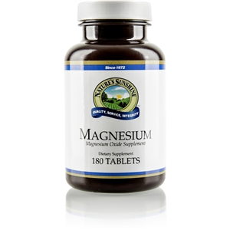
Proven Magnesium Benefits
Magnesium is the fourth most abundant mineral in the human body.
It plays several important roles in the health of your body and brain.
However, you may not be getting enough of it, even if you eat a healthy diet.
Here are 10 evidence-based health benefits of magnesium.

1. Magnesium Is Involved in Hundreds of Biochemical Reactions in Your Body
Magnesium is a mineral found in the earth, sea, plants, animals and humans.
About 60% of the magnesium in your body is found in bone, while the rest is in muscles, soft tissues and fluids, including blood (1).
In fact, every cell in your body contains it and needs it to function.
One of magnesium's main roles is acting as a cofactor or "helper molecule" in the biochemical reactions continuously performed by enzymes.
In fact, it’s involved in more than 600 reactions in your body, including (2):
Energy creation: Helps convert food into energy.
Protein formation: Helps create new proteins from amino acids.
Gene maintenance: Helps create and repair DNA and RNA.
Muscle movements: Is part of the contraction and relaxation of muscles.
Nervous system regulation: Helps regulate neurotransmitters, which send messages throughout your brain and nervous system.

2. It May Boost Exercise Performance
Magnesium also plays a role in exercise performance.

3. Magnesium Fights Depression
Magnesium plays a critical role in brain function and mood, and low levels are linked to an increased risk of depression.
4. It Has Benefits Against Type 2 Diabetes
Magnesium also benefits people with type 2 diabetes.
5. Magnesium Can Lower Blood Pressure
Studies show that taking magnesium can lower blood pressure .
6. It Has Anti-Inflammatory Benefits
Low magnesium intake is linked to chronic inflammation, which is one of the drivers of aging, obesity and chronic disease.
7. Magnesium Can Help Prevent Migraines
Migraine headaches are painful and debilitating. Nausea, vomiting and sensitivity to light and noise often occur.
8. It Reduces Insulin Resistance
Insulin resistance is one of the leading causes of metabolic syndrome and type 2 diabetes.
9. Magnesium Improves PMS Symptoms
10. Magnesium Is Safe and Widely Available

Getting enough magnesium is essential for maintaining good health.
Be sure to eat plenty of magnesium-rich foods or take a supplement if you're unable to get enough from your diet alone.
Without enough of this important mineral, your body can't function optimally.

810-584-5241
yourpathforwardholistics@gmail.com

