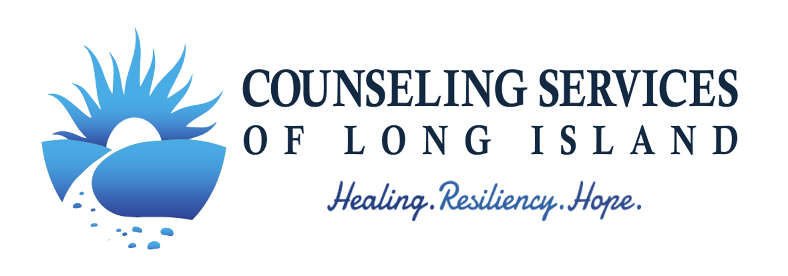
Seminar Title: | LEGAL & ETHICAL ISSUES FOR SOCIAL WORKER-PSYCHOTHERAPISTS
Date: | Sunday, October 27th (9:30a Registration, 9:45am-4pm Program)
Location: | TBD (Eastern Nassau)
Presenter: | Bruce Hillowe, JD, PhD, Attorney at Law
Cost:
$219 Single Registration
$209.00 (Early Bird by 8/1/19)
- $199.00 3+ Group Rate (each)
__________________ Total
Name(s):_____________________________________________________________________________________
Profession: ___________________________________________________________________________________
License: (Please select) _______ LMSW _______ LCSW _______Other
Company Name: _______________________________________________________________________________

Address: _____________________________________________________________________________________
City: _________________________________________ State: ________________ Zip: ______________________
Work Phone: __________________________________ Home Phone: _________________________________
Email: __________________________________ Fax: _________________________________________
License Number: ______________________________________________ (required for confirmation of registration)
Prepayment is REQUIRED

_____ Check enclosed (Please make payable to “Counseling Services of Long Island, LCSW PC”)
*Note: For Group Rate - Please complete a separate registration form for each attendee, and mail together.

Mail to: CSLI, P.O. Box 7149, Garden City, NY 11530

Certificates of attendance will be issued via email within one week of the workshop.

Continuing Education Units (CEUs) and certificates information:
Social Workers: Counseling Services of Long Island, LCSW PC is recognized by the New York State Department’s State Board for Social Work as an approved provider of continuing education for Licensed Social Workers #SW-0547.
New York State Office of the Professions (NYSED) regulations require that participants must be present for the entire approved educational activity in order to receive a certificate for continuing education credits. There is no accommodation in the State regulations for late arrival, late return from lunch or breaks, or early departure. According to NYSED, in order to award social work CEUs; “When you offer a multi-day or multi-part course/educational activity, the learner must complete all parts in order to earn the certificate for contact hours, in the same way that a student must complete a semester-long course to receive college credit. You may not award partial credit for a program, even a one-day program, if the learner does not complete all requirements at that time.”
Cancellation Policy:
If you contact us before Friday, September 27, 2019, you may exchange your tuition for a certificate to attend a future seminar or a tuition refund less a cancellation fee of $10. If you contact us Saturday, September 28, 2019 – Thursday, October 24th, you may only exchange your tuition for a certificate to attend a future seminar. If you contact us Friday, October 25th or after, the tuition fee is forfeited.
Occasionally, changes are made due to speaker availability, participant demand or unforeseen circumstances. While CSLI will do everything possible to ensure participant satisfaction, CSLI's liability is limited to the tuition fee only.
Notification of Seminar Cancellation:
We will make every best effort to hold our seminars on bad-weather days for anyone who can make it. If we learn that a seminar must be cancelled, we will make every effort to contact you.
We update our after-hours voicemail greeting with any weather-related seminar changes. If bad weather threatens, please call our office before you depart.
If we are aware of bad weather in the area, CSLI will extend the seminar refund deadline to include the morning of the program.

If you have any questions,
please feel free to email us at Info.CounselingServicesofLI@gmail.com or call (516) 804-0448.

