BREAKFAST
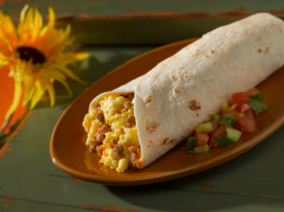 BREAKFAST BURRITO $3.00
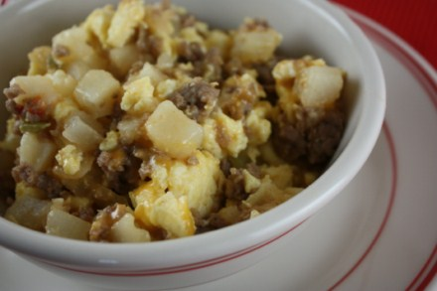 BREAKFAST BOWL $5.00
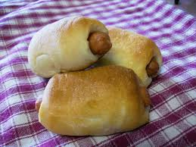 SAUSAGE KOLACHE W CHEESE $3.00

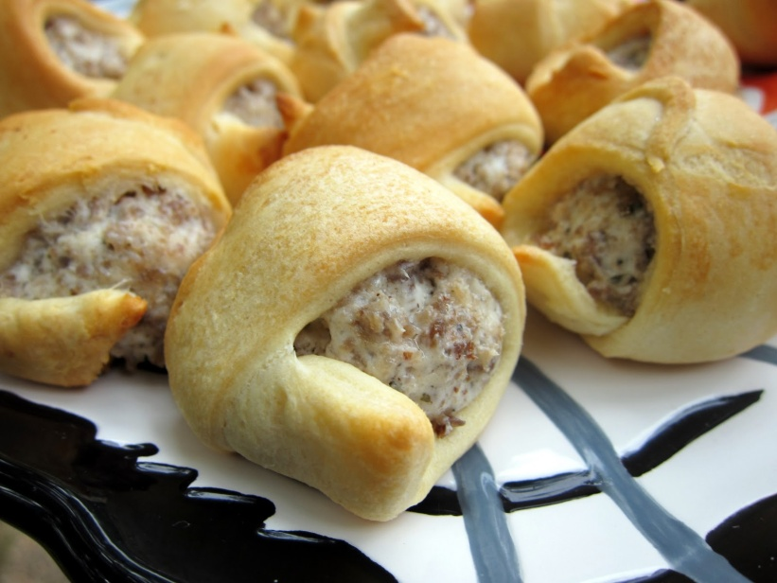 SAUS AND CREAM CHEESE KOLACHE $2.00

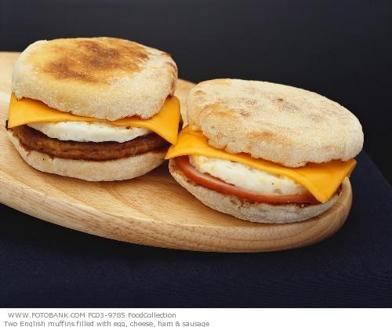HAM/SAUS ENGLISH MUFFINS $3.00
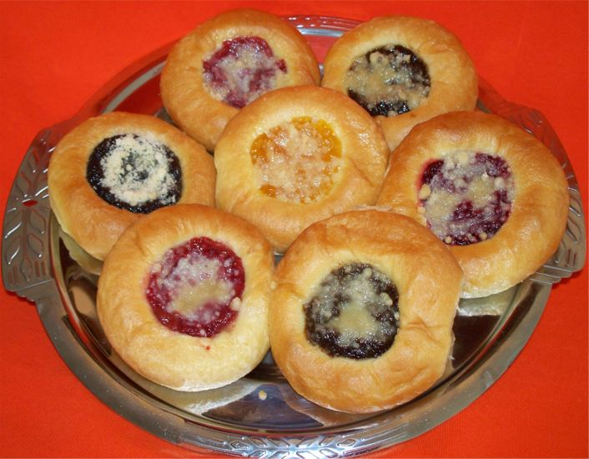VARIETY OF FRUIT KOLACHE $2.00

LUNCH
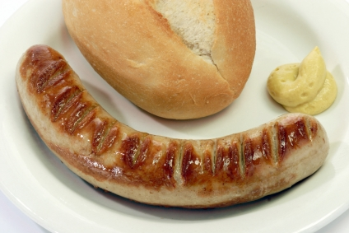 BRATWURST $4.00
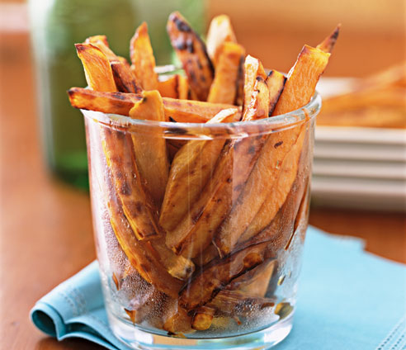 SWEET POTATO FRIES $2.00
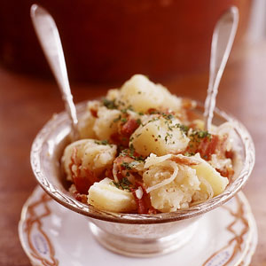 GERMAN POTATO SALAD $3.00
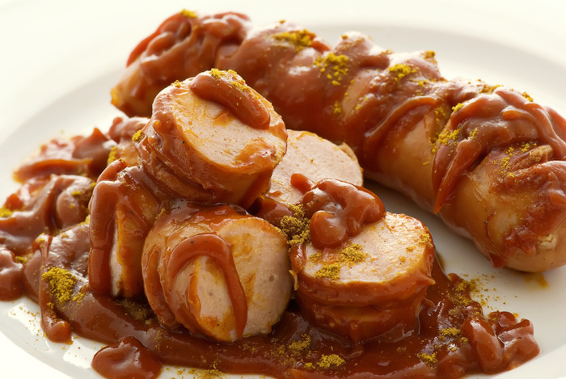 CURRY SAUSAGE $4.50
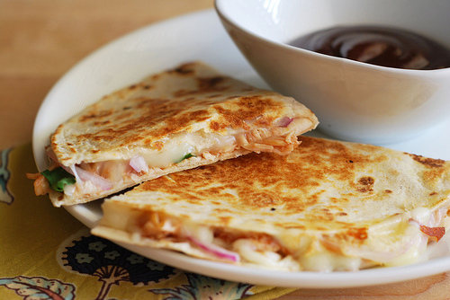 BBQ CHICKEN QUESADILLAS $4.00
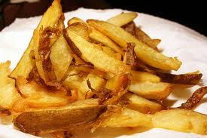 REG FRENCH FRIES $1.50

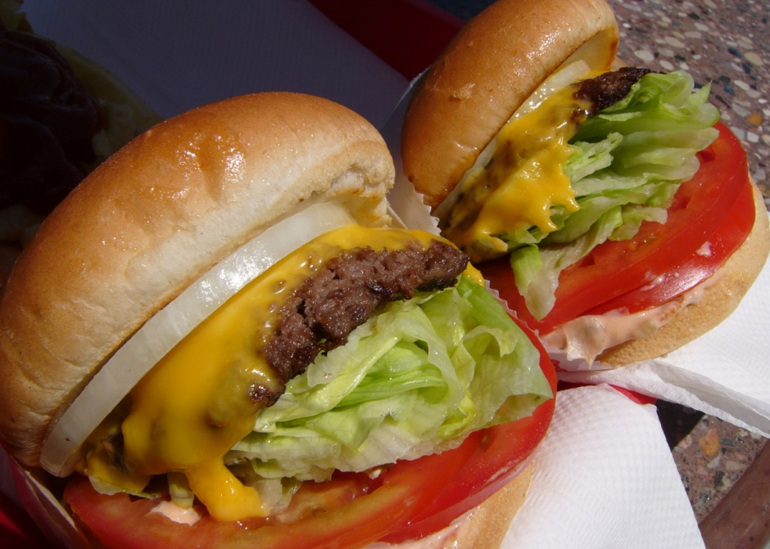 HAMBURGERS (W CHEESE) $5.00

