3D Table Topper

Create a three dimensional table topper using just a few strips of a light, a medium and a dark fabric and the Creative Grids 60 degree double strip ruler.

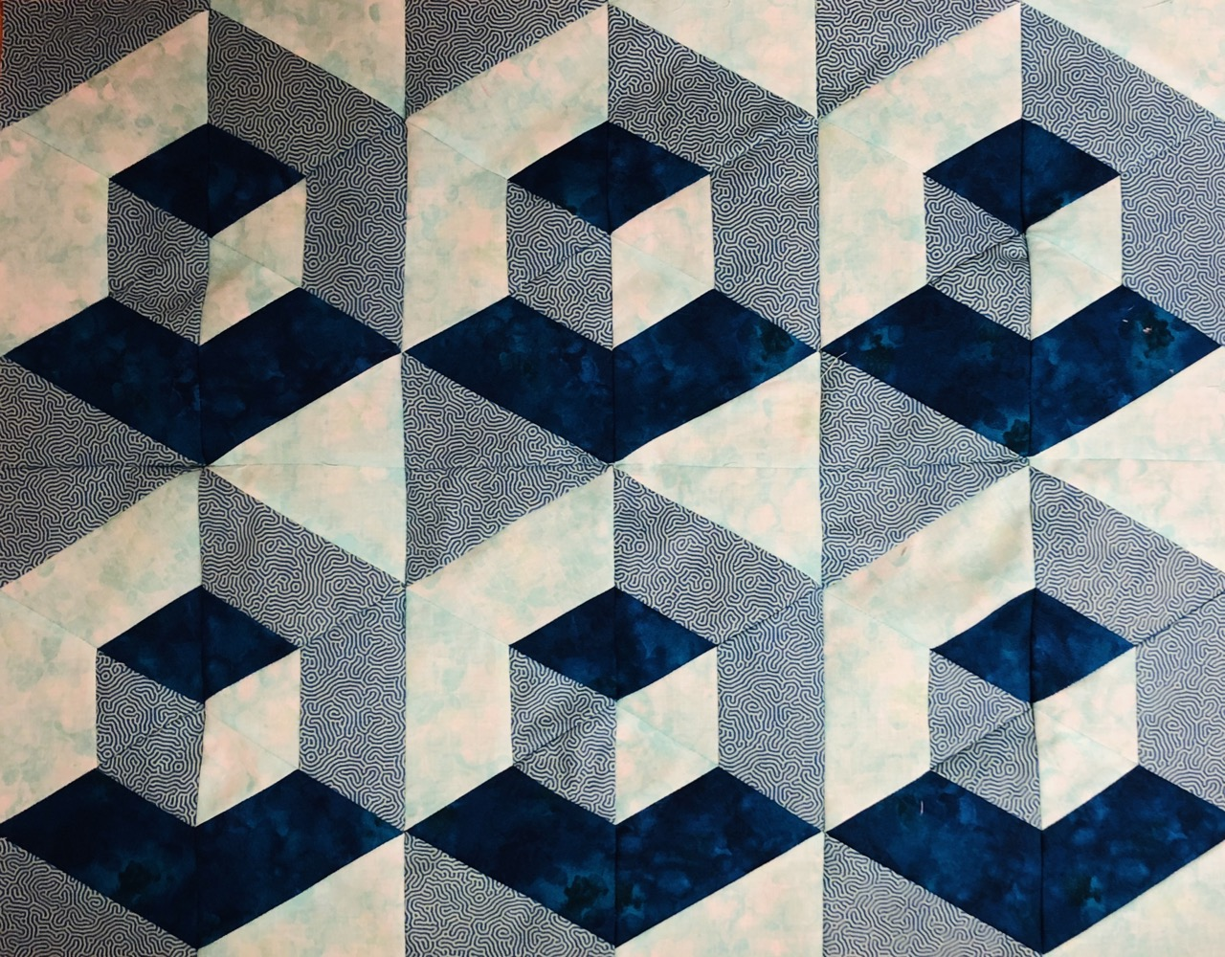

Supply List

- Creative Grids 60 Degree Double Strip Ruler (You may purchase one during class but please indicate prior to class if you would like one. Cost is $30.99 + tax)
- Kit using precut strips in a warm or cool color way. Cost $12.
Or
- 1/3 Yard Each of Light, Medium and Dark Fabrics cut into 2 (2.5”) strips and one 4.5” strip.
- Sewing machine, rotary cutter, pins, etc.

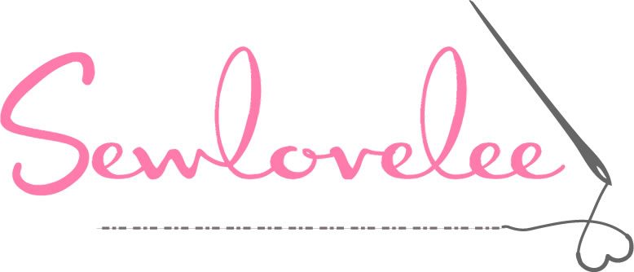
4504 Irvington Road
Irvington, VA 22480
804-438-5800
www.sewlovelee.com

