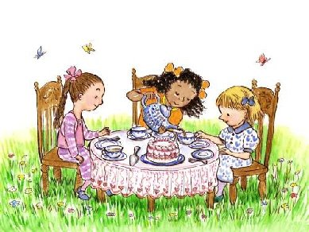
Bundles of Fun Tea Parties!!
We can offer a colorful sweet Tea Party packages to suit any age – we can customize your special party in your own home or venue to create a fun and memorable event for your child.
- Tea Party
Host a Tea Party in your home or venue. We will come and create the atmosphere for your beautiful Tea Party Table Setting. You may also add to your package from our many services available for your convenience.

♥ Tea Party Service:
A 1.5 hr service, we setup, attend and serve your party guests and cleanup!

♥ Dining Table:
Beautiful table set of your color theme of choice, tablecloths, tea cups and saucers, vase of fresh flowers, pitchers of pink lemonade with glasses, tier trays & platters, personal name cards for each guest and more…
♥ Treats: per 8 guests
-24 mini cupcakes
-36 mini theme cookies (3 styles)
-10 fruit kabobs or
-10 cake pops
► Now choose one of the following options for your party…
♥ Hat making station, hats, ribbons, lace, & flowers to take home
♥ Accessory settings (necklace, boa, tiara, gloves in purse to take home
♥ Garden basket with fresh flowers to take home
♥ Pink pastry box with sweet treats to take home (large cookie, 2 mini cupcakes, candies all pre-packaged with personal thank you labels
♥ Pink or White Cupcake Box with inserts with personalized thank you
label (Loot gift) for all guests to take home their decorated goodies.

**No additional party favors required

Bundles of Fun Tea Parties can also be customized for any event!

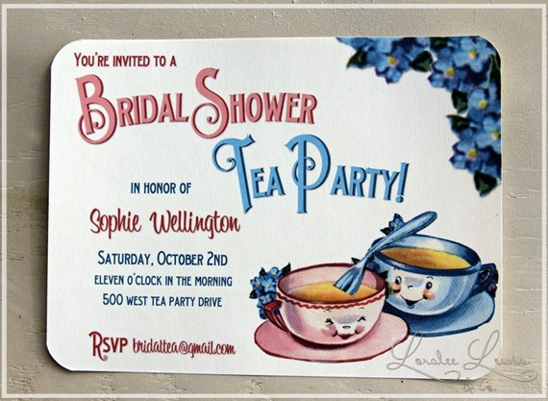
Prices:
Attended Parties with Host(s) $30 per guest minimum 8 guests per event.
Unattended Parties without Host ($25 per guest minimum 8 guests per event.

Book Your Party Early!
Weekend dates fill up quickly as Saturdays and Sundays are popular for parties.
**Bundles of Fun will cater to the Lower Mainland, some driving fees may apply for some distances.
﻿
50% deposit is required at time of booking. Deposit is non-refundable if party is cancelled 2 weeks or less before reserved date. Final head count must be confirmed no later than three business days before the party. You will be charged for the number of participants you originally booked.
Our products are not allergen free. Our products may contain some or all of the following common food allergens: milk, eggs, peanuts, tree nuts, soy and wheat. Please inform each of your guests of the foregoing allergen warning. Please let us know immediately prior to your party if any of your guests have food allergies and we can custom order allergen free products

