Relationship between Florida’s Wetlands and the Mosquitos Carrying the Zika Virus
Ana Ventura Palacios
George Mason University
Fall 2016

Introduction
Florida used to be flooded in wetlands, which made it inhabitable and on top of that, attracted mosquitoes (Swihart, 2011, p.15-16). Recently, the CDC has reported that everyone, particularly pregnant women, should be aware of Miami-Dade County due to reported cases of Zika being locally acquired (“Zika Virus,” 2016). Miami-Dade County is located near freshwater and coastal wetlands (“Wetlands,” 2013). Figure 1. demonstrates the estimated areas that are wetlands in Miami-Dade County. This figure does not specifically state if the wetland is freshwater or coastal. Just by looking at the proximity of wetlands near Miami-Dade County, it gives the idea that wetlands could possibly be the source of the Aedes mosquitoes. This research paper investigates the relationship between Florida’s wetlands and the Aedes species mosquitos carrying the Zika virus.
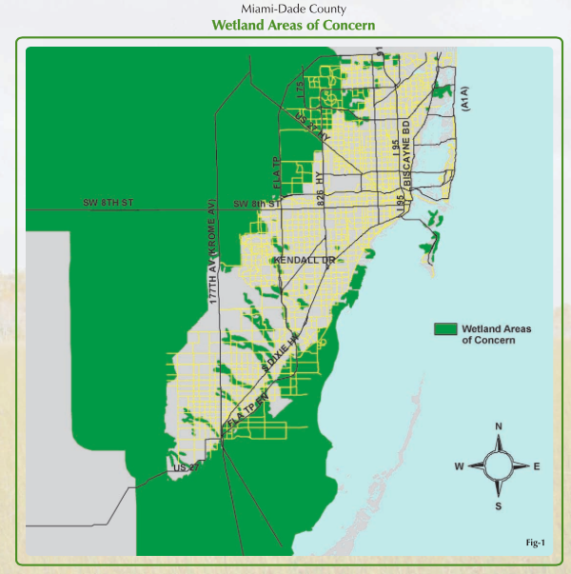
Figure 1. Miami-Dade County: Estimated Wetland Areas (Wetlands Permitting Brochure, Miami-Dade County website)

Background

The state of Florida defines their wetlands as areas covered with surface or ground water that may allow for vegetation to occur (“Wetland Evaluation and Delineation,” n.d.). Some examples of the different types of wetlands in Florida are swamps, bogs, marshes, bayheads, etc. (“Wetland Evaluation and Delineation,” n.d.). A specific example would be the Everglades located in the south of Florida as shown in Figure 2. Unfortunately, Florida’s vast wetlands have decreased due to agricultural reasons and mosquito control (Swihart, 2011, p. 16).
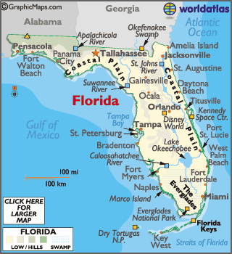
Figure 2. Map of Florida’s Wetlands (World Atlas website)
This past year, 2015, Brazil experienced an outbreak of the Zika virus that affected pregnant women, which resulted in them giving birth to newborns with microcephaly (World Health Organization (WHO), 2016). The first record of the Zika virus was found in monkeys in Uganda in 1947, then five years later, identified in humans living in Uganda and Tanzania (WHO, 2016). This virus is mainly transmitted by the Aedes mosquito species, the most common ones being Aedes aegypti and Aedes albopictus (Centers for Disease Control and Prevention (CDC), 2016). Figure 3 is an image of the Aedes aegypti mosquito. Zika virus may also be transmitted through sex, blood transfusion, mother to child, and medical or laboratory exposure (CDC, 2016).
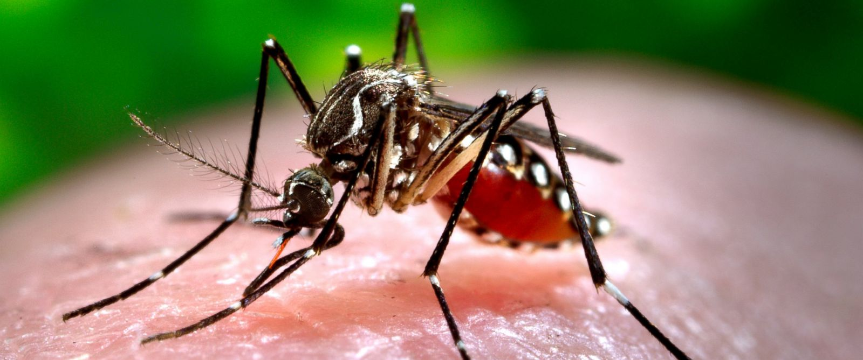
Figure 3. Aedes aegypti mosquito (BBC news website)
The Zika virus has been reported here in the United States. Figure 4 is a table that comes from the CDC website and it shows the number of Zika cases reported in each state that is associated with traveling and whom were locally acquired. Figure 4 was shorten to fit in this paper, but the CDC website has the full table listing all the states. The table in Figure 4 also shows that the state of Florida was the only state where the Zika virus was locally acquired. It is not found in the whole state of Florida, but only in the Southern part, specifically in Miami-Dade County as shown in Figure 5 (CDC, 2016). The red zones in Figure 5 are warning pregnant women not to travel to those areas and the yellow zones are telling them to take caution.
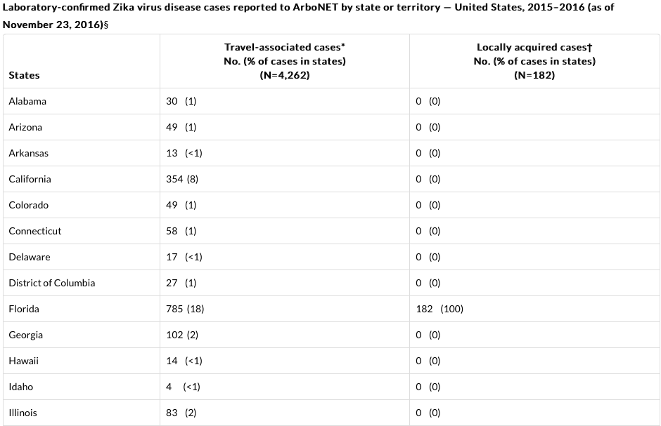
Figure 4. Cases of the Zika virus in the United States (CDC website)

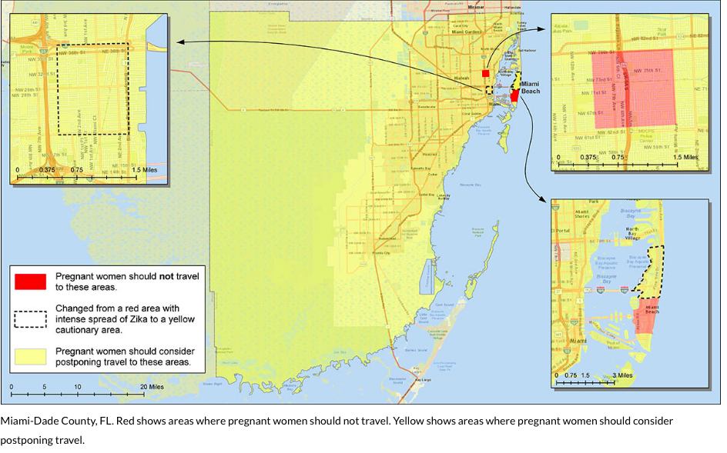
Figure 5. Map of Southern Florida (CDC website)
Health Implications
When someone has the Zika virus, they may experience the following symptoms for a couple of days up to a week: “fever, rash, joint pain, conjunctivitis, muscle pain, and headache” (CDC, 2016). Zika virus mainly affects pregnant women because their baby may be born with microcephaly (CDC, 2016). Babies that are born with microcephaly have a small head, meaning that their brain may not have fully developed (CDC, 2016). Figure 6 shows what the size of a normal baby’s head looks like compared to one with microcephaly. A recent health implication of Zika would be the Guillain-Barré syndrome (GBS) and it affects the nervous system causing muscle weakness (CDC, 2016). Research is currently being done to find an association between the Zika virus and GBS (CDC, 2016).
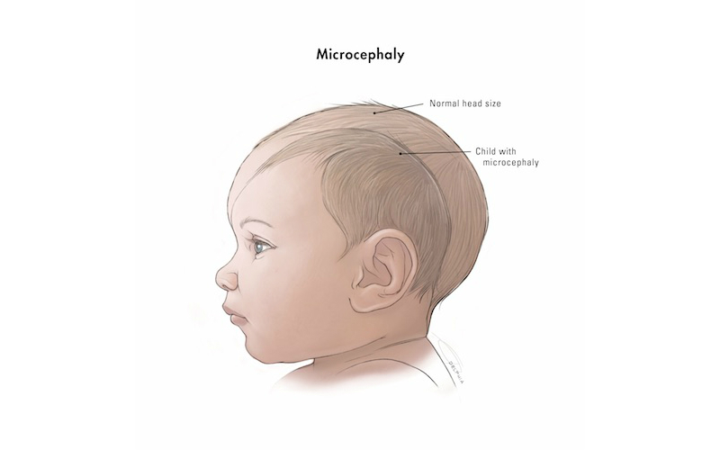
Figure 6. Microcephaly (Boston Children’s Hospital Notes website)
Methodology
In order to diagnose an individual with the Zika virus, they must be experiencing the symptoms mentioned in the health implications section, but sometimes they will not have any (CDC, 2016). The doctor will ask if the person has traveled to a country where Zika is active or had sexual contact with a person that has recently traveled there (CDC, 2016). Laboratory work that will be collected from the patient are blood and urine samples (CDC, 2016). The following tests may be used to diagnose Zika: rRT-PCR, Trioplex Real-time RT-PCR Assay, serum IgM antibody testing, and Zika MAC-ELISA (CDC, 2016).
First supporting case/example
The following example shows the type of relationship between one of Florida’s largest wetland, the Everglades, and the Aedes mosquitoes. The Naples Daily News published an article that discussed about the Everglades National Park not having Aedes mosquitoes (Fletcher, 2016). Pedro Ramos, whom is the supervisor, reported that these mosquitoes prefer an urban environment than a natural one (Fletcher, 2016). Professor Durland Fish from the Yale School of Medicine acknowledged this allegation because he led a research team that identified 30 mosquito species that were collected from thousands of mosquitoes in the “Everglades National Park, Big Cypress National Preserve, Fakahatchee Strand State Park Preserve and Picayune State Forest” (Fletcher, 2016). Professor Fish also added that the Aedes aegypti mosquitoes thrive in still water and feed off of humans to survive (Fletcher, 2016). Pedro Ramos said they are monitoring the mosquitoes in the Everglades for safety measures (Fletcher, 2016).
Second supporting case/example
The following case describes how the first individuals acquired the Zika virus locally in Miami-Dade and Broward County. The first person was a female resident from Miami-Dade County and the second person was a male resident from Broward County (Likos et al., 2016, p. 1032). Neither individual had traveled out of the country or had sexual contact with an individual who had recently traveled to a country with ongoing Zika virus (Likos et al., 2016, p. 1032). Afterwards, one person from each county mentioned earlier would be positive for Zika. None of these individuals lived in proximity to one another, but they had similar workplace areas (Likos et al., 2016, p. 1033). When their workplaces were investigated, researchers found that they were nearby sites where Aedes aegypti mosquitoes laid their eggs (Likos et al., 2016, p. 1035). They also inspected their resident areas and found larvae sites too (Likos et al., 2016, p. 1035).
Analysis
The two supporting cases answered the following question: is there a relationship between Florida’s wetlands and the mosquitoes carrying the Zika virus? In the first case, both the supervisor of the Everglades National Park and the Professor from the Yale School of Medicine said that the Aedes aegypti mosquitoes prefer to live human-made environment than the wild. This leads to the second case, which demonstrated resident homes and workplaces as target sites for the Aedes aegypti mosquitoes to lay their larvae. These two cases confirm what the CDC has been announcing not only to the state of Florida, but to the United States, to drain sources that contain still water because this specifically attracts the Aedes aegypti mosquitoes (CDC, 2016). This means that there is no direct relationship between Florida’s wetlands and the Aedes mosquitoes. Even though when looking back at Figure 1 and seeing how Miami-Dade County is surrounded by wetlands, it just means that wetlands might possibly attract the Aedes aegypti mosquito because of the tropical or subtropical environment it has.
Solutions
In the background, it mentioned that wetlands had decreased and one of those reasons was due to mosquito control (Swihart, 2011, p. 16). Mosquitos thrive in the wetland environment and the control measure that the state of Florida used back then was drainage through ditching (Swihart, 2011, p. 16). Now Florida has a mosquito control program in almost every county. Since Miami-Dade County is where cases of the Zika virus have been locally acquired, they have specific strategies in place.
One method used is truck spraying to treat larvae and adult mosquitos in the Miami Beach and Little River area and aerial spraying for Miami Beach only (“Mosquito Control,” 2016). The spraying hours for larvae and adult mosquitos are before dawn and at dawn or dusk respectively (“Mosquito Control,” 2016). Another strategy is maintaining the water in Bromeliads (popular plant in Florida) free from mosquitos by spraying water (flushes them out), using larvicide to treat the water, and even putting drops of cooking oil in the water or using non-stick cooking spray directly on the plant to suffocate the mosquitos (“Mosquito Control,” 2016). The reason being that Bromeliads trap water (“Mosquito Control,” 2016). They will perform site inspections looking particularly for any type of water holding container or source (“Mosquito Control,” 2016). Last method is draining any water collected in containers, wearing clothing that covers the body, putting screens on windows and doors, etc. (“Mosquito Control,” 2016).
Conclusion
Wetlands are part of Florida’s natural environment. Unfortunately, the residents living in Florida have to deal with mosquitoes that the wetlands attract, except the Aedes aegypti mosquito. The Aedes aegypti feed off of human beings and thrive in our environment due to water collecting in any type of source. Residents should inspect their household daily for any place that may be a potential source for these mosquitoes. The state of Florida should continue to follow the CDC’s guidelines and protocols in dealing with the Zika virus.

References
Centers for Disease Control and Prevention. (2016). Zika virus. Centers for Disease Control and Prevention. Retrieved from http://www.cdc.gov/zika/about/index.html
Fletcher, J. (2016, September 14). No spraying for Zika in the Everglades, park supervisor tells Naples audience. Naples Daily News. Retrieved from http://www.naplesnews.com/story/news/2016/09/14/no-spraying-zika-everglades-park-head-says/90349114/
Likos, A., Griffin, I., Bingham, A., Stanek, D., Fischer, M., White, S., … Philip, C. (2016). Local mosquito-borne transmission of Zika virus – Miami-Dade and Broward Counties, Florida, June – August 2016. Morbidity and Mortality Weekly Report, 65 (38), 1032-1038. Retrieved from http://www.cdc.gov/mmwr/volumes/65/wr/mm6538e1.htm
Miami-Dade County. (2016). Mosquito Control. Miami-Dade County. Retrieved from http://www.miamidade.gov/mosquito/index.html
Miami-Dade County. (2013). Wetlands. Regulatory Economic Resources. Retrieved from http://www.miamidade.gov/environment/wetlands.asp
Swihart, T. (2011). Florida’s water: A fragile resource in a vulnerable state. New York: RFF Press.
Wetland evaluation and delineation. Florida Department of Environmental Protection. Retrieved from http://www.dep.state.fl.us/Water/wetlands/delineation/index.htm
World Health Organization. (2016, September). Zika virus [Fact sheet]. Retrieved from http://www.who.int/mediacentre/factsheets/zika/en/

