What are Healing Crystals?
A crystal is just a rock right? Not quite. Crystals are solids that form by a regular repeated pattern of molecules connecting together. This uniform structure is what makes a crystal a crystal. A rock, such as granite is not a crystal because it does not have a uniform structure. Whereas a crystal, such as amethyst is made up of the mineral, quartz. In the world of crystals, each type of gemstone has a certain frequency and can help heal or encourage certain states. Holding crystals or placing them on your body is thought to promote physical, emotional and spiritual healing. Crystals do this by interacting with your body’s energy field, or chakra.
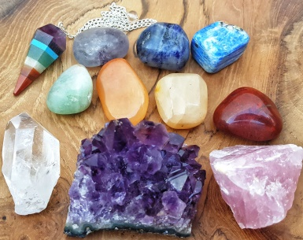
The beauty and power of crystals and other stones have been long recognized, since the dawning of civilization - prized for not only their beauty but for their healing and spiritual power. Healers, shamans and priests have long used crystals for their unique and special properties. It is widely believed crystals vibrate at the same pitch as humans - such that the resonance between the stone and the human either combats the vibration of the illness or amplifies that of health.
The Healing Benefits of Crystals
Red-Red crystals stimulate, activate and energies. They are associated with one’s ability to use daily practical skills and physical survival skills, and with movement, motivation and protection. Ruby is a gorgeous example of a red crystal, as it works with the energies of the heart center, energizing yet balancing in its effects.
Pink-Pink crystals have a gentle and subtle way of pushing things towards a resolution. Pink brings emotions and sensitivity into our daily actions. Rose Quartz is possibly the best known and favorite of the pink stones, and has a calming and reassuring effect. However, it can also be a powerful releaser of unexpressed emotions where they may be getting in the way of personal growth. It is the stone of unconditional love, promoting self-love and also attracting love from others.
Orange-Orange crystals combine energizing and focusing qualities, allowing creative and artistic skills to flourish. Carnelian is one of the more popular orange stones, and is characterized by a sense of warmth. It is an excellent crystal for increasing motivation, enthusiasm and energy. Carnelian fosters self-worth, and will nearly always be of benefit in healing. On a physical level, Carnelian promotes vitality by supporting the absorption of vitamins and minerals, and ensures ample blood supply to organs and tissues of the body.
Yellow-Yellow crystals relate to the functioning of the nervous, digestive and immune systems of the body. Stress, fear, happiness contentment are all linked to this color. Amber has a beneficial effect on the nervous system and self-healing processes. Citrine Quartz Crystal, when it is a bright, clear yellow it will help to keep the mind clear and focused. And Iron Pyrites, also known as “fool’s gold”, helps to cleanse, strengthen and calm the digestive system.
Green-Green crystals are associated with the heart. They serve to balance emotions and relationships, encourage personal space and growth, and bring about a sense of calm. Green Aventurine is an excellent heart balancer; it promotes easy expression of feelings. Additionally, this crystal is said to relieve anxiety and promote cheeriness in its possessor, and to bring about good luck.
Light Blue-Light blue crystals are associated with the throat and therefore communication. Voice, taste, smell and sight... well all the senses, and your internal communication is the way you talk to yourself, your thoughts and your ability to express yourself, are all influenced by the vibration of light blue. Aquamarine is well known for its ability to promote clear communication, courage and confidence. It helps you stand your ground, and helps to release the flow of clear communication.
Indigo-Indigo crystals are linked to your "third eye". Perception, understanding and intuition, together with a deep sense of peace are attributed to Indigo. Azurite serves to free up difficult and long standing blocks in communication and will reveal obstacles stopping us from using our full potential. Additionally, Azurite stimulates memory and recall.
Violet-Violet crystals tap into inspiration, imagination, empathy and the sense of service to others. Violet and purple stones help to rebalance extremes within the systems of the body, so they can be of use when you are not sure of the nature of a problem. Amethyst is perhaps the most useful all-purpose healing crystal. It is universally applicable in its uses and benefits. Amethyst is a good stone to use with meditation as it quietens the mind and allows finer perceptions to become clear. It can enhance intuition and psychic powers of all kinds. Amethyst is also excellent for lucid dreaming. Additionally, Fluorite protects against computer and electromagnetic stress, place a fluorite crystal at your work station to improve mental clarity and efficiency.
White-White or clear stones symbolize the potential to reflect all energies around them. White is related to the concepts of clarity, cleansing and purification. Clear Quartz is amazing for strengthening energy. It channels universal energy, absorbing, storing, amplifying, balancing, focusing and transmitting. For this reason it is beneficial in healing, manifesting and meditation.
-While white stones reflect and clarify light, black stones absorb light. White will reflect the visible; black will show you the hidden potential of any situation. Black is solidifying and manifesting. It holds all energies quietly within itself and so requires patience to explore fully. Black stones are usually grounding, acting as energy anchors to help you return to a normal functioning state. Many will also reveal hidden aspects so that they can be dealt with, in this respect black stones have a purifying role.
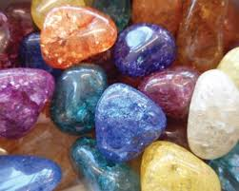

810-584-5241
yourpathforwardholistics@gmail.com

