Richard Dancu Trifan, Composer / Pianist 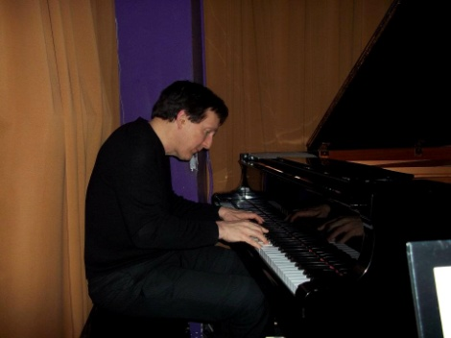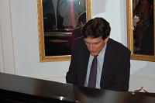
Curriculum Vitae

Address:
600 Stonetown Rd.
Ringwood, New Jersey 07456
(973) 728‐3160 [studio] (201) 314‐1690 [mobile]
Website: www.richardtrifan.com
E‐mail: richardtrifan@gmail.com

Music Education
Daniel S. Trifan, master pedagogue
The Juilliard School – 5-year program, in Composition, Piano and Orchestration

Principal teachers:
- Madame Rosina Lhevinne, The Juilliard School, New York
- Daniel S. Trifan, master pedagogue
- Katherine Parker – The Juilliard School
- Lawrence Widdoes – Composition, The Juilliard School

Juilliard Music Theory & Orchestration
- Noah Creshevsky – Music Theory & Ear Training
- Hugh Aitken – Orchestration

Master classes:
- Misha Dichter (with Mme. Lhevinne)
- Vladimir Ashkenazy (with Mme. Lhevinne)
- Vincent Persechetti (composition) guest student

Competitions/Awards
- BMI Young Composers Award – Three Epigrams for Piano
- Philadelphia Orchestra – Piano Concerto in D minor - Poulenc

Selected Past Concert Appearances

December 1998 – First Reformed Church Benefit Series, Kecskemet, Hungary
- Dedicated to benefit flood victims of the Ukraine, fall 1998:
Program:
Prelude #5 in D Major Bach
Prelude #15 in G Major Bach
Nocturne #5 in B-flat Major Trifan
Ballade #1 in G Minor Chopin

INTERMISSION
Ballade #5 in C Minor Trifan
Ballade #6 in E Minor Trifan
Hungarian Rhapsody # 11 in A minor Liszt

May 2003 – Romanian Cultural Center, New York, N.Y.
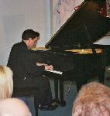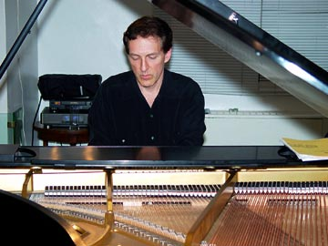
Program:

Prelude #15 in G Major Bach
Minuet #1 in D Major Trifan
Nocturne #5 in B-flat Major Trifan
Ballade #1 in G Minor Chopin

INTERMISSION
Ballade #5 in C Minor Trifan
Arias from “The Global Opera” Trifan
- 6) “Vision for the World” in E Major
- 7) “What I Have Found” in A-flat Major
Ballade #6 in E Minor Trifan
Scherzo #3 in C Minor Trifan
Three excerpts from “Romanian Folk Dances” Bartok
Romanian Folk Dance Inspiration Trifan

June 2009 – Russian Cultural Center, Washington D.C.
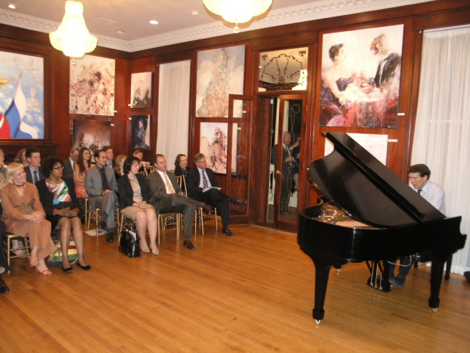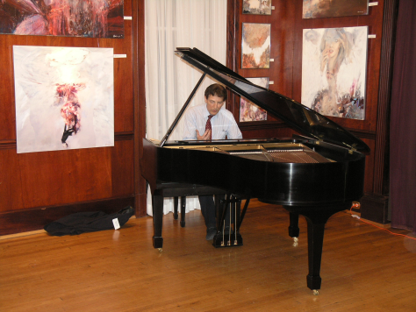
Program:
Nocturne #5 in B-flat Major Trifan
Ballade #5 in C Minor Trifan
Arias from “The Global Opera” Trifan
- 6) “Vision for the World” in E Major
- 7) “What I Have Found” in A-flat Major
Scherzo #3 in C Minor Trifan
Romanian Folk Dance Inspiration Trifan
Excerpts from Swan Lake Tchaikovsky

November 2011 – Prague, Czech Republic
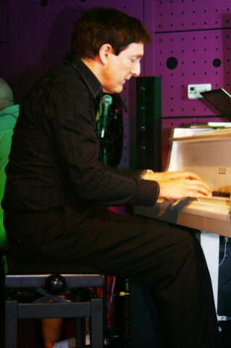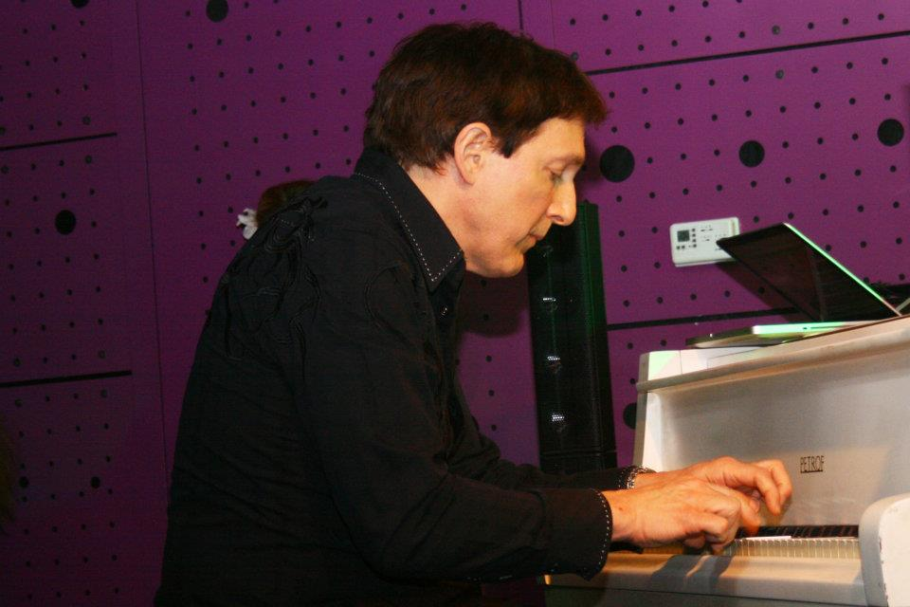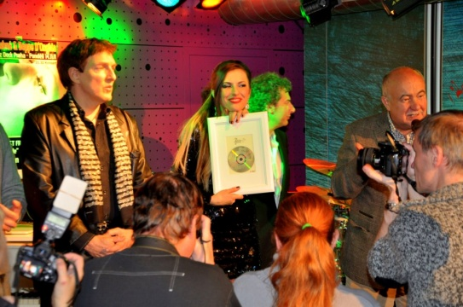
Program:
Nocturne #5 in B-flat Major Trifan
Ballade #5 in C Minor Trifan
Romanian Folk Dance Inspiration Trifan
He also gives benefit recitals of his works for the advancement of other arts such as painting and sculpture, and will shortly be working to advance orphans' causes through humanitarian events with the Eurasia Center in Washington D.C. at www.eurasiacenter.org

Short Biography

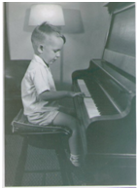Trifan, 3rd birthday
Richard Trifan started his piano and composition studies before the age of three with his father, Daniel S. Trifan, a classical violinist who followed the tutorial model of Leopold Mozart. He received his formal musical education at the Juilliard School at Lincoln Center, having studied piano at age 12 with the late Mme. Rosina Lhevinne as well as composition and orchestration. At the age of eleven, he won the Philadelphia Orchestra Children's Concerts competition along with his brother Daniel, performing the 2-piano concerto in D Minor by Poulenc.
Recent Works:
- The Global Opera
- Minuet #11 in D Major
- Nocturne #5 in B-flat Major
- Ballade #5 in C Minor
- Ballade #6 in E Minor
- Scherzo #3 in C Minor
- Romanian Folk Dance Inspiration
- Sonata #1 for Horn and Piano
- Three Epigrams for Piano
- Quartet #2 in A minor ("the Balkan")

Artist Statement:
I dedicate my music towards bridging cultural divides. The responsibility of the few is to entrance, motivate and enlighten the many with works of emotion and skill, inspiring the many towards an equally-rewarding self-expression. I do this from a global perspective and without bias; I would ask for immortality if only to continue this mission.
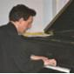

Full Biography
Richard Dancu Trifan is from the first family to have successfully home-schooled their children and won their case with the New Jersey state supreme court; he started his piano and composition studies before the age of three with his father, Daniel S. Trifan, a classical violinist who followed the tutorial model of Leopold Mozart, himself a PhD graduate of Harvard University and the son of Marioara Dancu and Daniel Trifan, immigrants to America from the Carpathian mountain villages of Lancram and Medias in Transylvania.
His father was to be the most valuable music teacher Richard would ever have. Richard's mother, Dorothy Lee Trifan-Ridlon, was the daughter of Oscar Ridlon (of Scottish descent) and Leola Montez Grover-Ridlon (Owens), of English descent from the Wellman family who came to America in the 1630's, settling in Lynnfield (Salem village), Massachusetts. Richard, as the youngest child of 3, often tried to emulate and equal the achievements of his older brother Daniel and sister Marioara, themselves also early prodigies in music composition and piano (all having perfect pitch), reading, writing, and speaking on a variety of scientific, political and musical topics before the age of five.
Education
He received his formal musical education at the Juilliard School at Lincoln Center, having studied piano at age 12 with the late Mme. Rosina Lhevinne as well as composition and orchestration. He attended the Horace Mann School at the age of 13 in conjunction with his music studies, Columbia University (freshman year), Fairleigh Dickinson University, and has an MBA in marketing as well as a BBA in management, with information technology and finance.
Awards
At the age of eleven, he won the Philadelphia Orchestra Children's Concerts competition along with his brother Daniel, performing the first movement of the 2-piano concerto in D Minor by Poulenc. He was the United States winner of the BMI Student Composer Awards for his first piano suite "Three Epigrams for Piano", an early compositional foray into modern piano literature. Later works would re-emphasize the beauty of the melody and diatonic harmonic structure while remaining unique and un-eclectic, a challenging growth step in a composer's life work.
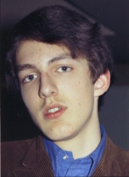
Recording, Touring and Concerts
During this time Richard learned the Moog synthesizer from Walter Sear, one of Dr. Robert Moog's founding partners in New York. He used the console Moog Series IIIC with Walter Sear's EML PolyBox which split the Moog sound oscillators into all the notes of the diatonic scale in real time, developing a unique poly-tonal improvisational / soloist capability with these two instruments used together in real time.
Opera and Theater

Richard's first opera "The Global Opera" is a five-act epic set to an original story of 4 virtuous characters, who (through their immortality) journey through 8 centuries of the human condition in Europe and Asia. Each act is sung in a different language, that of the country through which the characters were traveling, a concept never before tried on the operatic stage. This concept caused him to be interested in the Eurasia Center, a Washington D.C.-based non-profit think tank already established, which he would later join in 2008 as its Cultural Liaison, and how its mission for the greater good of American and Eurasian businesses is augmented and enriched through global exchange of culture. For Richard, the boundary between opera and theater is a cultural enigma, and this challenged him to create a true "multi-media" opera and adding the 4th dimension of time to the work.
Characters in order of vocal appearance:
Horst, a guild tradesman
Prince Magnus, son of a Nordic king
Vladimir, his trusted friend
Giovanna, fiancée to Vladimir
Baron von Eckst, a nobleman of the Saxon tribes
Elsa, the Baron’s daughter
Burgomeister Toppler, of Rothenburg (a real historical character in the 1300’s)
Duke of Venice, an avaricious nobleman
Horatio, a Venetian artist
Marina, a peasant girl from Kiev
Catherine the Great, Empress of Russia (a real character)
Medhat, an Arabian tradesman
Aleksandr Pushkin, a new Russian writer (a real character)
David Ben Aron, a Yeshiva scholar
Sara, a young journalist
Youssef, a law scholar & descendant of Medhat
Russ Simmons, an American businessman
Professor Soko, a Japanese teacher
Li Pen, a Chinese student
Deepak, her fiancée
Brief Synopsis of the Global Opera

The Global Opera is a story about virtue – ideally immutable in the face of adverse influences. Musical leitmotifs punctuate the music, representing qualities of character (e.g. the Virtue motif, the Avarice motif) and also impending corruption in the form of a local nobleman or other position of power. However, the Global Opera wants also to make the moral point that economic / social class alone does not predispose one to either virtuous or avaricious behavior; there are honorable and corrupt noblemen and paupers alike, both inspired to virtuous behavior, in either circumstance, from earlier formative character years. In this way the Global Opera tries to call attention to virtuous character, and the influences of civilization, economic opportunity and outstanding character on the continuing moral / spiritual evolution of people. Certain historical and timeline liberties are taken in order to insert certain known historical figures as peripheral characters in the story, hopefully helping the audience to “locate” themselves within the story.
The concept of the 4 main characters as being friends, and also seemingly ageless / immortal as each act jumps forward 200 years, imparts a surreal yet necessary quality to this vehicle. This assumption (and the required suspension of disbelief) is necessary in order to let the audience focus on the moral timelessness and universality of virtue, altruism, and other “positive” human perspectives vs. those of avarice, greed, callousness, disregard for other human life, etc. (which, as non-contributory to an improving society, will die with them). Only through the portrayal of centuries of experiences through the 5 acts can the steadfast, incorruptible continuum of true virtue be sufficiently communicated and felt by the audience.
Other Recent Works
In addition to his operatic and theater work, Richard is also a composer for the organ, varying string and woodwind sonatas, and the Moog synthesizer as a futuristic instrument within the classical orchestra. The Moog synthesizer is heard in the Fifth Act of the Global Opera, as this act is set about 200 years in the future.
Acknowledgement to Parents and Family
Richard acknowledges that his life has been exceedingly fortunate due to his parents, loving family upbringing and early education. "The first 5 years of life determine 90% of what we all can or cannot become". Although a firm believer of higher education and subsequent free choices in our lives, Richard advocates the immeasurable contribution that parents bestow on their children through tireless love and giving of their time to enrich their child. Richard is working on a book about his parents and the ideal family structure they championed.

