**Wellness Booklet**

Mind-Heart-Body-Spirit

Wellness

Guidance on healthy life

- by Roxana Marinescu, RN,

Bachelor in Nursing

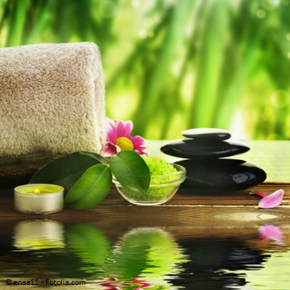

This booklet has been created with the caring and openhearted wish to inspire a better wellness of you.

*The guidance and knowledge found here are from what I have read, experienced and absorbed. They are inspired from my nursing background and research work.*

*I hope they will be valuable for you.*

*I give thanks to all my close friends who have helped me on the way, inspiring mentors, including academic professors, community activists, as well as leaders and authors. They have been guiding me out of their plentiful Unconditional Love.*

*Our well-being might seem that belongs and depends just of us but it’s not….)*

*- it’s deeply interconnected and owes immensely to the others’ efforts, commitments and devotion to this community. Anything we do for others will greatly impact them and the whole community . We are all interconnected through love, service , awareness, sensitivity and virtues.*

*This Wellness guiding booklet focuses to help you discover your own pathway to wellbeing.*

*As a nurse that has worked with multitude of chronically ill patients in a multitude of settings, , my intention is through the knowledge I present you here to impact in a positive way your life and improve your holistic health ! This material is not a substitute of your current medical therapy and for all your medical concerns consult with your medical provider!*

*Enjoy!*

*At the end of reading this material , count how many things you have absorbed and then apply them in your life!*

*The Wellness concept I am bringing here is a holistic concept and it includes a multitude of components:*

*Spiritual - Inspirational- Motivational - Emotional – Social- Cultural-*

*Intellectual-Physical- Environmental- Occupational- Financial and others.*

*You will later after reflection choose the Areas you are interested in working on, or learning more about for the next months*

*We recommend you choose one or two*

|  |  |
| --- | --- |
| *Spiritual Wellness:*   * *Follow Mentors,* * *Create a life vision and Purpose* * *Pray* * *Engage in spiritual fellowships* * *Meditate* * *Offer work for charity or volunteer* | *Physical Wellness:*   * *Engage in physical activity* * *Practice healthy eating* * *Practice healthy sleep*      * *Practice healthy sex* * *Go for your annual check ups,* |
| *Emotional Wellness:*   * *Engage in projects that give you joy,* * *Pray and Meditate* * *Practice Self Compassion and Mindfulness* * *Praise yourself and others* * *Practice daily gratitude* * *Grow positive relationships* | *Mental Wellness:*   * *Engage in new learning and experiential experiences* * *Find your strengths,* * *Find your Passions and hobbies* |
| *Occupational Wellness*    Make your working place,  work circumstances and  networking people charging and empowering  Make your workplace a healthy place | *Environmental Wellness*  Love and Honour your environment  and all living creatures on Earth  Keep your environment clean and safe  Learn new environmental knowledge  Involve in environmental projects    Connect |

***Spiritual- Inspirational- Motivational Wellness***

*Reflect about your mentors who inspire you*

*I invite you to find these inspirations, connect , follow them !*

*Mentors are so important for keeping you motivated !*

***Write the names of your favorite mentors and spiritual models and describe in few words what of their qualities inspire you ;***

***Collect also quotes, sites , apps, books and articles about them***

***Reflect now what are your deepest meaning and purpose in life and vision***

*Feeding your spirit with good readings goes a long way especially in times of challenge*

*Write what motivational readings you would like to read*

*Change comes from inside but it is also greatly influenced by outside such as relationships, environments, communities, systems, organizations, networks, movements, practices, resources, structures*

*Serve the community, get involved in leadership in the field of your interest!*

***What organizations*** ***or programs you think you would like to get involved?***

*Empower yourself, the community, your region, your country, continent and the planet!*

*Belong to a fellowship, Pray, have Faith, have Hope!*

***Praise often other people for their talents and virtues!***

*Praising each other encourage us to achieve great things!*

*Support, encourage others in their dreams, aspirations and endeavours!*

***Write some ways you can support other peers in their efforts, for example by writing an encouraging message or letter to someone in need and we all have different needs***

*Cultivate positive thoughts, emotions and character strengths !*

***Emotional- Social- Cultural Wellness***

*Stay close to the people you love and the peers you have similar deep aspirations with , visions and missions!*

***Write the names of your loved ones and the people you want to stay in close connection with, write them, meet them, or talk with them on the phone on a regular basis ; Give them special focused attention from now on***

***Become aware and reflect on people you have deep connections with, such as similar aspirations ,passions, or that you admire and appreciate deeply!***

***Research has showed that actual face to face meeting or talking over the phone are the only means that provide deep communication between two people as comparing with e-mailing or texting( Barbara Fredrickson, PHD)***

*Boost positive emotions through positive daily interactions with others- known or unknown, positive conversations , positive actions and activities and positive environments*

*In this way you can increase resilience !*

*Be aware that always after dark comes light!*

***Reflect daily on the positive social connections, for a week period ;***

***Research has shown that even small positive interactions with other people increase level of happiness (Barbara Fredrickson, PHD);***

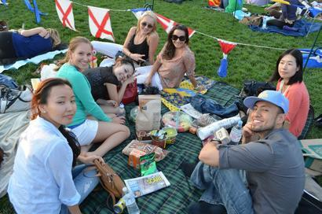

***Create more positive interactions with other peers during the day;***

***research has shown that these micro-moments of positive interaction increase level of health and happiness-Barbara Fredrickson, PHD***

***Write daily for how many days you like, about positive experiences in your life;***

***describe in detail the experience and the positive emotions it entailed;***

***research has shown that this reflection and writing increase level of happiness***

***What is Love?***

***According to Barbara Fredrickson, Love is one of the most important emotions for one’s happiness, as research has discovered, it has long term benefits on the level of happiness***

***when you love someone very dearly, love is also a symbiosis with a cause, person or group about whom you are very fond of and feel a strong connection with***

***Love is a feeling that you can experience with many people with whom you connect, explore and discover their inner awesomeness***

*Do work that bring joy and uplift you!*

***Do acts of kindness-Research in positive psychology as well as the most religious traditions have shown that engaging in a higher cause outside yourself is a route to your happiness***

***What projects or activities that give you joy you would like to focus on the following months?***

***Also research studies have shown that being married, having more friends is a way for increased well-being***

***Gratitude exercise:***

***Stay grateful for the present moment!***

***Think daily of positive things, persons, that brought you joy and fulfillment!***

***Write 5 recent small things that you are grateful today for !***

***Write Thank you Cards, e-mails or letters to people who help you on your way!***

*Do not be overwhelmed by the difficult ! If you are passing through difficult times , you may* ***Write to yourself a Letter of Self- Compassion, preferably for 7 days in row ( according to Prof. Kristin Neff, PHD :***

*Write as if you would write to your best friend that you imagine has a similar situation with yours; Imagine what words you would use and how you would comfort her/ him;*

*You can start with: I feel sorry for you that you have to encounter these difficulties; I am compassionate for your situation; and then reflect her/his situation and your comforting thoughts :( can be one -two pages long)*

*If you encounter difficulties, research shows that joining support groups of people who have similar problems with yours helps you*

*If it is accessible to you through school or church,* ***coaching i****s another useful tool that you can use to better yourself ;*

***classical psychotherapy or counseling*** *for those who are confronted with acute mental health illness or life crisis*

*Cultivate positive emotions through positive connections and conversations such as compassion, generosity, joy, calm, forgiveness, gratitude, happiness, faith, hope and positivity of the mind*

***Meditate regularly about your good character traits, strengths and abilities;***

***You may write them in your journal;***

***( Complete questionnaires such as*** [***http://www.viacharacter.org/www/Character-Strengths-Survey***](http://www.viacharacter.org/www/Character-Strengths-Survey)

***Or*** [***https://www.gallupstrengthscenter.com/***](https://www.gallupstrengthscenter.com/) ***)***

*Reward yourself unconditionally for progress achieved*

***Optimism / Hope Boosting Exercise:***

***Write in your journal for 7 days in a row, each day 3 circumstances/situations that at first seemed difficult/ not solvable and that afterward they ended up being easy, successful, pleasant experiences***

***Listen and repeat to yourself Positive Affirmations***

*- you can find many on audibles, you tube, …:( audible: Positive Attitude- By Sheila Skye):*

*“ I am open to more tranquility, I have a lot to be grateful for in my life,, I enjoy supporting and helping other people, I use my talents to make my dreams a reality, I value my life, I am learning and growing every single day, I see the good within myself, my positive thoughts are now helping me improve my reality, I now focus on my opportunities,, I now welcome more prosperity into my life”*

*Focus on the positive aspects of a situation from the present or past*

*Be aware of your stressors and focus your attention to your opportunities in order to move forward!*

***Write about your current life opportunities you have to focus on***

*Relax, meditate regularly when you wake up , in the evening,...*

*( I personally like to meditate silently , on Sri Sri-Sattva App or on Vishen Lakhiani- 6 Phase meditation youtube audio)*

*Spend time in the nature*

**

*Listen to favorite music , relaxation music, nature sounds,..that can put you in a happy,blissful state*

*Watch relaxing documentaries that soothe your mind and soul*

*Watch movies, read books that increase positive emotional expression, encourage laughter and relaxation*

*Set positive intentions for your day to increase productivity, happiness and quality of life*

*Think of the multiple reasons, aspects and facets of a situation*

*Mingle with people of different cultures, appreciate and assimilate the good things in them*

*Enjoy your favorite hobbies like music, visual arts therapy ,expressive writing, be creative !*

*Express your creativity in all your major life goals when you plan to manifest them in the real world*

***Write about new hobbies you would like to start or artistic ideas or project you would like to initiate***

*Travel, learn about and assimilate the good things from other cultures and beliefs!*

***Write what places you would like to visit , with whom, what you would like to do there, and how you could plan it***

*Hug and kiss , Smile and laugh often*

***Intellectual wellness***

*Discover and follow your passions, Discover new passions that serve humanity*

*( Listen to Vishen Lakhiani- Mindvalley Consciousness Engineering- and Brendon Burchard- they are highly motivating about discovering and following your passions, and live vertically, accordingly with your values)*

*Be curious of the world, Increase focus, creativity, clarity*

*Create regularly, on existing frameworks, get inspired from others,*

*Train with experts, Follow mentors*

*Sharpen memory skills- Learn a new language or a new game*

*Discover own signature character strengths and use them to increase your well being!*

***Physical wellness***

*Know that you have an inner healing force that is the most important and strongest force for healing !*

*Trust your inner healing force!*

*Drink plenty of water! (flavor it with slices of fresh or frozen fruits or tea leaves or tea bags)*

*Eat healthy- naturally, whole foods, not processed or minimally processed,*

*preferably organic or with no pesticides, prepared or cooked in a healthy way,*

*Purchase fresh or frozen vegetables with no added or minimal ingredients*

**

*Learn how to cook at home, Purchase healthy foods!*

*Be mindful of the salt content in foods ( preferably to be less than 200 mg per serving)*

*Write a healthy recipe that you would like to learn*

*Share meals with your best friends and enjoy fellowships*

*Have regular meals and healthy snacks- set up reminders if you need it*

*Be mindful of the size of meal portions and drinks*

*Follow the guidelines of a moderate diet, rich in vegetables, beans, nuts, seeds, fruits*

*Eat a diet low in animal fats, salt or sugars - natural sugars are the best,*

*Cleanse your body, Fasting regularly helps your body stay healthy.*

*(Fasting includes To Fast from animal meat , Fast from other animal foods , Fast from smoking and drugs ( prescribed and unprescribed), )*

*Sleep enough,*

*Take short naps when you need it !*

*Take short breaks throughout the day by being physically active, stretching , meditating….*

*Stretch in the morning for few minutes - dance, or favorite sports , yoga*

*Go to bed with relaxing and enjoying activities and thoughts, You can listen to relaxing apps to fall asleep easier ( ones with nature sounds) , Dream*

*Avoid visualizing digital equipment before bed ( 2 hrs) such as cell phones, computers, tablets,*

*Exercise your favorite sports at a pleasurable pace : swimming, jogging, tennis, walking, hiking, volley, soccer, basketball, gym, cricket, …*

*Join a walking, hiking, volley, yoga, running group or lead one;*

*Yoga is beneficial for relaxation, emotional, mental and physical well-being- Stretch- Be flexible -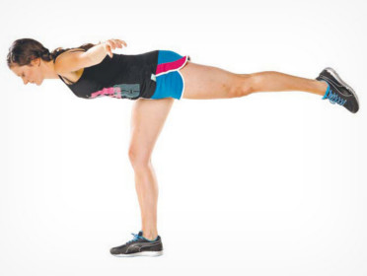*

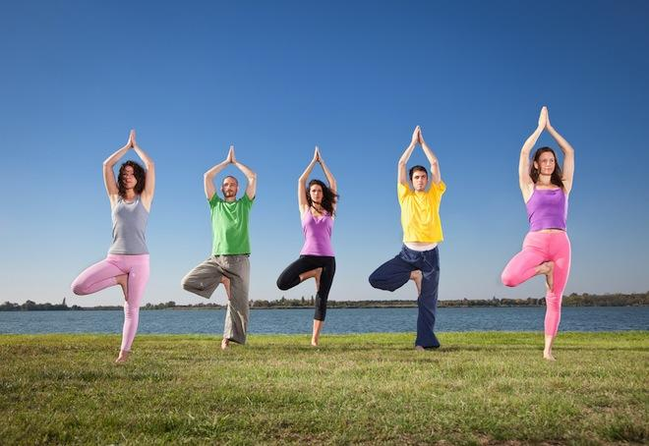

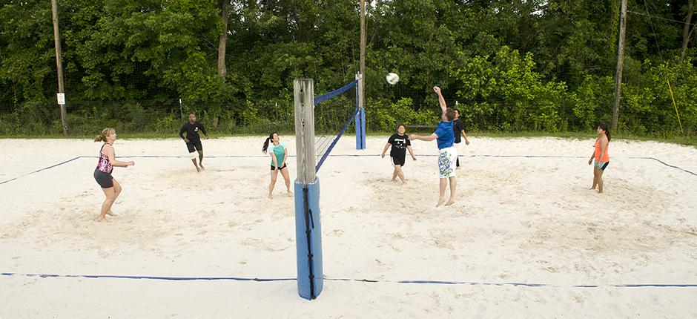

*Balance is important for our bodies- Do balance exercises regularly – use professional online yoga sites , yoga books or join live classes for balance exercises- they will help you with keeping your balance and preventing dizziness later in life*

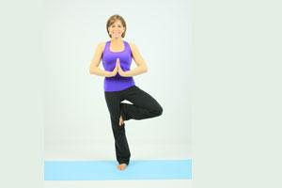

*Practice low impact aerobics, strength training, isotonic exercises, isometric exercises at home, gym or in live classes*

*Practice low weights lifting to build up muscle mass and strengthen your bones*

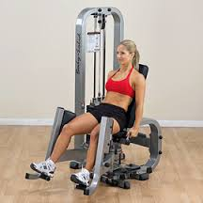

*Do the Annual screenings: Annual wellness exam, Annual Obgyn exam, Annual STD (sexually transmitted) screening,*

*Have Safe sexual practices, learn your patterns and see what are the factors that predispose you to risky situations,*

*Have an Annual Skin exam by a professional (for sun, malign lesions)- Watch for new lesions on the skin*

*Have an Eye exam as needed, diabetic patients need to have the eye exam annually*

*(women) Self-check your breasts for lumps and abnormal lesions on a regular basis, (men) Self-check your testicles for lumps and abnormal lesions on a monthly basis, (women) have a Regular Mammogram as prescribed*

*Screen for colon cancer, diabetes, as recommended,*

*Have an annual dental exam to early treat any cavities*

*Heal addictions such as excessive drinking, smoking, illicit drugs, … with Support groups, Prayer, Prayer Groups, Meditation, Meditation Groups , Fellowships, Counseling, Community Volunteering and Service , Leadership*

*Join Smoking Cessation Classes in your area organized by the main hospitals or use free smoking cessation support such as* [*http://www.lung.org/stop-smoking/i-want-to-quit/how-to-quit-smoking.html?referrer=https://www.google.com/*](http://www.lung.org/stop-smoking/i-want-to-quit/how-to-quit-smoking.html?referrer=https://www.google.com/)*,* [*http://quitsmart.com/*](http://quitsmart.com/)*, quitlinenc.com,*

*Get a pet ! Adopting pets is more rewarding than buying one !*

*Compared to people without pets, studies show people with pets have significantly lower heart rate and blood pressure levels, less reactivity during physical and mental stressors, and recover faster from stimulation*

***Environmental wellness*****

*Protect yourself, your family, community, region, state, country , planet against toxins and chemicals in soil, foods, water, air;*

*Educate yourself about protecting the environment, Do not pollute others,*

*Be mindful about the chemicals used for growing the lawns and golf courses and keep them at a minimum- they have been linked to cancer , can spread through wind at long distances, be inhaled by humans and affect the animals around ( use when possible organic ones)*

*Grow your own food, buy from locals who don’t use pesticides, minimize buying processed foods that have chemicals, preservatives and colorants, buy fresh, local, organic; Support the organic industry*

*Read* ***EWG 2016 Shopper Guide to Pesticides in Produce:*** *https://www.ewg.org/foodnews/summary.php*

*The Clean Fifteen™EWG's Clean Fifteen™ list of produce, least likely to hold pesticide residues, consists of avocados, sweet corn, pineapples, cabbage, frozen sweet peas, onions, asparagus, mangoes, papayas, kiwis, eggplant, honeydew melon, grapefruit, cantaloupe, and cauliflower. All the others are more polluted with pesticides so it is better if we buy them from locals who do not use those pesticides or who grow organic.*

*Become aware of GMO’s ( not found in organic foods), be aware of chemicals in detergents, soaps,*

*Buy cosmetics, soaps and detergents that are biodegradable and have mostly natural ingredients*

*( use* ***the EWG App called: EWG Healthy Living as a guide for healthy body care items)***

*Protect against high amount of medical radiation- inquire always about the necessity of imaging and ask your doctor for the least needed radiative investigation*

*Filter the water, air,*

*Protect against dust, fumes, toxic inhalants and smoke, use environmentally friendly cars and equipment,*

*Protect yourself against peak hours- intense solar radiation*

*Wear clothes for protection : shirts, hats, shorts and pants to shield your skin from the sun’s UV rays, reducing risk by 27%. They are the most effective in protecting your skin.*

*Go outdoors in early morning or late afternoon when the sun is lower in the sky (Check UV Index, it provides important information to help you plan your outdoor activities in ways that prevent sun overexposure)*

*Find shade – or make it, Plant trees to increase shade area, Picnic under a tree or a shelter .*

*Keep infants in the shade or under a shelter , reducing the radiation and risk for multiple burns by 30%*

*Protect your eyes by using sunglasses against UV radiation.*

*Sunscreen Should Be Your Last Resort Don't depend on sunscreen alone! Use natural sunscreens with no chemicals*

*Shade and clothing offer much better skin protection.*

*There are very few sunscreens that are healthy for the body, by not containing chemicals harmful for your skin as well as for your hormonal system:*

*If you buy a sunscreen , check the* ***EWG Guide for sunscreen****s with no health concerns*

*(you can download* ***the research based EWG App called: EWG Healthy Living*** *where you can find out health info about any sunscreen that you might like to buy )*

[*Avoid Vitamin A in Sunscreen*](https://www.ewg.org/sunscreen/report/the-problem-with-vitamin-a/) *[This ingredient could increase your risk of skin cancer.](https://www.ewg.org/sunscreen/report/the-problem-with-vitamin-a/)*

*Protect against loud noises*

*Reduce EMF ( electromagnetic field) exposure, such as from mobile cell phones, cordless phones along with their base stations, wifi devices/ routers, microwave ovens, television and radio transmitters,* ***especially before bedtime and in the bedroom-*** *they have been shown to have potential negative effects on disrupting cellular function, sleep, mood and overall health.*

*Be aware of your EMF exposure in your area*

***Write at least one way you can improve your environmental well-being in the following months:***

***Occupational wellness***

*Occupational wellness takes care of a worker at his work site.*

*At work you need to respect ergonomics to set up your desk. Also it’s advisable to take short stretching and relaxing breaks each hour , and have a lunch break when you eat, relax, are physically active.*

*Ergonomic Desk*

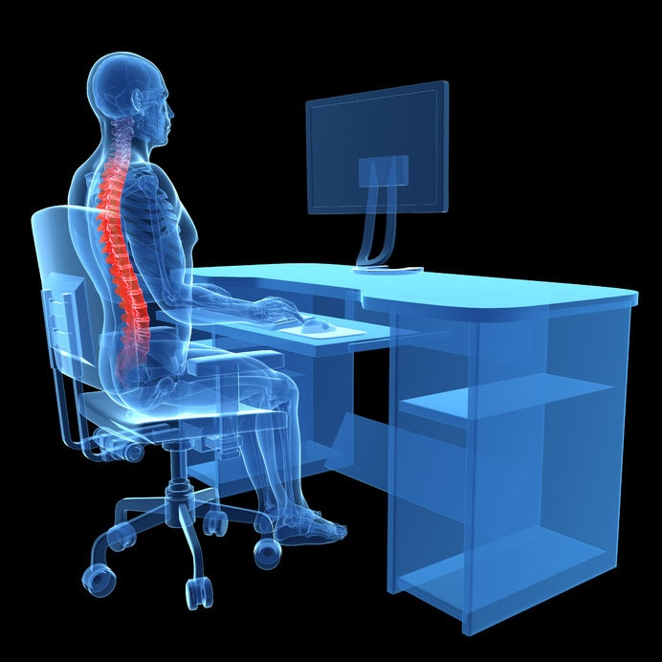

*Ergonomic Mouse Pad*

*Stretching at your desk- regularly*

*A professional worker who works outdoors, needs to protect himself against sun - by adjusting his schedule*

*So that he will use as much shade time and expose himself minimally to strong solar radiation ( work early mornings and late afternoons and have long lunch breaks when the sun is at his peaks)*

*and as well of course use protective clothes with long sleeves, big hats and*

*if needed, use possibly completely natural and organic sun lotions with no chemicals in them that when absorbed in his skin , blood circulation and body will have no harm .( see to be accepted by EWG )*

*A professional worker that works at altitude in constructions needs to protect himself by wearing a safety belt and helmet and other equipments that ensure his stability and safety at that high altitude.*

*A professional worker that works with equipments that make a lot of noise needs to protect himself against those noises by wearing professional earphones or other ears protections similar to earplugs that diminish the noise.*

*A professional worker that works with a lot of dust making activities needs to wear a mask that filters the air that he inhales in his lungs.*

*Per OSHA recommendations, Protect yourself against lifting heavy weights, bending, reaching overhead, pushing and pulling heavy loads, working in awkward body postures and performing the same or similar tasks repetitively*

*Exposure to these activities, increase risk for musculoskeletal disorders ( MSD’s) and injury.*

*Ergonomics --- fitting a job to a person --- helps lessen muscle fatigue, increases productivity and reduces the number and severity of work-related MSDs such as :*

*Carpal tunnel syndrome, Tendinitis,Rotator cuff injuries (affects the shoulder),Epicondylitis (affects the elbow),Trigger finger, Muscle strains and low back injuries.*

*A cashier who overuses his wrists by rotating movements , needs to wear a protective splint*

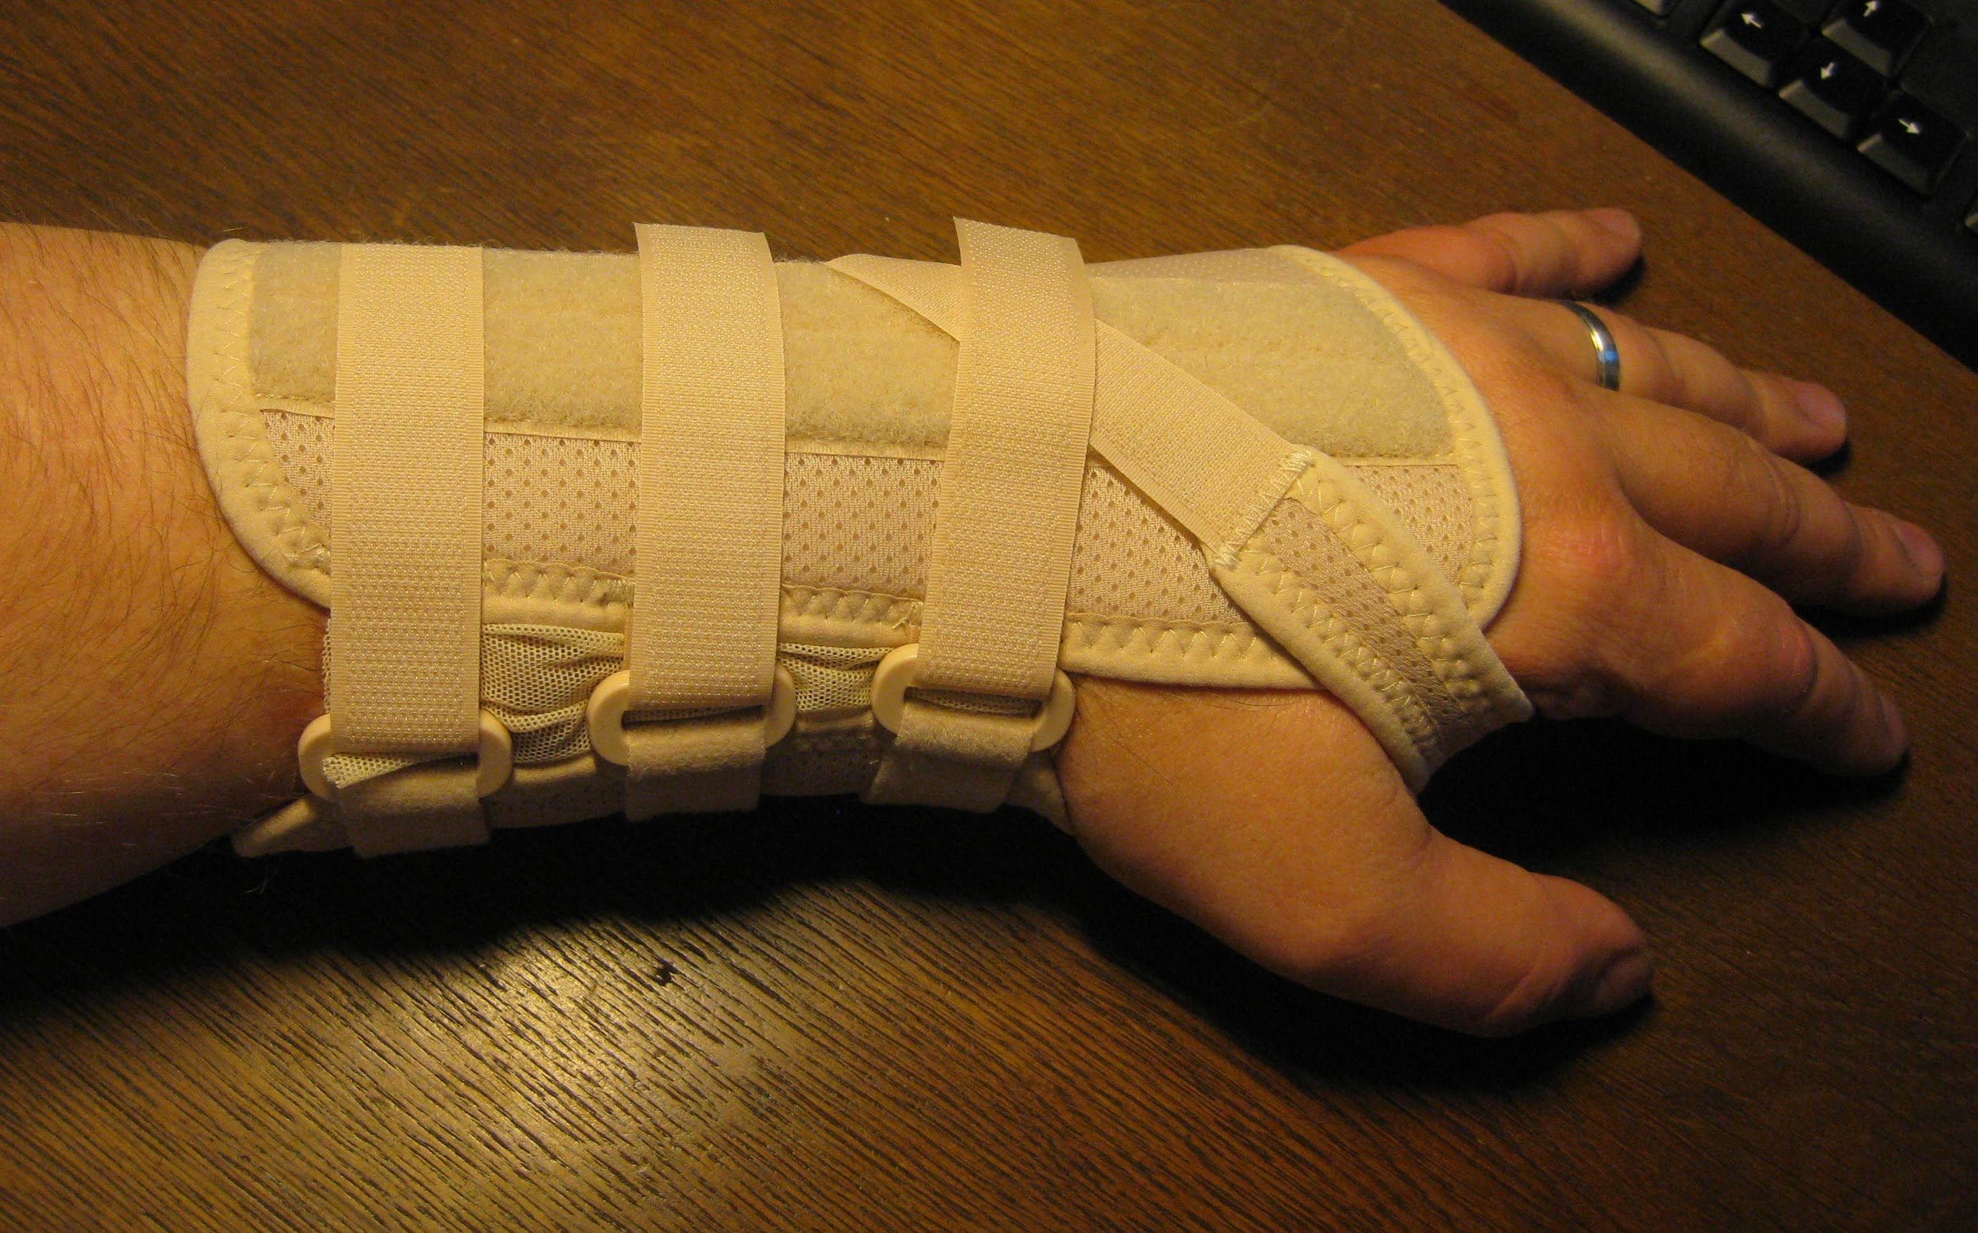

*Employers are responsible for providing a safe and healthful workplace for their workers. In the workplace, the number and severity of MSDs ( musculoskeletal disorders) resulting from physical overexertion, and their associated costs, can be substantially reduced by applying ergonomic principles.*

*Ergonomics are important in high-risk industries as construction, food processing, firefighting, office jobs, healthcare, transportation and warehousing****.***

*If you think your job is unsafe or if you have questions, contact OSHA at 1-800-321-OSHA (6742).*

*For other worker protection information, such as Workers' Rights, Employer Responsibilities, and other services OSHA offers, visit* [*OSHA's Workers'*](https://www.osha.gov/workers/index.html) *page.*

*Work related MSDs are among the most frequently reported causes of lost or restricted work time.*

*BLS( Bureau of Labor Statistics) defines musculoskeletal disorders (MSDs) to include cases where the nature of the injury or illness is pinched nerve; herniated disc; meniscus tear; sprains, strains, tears; hernia (traumatic and nontraumatic); pain, swelling, and numbness; carpal or tarsal tunnel syndrome; Raynaud's syndrome or phenomenon; musculoskeletal system and connective tissue diseases and disorders, when the event or exposure leading to the injury or illness is overexertion and bodily reaction, unspecified; overexertion involving outside sources; repetitive motion involving micro-tasks; other and multiple exertions or bodily reactions; and rubbed, abraded, or jarred by vibration.*

***Write at least one way you can improve your occupational well-being in the following months:***

*Financial wellness - how to work smart, buy smart and cheap, always by reducing unuseful spendings , favoring good quality items, protect against losses, plan in advance, find new money making opportunities.*

***Write one way you can improve your financial situation:***

***Complementary naturopathic therapies***

*address how you treat your body using its own strengths and inner healing mechanisms: such as ayurvedic medicine, naturopathic medicine, functional medicine, Western and Chinese Herbalism , acupuncture, chiropractic, osteopathy, aromatherapy and massage*

*Massage* has a relaxation effect. It has a great influence on the autonomic nervous system and calms down the whole body. Thus relaxing the body and mind it stimulates body to achieve optimum health and so digestion improves, blood pressure reduces, pain is eased, hormonal balance is accomplished. Massage enhances the general blood circulation. It can be beneficial in conditions such as reduced peripheral circulation, lymphatic congestion, muscle spasms, tension, anxiety, backache, tension headache, flaccid musculature.

**Essential Oils- Aromatherapy**

Essential oils are perfect to soothe and calm the mind and body , being helpful with sleeping/ relaxation. Soothing oils are lavender, ylang/ylang, Roman Chamomile , clary sage , orange, vetiver, geranium, Melissa, sandalwood, bergamot, rose. Essential Oils can invigorate your body in the morning and when you feel fatigued. Invigorating oil are peppermint, orange, eucaliptus, white fir, lemon, basil, wintergreen, thyme. Essential oils can be used for soothing the muscles and joints before and exercise. Rosemary, peppermint ,frankincense, lavender are used to enhance alertness and concentration .

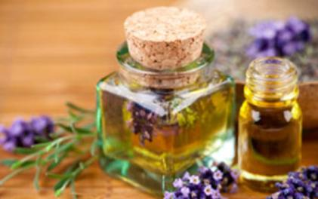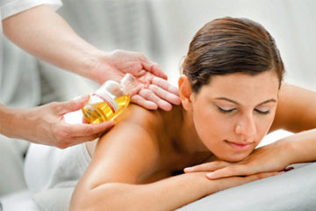

***Homeopathy and herbalism***

Homeopathy is the fine esoteric science of healing based on the principle ” likes cure likes” with infinitesimal dilutions and potions. It is used all over the world with incredible results for chronic conditions . It has been proven effective in lung , cardiac( non organic) , emotional, immunologic diseases and many others, I can be used also as a prevention mean or to stop recurrences of an existing condition. There are European homeopathic doctors as well as Naturopathic doctors who prescribe these remedies and send the prescriptions to homeopathic pharmacies or compose them by themselves.

Herbalism is used for different conditions- gastrointestinal, cardiac, emotional, reproductive conditions. One of the classical authors whom I admire her work is a German botanist and famous healer from 1800’s called Maria Treben who has been translated in many languages in millions of books all over the world

*Other complementary therapies : psychotherapy, counselling,music and art therapy, *

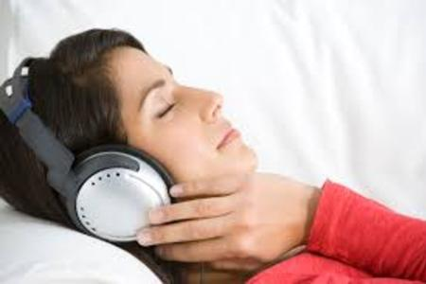

*The Art of decluttering the space*

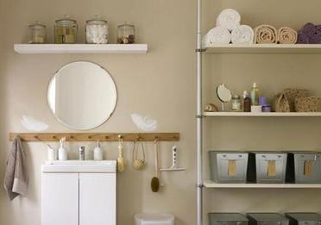

*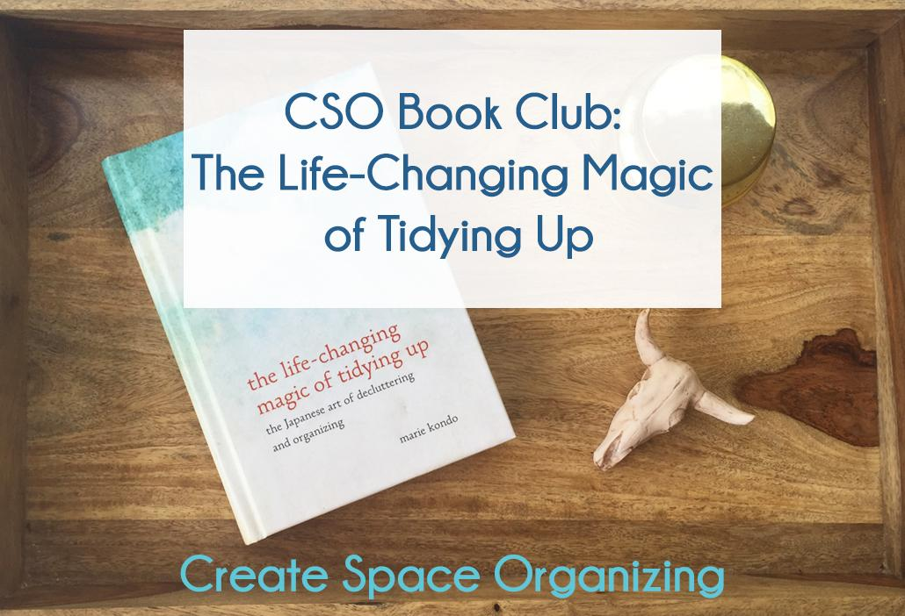feng shui, space healing*

*Pet therapy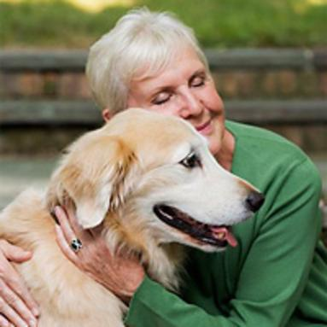*

*, sound therapy and music therapy.*

***Write at least one or two complementary therapies that you are curious to investigate and learn more about it:***

***How you plan on improving your well-being in the following months?***

***Set up one or two goals that belong to any of the wellness sections discussed above,***

***that you will follow weekly , by doing at least one activity that addresses them: When completed , you will check on your calendar***

***What do you think would be other elements that will increase your wellbeing (write 5-10 things and review them later )?***