The Feldenkrais Method® and me - 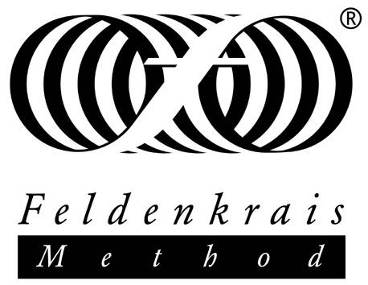
Five or so years ago, I was staying in Edinburgh with a visiting choreographer/dancer friend, formerly of the Merce Cunningham Studio in NY. I’d been doing her class as best I could – a shadow of my former self as a dance professional 30 or even 15 years earlier. Guaranteed to be a downer really – still, was I or wasn’t I a dancer? Dancers dance, so dance, dammit. To cap it all I had an annoying out-of-place heel which was impervious to treatment and which disturbed my balance and sense of rightness. I thought my joy in moving was forever in the past.
At her flat my friend, Ruth Barnes, suggested we did a Feldenkrais session – she had some on CD. Sure, I said – not thinking it was really going to be for me, probably a bit ‘new age’, but what the hell - so we lay on the floor as we were told, as I now know you almost always do [gravity is a major player in how we move – lying down is the closest we can get to switching off the great work of being-erect-in-gravity] and listened and …
What fun this Feldenkrais class was! After 50+ years of dancing, you [think] you know your body and what movement is and where all your bits are and what way up. What a delight to be wrong! How great to be surprised about movement! And this class didn’t require me to sign up to any belief system, to judge, or even to try. Just do the movement and pay attention to yourself as you do it, refine and develop it as seems best in response to the verbal instructions, try it this way and that, discard the things that don’t work, go with the ones that do.
And when the lesson ended and I stood up, the pronated heel which Refused to Go Back was neat-and-tidily in place. How on earth did that happen? This was my first experience of Awareness through Movement – one of the two ways the Feldenkrais method is taught. Feldenkrais isn’t aimed at movement specialists, by the way, but is enjoyable and useful for all ages, movement experience, and mobility– my experience is just mine. So there was me, an instant convert. There was in the world a way for me to enjoy being-me, in-my-body, moving, to re-find a core part of my identity which I thought was lost for ever. And what is more - to fix my heel. Being at that time in the throes of yet another miserable experience in a toxic work environment, the answer was clear. Pack it in and train as a Feldenkrais practitioner! So off I go to Malmo, Sweden, for the required 4 years of intensive contact plus private study. I graduated in May 2012, enabling me to teach one-to-one sessions (Functional Integration ‘FI’), having been teaching the group classes (Awareness through Movement ‘ATM’) since 2010.
------------------------------------------------------------------------------------------------------------------------------Virginia Taylor PhD is a Feldenkrais practitioner and dance professional. (Re)mindyourbody is a developing social enterprise providing Feldenkrais, dance, arts and health activities, mostly in the north of England. Contact Virginia Taylor 0797 796 1563, www.remindyourbody.co.uk. Feldenkrais Method® is the registered trademark of the Feldenkrais Guild UK Ltd, Reg No. 1563759, www.feldenkrais.co.uk.
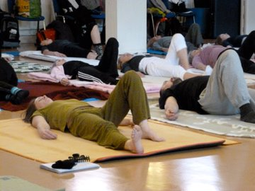ATMs are verbally guided sequences of movements allowing students to discover new patterns of organisation. The movement explorations involve thinking, sensing, moving, and imagining. Many are based on developmental movements and ordinary functional activities. Some are based on more abstract explorations of joint, muscle, and postural relationships. The lessons consist of comfortable, easy movements that gradually evolve into movements of greater range and complexity. There are hundreds of Awareness Through Movement lessons - some simple in structure and physical demand, maybe just moving the eyes – right up to some extreme ones, standing on your head, judo rolls, yogic flying. The teacher chooses lessons which are right for the students, and the student never does something that hurts. Sometimes NOT doing a movement is how you learn – perhaps doing it invisibly small, or in the imagination. New discoveries in neuroscience confirm that this is worth doing, but it can play hell with your work ethic and your guilt. Feldenkrais refuses ‘no pain no gain’, refuses that you do what you are told without question. Some people prefer to do as they’re told rather than to think for themselves - and they won’t like Feldenkrais at all.
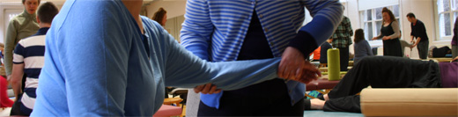
The other way Feldenkrais is taught, FI lessons, mostly use touch to guide the student through a learning experience of their habitual patterns, offering new movement patterns that are pain-free, efficient and performed without excessive force or unnecessary neuromuscular activity. The practitioner develops a lesson for the student, tailored to what the student ‘wants to do better’ (a classic question). FI – ‘Functional Integration’ - is usually performed with the student lying on a table designed specifically for Feldenkrais practice. Sometimes cushioning of various kinds is used so the student is comfortable. Feldenkrais believes that learning cannot take place in situations of discomfort or pain. There is no model of how people in general should move, or stand, or be, which is imposed on the student. It is a dialogue – sometimes referred to as a dance between the two nervous systems – pleasing to me, for obvious reasons.
So how DID it happen, in Edinburgh 5 years ago, that my heel went back where it should be? I had had some knee cartilage removed a while earlier – it is obvious [now] that this is going to disturb the mechanics of the joint but I was too dim to think of that. What’s more, so were the various health professionals I saw. Feldenkrais explores function. That ATM I did (everyone’s favourite I know now – ‘no.5’ in Feldenkrais’s 1972 ATM book) has a main agenda nothing to do with heels. But one ‘chapter’ in it tilts the bent knees with feet flat – this puts the ankle/heel joints through a whole range of alignments in relation to the knee (and hip, and pelvis, and spine, and head, and ….). Giving the body that experience enables the nervous system to review possibilities. My heel found a good place and stayed there. Feldies talk of the intelligence of the nervous system – given options, the [healthy] nervous system will take the best nourishment it can. Sometimes it takes a while, sometimes it can be immediate. If the nervous system is impaired Feldenkrais can still help – people with MS have found it useful, for example. [Studies available].
Feldenkrais is not a miracle cure – it can’t undo tissue damage – but it enables access to what is there to be had. It is a learning process, functioning on all levels of the person including unconscious ones. It’s nice that things can go right without a ton of work and effort - it is an optimistic place of being-in-the-world, not just about knees and feet. Moshe Feldenkrais himself (1904-84, Ukrainian born, later Israeli, physicist/engineer, Judo expert) conceived his Method as ‘learning how to learn’: not just doing movements, but using movement as a key to unlock the capacity of the whole person to learn and change. New movements are actually new ideas which stimulate the brain and the mind, which help us to think in new ways, to be creative, alive, imaginative. For humans to thrive and be healthy, they need to continue to be curious and to learn: extremely old people who thrive are often artists or have other continuing connections to growing and changing, to acting in the world. This sounds rarefied but no one can be more suspicious of snake oil than me – and Feldenkrais is completely practical, dry as a bone – indeed it focuses on the efficient function of the skeleton. It kills me.
New discoveries in neuroscience (brain plasticity, ‘mirror neurons’, etc.) validate strategies of the Feldenkrais Method, pragmatically discovered by Feldenkrais years ago, and incorporated in ATM texts and in training methods. The Method could be used far more widely in neurological and functional disorders, and I live in hope that, being non-invasive and cheap, mainstream medicine will make more use of it soon. Fuller accounts of the Method and how it stands in the scientific community can be found on-line – email me for links, or go to the UK or US Feldenkrais professional organisations and follow the trails yourself. (this article acknowledges the use of on-line resources considering them ‘fair use’, details on application)
Typically, Feldenkrais is turned to when all else has failed. (Neil Young has a nice story of how ‘mainly Feldenkrais’ fixed his feet and his stoop, P400 in his autobiography). Still, we are there for people at that point. One of my early students had a chronic whiplash for years, a major factor in their life and functioning. After a few months I overheard another student ask ‘how’s your injury?’: the reply came ‘what injury?’. The injury no longer dominated the student’s consciousness. This is not everything, but it is worth having, and may lead to a yet better place since it can provide a model for accessing better functioning on all levels of the person. Feldenkrais makes people feel better however old they are or however much diagnose-and-fix approaches have given up on them.
Feldenkrais isn’t exercise in the conventional sense, as you will have gathered by now. It won’t help you to lose weight or get a 6-pack. It will however help you improve your regular practice, whether running, golf, tennis, so you can get fit more easily and pleasurably. It can help you stop getting back pain, shoulder pain, wrist strain, from sitting at your computer all day. It offers strategies to change movement habits – change is difficult on a will, intention, hard work, do what someone else tells you, model. Trying to change a habit can often reinforce the habit. By looking at the function of the person as a whole system, a habit can be changed. [Listen to the words]. For the elderly, people with MS, post-stroke, Feldenkrais offers movements people can do, and it is never too late to improve. Feldenkrais does not focus on a ‘cure’, with a mindset that anything that falls short of that is not worth doing. Everyone can feel better.
And how about my dancing? My new Felden-self is able to dance from where I am now, not mourning too much about legs pointing skywards and triple turns and what not. Every micro-moment of a movement is now of interest, much more of it present in my mind, not just arriving in one impulse at a goal (and the bigger the better to boot). Feldenkrais never values range above all else. This now makes real embodied sense to me (wish it had done when I was dancing pro, maybe I would have been better at it). I had a great time last year on another Edinburgh project, run by the Festival, where pro and ex-pro dancers over 50 worked with Spanish choreographer Gelabert for two weeks (there I am, below). I lead an adult contemporary dance project in Penrith and do what other projects come up. I can now do things I never could, with economy and precision – a slow spin led by my middle finger’s pathway through space – a different sense of balance with a clear map of how my weight passes through the bones – I can enjoy being me, dancing, again in a way I thought was gone forever. Viva Feldenkrais!
PS: Snake oil department: between leaving my Proper Job and starting my Feldenkrais training, I visited my cousin in Canada. The message in my fortune cookie one night read ‘Le médicin soigne, la nature guérit’ [The doctor tends, nature cures]. This was heartening. But it is to be remembered that ‘proper’ medicine, however ‘scientific’, doesn’t actually do the curing, it is our own ability to heal that heals us. And Feldenkrais is scientific, it sets up a hypothesis, tries it, discards the things that don’t work, moves on. It is annoying that it is well-nigh impossible to set up a medical model study since every person’s body is different, and their response to previous and new experience is different. Still, for adventurers who care to try, Feldenkrais offers a royal road to the nervous system, enabling ‘la nature’ to discover what it can.


