Class 8
Please find below several resources set up in order of our typical school day in Class 8. I have included several new Lamh signing activities to use throughout the summer. I have uploaded lots of signs since April but even if you find a few of them useful that’s fine. Each of the other links below remain the same and cover a range of strands on our curriculum including Communication & Language, Maths, SPHE, SESE (Science, Geography and History), Music and Art. The links take you straight the touch screen activities and can be used with any interactive tablet.
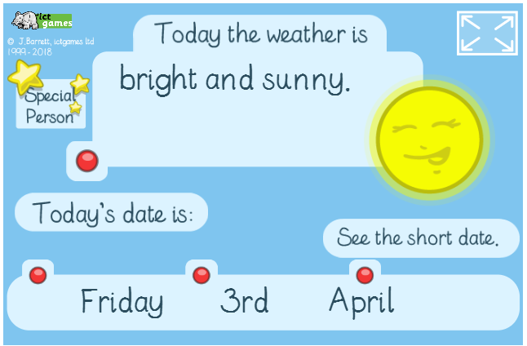

https://www.ictgames.com/mobilePage/dateChart/index.html

https://www.youtube.com/watch?v=U9Q7Y3t4m3g

https://www.youtube.com/watch?v=RVFBFqpbAbc

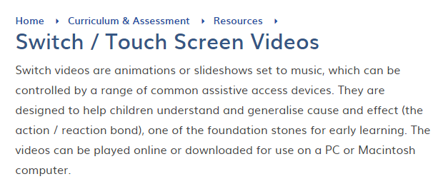

https://www.priorywoods.middlesbrough.sch.uk/page/?title=Switch+%2F+Touch+Screen+Videos&pid=231

Please find below a link to a YouTube video that we have used every morning this term. Although it is 56 mins long, I have made a note of the four clips we use for shapes, colours, numbers and phonics and the precise time each clip starts for your convenience.

https://www.youtube.com/watch?v=fMMJ5IIbHLw

Shapes – 2 mins 42 seconds Colours – 25 mins 52 seconds

Numbers – 37 mins 22 seconds Phonics – 53 mins 27 seconds

https://www.lamh.org/
As we practise our Lamh signs every day in class it is an important way for the pupils to communicate. Please click the link above to get free access to Lamh signs online which has been extended to the end of August. We can focus on a number of signs for the month of June and throughout the summer. I have divided them into four groups below and include instructions from the Lamh guide book. I’ve also included a really good link to the YouTube below which focuses on different signs that will be useful over the summer months. Signs included in the tutorial are garden, slide, trampoline, bubbles, swings and sand.

https://www.youtube.com/watch?v=HqBjhh3Gfog

PEOPLE | OBJECTS
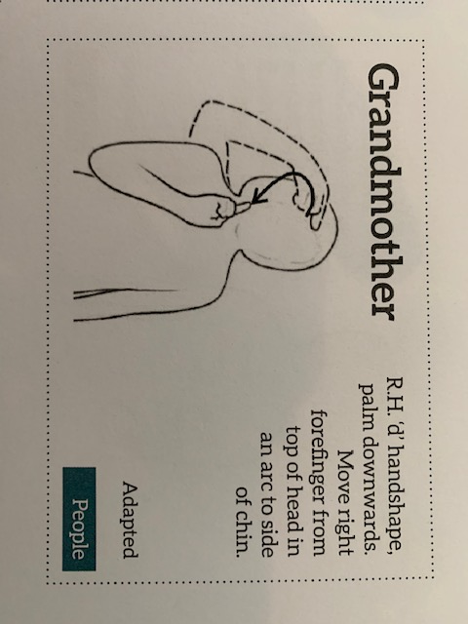  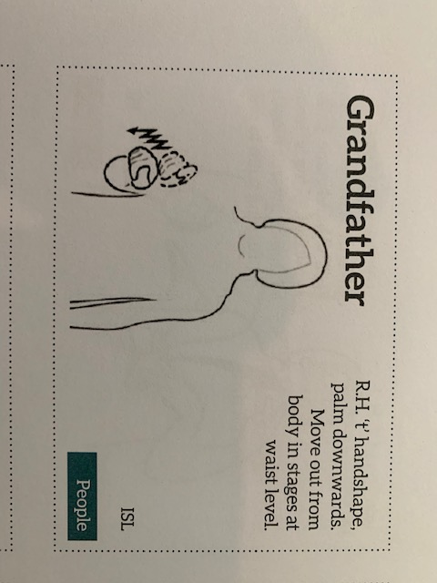  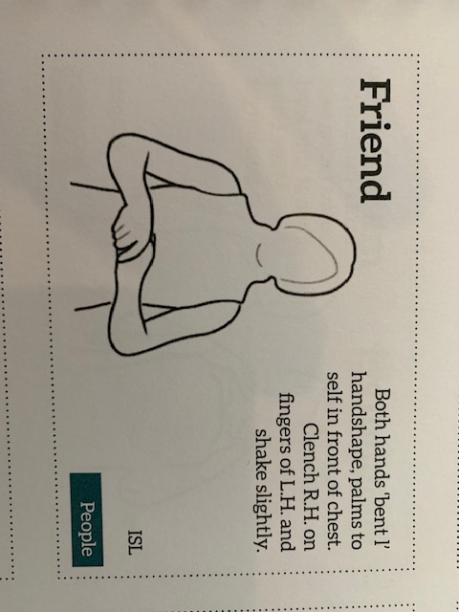 | 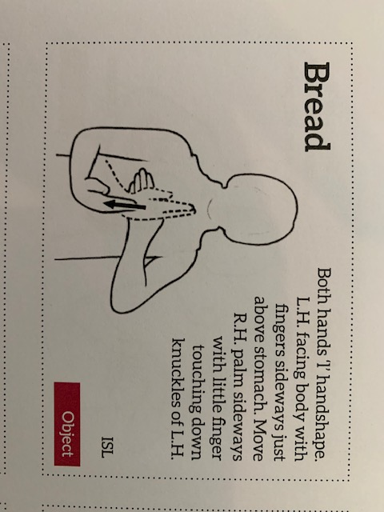  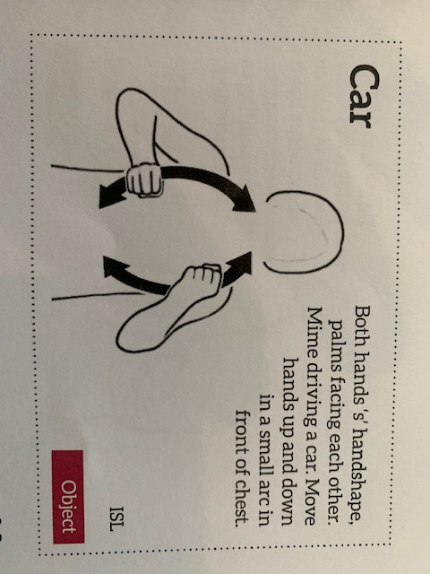  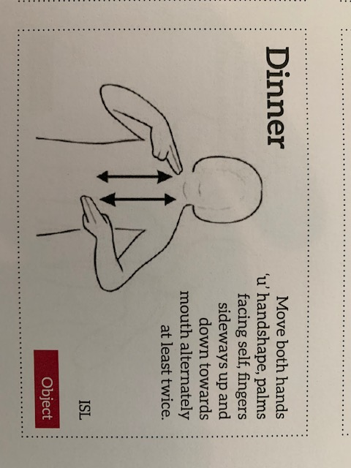
ACTION | SOCIAL
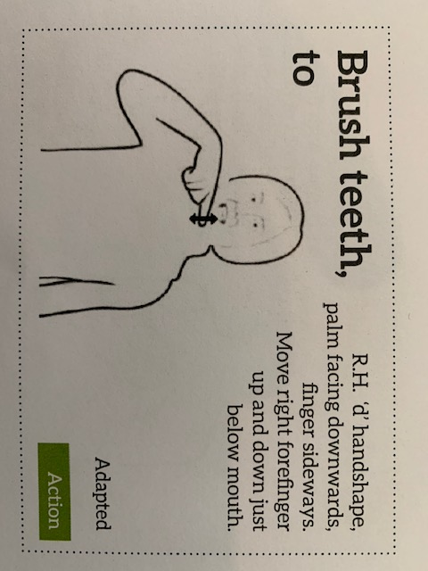  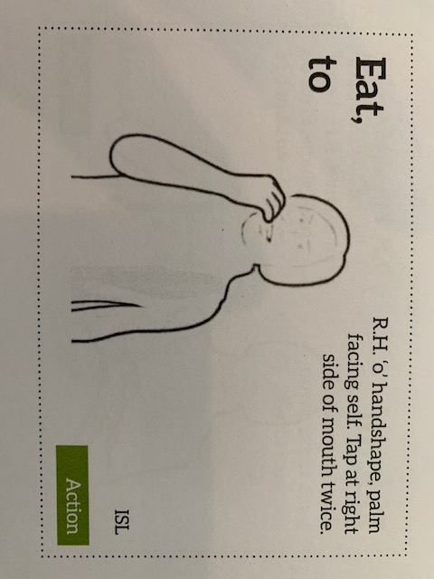  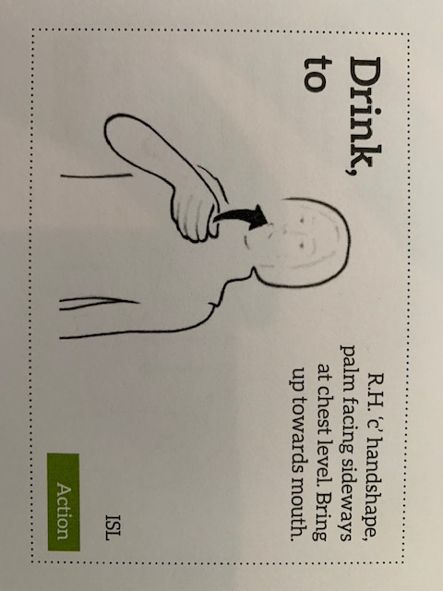 | 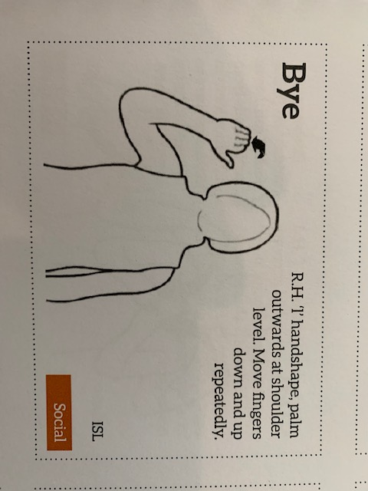  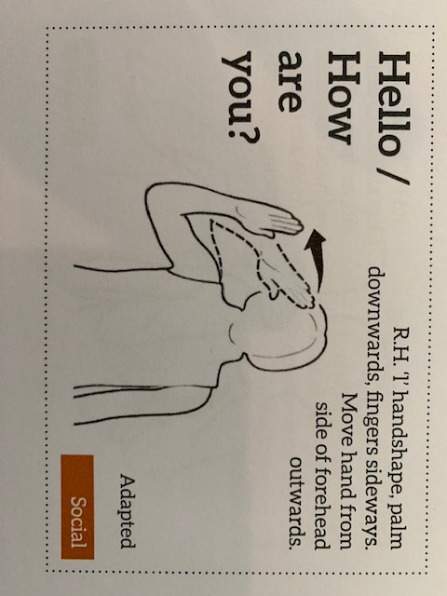

https://tacpac.co.uk/
Please refer to the following letter and guidelines below.

Hello all Tacpackers!
We’ve received lots of messages from teachers asking us to make Tacpac available to parents.We here at Tacpac HQ are well aware how much your pupils might be missing their regular Tacpac sessions now that schools have closed. We are working hard to help eveyone continue sessions, and offer help and support during this strange time.
We would like to offer all the parents whose children are missing their Tacpac sessions, set 5 free of charge for 3 months to use at home. We are compiling a series of short training bites on Facebook to help everyone get started, to get the best out of their sessions and to understand how Tacpac works.
To become effective givers to your receivers, you’ll need to know the basics of Tacpac, and a bit of the theory behind the work. Thank you for your patience and consideration while we prepare these short training videos to get Tacpac up and running for our parents.
If you would like your parents to use this set for free please just ask them to go to https://tacpac.co.uk/product/set-5, and at the checkout add the code 8Q7A3TXS
Once done, please direct them to www.facebook.com/TacpacLtd to watch our short help videos designed especially for parents. Even if your school subscription has expired but you think parents may find this a valuable resource, please do share this with them.
If you are already using Tacpac at home, please use the guidelines for health and safety: Wash your hands before and after sessions. Wash all material objects in the washing machine after each session, and disinfect all hard objects that cant go into the wash.
PLEASE DO NOT PARTAKE IN A SESSION IF YOU HAVE A NEW COUGH OR UNUSUALLY HIGH OR LOW TEMPERATURE. PLEASE DISCOURAGE OTHERS FROM DOING SO.
For those of you who have live accounts, please do go into the Tacpac Community page and let us know what you need, how you’re doing. The Tacpac Team are all working from home, and are here if you need us.
Please send your questions either to office@tacpac.co.uk or use the Community Page
Enjoy your sessions!
The Tacpac Team.

