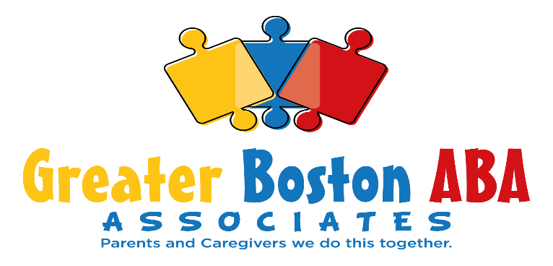 | Greater Boston ABA Associates  (617)957.6451  email kcesario_aba@yahoo.com  130 Liberty St. Ste 13a  Brockton, MA 02301

ABA SERVICES

RELEASE OF INFORMATION

Patient Name: _______________________________________ DOB: ____________________

I, _________________________, hereby authorize Greater Boston ABA Associates, provider to have
(Patient/or guardian if under 18)
correspondence to and from ___________________________________.

I understand that supervision activities and information gathering activities may include:
Verbal Discussions; face to face discussions or telephonic information sharing
Review of client record
Authorization to meet with individual/school/agency noted above
Other (please specify): ________________________________________________________________________

Notes: ____________________________________________________________________________________

I hereby consent to this release of information. I give this consent voluntarily, without threat of punishment or promise of special reward. I have been given the opportunity to have my questions answered. I have also been offered a copy of this for and understand that I may withdraw consent at any time without fear of punishment. This consent will expire one year from date signed unless otherwise revoked by patient/guardian or if services are terminated.

Signature of Parent and/or Legal Guardian Date

Signature/Clinician staff Date

