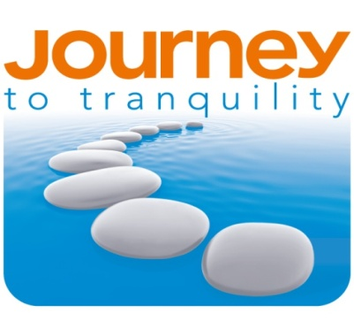
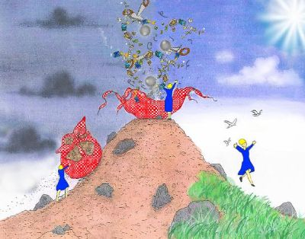
Introduction to Journey Work for Parents or Children

www.journeytotranquility.co.uk

Sandra Lindon -
Health & Well-being Practitioner
Tel: 07711 382117
www.journey-therapy.co.uk

Sue Franklin -
Health & Well-Being Practitioner
Tel: 01442 213152

The Journey method is effective with many personal or family relationship issues
- Fears, phobias, anxiety, depression
- Anger issues
- Negativity & resistance to change
- Lack of confidence and self-belief
- Addictions
All of these behaviours have an underlying emotional root cause. Journey work is excellent at pinpointing the life experience that caused the behaviour originally. It is really effective in clearing old programming, fears and negative conditioning.
Who can benefit from the Journey method?
It is suitable for children from the age of three, through to adults. In family dynamics, it may be the child that is displaying unhealthy behaviour (e.g. anger issues, sadness, withdrawal) in which case it is useful to work with the child. Experience shows that working with the significant parent can also be effective, as the child may be reacting to issues that are affecting the parent's behaviour or home life in general.
The Journey method for families assists parents or children to let go of past painful experiences and instils a deeper awareness of their own inner healthy resource qualities; allowing them to feel calmer, more confident and have more self-belief. This enables the family environment to be more consistently happy so that ultimately the whole family benefits too - a win/win!

Appointment length
It is the aim and is generally possible for the client to come to a feeling of completion about the issue within a single appointment. Two or three appointments may be necessary for more complex issues, but each session is normally very powerful and effective yet gentle. So the session length varies according to the individual and the complexity of the issue.
Journey work for adults - generally takes up to 3 hours. Journey work for children & teenagers - between 45 minutes and 2 hours.
What to expect from an appointment and how does it help?
Unhealthy patterns of behaviour or emotion have been shown to be linked to painful childhood experiences that could not be fully expressed at the time. A child's mind will try to deal with and make sense of a painful experience in a number of ways; for example by shutting down their ability to feel strong emotions and/ or by creating new operating rules that will prevent them from feeling disappointment or fear or pain in future. Unfortunately, as children do not come equipped with a manual on how to deal with life, they will often create unsupportive rules or beliefs for themselves (e.g.' Its not safe to feel my emotions; life is not safe, I always have to be on my guard; this must mean I'm a bad boy/girl').
If a traumatic experience is just ‘stuffed down’ or suppressed, several things occur: the child may become emotionally ‘stuck’ and unable to respond healthily to the world around them; the ‘stuckness’ causes old patterns of behaviour and feelings that are responses to an outdated knowledge base to be repeated. Without any intervention, it is likely that these unhealthy patterns of behaviour will still be in operation in the adult that they become.
Journey work enables the client (either adult or child) to access the memory of the original life experience responsible for the present issue. Through a safe, gentle yet very powerful method of inner visualisation and dialogue, they are able to empty out the stored pain and realise the mistake that was made in taking on these limiting beliefs and decide to let go of them. They now have the freedom to create a new, more supportive set of operating rules or beliefs. By this process the client's true potential is revealed, and a new pattern of behaviour is gradually developed.
It is usual to feel calmer, happier and clearer after an appointment because the burden of unhealthy emotions has been released and a new inner resourcefulness has been revealed. The process will carry on integrating within the body for some weeks even months afterwards, whilst the biochemistry gradually settles down and balances. Some people notice immediate improvements and for others the change is more gradual.
Clients are always assured of complete confidentiality, and non-judgement about anything that comes up during the session. There is no need to talk in detail about the issue, it is more important to acknowledge how the situation makes them feel emotionally.

The Biochemistry of emotions and connection to behaviour
(Source: The Molecules of Emotion by Candace Pert , PH.D)
Emotions are actually chemical messengers (biochemicals) which are delivered to their site of action through the blood stream. For example endorphins (the happy hormones) and adrenaline which is the stress hormone related to fear or anxiety.
Society encourages us to avoid feeling uncomfortable emotions such as fear, anger, and sadness. But when we do this, we actually suppress the emotion and cause a biochemical imbalance within the body.
The body is a complex feedback mechanism where levels of various substances which regulate all of its operating systems are constantly monitored and adjusted as necessary. When the biochemicals of emotion are suppressed, this flow of information becomes blocked and causes malfunction at a cellular level. Denied feelings over time will result in ultimate toxicity, often taking the form of an explosive release of pent-up emotion which may be overwhelming or even violent. By letting all emotions have their natural release (in a healthy way), the 'bad ones' are transformed to 'good ones' and we are released from this burden of suppressed pain.

Worldwide use of the Journey method (to name but a few examples)
- It has been demonstrated to improve the behaviour and school grades of children in South Africa and Australia.
- To improve the emotional health & well-being within disadvantaged first nations communities in Canada and Australia.
- The Canadian Department of Justice uses it to bring conscious leadership into the courtroom.
- The Israeli Education Authorities have put their management team through the Journey practitioner programme.
- The Journey method is being used for all ministry departments in the Netherlands for employees who are suffering from burnout or other stress related illnesses. Government employees in Holland suffering from work-related stress will only be funded to attend a clinic offering Journey work. The recovery of the employee is quick and there is no incidence of relapse.

Call either Sue or Sandra to discuss how Journey work could assist your clients.

