Middle Park State School
Parents & Citizens’ Association
Minutes of Meeting
Date: | 3 April 2019
Attendance: | As per attendance sheet
Meeting Chair: | Katherine Graham
Minutes By: | Shafrinah Wadood
Opened: | 7:06pm

- Apologies – As per Apologies Sheet

- Confirmation of the Minutes of the previous meeting – The Minutes from the March 2019 P&C Meeting were reviewed and ratified.
Moved: Katherine Graham Seconded: Kerryn Lewis Carried: Yes

- Correspondence Received – Inward & Outward –
- Container Refund Scheme – email advising steps to be taken to take part in this scheme. Agreement for Container Refund Scheme (CRS), Steel Bin Service and Wheelie Bin Service also received.
Moved: Katherine Graham Seconded: Kerryn Lewis Carried: Yes
- CMSolutions – email advising the benefits to our P&C of having a membership with them. A detailed description of their services was also sent over.
Moved: Kerryn Lewis Seconded: Katherine Graham Carried: Yes

- Business Arising from the Correspondence – Nil
Moved: Seconded: Carried:

- Executive Committee’s Decisions – Nil
Moved: Seconded: Carried:

- Treasurer’s Report – Presented by Kerryn Lewis
See Appendix 2, 3 & 4
Below is a summary of the current position for Middle Park P&C.
Total Cash at Bank as at 31 March 2019 - $472716K
BUILDING FUND $5068.50
Current outstanding payments $20K – Super, GST, PAYG, Creditors
Significant commitments to be paid this year include:
$50K School Contribution
$280K Facilities Contribution
Estimate $100K over 3 years - Air Con maintenance & replacement program
 | Profit  YTD Actual | Budget  YTD Actual
P&C Consolidated | ($39636) adjusted $40K | ($47K) | $76K school contrib. paid
OSHC | $51831 | $49791
Tuckshop | ($5035) | ($6800)
Uniform | $6987 | ($1233)
General | ($93419) adjusted ($17K) | ($12.5K) | $76K school contrib. paid  $9.7K aircon, + audit, insurance, $1K from school collected last year as donation from Jess Pugh MP

Additional notes:
Bluestone Bookkeeping have advised they will no longer be continuing in the role of external bookkeeper, we were paying them $300/mth. We have sought quotes from Westmere Accounting & Tradies Bookkeeping. Westmere Accounting have quoted the following: each quarter, we can review figures/ files provided by you and provide feedback and check quarterly tax code and accounts, payroll in Xero, and send you Profit and Loss report for the quarter , prepare and lodge Superannuation report, Business Activity Statement (BAS) for a fee of $280 per quarter.
I move that we engage Westmere Accounting to provide services on a quarterly basis, plus transfer the Xero subscription to Westmere Accounting. $280 + $120 + GST/mth. We may also require one month of services in the transition stage approx. $280 + GST.
Moved: Kerryn Lewis Seconded: Sue Jones Carried: Yes

- Admin Report – Presented by Anne Kitchin
Calendar – Appendix 1
ENROLMENT
643 students
CASH AT BANK
Net Assets at 03/04/2019 $506 585.74
Balance Sheet Summary April 2019.pdf
STAFFING
- Karen Martin 24/49/5
- Kate Davison – 26/410/4
- Fiona Graham 17/62819/7
- Rebecca Storey –Guidance Officer 9/524/5
EVENTS TO BE RATIFIED
Calendar – Appendix 1
Moved: Katherine Graham Seconded: Kerryn Lewis Carried: Yes
School Council
The school council meeting was held last night. The following policies were accepted for the year.
- Annual Budget
- Annual Implementation Plan
- Investing For Success
- Student Achievement Data
..\..\School Council\Data\2018\Academi Results English 2018.pdf
..\..\School Council\Data\2018\Academic Results Maths 2018.pdf
..\..\School Council\Data\2018\Academic Results Science 2018.pdf
..\..\School Council\Data\2018\Academic Results HASS 2018.pdf
- Student Behaviour Data
- Enrolment Data

The council has been emailed the constitution to give feedback before the next meeting on any part of the document that they find incorrect or ambiguous.
The Next meeting will be held on 19 June which is not a P&C week.

General Report
- Facilities
There was a facilities meeting planned for last Friday with the P&C but no members were able to attend. I have included a little of the information we had
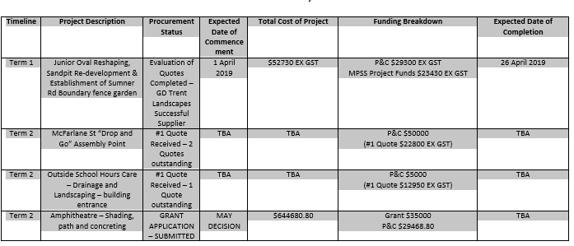

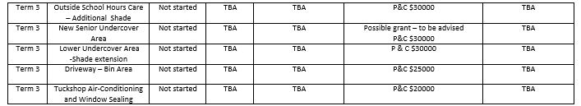

- Resource Centre
The Resource centre is open for business. There is a purpose build /Special Education area and classroom. Additionally there is a large break out space for intervention, housing for resources and some meeting rooms.

- Opening of the Grandstand
The ceremony to open the grandstand has been postponed. The dignitaries who were to attend are unavailable until 13 May. There will be an upper school ceremony in place of assembly.

- Cross Country
The cross country was postponed and unfortunately does need to be run at the same time as the Easter Bonnet parade.

8:50am | All year 3, 4, 5 and 6 students to have their “age” label attached and assemble on the top oval in their House stand. All Checkpoint officials to their checkpoint.
9:00am | Marshalling for 12yrs students
3km | 12years (born 2007) girls and boys
3km | 11years (born 2008) girls
3km | 11years (born 2008) boys
2km | 10years (born 2009) girls
2km | 10years (born 2009) boys
1km | 9years (born 2010) girls
1km | 9years (born 2010) boys
1km | 8years (born 2011) girls and boys
Amy would appreciate 2 parent volunteers for the day.
XCountry Map - 1km.pdf
XCountry Map - 2km and 3km.pdf

- Sports Jerseys:
Thankyou to the parents who put quite a bit of time and effort into the application for sports Jerseys for Rugby, netball and multi use. We have always had the policy that non contact sport wears the sport uniform but the jerseys will be greatly appreciated.

- Cyberbullying
We are working very hard with our students to inform them and equip them about how to deal with cyberbullying. There was a parent meeting at JHSS on Monday night which had an excellent guest speaker to discuss the issue of cyber bullying. There were very few attendees. This is an area that is looming for all families. I have also had a parent at our school who has volunteered to speak to parents. I would like your input into what you feel would be the ideal time to hold this.

- Fundraising
Bec Ham has met with the Principal and Business Manager to discuss upcoming fundraising events. It was a long meeting and we still have some things to discuss. Bec has contacted me today around the possibility of continuing this session via email.

- Energy audit
There has been a request for the information that we gained from the energy audit. These findings were gleaned from several sources and Dee would be happy to share them after the meeting on Friday

- Lockdown
There was a lockdown drill today. This is always a learning curve. The process improved in accuracy and efficiency this time. We are waiting for feedback from staff to inform the update of the policy and in turn inform staff.
- Meeting Time
There have been many emails and meetings around various aspects of the P&C working arrangements. I propose that I make a permanent meeting time and put it in my calendar that I will be available to discuss any issues or plans. I propose Friday morning at nine am as a possible time for this meeting to be scheduled in my diary
I would like to move that the principals report be accepted by the P&C
Moved: Anne Kitchin Seconded: Kerryn Lewis Carried: Yes

- Outside School Hours Report – Presented by Jess Tierney
ATTENDANCE
- Vacation Care: Between 80 – 90 children most days. On par with 2018’s Easter Vac figures.
- After School Care: Between 114 – 148. (2 from capacity on a Thursday)(Over 135 across 3 midweek days)
- Before School Care: Between 104-117 (unchanged since previous report).

PERSONAL DEVELOPMENT/STAFF TRAINING
- Jessica Tierney to attend Professional Development linking with school’s leadership and high 5 programs facilitated by Anne Kitchin
- Inara Wesche to facilitate an Inclusion Support specific PD to best support our SEP children, transitions and OSHC environment. Date TBC (meeting 02/05/19).
- Signed up to free online webinars & training through Early Childhood Australia. These will be conducted and workshopped at staff meetings.
- QCAN Training Workshop: Examining Behaviour 05 June 2019 – to be attended by Jessica Tierney and Leah Utteridge.

COMMUNITY INVOLVEMENT
- Jessica Tierney & Leah Utteridge to attend a Monthly Reflection Meeting with local OSHC’s facilitated by Jindalee OSHC on 07/05/19
- Jessica Tierney & Leah Utteridge to attend a QCAN Member Meeting at Jindalee OSHC on 20/06/19
- Jessica Tierney & Tegan McLeod to attend a QCAN Yarning Circle - Reconciliation on 28/05/19

INCIDENTS/ACCIDENTS/INJURIES/ILLNESSES
- Behavioural Incident 28th April 2019
  - Violence towards children and staff members.
  - First & Final warning letter issued
  - Behaviour Support plan in place, agreed & signed upon by child involved, parent & Jessica Tierney.
  - Behaviour Support Plan is reviewed monthly.
- Increase in general accidents for the month. Expected given Vacation Care (longer hours & increased activities)
ACTIONS/COMMITMENTS THIS MONTH
- 2IC position has been advertised internally. Applications due 5pm, 05 May. Interviews to follow within the next 1-2wks.
- Outsourcing of Policy & Procedures review, amendment and customisation being carried out by QCAN. Quoted cost $80/hr. Information being sent through 01/05/19.
- QikKids Journeys registered
  - “On boarding” (training & setup) commences 09 May 2019
- Debt Collection
  - Standard agreement for services has been requested from Prushka and Marshall Freeman.
  - Once received Katherine & Kerryn will advise final decision.
- Resource Orders:
  - Ikea – placed
  - Amart Furniture – placed
  - Fantastic Furniture – placed
  - Uniform Orders – placed

Moved: Jess Tierney Seconded: Katherine Graham Carried: Yes

- Tuckshop Report – Presented by Sue Jones
The teachers’ menu will be added soon. Extra day for tuckshop is in discussion – possibly Tuesday. Still in need of regular volunteers. However, there were 4 new volunteers this week.
Moved: Sue Jones Seconded:Di Barber Carried: Yes

- P&C Shop Report – Presented by Stephanie Donaldson
Entertainment books sales have begun
Senior shirts have been delivered. Sample was displayed. New orders can be made but required to have a minimum of 10 per order.
Moved: Stephanie Donaldson Seconded: Tristan Dieben Carried: Yes

- P&C Administration Report - Nil
Moved: Seconded: Carried:

- Fundraising Committee Report – Presented by Kelly Ede
We had a slow start to term 1 but finished with the Easter Egg Guessing Game and the Cross Country Snow Cones - together raising $864.

Term 2 will see the Loose Change Challenge, Mother’s Day stall, Election Day BBQ and the family photo fundraiser all happening before June 1st.

Moved: Kelly Ede Seconded: Katy Kilgour Carried: Yes

- Facilities Report – Nil
Moved: Seconded: Carried:
- Social Media/Marketing Report – Presented by Sue Jones
See Appendix 5
*I officially took on the role as social media/marketing coordinator after the March meeting, however I had started this new direction on the 4th of March. In the last 28 days:
 | Previous | Current | Count | % | Notes
New page likes | 601 | 605 | 12 | 100% | 12 new likes but dislikes?
Post reach | 340 approx. * | 1,295 | 745 | 136%
Post engagement | 102 clicks *  14 comments * | 2,3000 | 2000 | 809%
Page views | Unsure | 162 |  | 54%
Page previews | Unsure | 10 |  | 9%
3 second video views | Unsure | 403 |  | 247%
New followers | Unsure | 632 | 13 | 117%
Clicks to website |  |  | 1 | 100%
*based on single post about tuckshop on the 31/2/19
* I have set up OSHC page - https://www.facebook.com/mpssOSHC. This will allow Jess to have a public platform to share about our amazing centre. Unfortunately, not many outsiders (and current parents) do not know that we have an OSHC. I will work with her on implementation. Posts will be shared with @MPSSP&C Facebook page. –
*I am working on a tuckshop, P&C shop and possible fundraising. Again, this will allow coordinators to share their info, but it is mainly a way to post and answer questions using a professional tone and safeguarding our personal accounts.
*I am working with the school leadership team on synergy between our Facebook pages.
*I request that all social media go via myself to allow for cohesion.
Social media campaign ideas:
Get to know our P&C –
Interviews with P&C executives, members and helpers.
Thankful for our P&C –
#ThankYouP&C #AttitudeOfGratitude
#FundedByTheP&C –
Pictures of things that were funded by the P&C.
For the school –
Share info from student council
Thank you for your time.
Sue Jones.

- Chaplains Report – Presented by Shafrinah Wadood
Welcome back for 2019
General overview:
- FRIENDS Program for term 1 has been completed. Will continue next term with new participates.
- Social and emotional pastoral conversation with targeted students.
- Breakfast Club finished for this term. First Breakfast Club will be the 30/04/19.
- Continuing to run games in the library during first break. Well attended.
- Supporting a number of students from different Years levels.
- Attended Year 1 and 2 swimming carnival.

SU Qld team Contribution
- Attending SU In-service 06/03/19

Thank you for the continuing support of the P & C.
Bernie McMullen
Moved: Shafrinah Wadood Seconded: Katherine Graham Carried: Yes

- Culture Committee – Nil
Moved: Seconded: Carried:

- General Business
- Grant by Oregon discussed. Oregon to be advertised by school. If safety seminar is conducted, we get a free fridge.
Moved: Janet McPherson Seconded: Sue Jones Carried: Yes

- Music Stand Covers
Quote was brought in from School Banners (Website: schoolbanners.com.au)
50 x music stand banners @ 37.50 each OR 20 x music stand banners @ 49.50 each. Digitally printed 240gsm shiny trilobal banner fabric, heat cut sides, 100mm top envelope pocket on the back and finished with a fringe Free Design artwork.
PLUS 1x Custom made School Flag, 1800 x 900 (full size) @ free cost (digitally printed and finished with flag cord and clips) Free Design Artwork.
PLUS GST. PLUS FREE DELIVERY.

It was reflected that $2,000 is a good amount to be spent on the covers, but more quotes were asked to be brought in.
Moved: Di Barber Seconded: Kerryn Lewis Carried: Yes

- Working Bee to be organised during winter months – will be discussed at next meeting as part of facilities report.
- Building Fund (to be called the AC Fund) will be discussed at Facilities Sub Committee meeting
Moved: Sean Finnerty Seconded: Katherine Graham Carried: Yes

- $100K to be placed in a 5 month Term Deposit with the Commonwealth Bank.
Moved: Kerryn Lewis Seconded: Kelly Ede Carried: Yes

- Wobble stools would like to be bought for some kids finding it hard to concentrate in Prep classes. A quote from Modern Teaching Aids (MTA) at $60ea was brought in. A set of 6 can be bought at a cheaper rate. It was agreed that if it were approved that the school or P&C can buy them.
- Furniture replacement scheme – replaced some furniture across the school.
Moved: Di Barber Seconded: Sue Jones Carried: Yes

- New Memberships
Sharon Brand

Meeting closed at 8:45pm

The next P&C Meeting will be held on 8th May at 7pm in the Resource Centre

Appendix 1
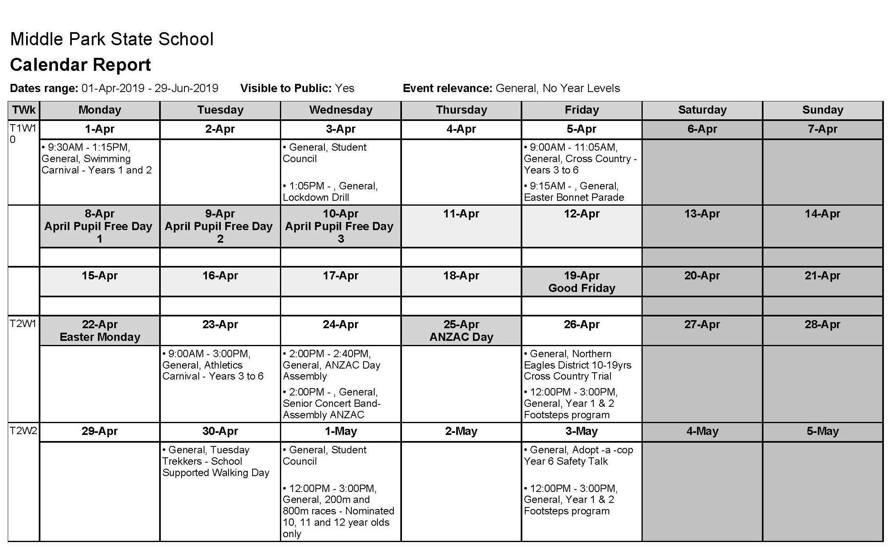
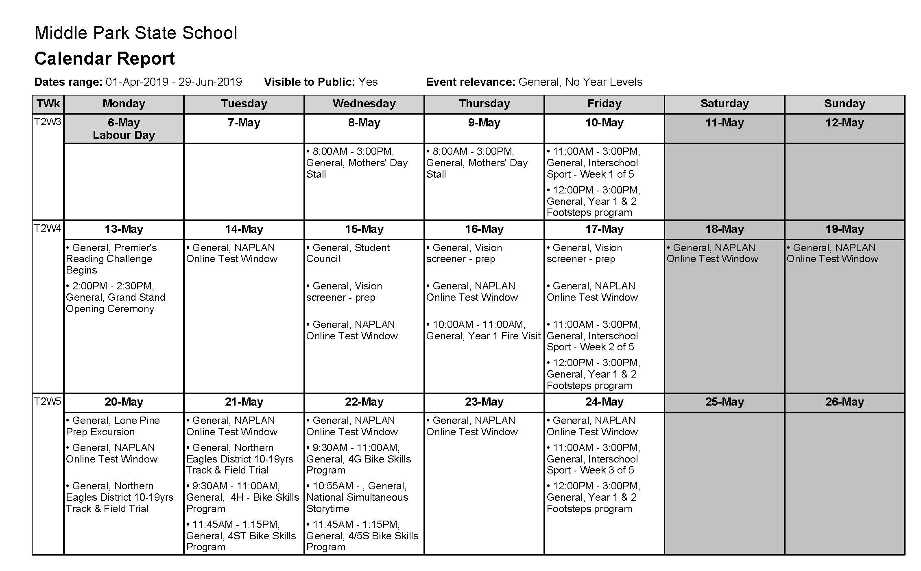
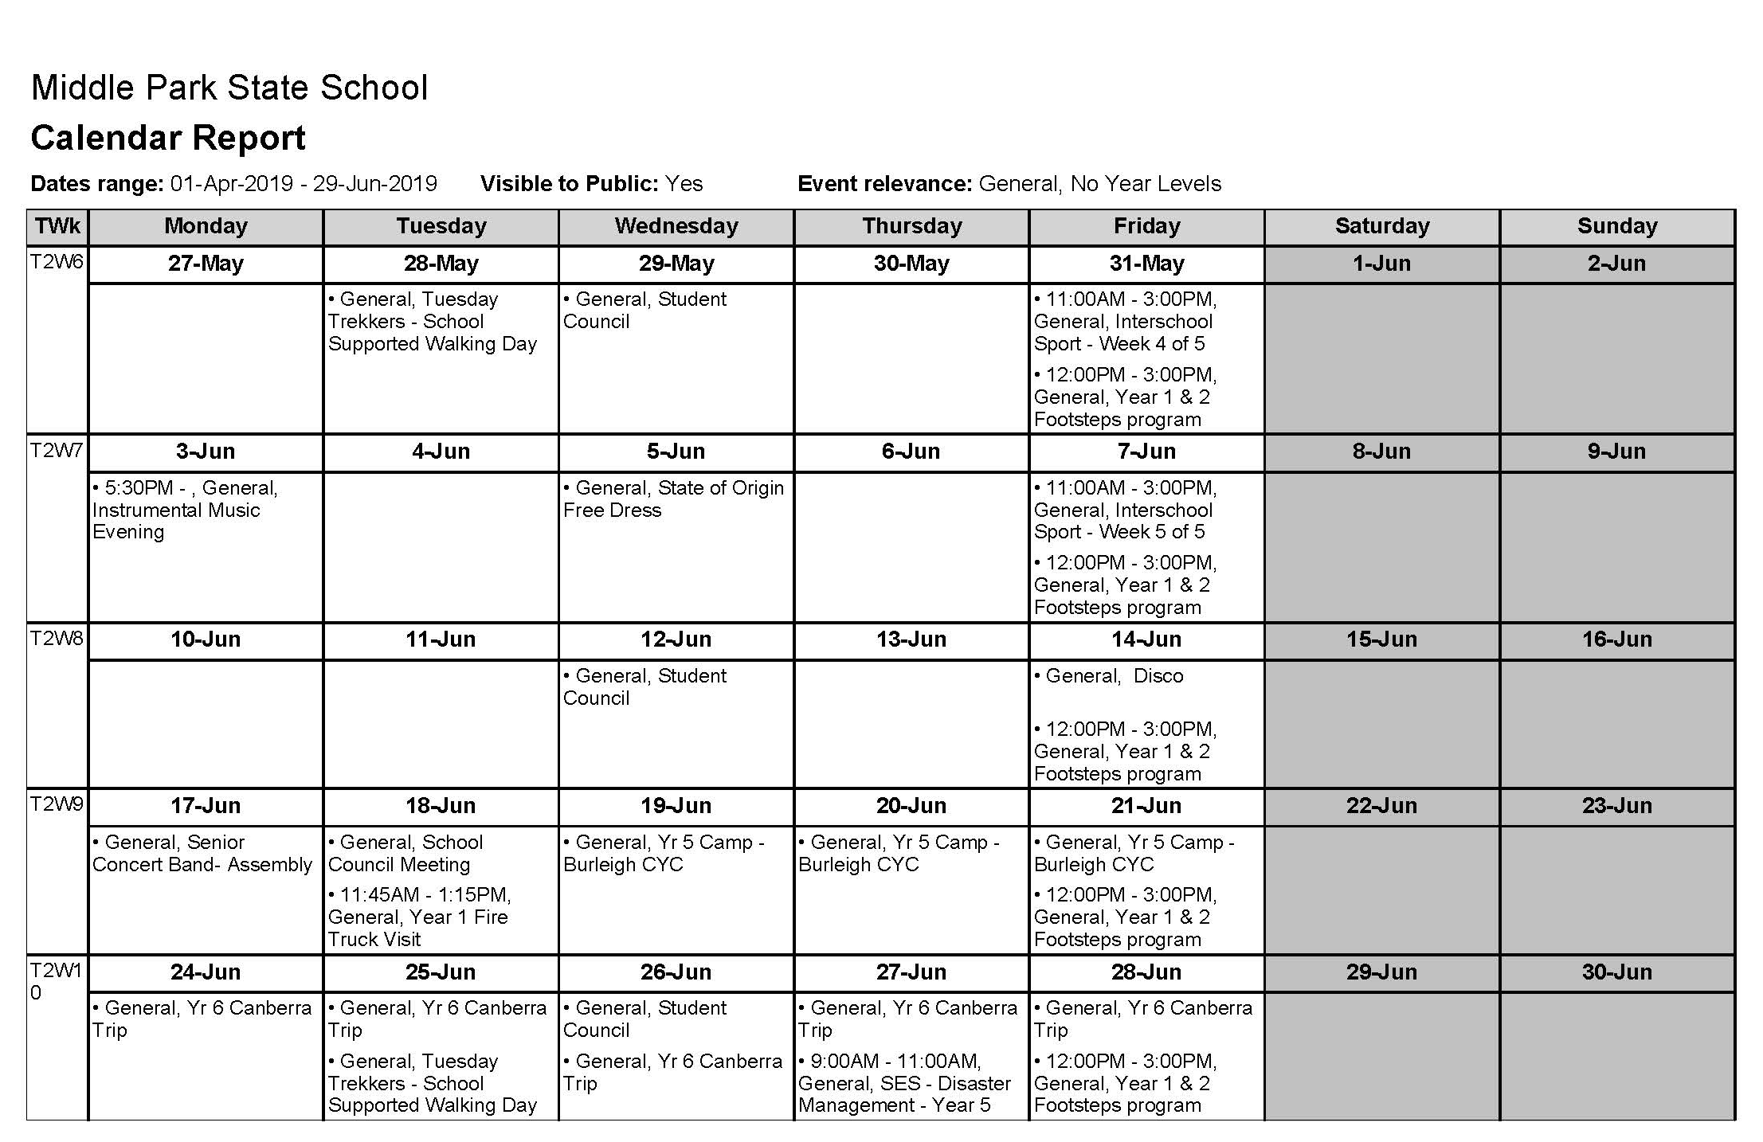
Appendix 2
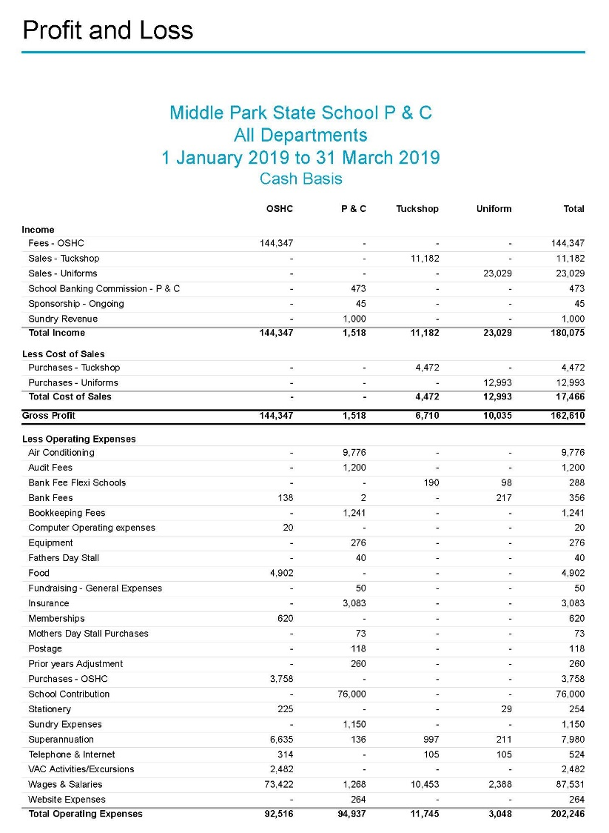

Appendix 3
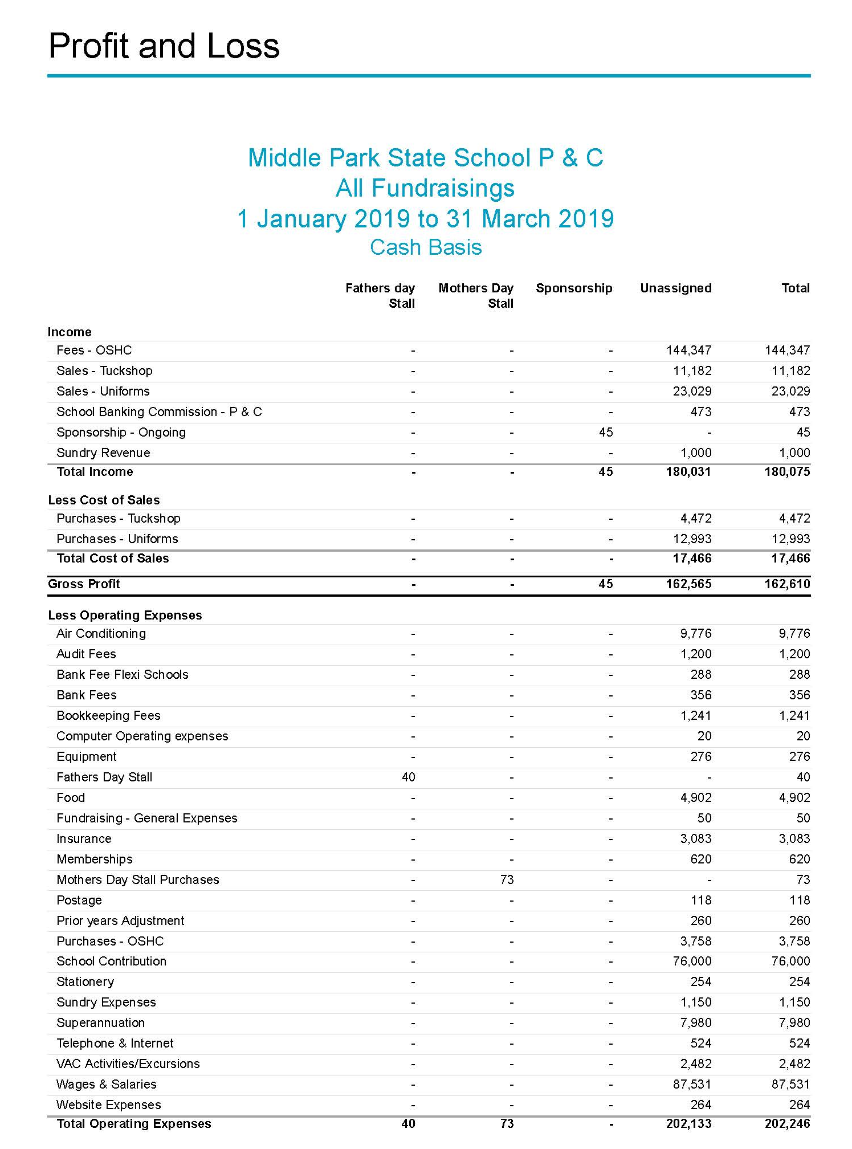

Appendix 4

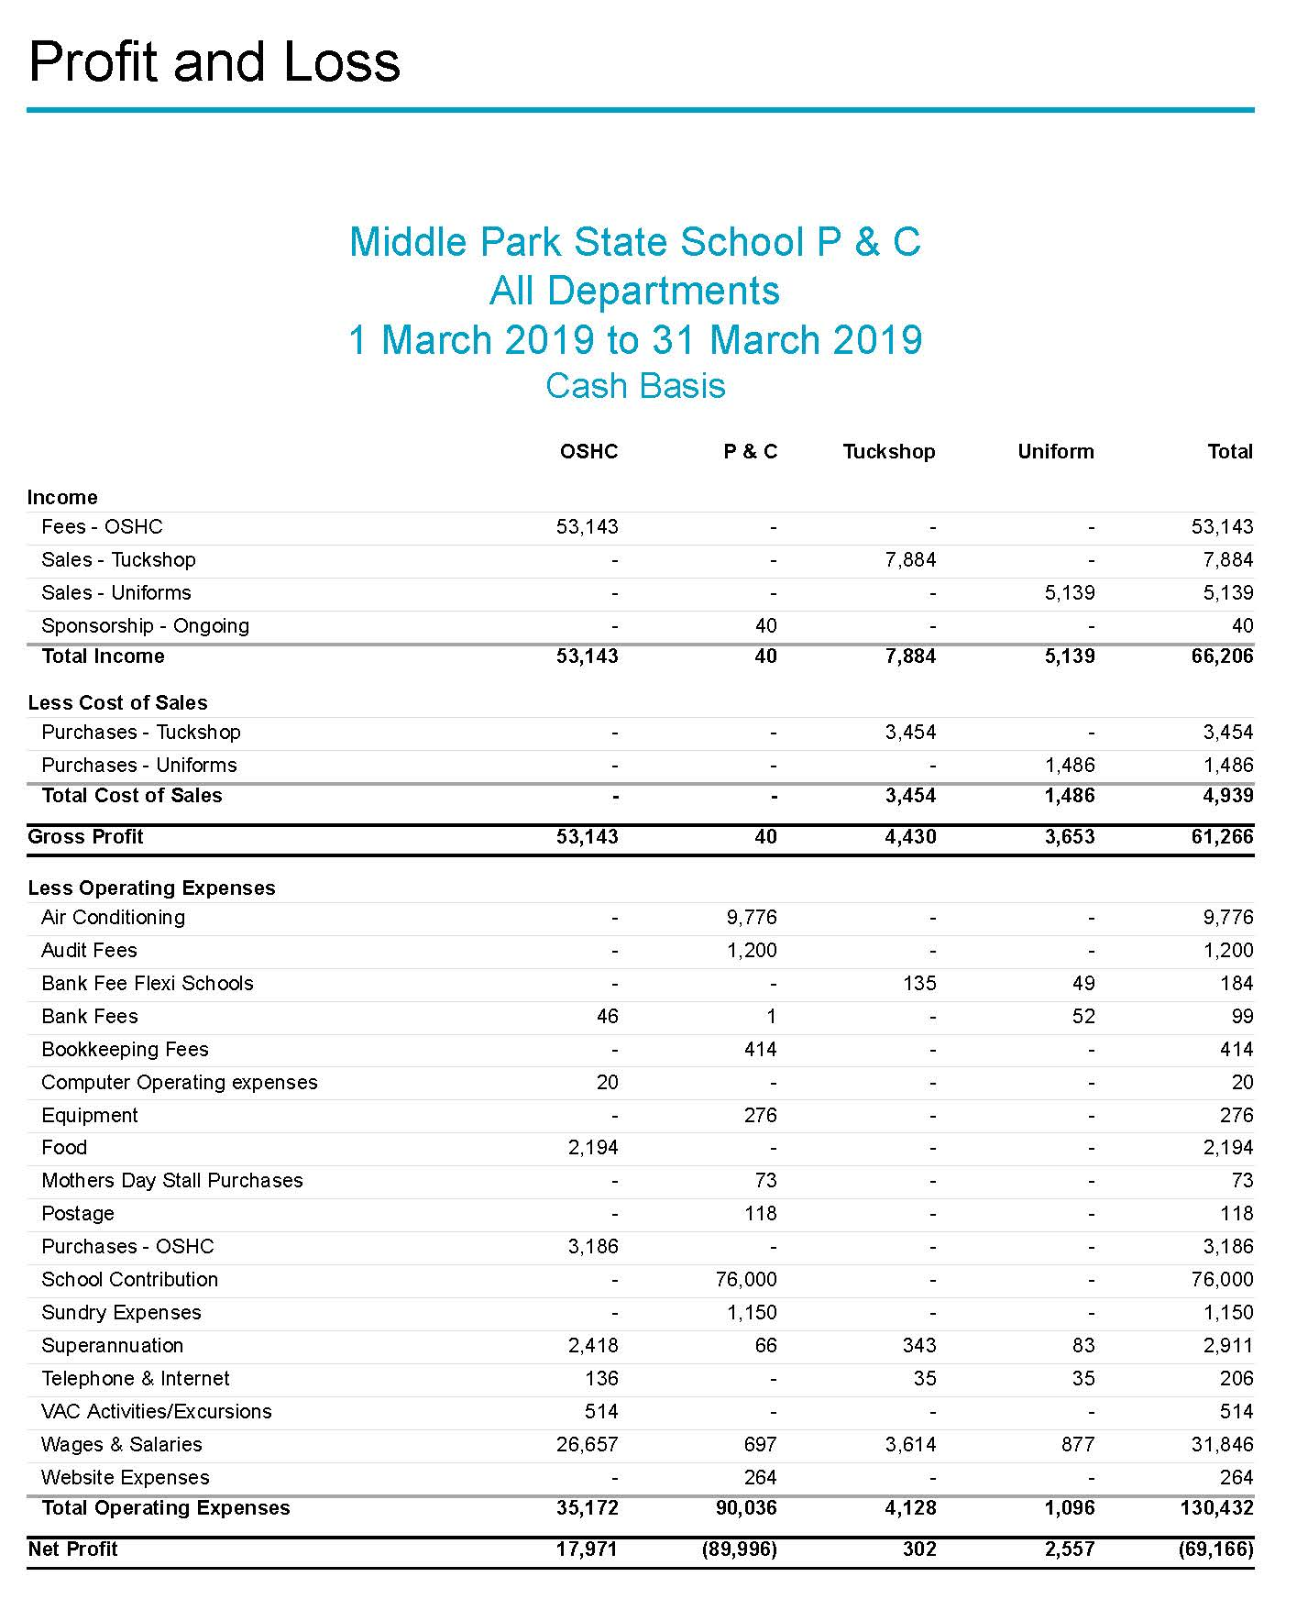

Appendix 5

Published | Post | Type | Reach | Engagement:  Clicks  Comments, shares, etc.
02/04/2019  17:01 | Cross country timetable. | Status | 42 | 2  0
02/04/2019  14:59 | Why is it always at pick up time?? Don’t forget the umbrellas guys. And remember to be patient and careful whilst driving & parking around the school. 🌂🌧☔️ | Photo | 262 | 6  10
02/04/2019  07:57 | Today is World Autism Awareness Day. This is a great video to show your children that helps to explain autism and hopefully foster a little understanding. https://m.youtube.com/watch?v=7JdCY-cdgkI I am sure that we are all looking forward to the opening of the new & improved “IMPACT” room this year. This is a space where children can come in times of need or also to work collaboratively in small groups or one-on-one. Having a son with Autism, I am very grateful that I enrolled him at Middle Park State School, where he thrived after previous bad experiences and lack of support. -SJ. | Link | 220 | 4  3
01/04/2019  20:20 | A beautiful day for a swimming carnival. | Photo | 275 | 47  18
31/03/2019  22:05 | 💥Monday 1st April - Junior (Yr 1&2) swimming carnival 9:30am (Angie's Barista Koffee will be in attendance.) 💥Monday 1st April - last chance to have a guess (50c) for Easter egg guessing game (lower undercover area) - before school 💥Tuesday 2nd April - School council meeting - 7pm 💥Wednesday 3rd April - P&C meeting - 7pm 💥Friday 5th April - Senior (Yr 3-6) Cross country - 9am 💥Friday 5th April - Prep & Yr 1 Easter parade - 9:15am 💥 Friday 5th April - Snow cones available from the tuckshop $2.50 - 2nd break only. 🎉Friday 5th April - Last day of term 1 / beginning of Easter school holidays - 3pm | Photo | 494 | 165  27
29/03/2019  16:55 | March school newsletter. https://middleparkss.schoolzineplus.com/newsletter/54107 | Link | 212  Reach  212 | 14  14  0  0
29/03/2019  06:50 | Do you have your Student Advantage Card? This is an easy way to support the P&C when shopping for school/office supplies. |  | 174  Reach  174 | 5  5  3  3
28/03/2019  19:27 | Reminder: Tomorrow is school banking day. Please drop your books off to the P&C shop from 8:15am. | Photo | 201  Reach  201 | 1  1  1  1
28/03/2019  14:18 | Middle Park State School P&C shared a post. | Photo | 167  Reach  167 | 2  2  3  3
28/03/2019  14:18 | FYI. Please note that the snow cones are also postponed. | Status | 68  Reach  68 | 4  4  0  0
27/03/2019  07:06 | Such a beautiful and loving community that we live in. | Link | 177  Reach  177 | 13  13  7  7
26/03/2019  22:10 | Thank you to those that attended our recent AGM. If you missed it, our next general meeting will be held on the 3rd April at 7pm in the library (a week earlier due to the school holidays), and the minutes are available on our website. https://www.mpsspnc.com/default.html | Link | 326  Reach  326 | 26  26  7  7
26/03/2019  07:41 | A colouring in competition for a great cause -Save the Bilby Fund. Did you know that rabbits (bunnies) are illegal in Queensland? Rabbits can cause land degradation by damaging vegetation through ringbarking trees and shrubs, preventing regeneration by eating seeds and seedlings and grazing on native herbs and grasses. They also contribute to the decline of native animal's numbers through competition for resources. Their burrows and digging may also cause erosion and increase sedimentation of waterways. #BilbiesNotBunnies | Photo | 263  Reach  263 | 19  19  3  3
26/03/2019  07:27 | ‘Cyber safety’ parent information session hosted by a local school - Jamboree Heights State School. | Photo | 156  Reach  156 | 5  5  2  2
25/03/2019  16:46 | Middle Park State School P&C shared a post. | Photo | 230  Reach  230 | 31  31  4  4
25/03/2019  09:28 | For those that may be interested. | Photo | 92  Reach  92 | 5  5  1  1
25/03/2019  09:27 | For those who may be interested. They are looking for a few more U13’s also. | Status | 172  Reach  172 | 8  8  2  2
25/03/2019  09:23 | Check everyday for your child’s letter. You can never have too many name labels. | Photo | 251  Reach  251 | 29  29  4  4
25/03/2019  08:12 | COMMUNITY NOTICE: PARKING AROUND OUR SCHOOL This week- Monday to Thursday will see MORE cars around as the school hosts BRAINways students at our school. Families from many schools around Brisbane will descend on our grounds and need to sign their students in and out from the event. Please consider: * Using the drop-off zone correctly - drivers are not to leave their car nor stay longer than 2 minutes in the drop-zone. * Parking further and walking to the school - please be mindful to NOT park on yellow lines, in the bus zone, across driveways, or leave a large space between you and another vehicle. *Do not drop children on corners, this is unsafe for your child(ren) and dangerous for other drivers. For VISITING FAMILIES AND STUDENTS, the Middle Park P&C welcomes you and we hope you enjoy your time at our school. A reminder that we are all important to somebody, so patience and care is appreciated. ❤️ | Photo | 377  Reach  377 | 71  71  9  9
24/03/2019  20:07 | A great little video for kids that are reluctant nighttime brushers (looking at my children 😒). | Shared Video | 309  Reach  309 | 33  33  4  4
23/03/2019  20:57 | This sounds like it might be a fun day/night out. | Link | 288  Reach  288 | 35  35  4  4
23/03/2019  19:56 | Middle Park State School P&C shared a post. | Link | 101  Reach  101 | 0  0  0  0
23/03/2019  19:56 | Middle Park State School P&C shared a post. |  | 134  Reach  134 | 3  3  0  0
23/03/2019  19:55 | Middle Park State School P&C shared a post. | Photo | 133  Reach  133 | 4  4  0  0
23/03/2019  19:53 | Middle Park State School P&C shared a post. | Link | 124  Reach  124 | 14  14  0  0
23/03/2019  19:53 | Middle Park State School P&C shared a post. | Link | 104  Reach  104 | 4  4  0  0
22/03/2019  15:56 | Science with 4H | Photo | 167  Reach  167 | 8  8  2  2
22/03/2019  15:55 | Out and about with 3S | Photo | 162  Reach  162 | 5  5  1  1
22/03/2019  15:54 | Middle Park State School P&C shared a post. | Status | 65  Reach  65 | 5  5  0  0
22/03/2019  07:42 | Students are invited to come to the lower covered play area before school and have a go at guessing the number of easter eggs in the jar. 50c per guess, and the closest guess wins the whole jar! Year 6 students will be in the lower covered play area each morning from 8:30 - 8:45, Thursday 21/03 until Monday 01/04. The winner will be announced on assembly. In the event of multiple correct guesses, the names of those students will be put into a hat and a winner drawn at random by Mrs Kitchin. The P&C would like to thank you for supporting this fundraiser. | Photo | 372  Reach  372 | 12  12  7  7
21/03/2019  09:16 | Our Tuckshop staff are wearing some gorgeous fruit themed odd socks for world Down Syndrome day today. | Photo | 411  Reach  411 | 83  83  21  21
21/03/2019  08:25 | Who has been collecting their free books for their little learners? Thanks #bigw #reading #books | Photo | 153  Reach  153 | 6  6  5  5
21/03/2019  06:05 | Middle Park SS will be celebrating harmony day on Monday 25th March. Please wear orange or traditional dress. No gold coin donation will be required. | Photo | 356  Reach  356 | 38  38  14  14
20/03/2019  19:58 | How amazing is the Easter vacation care program from our OSHC. Our new coordinator Jess and her team are taking enrolments now and places are filling fast. Registration forms can be found on our website - https://www.mpsspnc.com/upload/Registration%20Form%20Easter%202019.pdf | Photo | 412  Reach  412 | 129  129  21  21
20/03/2019  14:07 | The year 5 enjoyed their visit to Lone Pine Koala Sanctuary. | Photo | 245  Reach  245 | 36  36  12  12
20/03/2019  11:11 | Dear Parents and Caregivers, Parent Teacher Interviews – 2 April 2019 Please find below the link to book your parent teacher interview. https://middleparkss.schoolzineplus.com/view-session/1 As this is a new updated platform please find the Parent Booking Guide for your reference. Parent Booking Guide: https://middleparkss.schoolzineplus.com/sk-booking-guide If you have any questions please contact the office on either admin@middleparkss.eq.edu.au or 3712 9888. | Link | 488  Reach  488 | 147  147  15  15
20/03/2019  06:27 | What makes you happy? Let us know in the comments. | Video | 341  Reach  341 | 81  81  21  21
17/03/2019  10:50 | ☘️🇮🇪 Happy St Patrick’s Day from the Middle Park P&C. 🇮🇪☘️ | Photo | 346  Reach  346 | 44  44  6  6
16/03/2019  08:00 | The 2019 Special Olympics World Games Abu Dhabi 2019 have been officially opened. Middle Park P&C hopes that all athletes have an amazing time representing their countries and we wish them the best of luck. Of course we are cheering for Team Australia. 🇦🇺 🐨 If you or your child wishes to send their support to our amazing Australian athletes you can do so by sending a Herogram. bit.ly/19-Herogram #MeetTheDetermined #ChooseToInclude | Shared Video | 291  Reach  291 | 7  7  3  3
15/03/2019  20:44 | The Middle Park P&C are deeply saddened by the awful events that occurred today in New Zealand. We offer our deepest sympathies to our NZ neighbours and all those touched by this tragedy. Hug your children a little tighter tonight. The following may be helpful when talking to your children about the traumatic news. https://mobile.abc.net.au/news/2014-12-23/illustrated-guide-coping-traumatic-news/5985104 If you or someone you know needs support, call: Lifeline on 13 11 14 Kids Helpline on 1800 551 800 MensLine Australia on 1300 789 978 Suicide Call Back Service on 1300 659 467 | Photo | 850  Reach  850 | 222  222  66  66
15/03/2019  15:46 | Great reading MPSS! | Status | 104  Reach  104 | 2  2  1  1
15/03/2019  07:36 | Everyone is important. Let’s celebrate our differences! Middle Park State School encourages the use of the High 5 anti-bullying model. Say Bullying. No Way! #NDA2019 www.bullyingnoway.gov.au | Photo | 547  Reach  547 | 63  63  15  15
13/03/2019  23:04 | Congratulations to our new executive team. Katherine Graham - President (Re-elected) Tristan Dieben - Vice President Sean Finnerty - Vice President Kerryn Lewis - Treasurer (Re-elected) Flame - Assistant Treasurer Shafrinah Wadood Zubair - Secretary Christina Carter - Secretary Assistant (Previously Secretary) The committee would like to thank the departing executive members for all the hard work & commitment to the P&C and Middle Park State School. Ann Gooding - Vice President Michaela Griffiths - Leese - Vice President | Photo | 426  Reach  426 | 86  86  12  12
13/03/2019  15:45 | Our AGM will be held tonight at 6:30pm followed by our March Meeting. We hope to see you there. | Photo | 511  Reach  511 | 140  140  18  18
12/03/2019  20:54 | Our Annual General Meeting is tomorrow 13th March at 6:30pm. Thanks to our treasurer we now have an online form if you wish to become a member. The AGM is the only meeting that you can apply for membership without being in attendance. https://drive.google.com/open?id=1CP772Pqz6hnWcSzZP0jwzwLnRonS2Kb_hG46hyzSlU4 Hope to see you there. | Link | 85  Reach  85 | 3  3  1  1
11/03/2019  14:04 | Thank you Little Treads. 👞👟 | Photo | 331  Reach  331 | 117  117  12  12
08/03/2019  07:00 | How lucky our students are to be surrounded by such great role models within the schooling environment. Happy international women’s day. #BalanceforBetter #IWD2019 | Photo | 390  Reach  390 | 12  12  34  34
05/03/2019  20:48 | Get to know the 4074 community. | Link | 215  Reach  215 | 9  9  5  5
05/03/2019  14:45 | Middle Park State School P&C shared a post. | Photo | 243  Reach  243 | 36  36  11  11
05/03/2019  13:27 | Time for a more personal post: I ❤️ pancake day!! This day is celebrated around the world under different names, Shrove Tuesday, Fat Tuesday and in lots of different ways including Mardi Gras, (though they do not consume pancakes). (https://en.m.wikipedia.org/wiki/Shrove_Tuesday) I celebrate it every year in remembrance of my late grandfather who was born on Shrove Tuesday in 1920!! My children on the other hand love Pancake day as it means they get pancakes for dinner!! Do you and your family celebrate Pancake day, Shrove Tuesday, Fat Tuesday or Mardi Gras? What special things do you do and eat? Or please do share some amazing pancake ideas so that I can drool. | Photo | 302  Reach  302 | 31  31  6

