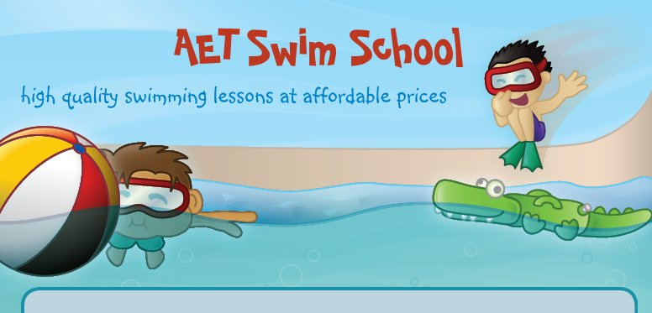

Swimming Lessons Terms & Conditions

- A course of lessons will be run on a continuous 10 week block scheme.
- The course fee is payable on registration, no place will be secure without payment.
- Transfer of pupils during the course of lessons may take place when authorised by the class teacher. The new placement is subject to availability of time and group. All transfers will be administered by staff.
- In the interest of Health & Safety, parents are not permitted on poolside.
- We reserve the right to cancel any lesson without prior warning and at short notice. A subsequent lesson will be added to the end of the course. Therefore it is essential that we have up to date contact details
- Refunds will not be given for non-attendance, holidays etc. Individual situations will be considered if the child is ill and has a Doctors note.
- To ensure pupils receive the teacher’s fullest attention, parents are requested not to approach the teacher during lessons or try to get the child’s attention.
- Details regarding the swim scheme will be displayed on the notice board and available online at www.aetswimschool.co.uk or twitter @aetswimschool, this is to help us be a green business.
- Children are expected to behave in an appropriate and acceptable manner, ensuring non-disruption of the class. The teacher has the authority to ask the pupil to leave poolside.
- The use of goggles during the lesson will be at the discretion of the teacher.
- Pupils and parents are asked to respect swim school staff, school staff and other parents and children.
- Children over 8 MUST use their appropriate changing room.

