STUFF THE BUS
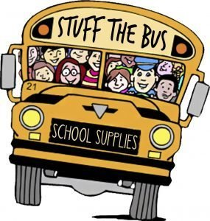

Stuff the Bus is a Project REACH school readiness program that provides backpacks, school supplies and other items to prepare low-income students for the first day of school and to ensure their success throughout the school year.
This initiative is run by volunteers and others who will collect donated supplies through a school bus parked in various locations (e.g., Las Palmas) to provide school supplies to Westside school children and homeless teens.
With economic difficulties increasing, and many families’ resources dwindling (Today, 3 in 4 children in Westside San Antonio qualify for financial assistance), these donations help children get the right start to the school year and ensure they are ready to learn.

How You Can Help

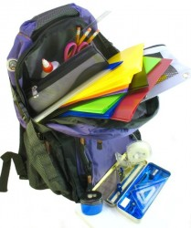Donate School Supplies
Backpacks, school supplies, and gently-used musical instruments can be donated during scheduled collection drives or at any time by dropping them off at 2300 W. Commerce St, Ste. 309.
Register
Form
Submit
For a suggested list of needed supplies click here.

SCHOOL SUPPLY LIST

Writing essentials
- No. 2 pencils (Stick with this classic to avoid classroom competition over whose writing utensil is the coolest — or most impractical.)
- Colored pencils
- A pencil sharpener (hand-held with a top to collect shavings)
- A large pink eraser (The old-fashioned ones do the best erasing.)
- Ballpoint pens
- A box of crayons (Teachers recommend buying a 16-pack for younger kids, more for older ones.)
- Washable markers
- Spiral-bound or composition notebooks
- Loose-leaf notebook paper (Teachers can be picky about paper. Schools usually supply specially ruled handwriting paper to help younger children with letter formation. Older children use wide-ruled paper.)
NOTE: Feather pencils, light-up pencil sharpeners, or pretty erasers that don’t work should be avoided

Organizational helpers
- Expensive folders with multiple pockets and zippers are often too bulky to fit in desks. Better to stick with more streamlined (and cheaper) models.
- A three-ring binder
- Pocket folders (If you get a folder with two pockets, label one “keep at home” and the other “bring back to school” to help your child organize his papers.)
- A box for storing items (Teachers recommend one that’s eight inches long by five inches wide by two inches deep to hold pencils, crayons, erasers and scissors.)
- Highlighters (These are probably unnecessary for kids in kindergarten through second grade.)
- Index cards, ruled and unruled (for making flash cards)
- A sturdy, supportive backpack (Some schools do not permit rolling backpacks because of space considerations, so check with your school before purchasing one.)

Craft materials
- Dioramas and other 3-D projects provide a hands-on learning experience for students. Most teachers recommend having these items available:
- Drawing paper
- Construction paper
- A ruler with English and metric measurements
- Glue sticks
- A four-ounce bottle of white glue
- Scotch tape
- A stapler
- Scissors (blunt ended for younger kids, pointed for older ones)
- Watercolor paints

Home computer supplies
- Printer paper
- Ink cartridges

Nice to have
- A sturdy lunch box
- A stainless steel water bottle (To be extra safe, you might want to avoid plastic bottles that contain bisphenol A, a hormone-disrupting chemical linked to such health problems as heart disease and diabetes.)

Sponsor a Child
- $10: Sponsor a Child for 1/2 School Year
- $20: Sponsor a Child for Full School Year

Sponsor a Teacher
- $20: Sponsor a Teacher (donation used to provide teachers in the Westside schools with classroom supplies such as tissues, pens, pencils, glue sticks etc.).
Mail checks payable to “Community Development Partnerships, Inc.” 10650 Culebra, Ste. 104-R 219, San Antonio, Texas 78251 (or drop it off at 2300 W. Commerce, Ste. 309, San Antonio). Please be sure to write “Stuff the Bus” in the memo or subject line of the check.

Volunteer

If you would like to volunteer for Stuff the Bus please email Jesusa Bautista or call 210-538-5000.

