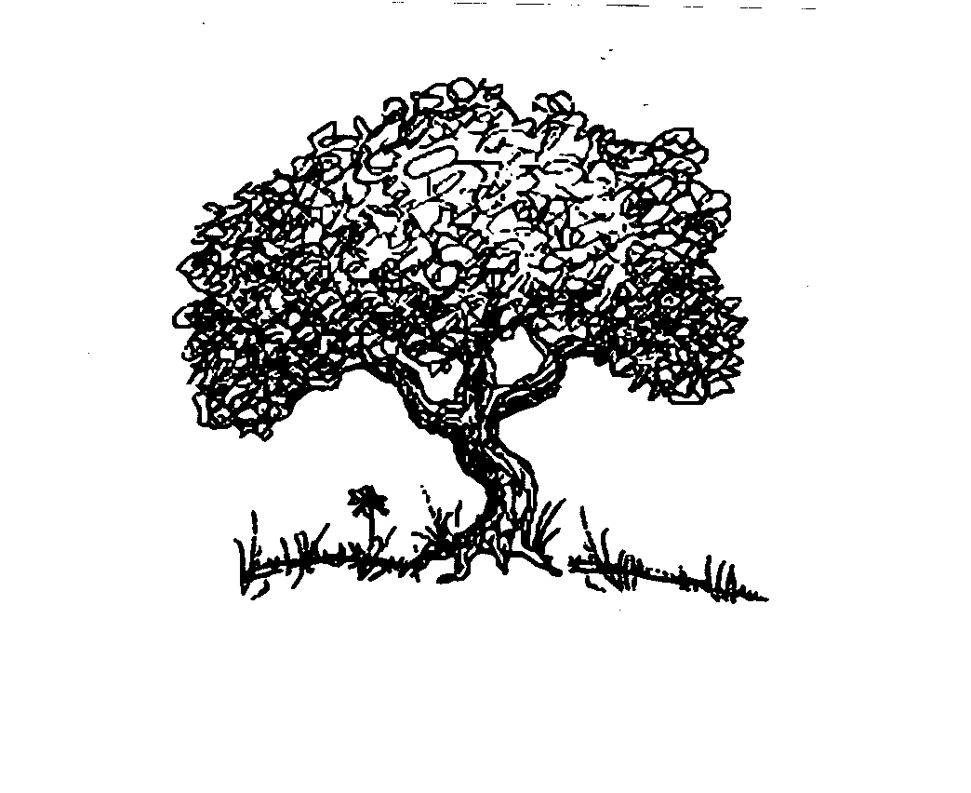

Fawn Gonzales, LCSW
Independent Practitioner
The Sharing Place

14 Cottage Street
Medford, OR 97504
(541) 779-2390
f. (541) 779-3260

Authorization to Use/Disclose Health Information

Client Name: _____________________________________________________ DOB ____________________
I authorize Fawn Gonzales, LCSW, to disclose information to, and obtain information from:
Name: ______________________________________________________________________________
Clinic/Agency: _______________________________________________________________________________
Address: ______________________________________________________________________________
Phone: _______________________________________ Fax: __________________________________
Description of information to be disclosed:
____ Unlimited Access ____ Chart Notes
____ Assessments, Consultations & Evaluations ____ Diagnosis
____ Nursing/Doctor/Hospital Medical Information ____ Educational Information ____ Toxicological Reports/Drug Screens ____ Progress in Treatment
____ Treatment Plan/Summary ____ Presence/Participation in Treatment
____ Verbal ____ Discharge/Transfer Summary
____ Medication Management Information ____ Continuing Care Plan
____ Demographic Information ____ Other______________________

The purpose of this disclosure of information is to improve assessment and treatment planning, share information relevant to treatment and when appropriate, coordinate treatment services. I understand that I may revoke this release at any time by submitting a written notification, but that such a request will not apply to any information exchanged prior to the date of such a notification being received by Fawn Gonzales, LCSW. Unless sooner revoked, this consent expires on: ___________________________________

Signature of Client: _________________________________________________ Date: _____________________

Signature of Parent or Guardian: _______________________________________ Date: _____________________

Signature of Therapist: _______________________________________________ Date: _____________________

