One decision that needs to be made when deciding to buy a gun for self defense is what caliber gun are you going to buy?
This document may be of help. Read it with an open mind and if you have questions, ask and I will try my best to answer or find the answer for you.

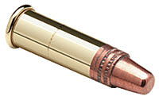
.22 LR

PROS: Firearms are small, ammo is cheap and they are adequate especially as a backup weapon.
FMJ bullets are suggested as bullet choice due to the fact this caliber does not have adequate energy to reliably expand and penetrate with the JHP so in this case, penetration is needed to get the bullet to a depth where maximum vital tissue damage can occur.
Cons: Not ideal as a primary weapon, but if it is what you can shoot with comfortably then it is acceptable.
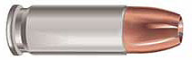
.25 ACP
PROS: Firearms are small. Not much else can be said as a Pro for the .25 ACP
CONS: Very minimal (poor choice for any use). Ammo is expensive.

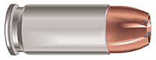
.32 ACP
PROS: Firearms are small, Minimal as backup with FMJ ammo. FMJ bullets are suggested as bullet choice due to the fact this caliber does not have adequate energy to reliably expand and penetrate with the JHP so in this case, penetration is needed to get the bullet to a depth where maximum vital tissue damage can occur.
CONS: Ammunition is expensive and hard to find. Minimal at best.
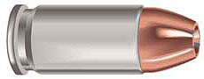
.380 ACP
PROS: Firearms are small, adequate as backup with FMJ ammo. FMJ bullets are suggested as bullet choice due to the fact this caliber does not have adequate energy to reliably expand and penetrate with the JHP so in this case, penetration is needed to get the bullet to a depth where maximum vital tissue damage can occur.
CONS: Ammunition is expensive and ballistics are minimal for self defense.

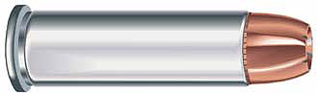
.38 Special
PROS: Adequate with 158g and heavier bullets, small firearm size, ammunition is inexpensive and easy to find.
CONS: Limited firearm choice (revolvers) and marginal ballistics.

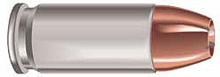

The 9mm Luger

PROS: An excellent choice in both 124 gr. and 147 gr. bullets. Ammunition is cheap and plentiful due to its world wide acceptance. Many guns offer high capacity magazines even in compact designs.
Note: In NYS this is 10 round capacity max.

CONS: Some believe that this cartridge offers marginal performance as a self defense round at the lighter loads. With improved bullet design I do not believe that this is true, though I would still go with the heavier bullet if possible.

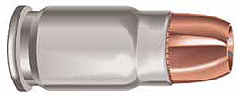

.357 Sig

PROS: Excellent choice. Penetration is excellent as well as ballistic performance. Were it not for the cons below this would be one of the best choices.

CONS: Ammunition is hard to come by and very expensive. Recoil can be harsh but with practice manageable.

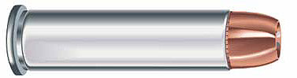

.357 Magnum

PROS: Excellent choice and ammunition is abundant and reasonably priced. (You can practice with cheaper .38 special ammunition)

Cons: Limited capacity as it is only available in revolvers. Recoil can be harsh but with practice manageable.

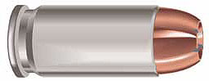

.40 S&W

PROS: Excellent choice, ammunition is abundant and economical. High capacity magazines are available in many models.
Note: In NYS this is 10 round capacity max.

CONS: Recoil can be harsh but with practice manageable.

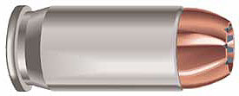
.45 ACP

PROS: Considered by many to be the ultimate self defense caliber. Superior performance with all available weights and even FMJ.

CONS: .45 ACP guns are usually large, heavy and have limited capacity. Recoil can be harsh but with practice manageable.

In closing I would like to add that the 22LR, .25, 38 special and .380 are considered minimal for self defense as a primary firearm. However, they are definitely not out of the running if they are a backup, all that is available or if they are the only ones that you find you can shoot well.

A well placed (center of mass, head or spinal column), 22LR, .25, 38 special or .380 is much better than a total miss or minimal hit with any of the other above.

But you should buy the biggest caliber gun that you can shoot comfortably.

Lastly, the decision as to what caliber also hinges on what gun you will be buying and what it is for. If you will be carrying concealed the size of the gun is critical since it must be comfortable to wear or carry and it must be kept concealed. It must be a gun and caliber that you will carry and not leave at home because it is too big or that you fear the recoil of.

On the other hand if the gun is for home protection, then size may not be as big an issue. (But we must consider over penetration issues if we are thinking about a home defense gun) That is for another article.

Lastly within each caliber choice is bullet choice.

Bullets come in a wide variety of shapes, metals, and multi-metal composites, and weights. Bullet types commonly encountered in self-defense applications are summarized as follows:
FMJ: Full Metal Jacket. The round-nosed bullet is enclosed on its top
and sides in a hard metal jacket, usually consisting of an alloy of copper or occasionally mild steel. The base of the bullet is open, exposing a lead core. The bullet design is not conducive to either expansion or deformation. According to terms of The Hague Convention of 1899, and subsequently the Geneva Convention, this is the only type of bullet permitted in small arms during warfare. It is also referred to as "ball" ammunition.
Except where stated this is not a good choice for self defense due to over penetration, but it is fine for practice.

JHP: Jacketed Hollow Point. The bullet is constructed of a soft lead core enclosed in a hard metal jacket. The top of the bullet has an opening in the jacket, exposing a hollow lead core. Upon impact, the bullet is forced to open up and expand. This results in less penetration, but greater tissue damage due to the larger diameter of the now expanded bullet.
“Best Choice for Self Defense “

NOTE: above where FMJ was suggested as bullet choice the reason for that is that those calibers do not have adequate energy to reliably expand and penetrate with the JHP so in these cases, penetration is needed to get the bullet to a depth where maximum vital tissue damage can occur.

LHP: Lead Hollow Point. The bullet is similar to a JHP, but is constructed completely of lead and has no jacket.

SJHP: Semi-Jacketed Hollow Point. This bullet is similar to a JHP, but the jacket does not completely cover the lead core. A small section of core at the top of the bullet is left exposed. This older bullet design is still common in the .38 Special, .357 Magnum and .44 Magnum calibers.

LRN: Lead Round Nose

LW: Lead Wadcutter. The bullet is flat-nosed.

The last 4, the LHP, SJHP, (not readily found) LRN, and LW should not be used for self defense but make great practice rounds.

More discussion on this issue will be covered in many of my classes.

Considered the best self defense weights for each caliber:
- .38 Special - 158 grain JHP
- 9mm - 147 grain JHP
- 357 Sig - 147 grain JHP (although the 125 grain loads are certainly impressive when loaded to potential of 125 grains @ 1450 fps)
- .357 Magnum - 158 grain JHP
- .40 - 180 grain JHP
- .45acp - 230 grain JHP

