 | DEPARTMENT OF VETERANS AFFAIRS  Veterans Benefits Administration  Washington, D.C. 20420
July 10, 2012

Director (00/21) In Reply Refer To: 211D
All VA Regional Offices and Centers Fast Letter 12-18

ATTN: All Veterans Service Center and Pension Management Center Personnel

SUBJ: Final Rule: Dental Conditions

Purpose

This fast letter provides information regarding the Department of Veterans Affairs (VA) publication of the final rule, RIN 2900-AN28, Dental Conditions.

Background

On March 17, 2011, VA published AN28, Dental Conditions, in the Federal Register proposing to amend its adjudication regulations regarding service connection of dental conditions for treatment purposes.

On January 30, 2012, the final rule of AN28 was published in the Federal Register at
77 FR 4469. The rulemaking clarifies existing regulatory provisions, and reflects the respective responsibilities of the Veterans Health Administration (VHA) and Veterans Benefits Administration (VBA) in determinations concerning eligibility for dental treatment. Because VHA has primary responsibility for determining eligibility for dental treatment, VBA will prepare a rating decision or provide the requested information under the provisions of 38 CFR § 3.381 only when VHA requests such a rating or information necessary to assist in its determination. AN28 became effective on February 29, 2012.

Dental Treatment Procedures:

(1) If a claim for dental treatment is submitted directly to a VBA regional office, VBA will not prepare a dental treatment rating, but will refer the claim to the VHA outpatient clinic. VHA may then determine and, as needed, request information or a rating from VBA in the following circumstances to determine

- a compensable service-connected disability (subject to service connection for compensation purposes);
- whether there is dental disability due to combat wounds or service trauma;

Page 2.

Director (00/21C)

- prisoner of war status; or
- whether the Veteran is totally disabled due to service-connected disability.

Note: If requested by VHA, a dental treatment rating will only be prepared to determine whether there was combat or service trauma that caused a dental disability, or whether one or more teeth were extracted while on active duty (under Class II). A copy of the dental treatment rating should not be furnished to the Veteran. VHA is responsible for notifying the Veteran of his or her eligibility determination.
(2) If a claim for disability compensation is submitted that includes a compensable dental condition as an issue, VBA will prepare a rating for compensation purposes and notify VHA.
(3) If a claim has not been filed, but the Veteran is requesting treatment at a VHA clinic, VHA may request information or a dental treatment rating from VBA under Class I, Class II, Class II(a), Class II(c), or Class IV, when needed. VHA is responsible for notifying the Veteran of his or her eligibility determination.
Note: VBA will not provide a dental treatment rating decision for Class IV-total disability. VBA will annotate on the VA Form10-1731 that the Veteran is totally disabled.

VBA Regulatory Changes Associated with AN28.

AN28 amended 38 CFR § 3.381, Service connection of dental conditions for treatment purposes, to provide for the following:

- VBA will adjudicate a claim for service connection of a dental condition for treatment purposes after VHA determines a Veteran meets the basic eligibility requirements of 38 CFR § 17.161 and requests that VBA make a determination on questions that include, but are not limited to, any of the following:

  - former prisoner of war status;
  - whether the Veteran has a compensable or non-compensable service-connected dental condition or disability;
  - whether the dental condition or disability is a result of combat wounds;
  - whether the dental condition or disability is a result of service trauma; or
  - whether the Veteran is totally disabled due to a service-connected disability.

Page 3.

Director (00/21C)

- VBA will determine whether non-compensable diseases, such as treatable carious teeth, replaceable missing teeth, dental or alveolar abcesses, and periodontal disease are eligible for treatment under Class II. Periodontal disease is not a compensable disability and not eligible for treatment even when secondary to a service-connected disability, except for Class II. VBA will not prepare a dental treatment rating for periodontal disease or disabilities that are non-compensably rated under 38 CFR § 4.150.

Questions

Enclosed documents include a copy of the Federal Register publication, which contains the text of the regulatory amendment; 38 U.S.C. §17.161, Authorization of outpatient dental treatment; and dental rating guidance. Submit questions regarding this fast letter to VAVBAWAS/CO/21Q&A

/S/
Thomas J. Murphy
Director
Compensation Service

Enclosures

Enclosure 1

[Federal Register Volume 77, Number 19 (Monday, January 30, 2012)]
[Rules and Regulations]
[Pages 4469-4471]
From the Federal Register Online via the Government Printing Office [www.gpo.gov]
[FR Doc No: 2012-1873]

==================================================================

DEPARTMENT OF VETERANS AFFAIRS

38 CFR Part 3

RIN 2900-AN28

Dental Conditions

AGENCY: Department of Veterans Affairs.

ACTION: Final rule.

-----------------------------------------------------------------------

SUMMARY: The Department of Veterans Affairs (VA) adopts as a final rule
the proposal to amend its adjudication regulations regarding service
connection of dental conditions for treatment purposes. This amendment
clarifies that principles governing determinations by VA's Veterans
Benefits Administration (VBA) for service connection of dental
conditions for the purpose of establishing eligibility for dental
treatment by VA's Veterans Health Administration (VHA), apply only when
VHA requests information or a rating from VBA for those purposes. This
amendment also clarifies existing regulatory provisions and reflects
the respective responsibilities of VHA and VBA in determinations
concerning eligibility for dental treatment.

DATES: Effective Date: This amendment is effective February 29, 2012.

FOR FURTHER INFORMATION CONTACT: Arlene George, M.D., MPH, Regulations
Staff (211D), Compensation Service, Veterans Benefits Administration,
Department of Veterans Affairs, 810 Vermont Avenue NW., Washington, DC
20420, (202) 461-9700. (This is not a toll-free number.)

SUPPLEMENTARY INFORMATION: In a document published in the Federal
Register on March 17, 2011 (76 FR 14600), VA proposed to amend 38 CFR
3.381, which identifies some of the circumstances under which dental
conditions that may not qualify as disabilities for purposes of VA
disability compensation may nevertheless be service connected for
purposes of VA dental treatment under 38 U.S.C. 1712 and 38 CFR 17.161;
clarifies existing regulatory provisions; and reflects the respective
responsibilities of VHA and VBA in determinations concerning
eligibility for dental treatment. We proposed redesignation of
paragraphs (a) through (f) as paragraphs (b) through (g) and the
addition of new paragraph (a) that explains the situations when VHA
will refer a claim to VBA. We also proposed to amend redesignated
paragraph (b) to clarify what conditions will be service connected for
treatment purposes. Additionally, we proposed removal of the following
sentence from redesignated paragraph (c): ``When applicable, the rating
activity will determine whether the condition is due to combat or other
in-service trauma, or whether the Veteran was interned as a prisoner of
war.'' This sentence is being removed because it is repetitive of
portions of paragraph (a).

Interested persons were invited to submit written comments to VA on
or before May 16, 2011. In response to the proposed rule, VA received
four (4) public comments. Of these comments, two were beyond the scope
of the rulemaking: One involved comprehensive dental care for children
of Vietnam veterans born with spina bifida and the other suggested
revision of the criteria for service personnel to obtain dental care.
Therefore, no changes were made based on these comments.

Of the two remaining comments, one was two-fold. The commenter
expressed concerns about the procedure for timely processing Class 5
rating requests; this is beyond the scope of this rulemaking, which
addresses only the circumstances under which VBA will make adjudicatory
determinations needed by VHA to determine eligibility for dental care.
The commenter also suggested that the language of the proposed rule
pertaining to Class 6 eligibility is ``vague and open to broader
interpretation than the examples provided.'' This comment also exceeds
the scope of this rulemaking. In providing background information on
the various circumstances in which VHA provides dental care to
veterans, the preamble to the proposed rule notice referred to veterans
``[w]ho are scheduled for admission or otherwise receiving care under
38 U.S.C. chapter 17 if dental care is reasonably necessary to the
provision of such care and services'' and listed as ``examples''
several types of surgery for which dental care may be necessary to
minimize the risk of complications due to infection from dental
conditions. The examples provided are not intended to be an exhaustive
list, but rather merely examples of medical conditions commonly
associated with greater health risks when combined with poor dentition.

The preamble language is reflective of 38 CFR 17.161, which sets forth
the criteria concerning eligibility for treatment and which we did not
propose to revise. To the extent the commenter suggests that we revise
such criteria, the comment is beyond the scope of this rulemaking. No
changes were made based on this comment.

The fourth commenter suggested VA broaden the scope of the
determinations listed in the proposed rule for greater consistency with
38 U.S.C 1712 and 38 CFR 17.161(i) and (j). The intent of the proposed
rule is not to reiterate all potential bases for eligibility for dental
treatment listed in 38 U.S.C 1712(a)(1)(A)-(H) and 38 CFR 17.161(i) and
(j), but to clarify VBA's role in making determinations on such
matters. Further, the phrase ``include, but is not limited to''
indicates that the matters listed were intended as examples rather than
an exclusive list. Thus, the matters referenced in 38 U.S.C 1712 and 38
CFR 17.161(i) and (j) are not excluded. Therefore, no changes were made
based on this comment.

Based on the rationale set forth in the preamble to the proposed
rule and in this preamble, VA is adopting the proposed rule as a final
rule without changes.

Paperwork Reduction Act

This document contains no provisions constituting a collection of
information under the Paperwork Reduction Act (44 U.S.C. 3501-3521).

Regulatory Flexibility Act

The Secretary hereby certifies that this final rule will not have a
significant economic impact on a substantial number of small entities
as they are defined in the Regulatory Flexibility Act, 5 U.S.C. 601-
612. This final rule would not affect any small entities. Only certain
VA beneficiaries could be directly affected. Therefore, pursuant to 5
U.S.C. 605(b), this final rule is exempt from the initial and final
regulatory flexibility analysis requirements of sections 603 and 604.

Executive Orders 12866 and 13563

Executive Orders 12866 and 13563 direct agencies to assess the
costs and benefits of available regulatory alternatives and, when
regulation is necessary, to select regulatory approaches that maximize
net benefits (including potential economic, environmental, public
health and safety effects, and other advantages; distributive impacts;
and equity). Executive Order 13563 (Improving Regulation and Regulatory
Review) emphasizes the importance of quantifying both costs and
benefits, reducing costs, harmonizing rules, and promoting flexibility.
Executive Order 12866 (Regulatory Planning and Review) classifies a
``significant regulatory action,'' requiring review by the Office of

Management and Budget (OMB), unless OMB waives such review, as any
regulatory action that is likely to result in a rule that may: (1) Have
an annual effect on the economy of $100 million or more or adversely
affect in a material way the economy, a sector of the economy,
productivity, competition, jobs, the environment, public health or
safety, or State, local, or tribal governments or communities; (2)
create a serious inconsistency or otherwise interfere with an action
taken or planned by another agency; (3) materially alter the budgetary
impact of entitlements, grants, user fees, or loan programs or the
rights and obligations of recipients thereof; or (4) raise novel legal
or policy issues arising out of legal mandates, the President's
priorities, or the principles set forth in the Executive Order.

The economic, interagency, budgetary, legal, and policy
implications of this final rule have been examined and it has been
determined not to be a significant regulatory action under Executive
Order 12866.

Unfunded Mandates

The Unfunded Mandates Reform Act of 1995 requires, at 2 U.S.C.
1532, that agencies prepare an assessment of anticipated costs and
benefits before issuing any rule that may result in an expenditure by
State, local, and tribal governments, in the aggregate, or by the
private sector, of $100 million or more (adjusted annually for
inflation) in any year. This final rule will have no such effect on
State, local, and tribal governments, or on the private sector.

Catalog of Federal Domestic Assistance Numbers and Titles

The Catalog of Federal Domestic Assistance program numbers and
titles for this rule are 64.011, Veterans Dental Care; and 64.109,
Veterans Compensation for Service-Connected Disability.

Signing Authority

The Secretary of Veterans Affairs, or designee, approved this
document and authorized the undersigned to sign and submit the document
to the Office of the Federal Register for publication electronically as
an official document of the Department of Veterans Affairs. John R.
Gingrich, Chief of Staff, Department of Veterans Affairs, approved this
document on December 6, 2011, for publication.

List of Subjects in 38 CFR Part 3

Administrative practice and procedure, Claims, Disability benefits,
Health care, Pensions, Radioactive materials, Veterans, Vietnam.

Dated: January 24, 2012.
Robert C. McFetridge,
Director of Regulation Policy and Management, Office of the General
Counsel, Department of Veterans Affairs.

For the reasons stated in the preamble, VA amends 38 CFR part 3 as
follows:

PART 3--ADJUDICATION

1. The authority citation for part 3, subpart A continues to read as
follows:

Authority: 38 U.S.C. 501(a), unless otherwise noted.

2. Amend Sec. 3.381 by:

a. Redesignating paragraphs (a) through (f) as paragraphs (b) through
(g).

b. Adding new paragraph (a).

c. Revising newly redesignated paragraph (b).

d. Removing the last sentence from newly redesignated paragraph (c).
The addition and revision read as follows:

Sec. 3.381 Service connection of dental conditions for treatment
purposes.

(a) The Veterans Benefits Administration (VBA) will adjudicate a
claim for service connection of a dental condition for treatment
purposes after the Veterans Health Administration determines a veteran
meets the basic eligibility requirements of Sec. 17.161 of this
chapter and requests VBA make a determination on questions that
include, but are not limited to, any of the following:
(1) Former Prisoner of War status;
(2) Whether the veteran has a compensable or noncompensable
service-connected dental condition or disability;
(3) Whether the dental condition or disability is a result of
combat wounds;
(4) Whether the dental condition or disability is a result of
service trauma; or
(5) Whether the veteran is totally disabled due to a service-
connected disability.
(b) Treatable carious teeth, replaceable missing teeth, dental or
alveolar abscesses, and periodontal disease are not compensable
disabilities, but may nevertheless be service connected solely for the
purpose of establishing eligibility for outpatient dental treatment as
provided for in Sec. 17.161 of this chapter. These conditions and
other dental conditions or disabilities that are noncompensably rated
under Sec. 4.150 of this chapter may be service connected for purposes
of Class II or Class II (a) dental treatment under Sec. 17.161 of this
chapter.
* * * * *
[FR Doc. 2012-1873 Filed 1-27-12; 8:45 am]
BILLING CODE 8320-01-P

Enclosure 2

§17.161 Authorization of outpatient dental treatment.
Outpatient dental treatment may be authorized by the Chief, Dental Service, for beneficiaries defined in 38 U.S.C. 1712(b) and 38 CFR 17.93 to the extent prescribed and in accordance with the applicable classification and provisions set forth in this section.
(a) Class I. Those having a service-connected compensable dental disability or condition. may be authorized any dental treatment indicated as reasonably necessary to maintain oral health and masticatory function. There is no time limitation for making application for treatment and no restriction as to the number of repeat episodes of treatment.
(b) Class II.
(1) (i) Those having a service-connected noncompensable dental condition or disability shown to have been in existence at time of discharge or release from active service, which took p}ace after September 30, 1981, may be authorized any treatment indicated as reasonably necessary for the one-time correction of the service-connected noncompensable condition, but only if:
(A) They served on active duty during the Persian Gulf War and were discharged or released, under conditions other than dishonorable, from a period of active military, naval, or air service of not less than 90 days, or they were discharged or released under conditions other than dishonorable, from any other period of active military, naval, or air service of not less than 180 days;
(B) Application for treatment is made within 180 days after such discharge or release.

(C) The certificate of discharge or release does not bear a certification that the veteran was provided, within the 90-day period immediately before such discharge or release, a complete dental examination (including dental X-rays) and all appropriate dental treatment indicated by the examination to be needed, and

(D) Department of Veterans Affairs dental examination is completed within six months after discharge or release, unless delayed through no fault of the veteran.
(ii) Those veterans discharged from their final period of service after August 12, 1981, who had reentered active military service within 90 days after the date of a discharge or release from a prior period of active military service, may apply for treatment of service-connected noncompensable dental conditions relating to any such periods of service within 180 days from the date of their final discharge or release.

(iii) If a disqualifying discharge or release has been corrected by competent authority, application may be made within 180 days after the date of correction.

(2) (i) Those having a service-connected noncompensable dental condition or disability shown to have been in existence at time of discharge or release from active service, which took place before October 1, 1981, may be authorized any treatment indicated as reasonably necessary for the one-time correction of the service-connected noncompensable condition, but only if:
(A) They were discharged or released, under conditions other than dishonorable, from a period of active military, naval or air service of not less than 180 days.
(B) Application for treatment is made within one year after such discharge or release.
(C) Department of Veterans Affairs dental examination is completed within 14 months after discharge or release, unless delayed through no fault of the veteran.
(ii) Those veterans discharged from their final period of service before August 13, 1981, who had reentered active military service within one year from the date of a prior discharge or release, may apply for treatment of service-connected noncompensable dental conditions relating to any such prior periods of service within one year of their final discharge or release.
(iii) If a disqualifying discharge or release has been corrected by competent authority, application may be made within one year after the date of correction. (Authority: 38 U.S.C. 1712)
(c) Class II(a). Those having a service-connected noncompensable dental condition or disability adjudicated as resulting from combat wounds or service trauma may be authorized any treatment indicated as reasonably necessary for the correction of such service-connected noncompensable condition or disability. (Authority: 38 U.S.C. 501; 1712(a)(1)(C))
(d) Class II(b). Certain homeless and other enrolled veterans eligible for a one-time course of dental care under 38 U.S.C. 2062. (Authority: 38 U.S.C. 2062; 38 U.S.C. 1712(a)(1)(H))

(e) Class II(c). Those who were prisoners of war, as determined by the concerned military service department, may be authorized any needed outpatient dental treatment. (Authority: Pub. L. 100-322; Pub. L. 108-170; 38 U.S.C. 1712(b)(1)(F))

(f) Class IIR (Retroactive). Any veteran who had made prior application for and received dental treatment from the Department of Veterans Affairs for noncompensable dental conditions, but was denied replacement of missing teeth which were lost during any period of service prior to his/her last period of service may be authorized such previously denied benefits under the following conditions:
(1) Application for such retroactive benefits is made within one year of April 5, 1983.
(2) Existing Department of Veterans Affairs records reflect the prior denial of the claim.
All Class IIR (Retroactive) treatment authorized will be completed on a fee basis status. (Authority: 38 U.S.C. 1712)
(g) Class III. Those having a dental condition professionally determined to be aggravating disability from an associated service-connected condition or disability may be authorized dental treatment for only those dental conditions which, in sound professional judgment, are having a direct and material detrimental effect upon the associated basic condition or disability.
(h) Class IV. Those whose service-connected disabilities are rated at 100% by schedular evaluation or who are entitled to the 100% rate by reason of individual unemployability may be authorized any needed dental treatment. (Authority: 38 U.S.C. 1712)
(i) Class V. A veteran who is participating in a rehabilitation program under 38 U.S.C. chapter 31 may be authorized such dental services as are professionally determined necessary for any of the reasons enumerated in §17.47(g). (Authority: 38 U.S.C. 1712(b); chapter 31)
(j) Class VI. Any veterans scheduled for admission or otherwise receiving care and services under chapter 17 of 38 U.S.C. may receive outpatient dental care which is medically necessary, i.e., is for dental condition clinically determined to be complicating a medical condition currently under treatment. (Authority: 38 U.S.C. 1712)

[20 FR 9505, Dec. 20, 1955, as amended at 26 FR 11214, Nov. 28, 1961; 27 FR 11424, Nov. 20, 1962; 29 FR 18219, Dec. 23, 1964; 32 FR 13817, Oct. 4, 1967; 33 FR 5300, Apr. 3, 1968; 45 FR 47680, July 16, 1980; 48 FR 16681, Apr. 19, 1983; 49 FR 5617, Feb. 14, 1984; 54 FR 25449, June 15, 1989; 57 FR 4367, Feb. 5, 1992; 57 FR 41701, Sept. 11, 1992. Redesignated and amended at 61 FR 21965, 21968, May 13, 1996; 73 FR 58876, Oct. 8, 2008; 75 FR 54030, Sept. 3, 2010]

Supplement Highlights references: 43(1), 57(1).

Enclosure 3

Dental Rating Guidance

Grant service connection as incurred or aggravated for individual teeth based on Combat or Trauma (issue Category is Dental, there is no subject entered on the Issue Management Screen). Select Incurred or Aggravated by Service, select Combat or Trauma, select each affected tooth (5 and 6 in this example).
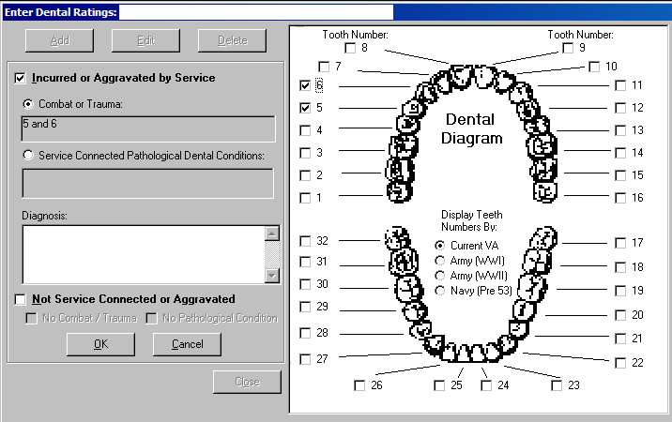

This gives a Text Selection Box. User can select one choice only:
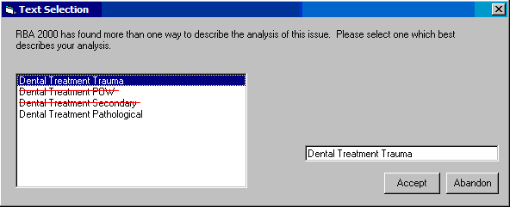

Current generated text, Dental Treatment Trauma option (must be changed):
Issue: Service connection for dental treatment purposes for {}.
Decision: Service connection for dental treatment purposes is granted for {} due to combat wounds or trauma.
Analysis text:
VA outpatient dental treatment may be furnished for dental conditions which are due to combat wounds or other service trauma. Service connection for dental treatment purposes is granted for {} because the records show {}.

New: Dental Treatment Trauma option
Issue unchanged: Service connection for dental treatment purposes for {}.
Change Decision to:
Service connection for dental treatment purposes is granted for the non-compensable service-connected dental condition, {}, due to combat wounds or service trauma.
Change Analysis text to:
VA outpatient dental treatment may be furnished for non-compensable service-connected dental conditions which are due to combat wounds or other service trauma. Service connection for dental treatment purposes is granted for {} because the evidence of record shows {}.

Current generated text, Dental Treatment POW option (this selection will be deleted):
Issue: Service connection for dental treatment purposes for {}.
Decision: Service connection for dental treatment purposes is granted for {} due to POW status.
Analysis text:
VA outpatient dental treatment may be furnished for dental conditions which are based on POW status of less than 90 days. Service connection for dental treatment purposes is granted for {} because the records show {}.
(this selection will be deleted)

Current generated text, Dental Treatment Secondary option (this selection will be deleted):
Issue: Service connection for dental treatment purposes for {}.
Decision: Service connection for dental treatment purposes is granted for {} as secondary to another service connected disability.
Analysis text:
VA outpatient dental treatment may be furnished for dental conditions that are caused by another service connected disability. Service connection for dental treatment purposes is granted for {} because the records show this dental condition is due to {}.
(this selection will be deleted)

Current generated text, Dental Treatment Pathological option (selection will be unchanged, can be used for claim within 180 days or more of discharge unless the discharge was corrected):
Issue: Service connection for dental treatment purposes for {}.
Decision: Basic eligibility for service connection for dental treatment purposes of {} is established as due to the non-compensable service connected pathological dental condition, {}.
Analysis text:
Basic eligibility for service connection solely for the purpose of Class II VA outpatient dental treatment or examination is established for tooth number(s) {} based upon the pathological dental condition of {}.

Add New option: Dental Treatment Pathological, Discharge Corrected
Issue: Service connection for dental treatment purposes for {}.
Decision: Basic eligibility for service connection for dental treatment purposes of {} is established as due to the non-compensable service connected pathological dental condition, {}.
Analysis text:
Basic eligibility for service connection solely for the purpose of Class II VA outpatient dental treatment or examination is established for tooth number(s) {} based upon the pathological dental condition of {} and correction of disqualifying discharge or release by competent authority.

Code sheet entry (identical regardless of Text Selection Box option selected):
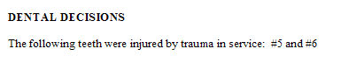

Grant service connection as incurred or aggravated for individual teeth based on Service Connected Pathological Dental Conditions (issue Category is Dental, there is no subject entered on the Issue Management Screen). Select Incurred or Aggravated by Service, select Service Connected Pathological Dental Conditions, select each affected tooth (3 and 4 in this example), and enter the pathological dental diagnosis.
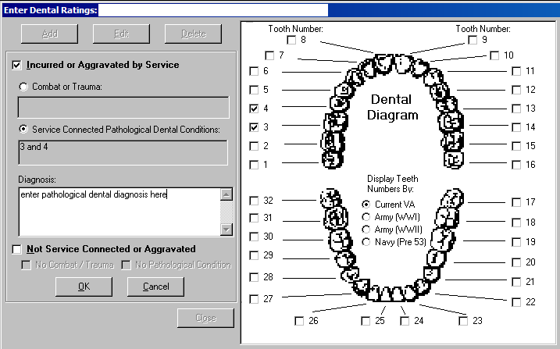

This gives a Text Selection Box. User can select one choice only:

Please see text descriptions above.

Code sheet entry (identical regardless of Text Selection Box option selected):
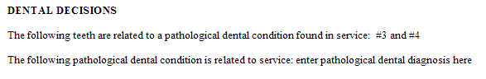
Deny service connection as incurred or aggravated based on Combat/Trauma or No Pathological Condition (issue Category is Dental, there is no subject entered on the Issue Management Screen). Select Not Service Connected or Aggravated, select No Combat/Trauma and/or select No Pathological Condition. The tooth diagram is not enabled for a denial.

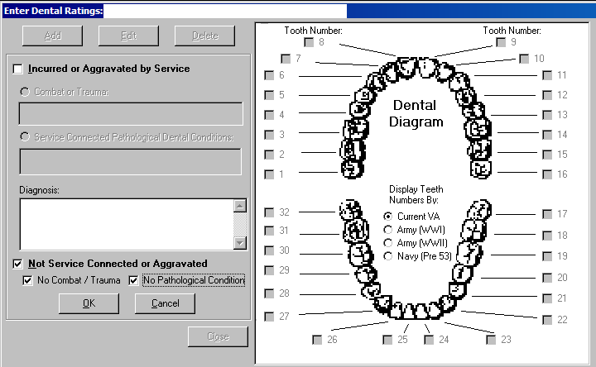

The text is identical no matter which option(s) are selected in the denial.

Issue: Service connection for dental treatment purposes for {}.
Decision: Service connection for dental treatment purposes is denied for {}.

Current Analysis text (must be changed):
VA outpatient dental treatment may be furnished for certain diseased, missing or defective dental conditions resulting from another service connected disability, for dental conditions which are due to combat wounds or other service trauma, or based on POW status of less than 90 days. Service connection for dental treatment purposes is denied as none of these conditions are met.

New Analysis text:
VA outpatient dental treatment may be furnished for certain diseased, missing or defective dental conditions resulting from combat wounds or other service trauma. Service connection for dental treatment purposes is denied as the evidence of record does not show any dental disabilities resulting from combat or other service trauma.

Code sheet entry when No Combat/Trauma selected:
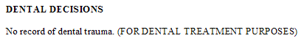

Code sheet entry when No Pathological Condition selected:
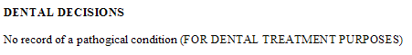

Code sheet entry when No Combat/Trauma and No Pathological Condition selected (note that misspelling of “pathogical” below will be corrected shortly):
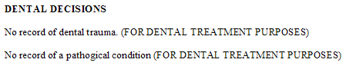

Multiple Dental Issues
Please note that you cannot create separate issues if you have multiple dental issues. All of the decisions must be entered as one issue. This will generate a correct code sheet below, but the current text generation only addresses the first grant entered. The rater must enter all appropriate text to address each of the decisions.

In this example, there is a grant of service connection as incurred or aggravated for teeth 4, 5, and 6. There is also a grant of service connection as incurred or aggravated for teeth 30 and 31 based on the service connected pathological dental condition of “adf.” Finally, there is also a denial of service connection as incurred or aggravated based on Combat/Trauma and No Pathological Condition.
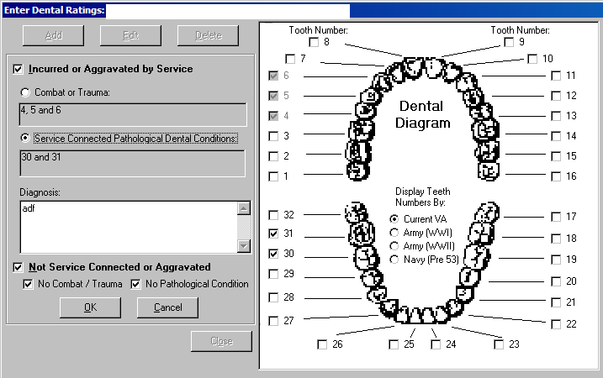

This gives a Text Selection Box. User can select one choice only:

The generated text is identical to that shown above for the “Grant service connection as incurred or aggravated for individual teeth” example.

Code sheet entries for all Dental decisions (note that misspelling of “pathogical” below will be corrected shortly):
